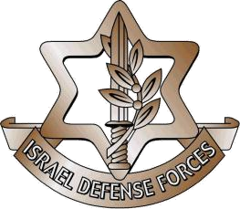

Dear \*\*\*\*\*,

We thank you for your participation in the Israel Defense Forces' first International Operational Simulation Summit. It was a whirlwind three days, filled with learning opportunities, special speakers and appearances, an incredible action-filled trip to the South and great food! We were so glad to learn from you and hope you gained some insight from others as well. We look forward to seeing you at our next event.

Have an amazing 2020, filled with excitement and growth!

Respectfully,

John Doe

J3

IDF