**Final Paper - Proposal**

LtCol Donald Maraska, USMC

**Subject of the paper:**

China’s “New Silk Road” through Israel…Opportunity or Threat…

**Background:**

China’s historic interest in Israel has focused on its ability to manage terror and its “Start-Up Nation” reputation, today it sees Israel as a strategic outpost; a small dot on the map true, but one which is vital for ensuring a much needed alternative trade and energy route. Israel’s geographical position, innovative human capital, and technological know-how make it possible for Israel to play a pivotal role in China’s “New Silk Road” project, and the opportunity to shape Chinese thinking and strategy in the region.

China’s “New Silk Road”, also known as “One Belt One Road” (OBOR), is Beijing’s enormous foreign-economic project aimed at creating a belt of railroads, pipelines, and sea routes with port infrastructure from the Indian Ocean to the Mediterranean, connecting China to the West. Israel’s potential in this project lies in becoming an overland bridge connecting trade routes from the Far East through Africa up to the Middle East and on to Europe.

Chinese is already very active in the region; securing a controlling share in the port of Piraeus (Greece), holdings in seaports in Egypt (Alexandria, Adabiya, Port Said), in Algeria (Cherchell), in Turkey (Amberley) and in Italy (Genoa and Naples) – all of them form part of China’s OBOR strategy. Active in Israel too, China Harbor was chosen to build the private port in Ashdod and Shanghai International Port Group was picked to be the operator of the private port in Haifa.

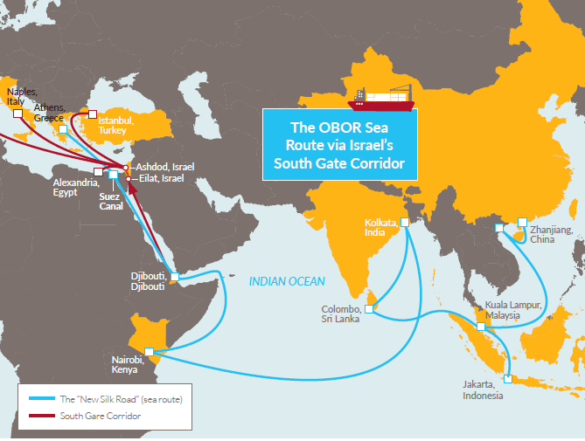

To ensure these ports operate at full capacity, provide a safe alternative to the Suez Canal, and a dependable commercial center, OBOR calls for the connection of the Red Sea with the Mediterranean via rail. Such a development could turn Israel into an essential part of the global trading ecosystem while boosting its economy, drawing population to the Negev, and deepening diplomatic ties with global trading partners.

A Red Sea – Mediterranean Sea rail project (has been discussed by the Israeli government in the past but appears to have stalled.

**Goal of the work:**

1. Evaluate the opportunities and/or threats for Israel associated with participating in China’s OBOR project through the four pillars of National Security: Military, Economic, Society, and Diplomatic, with specific focus on the potential of the RED – MED rail line.

2. Examine past Chinese direct investment and current OBOR projects to determine viability of the overall strategy.

3. Analyze opportunities associated with such an undertaking for Israel to strengthen diplomatic relations with China, African nations, the European Union, other trading partners, and/or Russia.

4. Identify economic and security opportunities and/or threats to Israel.

**Research questions:**

1. What are China’s interests / goals with regard to the “One Belt One Road” strategy?

2. Is the cost-benefit analysis positive for Israel?

3. How could such a project benefit Israel?

4. How would an Israel-China partnership be viewed by the United States?

**Research claims (if there are any):**

1. The overall benefits attained through Israeli active participation would outweigh the costs over time.

2. The development of a closer economic relationship with China would not threaten the Israel-U.S. relationship.

**Method of presenting the idea of the research (outline):**

Outline:

1. Introduction – presenting the subject and goal of the paper
2. Historical background
   1. Globalized market place
   2. China’s Trade Policy
   3. China’s Direct Foreign and Direct Investment Policy
   4. The New Silk Road (OBOR) Strategy – Interests and Goals
   5. Viability and Efficacy Current OBOR Projects
3. Potential Benefits - Israel
4. Cost-Benefit Analysis - Israel
   1. Military (Security)
   2. Economic
   3. Society
   4. Diplomatic
5. Israel-China Partnership…United States Perspective
6. United States Interests with regard to OBOR
   1. Regional
   2. Global
7. Analysis of Findings
   1. Potential Way Forward…
8. Conclusion

**The importance / novelty of the paper:**

The magnitude of Beijing’s “New Silk Road” foreign-economic strategy requires a similarly wide lens to digest. Where local economic undertakings can be viewed in isolation, such a project must consider the entire map to determine the local supply and demand equation. In this instance, simply considering the ground level view, through the lens of current capacities and economic conditions without regard to the larger picture of the OBOR strategic project will lead to incomplete information for the decision maker.

City-states along the ancient trade route became wealthy and powerful beyond imagination while those bypassed withered. We live in a global economy where goods must be moved. The choice to be a transportation hub brings both benefits and costs.

Transport economics deals with the allocation of resource and complication of network effects within the transportation sector. Goods flow over networks at certain speeds and costs but the infrastructure laid down and all other development effects (four pillars) must also be part of the equation.

Connection of the paper to National Security:

The topic has the potential to affect all four pillars of national security.

**Author’s link to the work:**

Past assignments were in threat area economic development.

Undergraduate degree: B.S. Economics

Masters Degree: Masters of Management.

Future assignment: Marine Corps Office of Legislative Affairs or Marine Corps Forces Europe/Africa (AOR includes Israel) – Through developing a deep understanding of China’s OBOR strategy, specifically as it relates to the Africa / Mediterranean region, I hope to better serve my future commanders.

**Accompanying instructor:**

Haim Waxman

**Observations:**

Military: Heavy equipment transportation, large-scale troop redeployments

Economic: Cost-benefit, Increased economic activity, jobs, higher tax revenue, heavy industry, natural gas transportation, raw materials and finished goods import/export

Society: Employment, population dispersion, development of additional industries and human capital

Diplomatic: Regional and international opportunities and partnerships, good will and mutual dependence, effect on existing relationships, diplomatic leverage