Prof. Yaron Zelekha

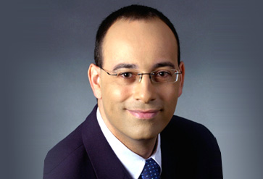
Prof. Yaron Zelekha is married and a father of three. He served in the IDF Research Department and was nominated for excellence by Head of the Military Intelligence Directorate for his creative thinking.

Holds academic degrees in accounting, economics and psychology, having completed all with honors, holds a PhD in economics from Bar Ilan University, provides lectures to various academic institutes and serves as president of the Supreme Academic Council of the Ono Academic College, as well as Chair of the Social-economic Research Institute of the ‘Histadrut’ (Israel’s national trade union center).

Zelekha was rewarded the Knight’s Badge from the Movement against Crime and Corruption, a Knight’s Badge from the Movement for Quality Government in Israel, and Medals of Appreciation from various government offices.

Among others, Zelekha served as Accountant General at the Israeli Ministry of Finance, vice president of finance at the Derech Eretz, Tevel Telecom and Partner companies. Chair and board member of leading content companies, the BAZAN Group for Oil Refining, the Trans-Israel Pipeline, the Inbal Insurance Company, M.I. Holdings LTD, the Israel Credit Foundation, Arkia and Mega Retail LTD.
Zelekha has filled various positions in different committees including chair of the Committee for Disability Allowance Reform, chair of the Committee for Inspecting the Organizational Structure of Israeli Soccer, chair of the Committee for Increasing Competitively in the Vehicle Industry and more.

Zelekha has written several books and articles, both in Hebrew and English, including:
“The Black Guardia”, “Uncertainty, Expectations and Macroeconomic Policy in Israel”, “Reforming the Consumption Patterns – the Guide to Economic Efficiency and Social Justice in Israel”, and more.

