Biography – as at 6th February 2019
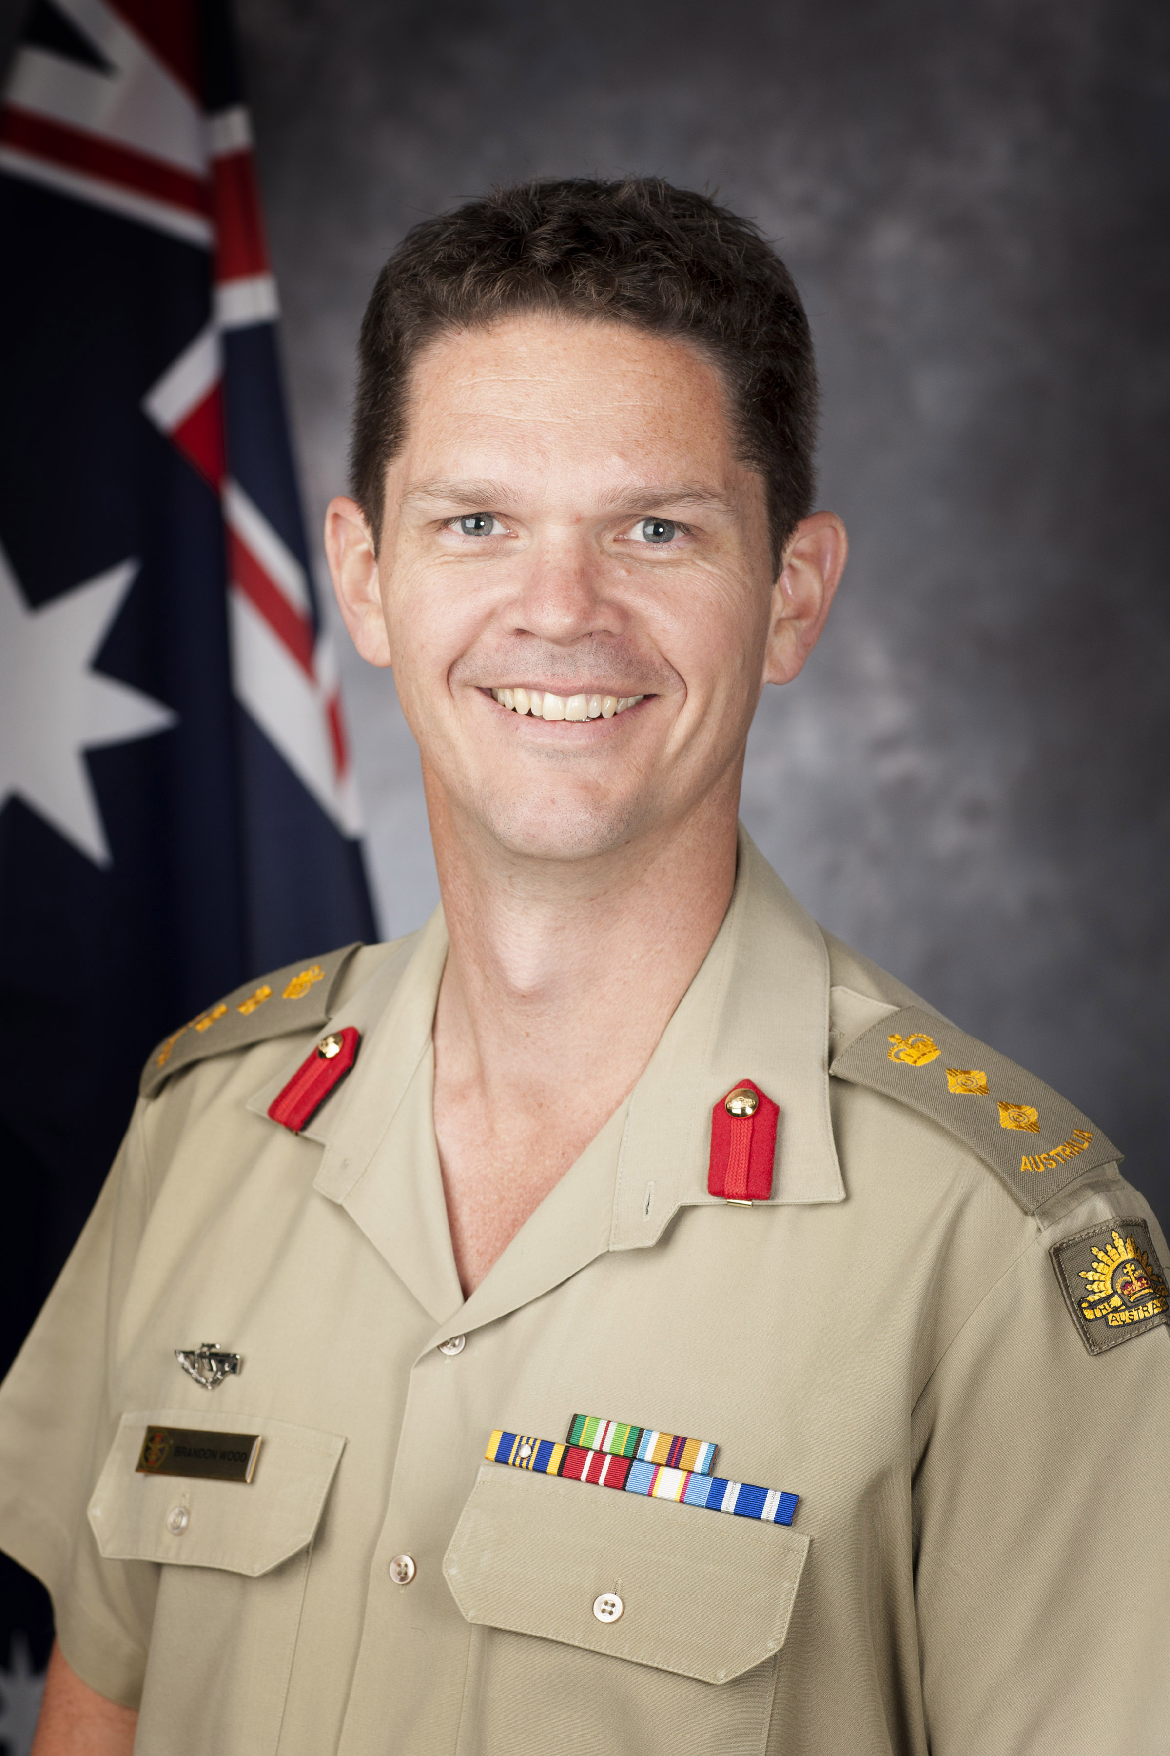
8242526 Colonel Brandon Wood

Brandon Wood was born in Canberra. He graduated from the Australian Defence Force Academy in 1991 and the Royal Military College, Duntroon, in December 1992 and was allocated to the Royal Regiment of Australian Artillery.

Colonel Wood has held the complete range of Artillery regimental appointments, including Troop Commander, Mechanised Forward Observer, and Operations Officer and Battery Commander Headquarter Battery within 8th/ 12th Medium Regiment; Battery Captain and Regimental Second-in-Command at 4th Field Regiment; and Adjutant at 7th Field Regiment. In 2004 he attended Staff College at Weston Creek and was then posted on exchange to the UK. In January 2007 Colonel Wood returned to Canberra to assume the position of Deputy Director Weapon Systems - Land, and in 2009-2010 Colonel Wood was the Commanding Officer at the School of Artillery.

In January 2011 Colonel Wood was posted as the Staff Officer Grade 1 Postings within DOCM-A, and in August 2012 Colonel Wood was promoted to be the Director of Officer Career Management – Army. In January 2013 he was appointed as the Director Personnel / J1 at Headquarters Joint Operations Command, and from March 2014 until December 2016 Colonel Wood was the Director of Senior Officer Management. From January 2017 Colonel Wood was the Defence Attaché within the Australian Embassy in Baghdad, Iraq for 12 months. In February 2018 he commenced the Chief of Army’s secondment to the Department of Prime Minister & Cabinet as the Senior Adviser Defence Strategic Policy and Campaigning within National Security Division.

Colonel Wood has had operational deployments as a United Nations Military Observer in East Timor, and as the Chief of Analysis within HQ ISAF in Kabul.

Colonel Wood holds a Bachelor of Arts (First Class Honours) and a Master of Defence Studies from the University of New South Wales, a Master of Arts in Maritime Policy from the University of Wollongong, and a Master of Strategic Affairs from the Australian National University.

Colonel Wood is married to Rebecca. He is a keen sportsman with particular interests in hockey, cricket and athletics. His other interests include a passion for travelling, motorsports, reading military history and current political affairs.

