Victoria Coates
Senior Director for Strategic Assessment at the National Security Council
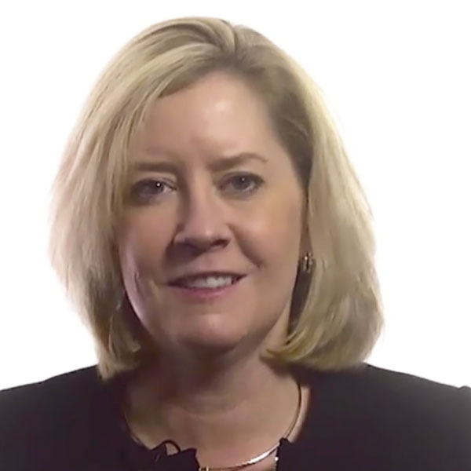
previous positions

2017 | Senior director for strategic assessments at the National Security Council in the Trump administration
2015 | National security advisor for Ted Cruz's presidential campaign
2013 | Policy advisor for national security
2012 | Joined the Foundation for Defense of Democracies as an adjunct fellow
2011 | Joined then-Governor Rick Perry's (R-Texas) presidential campaign as the foreign affairs advisor
2007-2011 | Senior research associate at the Rumsfeld Foundation
Education
1998 | Ph.D. in art history from the University of Pennsylvania
1991 | M.A. in art history at Williams College in Williamstown, Massachusetts
1990 | Graduated from Trinity College
Personal Information
Born and raised in Lancaster, Pennsylvania
Descendant of Andrew Gregg Curtin who served as Governor of Pennsylvania during the Civil War

