**Trump’s High-Wire Act of Reestablishing Deterrence without War**

**By** **[VICTOR DAVIS HANSON](https://www.nationalreview.com/author/victor-davis-hanson/" \o "Posts by Victor Davis Hanson)**

May 28, 2019 6:30 AM

* 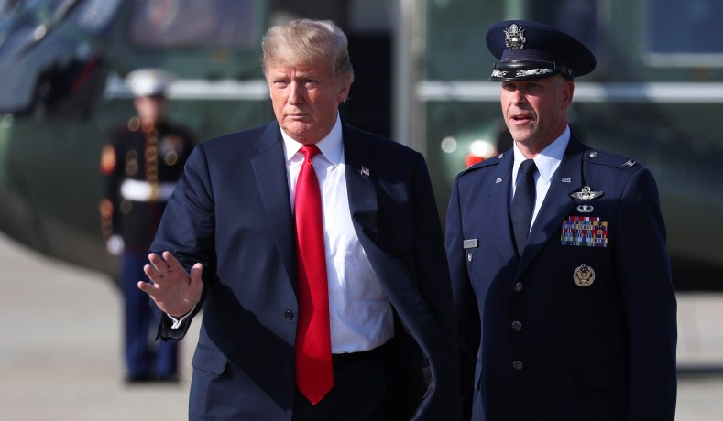President Trump waves prior to boarding Air Force One at Joint Base Andrews, Md., October 1, 2018. *(Jonathan Ernst/Reuters)*

Trump’s opponents at home and abroad would love to see him get the U.S. into a messy intervention right before the election.

Donald Trump inherited a superficially stable world from Barack Obama that, in fact, was quite volatile. There had been no tense standoffs with North Korea, but also apparent intercontinental ballistic missiles with possible nuclear warheads now pointed at the United States. Obama more or less punted on North Korea, by declaring it a problem — and hoping that Pyongyang’s missile and nuclear testing did not get too out of hand before 2017.

Then there was the “Iran deal.” It was an appeasing agreement that almost surely guaranteed that Iran would soon have nuclear weapons, along with a revived economy liberated from sanctions and empowered with American cash. Iran’s terrorist surrogates were the greatest beneficiaries of U.S. naïveté. At best, Obama assumed that when Iran went nuclear, it would be on someone else’s presidential watch and therefore not his fault. At worst, Obama, in delusional fashion, believed that empowering Iran would balance Sunni states and bring justice to historically oppressed Shiite and Persian minorities who would take their rightful place in the Islamic world.

Everyone knew that China violated almost every aspect of world commerce. Everyone knew that China would never allow the U.S. to trade with China the same way that Beijing traded with America. Everyone knew that 1.3-billion-person China was a neo-imperialist Communist dictatorship that was headed on an announced trajectory of world hegemony. Obama in particular thought that stopping China’s agenda would be medicine that was more painful than the disease.

Like the proverbial medieval mice who voted to warn of a marauding carnivorous house cat by putting a bell around his neck, the prognosis of Chinese mercantilism and aggression — and the need to confront Beijing — was right-on. But no one wished to do the messy, dangerous work of belling the Chinese cat.

The Obama administration’s Russian “reset” was an ungodly disaster. Vladimir Putin absorbed Eastern Ukraine and Crimea. He interfered freely but often clumsily in U.S. elections — *well prior to 2016*. John Kerry invited the Russians to reenter the Middle East on the lunatic idea of a Russian promise to address Syrian WMD. Putin violated prior agreements on the deployment of short-range missiles. The more Obama appeased Putin — dismantled missile defense in Eastern Europe, blamed the Bush administration for the tensions that were to be relieved by the reset, and in a hot-mic exchange offered to become more malleable with Putin if Putin would behave while Obama was up for reelection — the more Putin detested Obama.

Everyone knew that tired pretenses had nothing to do with the realities on the ground in the Middle East. The U.S. embassy belonged in Jerusalem. The Palestinians of today were no more “refugees” than were the Volga Germans. The strategic Golan Heights were never going to return to the Assad terrorist state. The U.S. had no business funneling financial assistance through the U.N. to Palestinians who either were engaged in terrorism or approved of it. Trump pulled back the curtain and showed all the little devilish men with gears and levers projecting a fake image of norms and protocols on the Middle East projection screen.

Again, these existential crises — Iran, North Korea, China, Russia, the Middle East — all preceded Trump. But they also all tested the Trump doctrine of restoring deterrence without engaging in costly optional wars in which in tactical victories cannot translate into definable strategic success or clear U.S. advantage in a cost-benefit analysis.

Trump’s enemies hope (translated into politicalese) that his ambitious foreign policy does not follow the success of Trump’s dynamic economy. At home, Trump caused a stir by all at once opening up more federal leasing for energy exploration, green-lighting pipelines, massively deregulating, cutting taxes, jawboning outsourcers and off-shorers, confronting asymmetrical trade partners, pulling out of the Trans-Pacific Partnership trade agreement and the Paris climate accord, and recalibrating NAFTA. That huge risk of maximum changes everywhere and swarming the opposition all at once achieved a force-multiplying effect on the economy that soon boomed.

Trump probably believes that if he goes full-bore abroad, true to form, a domino effect will follow, given that the U.S. gains more sway each time it faces down a miscreant. The stakes are certainly high. A big China trade deal, an agreement to denuclearize North Korea and Iran, flipping Putin to become a neutral rather than an adversary, or a Middle East halfway accord could change global realities and empower the U.S. And so the gambler Trump wagers that he can do overseas what he did at home and pull off land-breaking agreements — all at once.

Can he?

Note that Trump shattered the blue wall in part because of his sober Jacksonianism: restoring U.S. tough deterrence *without* inserting a large military presence in any of the hellholes that U.S. troops have been deployed to in the past 50 years, much less falling into a conventional war that America could win, but only at considerable cost. Bombing the “sh*t” out of ISIS was a successful example of a non non-intervention. Early on, the canny Trump, alone of his Republican rivals, fathomed that voters neither wanted any more Obama apologetics nor would put up with another Afghanistan, Libya, or Iraq.

Squaring that circle of toughness without risking a major war is now Trump’s political challenge, given that the shelf life of rhetorical deterrence is brief.

The United States cannot abide renegade lunatic regimes with nuclear missiles aimed at its heartland, or aggressive nuclearized regimes with which the U.S. had either already fought a major war or narrowly avoided one. China’s destruction of global trading norms only whets China’s appetite to translate its huge profits into military power and neocolonial adventurism, on the theory that countries that have appeased its mercantilism will probably do the same in matters of its aggressive foreign and military policy.

The Palestinians felt that during the Obama years they were insidiously persuading the United States to ostracize the moderate Arab regimes, embrace an Iranian foil, and decouple from Israel.

Putin asserted that his weak Russia was a match for a strong U.S. because he assumed that he was strong and Obama weak — and therefore his own godhead could do what his country otherwise could not.

Yet Trump all at once is attempting to straighten out all the foolishness of the last decade with China, Iran, North Korea, Russia, and the Middle East, and, again, he is doing so simultaneously, not sequentially. He might remember that China is the chief threat, and it has some leverage with both Iran and North Korea. In other words, it would certainly be in China’s interest to see the U.S. in a mess with its surrogates in Tehran and Pyongyang while America seeks to face down Chinese mercantilism — with the Middle East descending into another hot war.

So, Trump could achieve either high-profile success — or became mired in endless engagements and a pre-election, public-relations disaster.

Halving the Chinese trade deficit and forcing it to follow global rules would be an astounding achievement. So would denuclearizing North Korea and preventing Iran from getting the bomb. As would finally telling the Palestinians to give up terrorism and get on with building a state, or corralling Putin so that he abandons dreams of a new Soviet Empire and accepts that Eastern Europe, the Baltic States, and the breakaway republicans are never going to be Russian again. Prodding a change in government in Venezuela would create momentum elsewhere in authoritarian Latin America. Again, to do all that at once, rather than in sequence, would be singular achievements — and yet likely improbable.

George W. Bush tried to address just three existential challenges all at once following 9/11, and it all but destroyed his presidency. Bush not only fashioned a successful multifaceted anti-terrorism strategy that foiled subsequent attempts to repeat the World Trade Center and Pentagon bombings, but he took the war to the enemy. Yet soon the U.S. was fighting wars in both Iraq and Afghanistan, while trying to stop North Korea’s sudden emergence as a nuclear power, and while battling Iranian terrorists inside Iraq and Tehran’s own nuclear agenda — as China stepped up its global profile and began translating its enormous profits into a growing military, and as OPEC and Middle East suppliers helped drive up the cost of oil.

What was problematic about Bush’s “Axis of Evil” of Iraq, Iran, and North Korea was not that the term was necessarily inaccurate about the threats all three posed, or the need to address all of them eventually. The rub was that a country with a sizable force fighting in Afghanistan might abruptly find itself fighting three new dirty conflicts all at once.

In short, Trump might learn from the past and avoid what his opponents hope for — a series of conflicts dovetailing with the 2020 election, as the financial and psychological strain tax the electorate, as they did from 2006 to 2008.

Note in this regard how deeply Trump’s opposition is invested in seeing  him fail or, specifically, how private citizen John Kerry, last spring and summer, and, most recently, Senator Dianne Feinstein have met with the oleaginous Iranian foreign minister Javad Zarif, ostensibly as “adults in the room” who agree on waiting Trump out — which in fact was the explicit advice recently given to the Chinese by former State Department official Susan Thornton.

Trump’s “principled realism,” “Jacksonianism,” or “the Trump doctrine” ostensibly is tit-for-tat deterrence, *not* nation-building or optional interventions. If Iran hits an American ship, the U.S. will take out a port facility — but not set foot in Iran. If North Korea sends more missiles over Japan with Chinese approval, maybe Japan might have to do the same thing to North Korea with U.S. sanction.

But Trump also must remember that he ambitiously is trying to solve the major festering challenges of U.S. foreign policy — all at once and right before an election, when his political opposition at home, most of the European Union, and our enemies would like to see him fail at last. So in the next 17 months we should expect all sorts of provocations from abroad, and so-called Logan Acting at home, to make Trump stumble and get into a messy intervention before the election.

He should not take the bait.