**Trump’s Strategic Unpredictability, Its Pros and Its Cons**

**By** **[COLIN DUECK](https://www.nationalreview.com/author/colin-dueck/" \o "Posts by Colin Dueck)**

December 28, 2018 6:30 AM

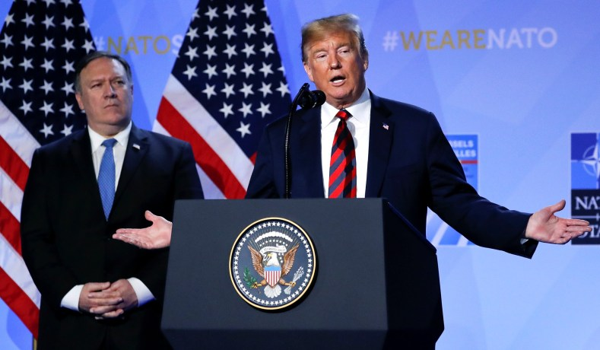President Trump speaks at a news conference following the NATO Summit in Brussels, Belgium, July 12, 2018. *(Yves Herman/Reuters)*

What can be an asset against adversaries is often a liability with allies.

“Don’t hold the ball so hard, okay? It’s an egg. Hold it like an egg.”  
— Crash Davis, *Bull Durham*

President Trump’s sudden December announcement of U.S. military withdrawals from Syria and Afghanistan highlighted a recurring question around Trump’s foreign policy: Is unpredictability an encumbrance? Or an asset?

In the movie *Bull Durham*, a minor-league North Carolina baseball team features an uneven pitcher — Ebby Calvin “Nuke” LaLoosh. LaLoosh has a million-dollar arm, but he has problems with control. He hits the bleachers. He hits the sportswriter. He hits the mascot. Catcher “Crash” Davis is brought in to help improve Ebby’s game. The idea is for the team to reap the benefits of the pitcher’s talent, including some of his unpredictability, without the downside.

Donald Trump entered the White House with some of Ebby’s qualities: gifted, but volatile. In fact Trump made it clear on the campaign trail that he positively believed in being unpredictable, not only personally and politically but as a way to reorient U.S. foreign policy. And he has certainly proceeded to do so.

As with everything surrounding Trump, the issue of unpredictability has since become wrapped up with how observers*feel* about him. Analytically, this hasn’t been especially productive. Because in truth, a certain degree of international unpredictability can have both advantage and disadvantages, and for the sake of U.S. national interests these need to be understood in a clear-eyed way.

You might say there are three types of unpredictability in foreign and security policy:

• Operational unpredictability against adversaries in wartime.

• Strategic unpredictability with foreign competitors in peacetime.

• Strategic unpredictability with allies.

With regard to operational unpredictability against wartime adversaries, no sensible analyst can really argue against it. Just to take one historical example: It was not by being entirely predictable that the Western Allies established a foothold in Normandy on June 6, 1944. On the contrary, they utilized surprise, deception, disinformation, speed, and firepower to set back German forces and win the day. In relation to ISIS, the incoming Trump administration chose in 2017 to loosen U.S. rules of engagement and roll back that terroristic proto-state aggressively. It was of course right to do so, and this involved among other things operational unpredictability.

With regard to strategic unpredictability in times of peace, this is where things really start to get interesting. The 2018 U.S. National Defense Strategy (NDS) urges strategic predictability but adds that “with our allies and partners, we will challenge competitors by maneuvering them into unfavorable positions, frustrating their efforts, precluding their options while expanding our own, and forcing them to confront conflict under adverse conditions.”

Given that a central focus of the 2018 NDS is on great-power competition, this would seem to indicate that both the Pentagon and the Trump administration embrace a mentality of imposing costs, pushing back, and counteracting Chinese and Russian aggressions partially through unpredictable U.S. countermeasures in *peacetime.* If so, this is and was entirely overdue. For example, the current U.S. economic-pressure campaign against China, while not without its costs to the U.S., has set the Chinese Communist Party back on its heels. And there are Russian foreign-policy experts who believe Trump’s threats to be more credible than those of Barack Obama’s.

It’s in relation to American allies that strategic unpredictability carries the greatest risks. No doubt the president looks to build leverage in relation to U.S. allies, on both military and commercial matters, by occasionally reminding those same allies of America’s exit options. No doubt he also looks to keep the peace by transmitting an impression of strength. But the president cannot have it both ways. Any reduction in the certainty of U.S. commitments to allies necessarily entails some increased risk of deterrence breakdown, insofar as foreign dictators or jihadists conclude that the U.S. may not respond to their aggressions against other nations.

This brings us to the president’s recent statements on Syria and Afghanistan. After many years of war, it’s not unreasonable for Americans to want a gradual and coordinated reduction of U.S. troop levels in these countries. Still, a sudden and unexpected drawdown of U.S. forces can only reduce America’s leverage against a range of adversaries and competitors including ISIS and the Taliban. And it plays into the hands of those who want to claim that the United States under Trump is not a reliable ally.

It is indeed galling to hear some former Obama officials critique proposed military disengagements, when they supported very similar and destabilizing drawdowns from Iraq and Afghanistan in 2011–12. Nevertheless, the inconsistency of their arguments does not cancel out a central truth: namely, that when the U.S. disengages overseas, it tends to be the bad guys that fill the void.

Donald Trump throws fastballs at allies and adversaries alike. Considered as a package, unpredictability in national-security policy carries both advantages and disadvantages, and critics along with supporters should be intellectually honest enough to admit it. Being unpredictable at the operational level is a plus. Even peacetime unpredictability designed to throw adversaries off balance can be advantageous. Unpredictability with allies is more of a mixed bag. It has secured certain limited concessions for the United States over the past two years, but at the same time carries undeniable risks. The worst risk of all is deterrence failure. In effect, we are left hoping that Trump’s incalculability unnerves America’s enemies as much as its allies.

As the pitcher Crash Davis tells a wary batter from an opposing team playing against the Durham Bulls, with Ebby LaLoosh pitching: “I wouldn’t dig in if I were you. Next one might be at your head. I don’t know where it’s gonna go. Swear to God.”

[](https://www.nationalreview.com/author/colin-dueck/)

[**COLIN DUECK**](https://www.nationalreview.com/author/colin-dueck/) is a professor in the Schar School of Policy and Government at George Mason University, and a Kirkpatrick visiting fellow at the American Enterprise Institute. His most recent book is [***THE OBAMA DOCTRINE***](http://www.amazon.com/exec/obidos/ASIN/B00ULVBYXU/ref=nosim/nationalreviewon)*: American Grand Strategy Today*.