Thomas Loren Friedman
American Political Commentator and Author
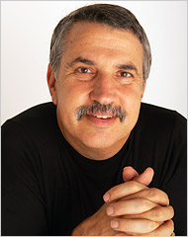
previous positions

2004 | Named to the Order of the British Empire by Queen Elizabeth
1995 | Foreign Affairs columnist for the New York Times Newspaper
1992 | The White House correspondent for the New York Times Newspaper
1984-1988 | Served as Israel bureau chief for the New York Times Newspaper
1981-1982 | Joined The New York Times Newspaper and was appointed Beirut bureau chief
Education
1975 | B.A. degree in Mediterranean studies from Brandeis University
1978 | M.A in Philosophy and Modern Middle East studies from Oxford University
Personal Information
Born July 20, 1953
Mr. Friedman is married and has two daughters

