Stéphane Dujarric
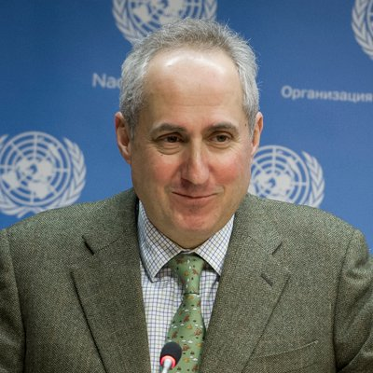
Spokesperson for the Secretary-General of the United Nations
previous positions

2014 | Spokesperson for the Secretary-General of the United Nations
2011-2014 | Director, News and Media, UN Department of Public Information
 | Director of Communication, UNDP
2005 | Chief Spokesman for United Nations Secretary-General Kofi Annan
2000-2005 | Associate Spokesperson, UN
1990-2000 | Various Positions, ABC Network
Education
Personal Information
Born in France, 1965

