**THE TIMES: 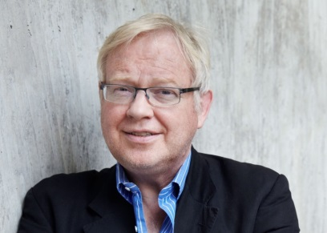Diplomatic Editor Roger Boyes** was formerly Berlin correspondent for The Times, covering Germany and northern Europe, and had a column in the German newspaper Der Tagesspiegel entitled 'My Berlin'. Boyes entered journalism as a Reuters correspondent in Moscow (1976–1977), joined the Financial Times as an Eastern Europe specialist in 1978 and was the Bonn correspondent of the FT from 1979 to 1981. He then switched to The Times and became the Eastern Europe correspondent based in Warsaw where he covered the solidarity revolution and the imposition of martial law. He has been posted to Rome as a Southern Europe correspondent (1987–89), Bonn and Berlin correspondent 1993- 2010. Since 2010 Roger has served as the Diplomatic Editor of the paper. He is considered a senior, respected journalist.