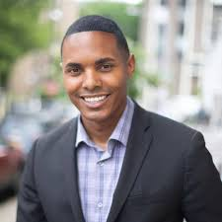 **Ritchie J.Torres**

|  |
| --- |
| Previous Positions |
|  |

**2013**-Council Member Ritchie Torres was first elected in November 2013 to represent the 15th Council District in the Central Bronx.

**2017**-In November, Council Member Torres was elected to his second term and became Chair of the new Oversight and Investigations Committee of the City Council

|  |
| --- |
| Education |

Torres enrolled at [New](https://en.wikipedia.org/wiki/New_York_University) York University but dropped out at the beginning of his sophomore year.

 Torres resumed working for council member [James Vacca](https://en.wikipedia.org/wiki/James_Vacca), eventually becoming Vacca's housing director.[[3]](https://en.wikipedia.org/wiki/Ritchie_Torres#cite_note-New_Yorker-3) In that role, Torres conducted site inspections and document conditions, ensuring critical housing issues were promptly and adequately addressed/

|  |
| --- |
| Personal Informations |
|  |

-Torres was raised by his mother in a public housing project in the [Throggs Neck](https://en.wikipedia.org/wiki/Throggs_Neck" \o "Throggs Neck) neighborhood of the [East Bronx](https://en.wikipedia.org/wiki/East_Bronx).

- He attended [Herbert H. Lehman High School](https://en.wikipedia.org/wiki/Herbert_H._Lehman_High_School), served in the inaugural class of the [Coro](https://en.wikipedia.org/wiki/Coro_(non-profit_organization)) New York Exploring Leadership Program, and later worked as an intern in the offices of the Mayor and Attorney Genera