**Rabbi Joshua M.Davidson**

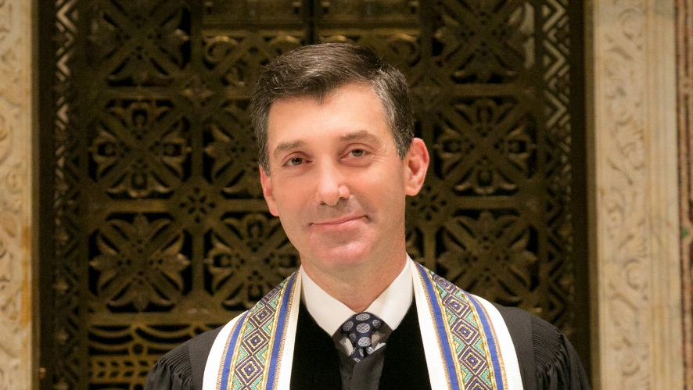

|  |
| --- |
| Previous Position |

**1997 - 2002**: He is the assistant and associate rabbi of Central Synagogue in New York City, advising that synagogue’s award-winning Social Action Committee.

**2002 - 2013** he served as senior rabbi of Temple Beth El of Northern Westchester in Chappaqua, New York

**2001 – 2006**: he served as chair of the Central Conference of American Rabbis’ Committee on Justice, Peace and Religious Liberties and vice-chair of the Commission on Social Action of Reform Judaism.

**2019**-Rabbi Joshua M. Davidson is the senior rabbi of Congregation Emanu-El of the City of New York.

Rabbi Davidson serves on the board of directors of the Kavod Tzedakah Collective.

Rabbi Davidson, over the last two years, has guided Congregation Emanu-El through a revisioning to meet the needs of the 21st century.

|  |
| --- |
| Education |
| -A graduate of Princeton University and ordained by the Hebrew Union College-Jewish Institute of Religion.  Personal Information's |
|  |

-Rabbi Davidson’s work has included anti-death penalty advocacy, gay/lesbian inclusion and interfaith dialogue.

-In 2009, he was honored for his interfaith efforts by the Westchester Jewish Council and the American Jewish Committee, on whose New York board he sits.

- He is a past board member of Rabbis for Human Rights-North America.