**Rabbi David Seth Kirshner**

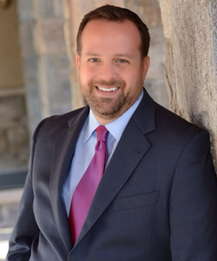

|  |
| --- |
| Previous position |

* President of the (2012–14) [New York Board of Rabbis](https://en.wikipedia.org/wiki/New_York_Board_of_Rabbis)
* President of the (2017–19) [New Jersey Board of Rabbis](https://en.wikipedia.org/w/index.php?title=New_Jersey_Board_of_Rabbis&action=edit&redlink=1)
* Appointed to NJ Israel Commission by Governor Chris Christie (2012)
* Member of the Chancellor’s Rabbinic Cabinet at the Jewish Theological Seminary
* Kellogg School of Rabbinic Management at [Northwestern University](https://en.wikipedia.org/wiki/Northwestern_University), Inaugural class
* UJC Rabbinic Cabinet
* Former Board member of the [Solomon Schechter Day School of Bergen County](https://en.wikipedia.org/wiki/Solomon_Schechter_Day_School_of_Bergen_County)
* National Council of the [American Israel Public Affairs Committee](https://en.wikipedia.org/wiki/American_Israel_Public_Affairs_Committee) (AIPAC)
* Hartman Fellow in Jerusalem
* Executive Officer of the Jewish Federations of North America (JFNA

|  |
| --- |
| Education |

-BA degree from New York University from Toronto

-MA in Hebrew letters and rabbinic ordination from the Jewish Theological seminary.