 | REPUBLIC OF CYPRUS  MINISTRY OF DEFENSE  NATIONAL GUARD GENERAL STAFF  OPERATIONS DIRECTORATE | 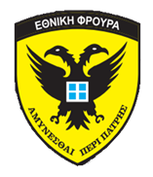

CIMIC EXERCISE «ARGONAUT 2019»

REGISTRATION FORM

Participant Contact Information:

Country
Rank/title
Name
Public authority / organization
Work address
E-mail address
Cell phone number
Office phone number
Passport (country of origin / number)
Accommodation (hotel)
Food allergies (or vegetarian)

Travel information
Arrival Day | Time | Airport of arrival | Flight n°
Departure Day | Time | Airport of departure | Flight n°

Any additional information

Please send by e-mail the submission form for each participant as soon is prosiple (ASAP) and not later than 10 May 2019 to depix_ops@army.gov.cy
or Fax to +35722417323

