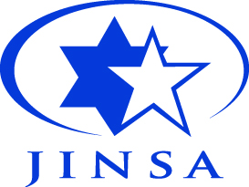

**Directions from the Hotel/Metro to the Program Location**

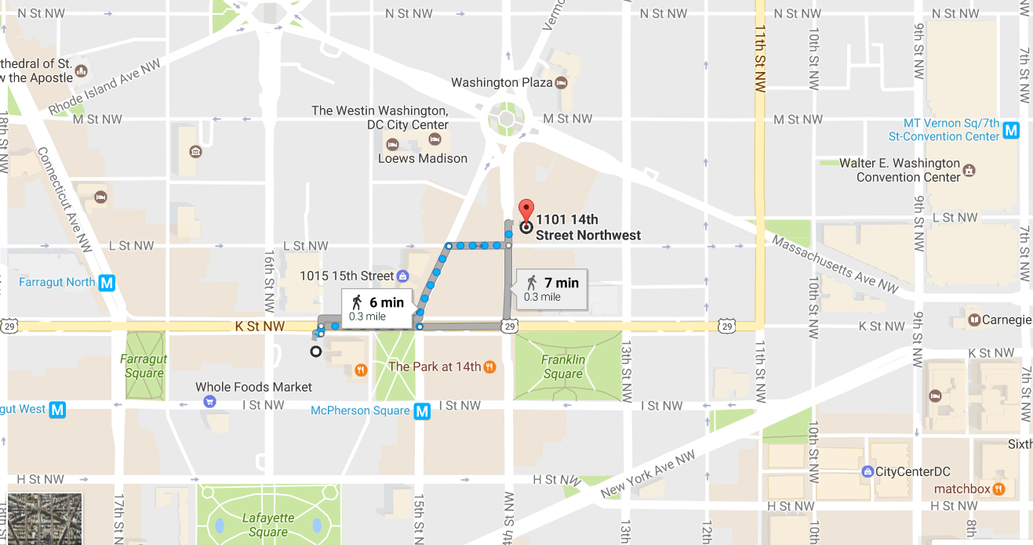

**About JINSA**

The Jewish Institute for National Security of America (JINSA) is dedicated to educating Congressional, military and civilian national security decision-makers on American defense and strategic interests, primarily in the Middle East, the cornerstone of which is a robust U.S.-Israeli security cooperation. JINSA believes that a strong American military and national security posture is the best guarantor of peace and the survival of our values and civilization.

**About the IDF Leadership Education Program**

JINSA inaugurated the IDF Leadership Education Program in 2016 to help fill crucial knowledge gaps about the United States among future generation of IDF Leadership. The program will expose rising IDF officers to various American political, military, business, historical and cultural elements that inform the U.S.-Israel relationship, as well as U.S. policies towards other countries and organizations that impact Israel. It will also educate the IDF on different aspects of U.S. foreign policy and strategic thinking, and will provide them the opportunity to engage with senior American defense, political, business and other leaders that will carry forward for many years.

Schedule (As of April 17, 2017) *

*\*All briefing times are subject to change and will take place at 1101 14th Street, NW*

*on the 2nd Floor unless otherwise specified.*

Tuesday April 18

*9:45 AM:* Arrive at DCA Airport, Washington D.C.

*10:15 AM:* Transfer to Hyatt Place Washington D.C./White House Hotel

*3:00 – 7:00 PM:* Walking tour of Washington, D.C. monuments

Wednesday April 19

*9:00 – 9:30 AM:* Introductory Remarks, **COL Shai Katav**

*9:30 – 10:00 AM:* Opening Remarks, **Michael Makovsky, PhD**

10:00 – 11:00 AM: *U.S. Presidential Election,* **Mark Mellman**

*11:00 AM – 1:00 PM:* Lunch

*1:00 PM – 2:30 PM: U.S. Policy Towards Asia Pacific,* **VADM John Bird, USN (ret.) and Jake Sullivan**

*2:30 PM – 4:00 PM: U.S. Energy Trends and Foreign Policy*, **Dr.** **Ed Morse**

*4:00 PM – 6:00 PM: U.S. Civil Society/Culture, and Economy,* **Michael Barone**

*6:00 PM – 7:30 PM: American Christians and Israel,* **Robert Nicholson**

Thursday April 20

*9:00 AM – 10:30 AM: Key Currents in the History of U.S. Foreign Policy,* **Dr.****Philip Zelikow**

*10:30 AM – 12:00 PM: U.S. Foreign Policymaking Process,* **Dr.****Philip Zelikow**

*12:00 PM – 1:00 PM:* Lunch

*1:00 PM – 2:30 PM: U.S. Foreign Policy Under Trump Administration,* **Dr.****Philip Zelikow**

*2:30 PM – 5:30 PM: Defining Themes/Docs in U.S. History,* **Dr. William Kristol**

*5:30 PM – 6:30 PM: U.S. Budget,* **Steve Bell**

*6:30 PM – 7:30 PM: Overview of DOD,* **Dr.****Jeb Nadaner**

Friday April 21

*8:00 AM – 3:00 PM:* Quantico Visit

*7:00 PM – 8:30 PM:* Shabbat Dinner with Rabbi Shemtov

Saturday April 22

Free Day

Sunday April 23

*8:00 AM – 3:00 PM:* Visit to Gettysburg, **Dr. Allen Guelzo**

3*:30 PM – 5:30 PM:* Shopping

Monday April 24

*8:00 – 9:00 AM:* DC Welcome, **IDF****Major General Mickey Edelstein**

*9:00 AM – 10:30 AM: U.S. Media Coverage of the Middle East,* **Jackson Diel and Josh Block**

*10:30 AM – 12:00 PM: U.S. Policy Towards the Middle East,* **Amb. Dennis Ross**

*12:00 PM – 12:30 PM:* Lunch

*12:30 PM – 3:30 PM: U.S. History,* **Dr. Jack Rakove**

*3:30 PM – 5:00 PM: U.S.-Russia Relations,* **Hon. Stephen Rademaker**

*5:00 PM – 6:30 PM: U.S. Policy Towards Iran,* **Michael Makovsky, PhD and Hon. Stephen Rademaker**

*6:30 PM – 8:00 PM: 2016 U.S. Election and U.S. Israel Relations,* **Dr. William Kristol**

Tuesday April 25

*9:30 AM – 12:00 PM:* Visit to the Pentagon

*12:30 PM – 1:30 PM:* Travel/Lunch

*2:00 PM – 3:00 PM: Briefing by* **Amb. Ron Dermer** (at the Embassy of Israel)

*3:30 PM – 5:00 PM: The Role of Congress in U.S. Foreign Policy,* **Hon. Stephen Rademaker and Roger Zakheim**

*5:30 PM – 7:00 PM: Educating Future U.S. Military Leadership,* **LTG. David Huntoon, USA (ret.)**

Wednesday April 26

*8:00 AM – 12:00 PM:* Capitol Hill Briefing and Visit

*12:00 PM – 1:00 PM:* Travel/Lunch

*1:00 PM – 2:30 PM: U.S. Military Ops in Iraq/Afghanistan,* **Mike O’Hanlon and LTG. Mick Bednarek, USA (ret.)**

*2:30 PM – 4:00 PM: The U.S.-Israel Relationship from Truman to Obama,* **Ambs. Elliott Abrams and Dennis Ross**

*4:00 PM – 5:30 PM: U.S.-Israel Case Study: The 2007 Syria Reactor Attack,* **Amb. Elliott Abrams**

*5:30 PM – 8:15 PM:* Break

*8:15 PM – 10:00 PM:* Farewell Dinner (at Char Bar)

Thursday April 27

*9:00 AM – 10:30 AM: Politics of the American Jewish Community,* **Peter Beinart, Steve Rosen and William Daroff**

*10:30 AM – 12:00 PM: Structure of the U.S. Military and its role in Foreign Policy,* **Sen. Jim Talent and Amb. Eric Edelman**

*12:00 PM – 1:30 PM: Strategic Challenges in U.S. Foreign Policy,* **Amb. Eric Edelman**

*1:30 PM – 2:30 PM:* Lunch and Wrap-Up Session

*2:45 PM:* Depart for Airport

Instructors

**Ambassador Elliott Abrams** – Senior Fellow for Middle Eastern Studies, Council on Foreign Relations; former Deputy Assistant to the President and Deputy National Security Advisor to President George W. Bush.

**Michael Barone** – Resident Fellow, American Enterprise Institute; senior political analyst, *The Washington Examiner;* author and journalist.

**Lieutenant General Mick Bednarek, USA (ret.)** – former Senior Defense Official in Iraq and Chief of the Office of Security Cooperation in Baghdad.

**Peter Beinart** – Associate Professor of Journalism and Political Science, City University of New York; former editor, *The New Republic*.

**Steve Bell** – Senior Advisor, Bipartisan Policy Center; former Defense and Energy Budget Analyst for Senate Budget and Senate Appropriations Committees.

**Vice Admiral John Bird, USN (ret.)** – Senior Vice President of Military Affairs, USAA; former Director of the Navy Staff.

**Josh Block** – CEO and President, The Israel Project.

**William Daroff** – Senior Vice President for Public Policy and Washington Office Director, The Jewish Federations of North America.

**Ambassador Ron Dermer** – Ambassador of Israel to the United States.

**Jackson Diehl** – Deputy Editorial Page Editor, *The Washington Post.*

**Ambassador Eric Edelman** – Roger Hertog Distinguished Practitioner-in-Residence at the Philip Merrill Center for Strategic Studies, John Hopkins School of Advanced International Studies; former Undersecretary of Defense for Policy.

**Major General Mickey Edelstein** – Israeli Defense Attaché to the United States and Canada.

**Dr. Allen Guelzo** –Henry R. Luce Professor of the Civil War Era and Director of Civil War Era Studies, Gettysburg College.

**Lieutenant General David Huntoon, USA** **(ret.)** – Former Superintendent, United States Military Academy at West Point.

**Dr. William Kristol** – Founder and Editor, *The Weekly Standard.*

**Michael Makovsky, PhD** – JINSA President and CEO.

**Mark Mellman** – President of the American Association of Political Consultants and CEO of The Mellman Group, a polling and consulting firm.

**Dr. Edward Morse** – Global Head of Commodities Research, Citigroup; former Deputy Assistant Secretary of State for International Energy Policy.

**Dr. Jeffrey (Jeb) Nadaner** – JINSA Senior Military Fellow; former Deputy Assistant Secretary of Defense for Stability Operations.

**Robert Nicholson** – Executive Director, Philos Project.

**Dr. Michael O’Hanlon** – Senior Fellow and Co-Director, Center for 21st Century Security and Intelligence, Brookings Institution.

**Hon. Stephen Rademaker** – Senior Adviser, JINSA Gemunder Center for Defense and Strategy; Principal, Podesta Group; former Assistant Secretary of State for International Security and Nonproliferation.

**Professor Jack Rakove** – William Robertson Coe Professor of History and American Studies, Stanford University; 1997 Pulitzer Prize for History.

**Steven J. Rosen** – Former Director of Foreign Policy Issues, American Israel Public Affairs Committee.

**Ambassador Dennis Ross** – Distinguished Fellow, Washington Institute for Near East Policy; former Special Assistant to President Obama and National Security Council Senior Director for the Central Region.

**Rabbi Levi Shemtov** – Executive Vice President, American Friends of Lubavitch (Chabad).

**Jake Sullivan** – Oscar M. Ruebhausen Distinguished Visiting Lecturer in National Security, Yale Law School; former National Security Advisor to Vice President Joe Biden; former Director of Policy Planning, U.S. Department of State; former Deputy Chief of Staff to Secretary of State Hillary Clinton.

**Senator Jim Talent** – Director, National Security 2020 Project, American Enterprise Institute; former U.S. Senator and U.S. Congressman from Missouri.

**Roger Zakheim** – Partner, Covington & Burling LLP; former General Counsel and Deputy Staff Director, U.S. House Armed Services Committee.

**Dr. Philip Zelikow** – Director, Miller Center of Public Affairs and White Burkett Miller Professor of History, University of Virginia; Former Counselor, U.S. Department of State.

JINSA Staff & Contact Information

**Naomi Burstein** – Program Associate

Cell: 973-752-9039

nburstein@jinsa.org

**Jonathan Sabag** – Director of Israel Affairs

**Harris Vederman** – Director of National Outreach

Cell: 202-361-4468

[hvederman@jinsa.org](mailto:hvederman@jinsa.org)

**List of Restaurants in the Area**

***This is not a comprehensive list nor is anything on this list mandatory. JINSA is not responsible for the quality of food or service provided, changes in Menu options, or guarantee the vegetarian, vegan or kosher labels.

Char Bar (Kosher)

2142 L Street NW

11:00 AM – 9:00 PM

Shouk (Vegan)

655 K St. NW (between 6th and 7th)

11:00 AM – 10:00 PM

HipCityVeg (Vegan)

712 7th Street, NW

11:00 Am – 10:00 PM

Soupergirl (Vegan, Kosher)

1829 M Street, NW

M-Thu: 11:00 AM – 7:00 PM

Fri: 11:00 AM – 3:00 PM

Sat – Sun: Closed

Beefsteak (Vegetarian)

1528 Connecticut Ave, NW

10:30 AM – 10:00 PM

Eatsa (Vegetarian)

[**1627 K St. NW #400**](https://goo.gl/maps/FbF9cx3jmi52)

7:00 AM – 6:00 PM

Other Restaurants in the Area:

**American Pubs**:

BlackFin Ameripub

1620 I Sreet NW

Maddy’s Taproom

110013th Street NW

City Tap House

901 9th Street NW

**Fast Casual Dining:**

Chipotle

1010 Vermont Ave NW

Cosi

1501 K Street NW

Buredo

825 14th Street NW

Shake Shack

1216 18th Street, NW

Synagogues in the Area

**Kesher Israel**

2801 N Street, NW

9:00 AM Shacarit

7:15 Mincha

8:36 Havdala

**American Friends of Lubavich (Chabad)**

2110 Leroy Place, NW

GW – 2301 E Street, NW

**6th and I Synagogue**

600 I Street, NW

9:30 AM Services