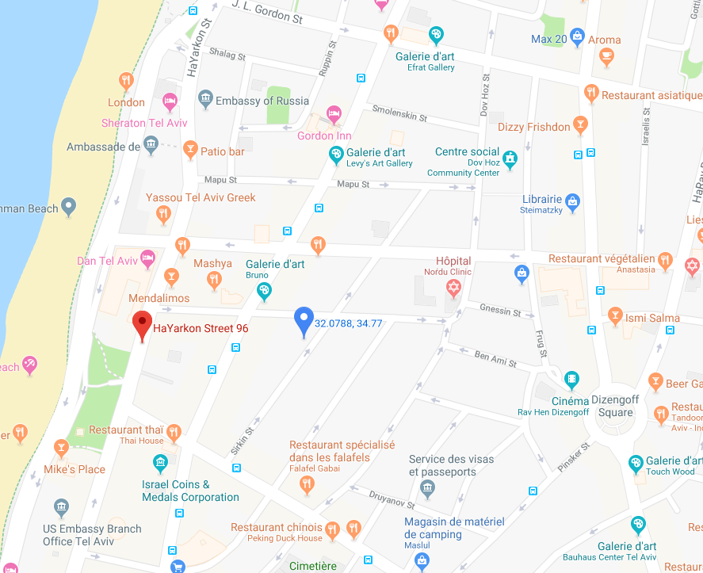

: Parking after French Embassy (parking fee: 15 Nis for 1 hour; 5 NIS per 15 mins)

: Dan Hotel underground parking (parking fee: 30 NIS for 2 hours)