November 2018

**INDC International Alumni Network**

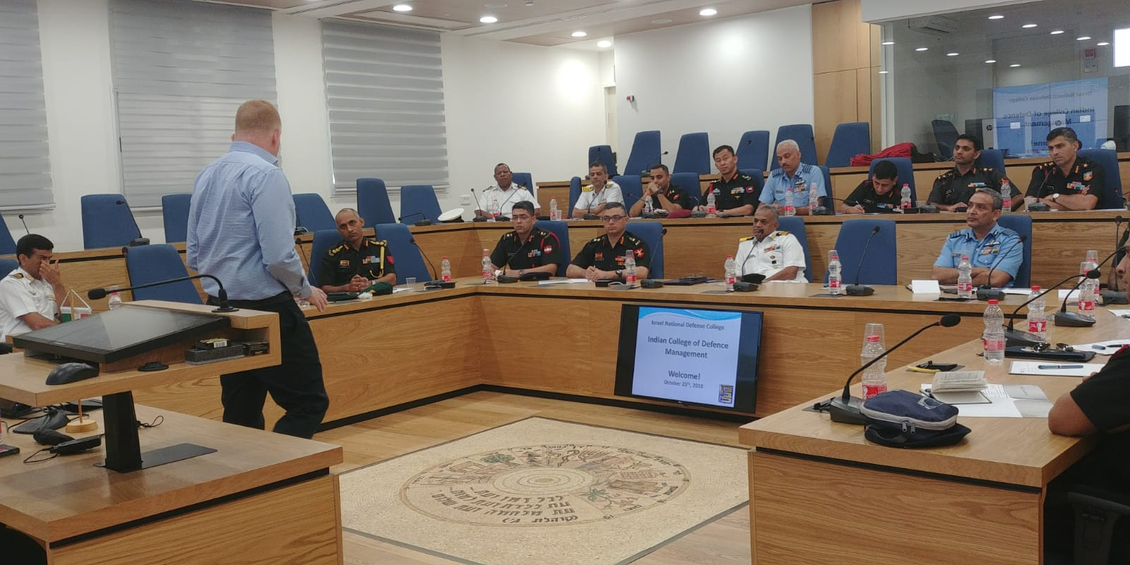

**Dear Israel National Defense College Alumni**

Best wishes from us here at ISMO and we hope this letter finds you well. Here are some updates from us at the Military Colleges from the last month of October.

This past month was full of special events for the current INDC participants.

We went on a three day tour to northern Israel, in that time we met with the Head of the Golan Regional Council, the Deputy Commander of UNIFIL and Israel's Northern Command Commander. We also spent a day in Haifa where we discussed some military ethical dilemmas, learned about the history of the area, and how Haifa is a symbol of coexistence between Jews and Arabs. We then spent the last day in Tel Aviv learning about the early days of Israel and early Zionistic movements.

In other news, the Military Colleges had the honor of hosting the Indian College of Defence Management. The delegation met with our INDC instructors, Col. Yonatan Sayada Marom and Mr. Raphael Schutz who presented the structure of the colleges and our INDC curriculum, the challenges that arise when teaching our senior officials, Israel's foreign policy and our regional challenges. Following this presentation, Dr. Mayer Finkel from the Dado Center lectured about the process of developing strategic knowledge in the IDF and the role of the 'Design Theory’. After that, a presentation was given about the IDF Conceptual Laboratory by Chief Methodologist COL. (res.) Dr. Gabi Siboni and Senior Consultant, COL (res.) Tal Raz, who discussed operational simulation as a tool for analyzing force build-up and force employment.

The IDF’s Chief of General Staff, LTG Gadi Eizenkot’s, two year term is almost over. The person to replace him is his deputy, MG Aviv Kochavi.

With the warmest regards,

**MAJ Ido Soceanu**Head of the International Fellowship  
& International Relations Desk  
Israel Defense Forces