L

Operations Directorate (J3)

Israel Defense Forces (IDF)

Tel Aviv, Israel

May 30, 2019

For the Attention Of:

Lieutenant Colonel Michael P. Crane

Executive Officer, Director of Operations

U.S. Central Command

LTC Crane,

I would like to thank you for your tremendous efforts and support in the past year. You played a vital role in our joint effort to preserve and protect freedom and democracy throughout the region; and for your efforts and role enhancing the cooperation between the IDF and the US Central Command.

Mike, on a personal note – I know Shahar and Benzi reached back to you during the weekend and after hours, and your cooperation made the difference.

On behalf of the men and women of the IDF operations directorate, I wish you all the best on your upcoming deployment.

With the upmost appreciation,

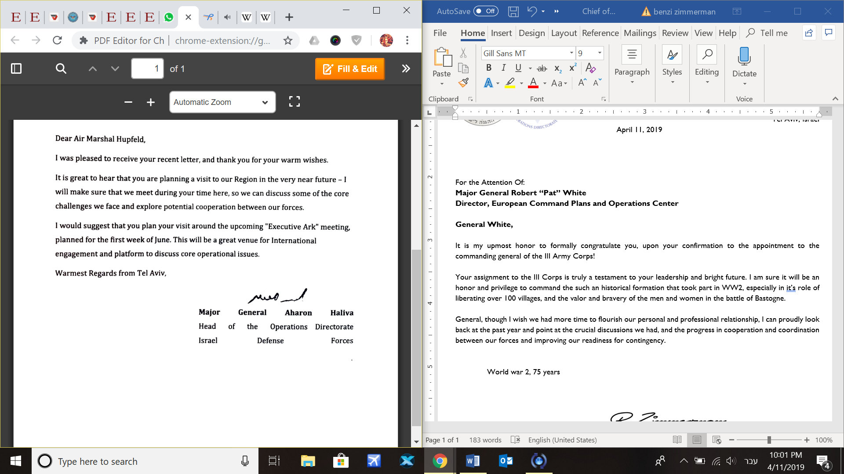

Copy: RADML Samuel j. Paparo

Director of Operations, USCENTCOM