MAJOR GENERAL GILES HILL CBE

ASSISTANT CHIEF OF THE DEFENCE STAFF DEFENCE ENGAGEMENT (ACDS DE)
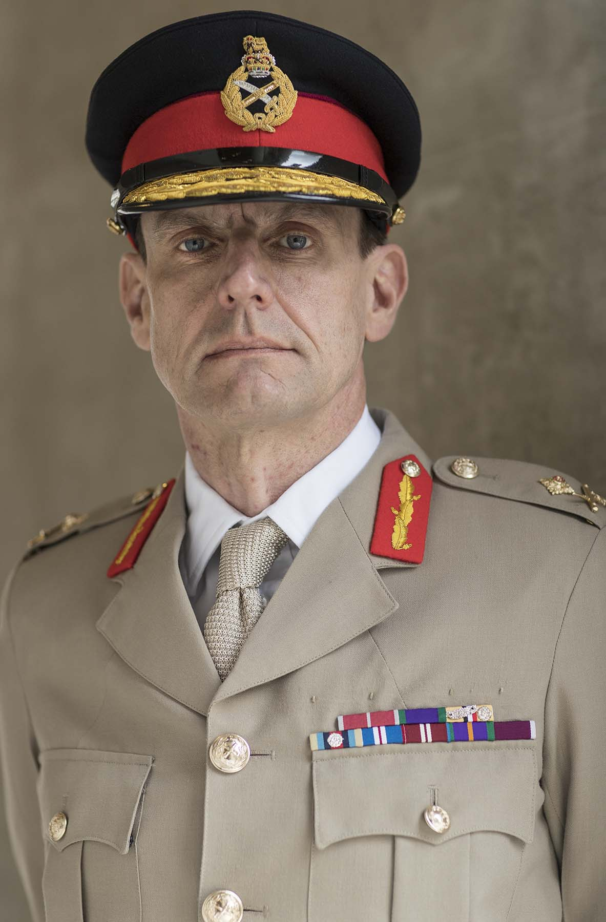

Major General Hill was born in Yorkshire and commissioned into The Parachute Regiment. He has commanded at every level from Platoon to Division, mainly in airborne and other very high readiness and light forces. Command appointments include:
- OC P Company; the selection organisation for all British Airborne Forces.
- OC A Company, 3rd Battalion the Parachute Regiment on internal security operations in Northern Ireland and in Iraq.
- Commanding Officer 1st Battalion the Parachute Regiment on tours in Afghanistan and Iraq.
- Commander 16 Air Assault Brigade, the UK’s only very high readiness intervention brigade.
- Deputy Commanding General US 82nd Airborne Division, the US Global Response Force.
- General Officer Commanding 1st UK Division. The British Army’s light forces division with specific responsibility for Overseas Capacity Building and Engagement.

Staff appointments include;
- Chief of Staff, 12 Mechanised Brigade.
- Military Assistant to the Assistant Chief of the General Staff.
- An instructor at the UK’s Joint Services Command and Staff College.
- Assistant Chief of Staff J5 at the UK’s Permanent Joint HQ (PJHQ) responsible for national operational level planning for the Middle East and Asia during the Iraq and Afghanistan Campaigns.
- J5 Planner – Special Plans Team, US Central Command (CENTCOM).

Outside of operational theatres he has also served in Arctic capable units in Norway and Canada, and on Jungle training in Botswana, Kenya and Central America.

He has attended all the normal UK staff courses, including the Higher Command and Staff Course (HCSC) and been the first UK officer to attend the 1 and 2 Star phases of the US Army Strategic Leadership Development Programme. He is Deputy Colonel Commandant of the Parachute Regiment and President of Army Golf.

His current role holds responsibility the effective delivery of Defence Engagement activity around the world.

