# **MABAL Itinerary - June 10th-13th, 2018**

**Contact Numbers**

Lt. Col. Matan Or- 972-52-9247983

Consul General Aviv Ezra- (312) 510-7973

DCG Itay Milner- (312) 823-4336

Bob Schwartz- (847) 714-6261

**Sunday, June 10th**

8:30 pm/9:15 pm **Arrival**

*Hotel: Best Western Grant Park, 1100 South Michigan Ave. Chicago, IL*

**Monday, June 11th**

7:30am- 8:00 am **Breakfast**

8:30 am-11:00 am **Chicago Council on Global Affairs**

*Conference Center, 130 East Randolph Chicago, IL*

**Contact:** Matt Abbott 312-256-8506 [mabbott@thechicagocouncil.org](mailto:mabbott@thechicagocouncil.org).

**CCGA Projects and Initiatives:** Niamh King, VP, Programs and Strategic Content

**“How the Midwest Economy is Challenged and Enhanced by Global Economic and Political Forces”:** [Phil Levy](https://www.thechicagocouncil.org/expert/phil-levy), Senior Fellow, Global Economy

**Break**

**“What Americans Think About ‘America First’”** [Dina Smeltz,](https://www.thechicagocouncil.org/expert/dina-smeltz) Senior Fellow, Public Opinion and Foreign Policy and [Craig Kafura](https://www.thechicagocouncil.org/expert/craig-kafura), Research Associate in Public Opinion

11:15 am- 12pm **Lorenzo “Storyman” Young** joins group for brief tour of Bronzeville

**Contact:** (773) 329-9967

12pm-2pm [**Bright Star Community Outreach**](https://www.brightstarcommunityoutreach.com/about/)

*4021 South State Chicago, IL*

**Contact**: Rodney Carter (773) 663-5370 Devlon Parson (773) 373-5220

**Lunch**

**About BSCO and** [**TURN Center**](https://www.brightstarcommunityoutreach.com/overview/) **& Q&A**: [Pastor Rodney Carter, Jr., COO](https://www.brightstarcommunityoutreach.com/staff/)

**Panel discussion & Q&A “Chicago Urban Community Issues”:** Pastors and community leaders: Nicole Carter, Michael Neal and David Swanson, Michael Goldberg

2:30 pm-4:15 pm **Chicago Police Headquarters**

*3510 South Michigan Chicago, IL*

**Contact:** Tina Skahill (312) 848 – 7602 [tskahill@aol.com](mailto:tskahill@aol.com)

**Deputy Chief Dwayne Betts of the Community Policing Division and Deputy Chief Keith Calloway of the Education and Training Division:**

* Community policing and how CPD interacts with community groups like TURN- this would include new training policies and procedures for Police beginning at the Academy level.

**Chief Jonathan Lewin of the Bureau of Technical Services and Deputy Chief Steve Caluris of the Deployment Operation Center:**

* Solving crime via social media analysis
* How the new high-tech centers located throughout high-crime areas have worked successfully to anticipate, prevent and reduce the rates of violent crime, esp. murders.

**Chief Noel Sanchez of the Bureau of Organized Crime:**

* Examination of how international forces impact local situations; extent of activities of Mexican and Central American drug cartels and violent gangs on Chicago drug and weapons (and potential terrorist) activities- especially via new immigrant (legal and illegal) communities. Joint Counter-Terrorism Task Force.

5:00-5:30 pm **Meeting with Hon. Bruce Rauner, Governor of Illinois**.

*Much Shelist, P.C., Law Firm, 191 N. Wacker Drive, Suite 1800*

**Contact**: Jonathan Sherman, Partner (312) 521.2687 or (312) 823-2602

Evening  **Free time on own**

**Tuesday, June 12th**

8:30- 10:15 am **Free Time**

10:30 am Leave hotel for drive to Hyde Park. U. of Chicago campus

11:00 am- 1pm **U. of Chicago, Booth School of Business**.

*Charles M. Harper Center 5807 S. Woodlawn Ave. Eugene F. Fama Room (C03)*

**Contact:** Holly Stauffer (773) 702-6680 Holly.Stauffer@chicagobooth.edu .

**The Economic & Policy Outlook in the U.S**.: Austan Goolsbee (moderated by Phillip Berger)

**Characteristics that make a successful CEO/leader:** Steven Kaplan (moderated by Phillip Berger)

1:00 pm – 1:30 pm **Walking tour of main Quads**

1:30 pm- 3:15pm **Newberger Hillel Center**

*5715 S Woodlawn Ave.*

**Contact**: Emily Briskman, Tel: 312-357-4671

**Lunch and Panel on Israel on Campus/BDS challenges**: John Lowenstein, JUF's Vice President of Campus Affairs, Emily Briskman, Assistant Vice President, Campus Affairs /Executive Director, JUF’s Israel Education Center and [Anna Levin Rosen](https://www.uchicagohillel.org/about1-c5ao), Rabbi and Executive Director, U. of C. Hillel

4:00- 5 pm **Meet with Chicago** [**Mayor Rahm Emanuel**](https://www.cityofchicago.org/city/en/depts/mayor/supp_info/about_the_mayor.html)

*City Hall, 121 North LaSalle St.; Room TBD.*

**Contact:** Jordan Miller, Deputy Director, Strategic Partnerships and Global Affairs. Tel: (312) 350-3140.

5:30 pm **Reception at Consul General’s residence**

**Wednesday, June 13th**

8:30- 10:00 am **JUF/Jewish Federation of Metro Chicago**.

**Contact:** [Steve Dishler](https://www.linkedin.com/in/steve-dishler-57859a4/) (312) 357-4674 [stevedishler@juf.org](mailto:stevedishler@juf.org)

**Federation’s activities:** Jay Tcath, Exec. VP

**Panel: Relationship between North American Jewish diaspora and Israel:** Michael Zaransky, Chairman of the Board, Andrea Yablon, Board member

11:30am -12:30 pm **National Guard Briefing** **by MG Richard J. Hayes**

Lunch and briefing by TAG Richard J. Hayes on role of Illinois National Guard in HLS: (CBRN with IHFC)

*Army Aviation Support Facility #2, 3200 South Justice Way Kankakee, IL*

**Contact:** Maj. Rob Bland 217-622-0883

12:45- 2:45 pm [**Nucor Steel**](http://www.nucor.com/products/)

Story of Nucor and the Midwest Steel Industry & tour of Factory

*One Nucor Way, Bourbonnais, IL.*

**Contact:** Johnny Jacobs (815) 939-5518 [Johnny.Jacobs@nucor.com](mailto:Johnny.Jacobs@nucor.com).

2:45 pmDepart for O’Hare Airport. **Do wrap-up session on bus.**

**Additional Bios and Background Information**

**June 11th**

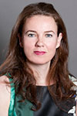**Niamh King**

**Vice President, Programs and Strategic Content**

**Chicago Council on Global Affairs**

Niamh King is the vice president for programs and strategic content at the Chicago Council on Global Affairs, where she has worked since March 2007. Under her direction, the Council on Global Affairs’ Programs team develops over 200 events annually, and includes the signature annual events the Chicago Forum on Global Cities, the Global Health Symposium, and the Global Food Security Symposium. Prior to joining the Council on Global Affairs, she held positions with Intel, the European Commission, FÁS, and the United Nations International Criminal Tribunal for the former Yugoslavia. She is a member of the board of directors of The America Ireland Fund Chicago Regional Advisory Board, the Women’s Board of the University of Chicago, the Chicago Project on Security & Threats, and the Japan America Society of Chicago.  King earned a BA in international relations and history from the University of Colorado at Boulder and her MA in development studies from the Institute of Social Studies at Erasmus University in The Hague, Netherlands.

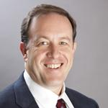**Phil Levy, Senior Fellow, Global Economy**

Phil Levy is senior fellow on the global economy at the Chicago Council on Global Affairs. Previously he was associate professor of business administration at the University of Virginia’s Darden School of Business. He was formerly a resident scholar at the American Enterprise Institute and taught at Columbia University’s School of International and Public Affairs. From 2003 to 2006, he served first as senior economist for trade for President Bush’s Council of Economic Advisers and then as a member of Secretary of State Rice’s Policy Planning Staff, covering international economic matters. Before working in government, he was a faculty member of Yale University’s Department of Economics for nine years and spent one of those as academic director of Yale’s Center for the Study of Globalization.

His academic writings have appeared in such outlets as *The American Economic Review*, *Economic Journal*, and the *Journal of International Economics*. He is a regular contributor to *Foreign Policy* magazine’s online *Shadow Government* section and writes on topics including trade policy, economic relations with China, and the European economic crisis. Levy has testified before the House Committee on Foreign Affairs, the Joint Economic Committee, the House Committee on Ways and Mean, and the US-China Economic and Security Review Commission. He received his PhD in Economics from Stanford University in 1994 and his AB in Economics from the University of Michigan in Ann Arbor in 1988.

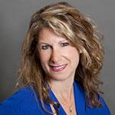**Dina Smeltz**

**Senior Fellow, Public Opinion and Foreign Policy**

With 25 years of experience designing and fielding international social and political surveys, Dina Smeltz joined the Chicago Council on Global Affairs as senior fellow on public opinion and foreign policy in 2012. She oversees the Council’s well-known annual survey of American attitudes toward foreign policy and has authored and coauthored many of the analyses based on that work. She also directs the Council’s collaboration with Russian, Mexican, Canadian, Australian, and East Asian research organizations. Smeltz has published commentary on public opinion and international issues in *The Washington Post,* *RealClearWorld*, *Foreign Policy*, and the Council’s survey blog (*Running Numbers*).

As the director of research in the Middle East and South Asia division (2001-2007) and analyst/director of the European division (1992-2004) in the Bureau of Intelligence and Research at the US State Department's Office of Research, Smeltz conducted over a hundred surveys in these regions and regularly briefed senior government officials on key research findings. Her experience includes mass public and elite surveys, as well as qualitative research. She has written numerous policy-relevant reports on Arab, Muslim, and South Asian regional attitudes toward political, economic, social, and foreign policy issues. Her writing also includes policy briefs and reports on the post-1989 political transitions in Central and Eastern Europe, and European attitudes toward a wide range foreign policy issues including globalization, European integration, immigration, NATO, and European security.

With a special emphasis research in post-conflict situations (informally referred to as a "combat pollster"), Smeltz has worked with research teams in Bosnia, Kosovo, Cyprus, Israel-Palestinian Territories, and in Iraq (2003-2005), where she was one of the few people on the ground who could accurately report average Iraqis impressions of the post-war situation. Smeltz has consulted for several NGOs and research organizations on projects spanning women's development in Afghanistan, civil society in Egypt, and evaluating voter education efforts in Iraq.

Smeltz has an MA from the University of Michigan and a BS from Pennsylvania State University.

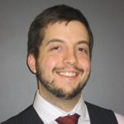**Craig Kafura is a research associate at the Chicago Council on Global Affairs** and a Pacific Forum CSIS Young Leader. At the Council, he coordinates work on public opinion and foreign policy and is a regular contributor to the public opinion and foreign policy blog Running Numbers. His writing has appeared in Foreign Affairs, The National Interest, and The Diplomat, among others. Kafura holds an MA in political science from Columbia University and a BA in political science from Yale University.

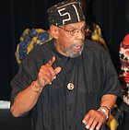**Lorenzo “Storyman” Young**

**Bronzeville Historian, Educator and Tour Guide**

Lorenzo Young is a third generation Bronzeville resident with a great passion for telling the Bronzeville story. A graduate of the School of the Art Institute of Chicago, he is a recipient of the Rochelle Lee Award, a nominee for the 2014 Chicago Innovation Award and has taught in both public and private schools.  Mr. Young connects with both students and their families through his Family History Project and Parent Storytelling workshops. The Family History Project aims to encourage students to develop an interest in their ancestry, while parents learn to create family legends and become family storytellers.

Lorenzo Young has been a docent for Chicago Trolley and Double Decker city tours, Shoreline Sightseeing lake tours and the Bronzeville Visitors Information Center tours. His professional affiliations include: The National Storytelling Network, The National Association of Black Storytellers, The Chicago Association of Black Storytellers, The Bronzeville Historical Society, The Bronzeville Alliance, and The Black Metropolis Convention and Tourism Council.

Lorenzo Young is presently a co-host of the Let the Elders Speak radio show, on wwwUrbanBroadcastMedia.com, which airs 11am CST.  Mr. Young interviews prominent contributors to the Chicago community, further educating, with aims to bridge gaps and strengthen generational ties.

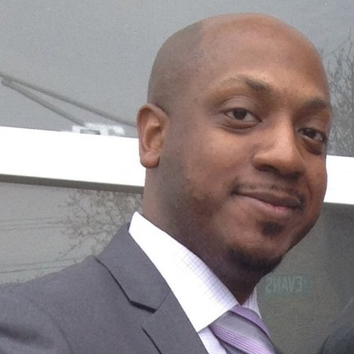**Rodney Carter**   
**Chief Operating Officer, Bright Star Community** **Outreach**

**Rodney Carter** was born in Chicago, Illinois. As a child prodigy, he was blessed with many talents. Realizing his gift for facts and figures and the ability to help and work with all types of people, Rodney knew at an early age that much of his purpose in life would be in the business sector.  With great success throughout his educational career, Rodney graduated with honors from Lakeland College in May 2005 with a bachelor degree in Accounting. Shortly after graduation, Rodney began his career as an Investment Accountant. Over the span of nine years, he serviced accounts for multiple nationally known insurance companies including CNA, AON, and Allianz.  During this time, Rodney also devoted himself to ministry work at his church, Bright Star, in a variety of roles. In 2011, he was appointed as Assistant Pastor of Bright Star Church.  With the body of experience he accumulated during his ministry and professional career, he decided to pursue full-time ministry leadership where he could serve both the congregation and public community in Bronzeville

**Nichole Carter**, Grant Writer, Administrator, Counselor, Trainer, Presenter, Community Advocate.  These are just a few of the roles that Nichole has successfully navigated since her tenure began at Bright Star Community Outreach in 2015. Now as the Director of Community Strategy and Development, Nichole is able to bring all of her expertise of building strong teams, her passion for public speaking and her commitment to providing excellence through holistic services to the Greater Bronzeville Community. Nichole is committed to positioning Bright Star Community Outreach as a convener of services and resources in Bronzeville versus a competitor.  Nichole brings to this position nearly two decades of executive management experience and almost a decade of non-profit experience. Nichole is committed to this work as her personal mantra is “Changing the World, one family at a time”. Nichole holds a Bachelor of Arts in English from Spelman College, and she also has a Master of Science in Marriage and Family Therapy.  She uses her Master’s Degree to inform her work, focusing on how to focus on every opportunity from a holistic perspective.

**Michael K. Goldberg** is the managing partner of Goldberg Law Group, a law firm with offices in Chicago and Phoenix. His law firm represents health care professionals before the Illinois and Arizona State Licensing Boards.  He has been an attorney for 25 years.  Mike lives in Deerfield, IL, a  suburb 20 miles north of Chicago.  He is married (25 years) and has two children ages (21) and (19), both of who attend Arizona State University.  Mike is passionate about bringing together the Jewish and African American Communities of the Chicago area to pursue social justice and equality.

|  |
| --- |
|  |

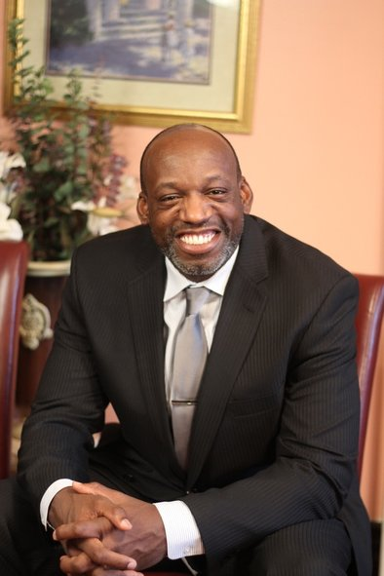**Pastor Michael Neal, Glorious Light Church.**

Pastor Neal answered God’s call and launched Glorious Light Church in Bronzeville in July 2008.  
  
Pastor Michael L. Neal is a native Chicagoan, born and raised on the South Side.  He is youngest of three children.  
  
Pastor Neal is very active in the Bronzeville Community, where he and The Glorious Light Church have launched a Real Men Read program at several grammar schools in the area. He serves as a voting member of the Bronzeville Community Action Council. He also serves as a parent representative on the local school council of Kenwood Community Academy High School. He has developed significant partnerships with various community-based organizations in the area. Under the direction of Pastor Neal, a new community development corporation has been founded, the Timothy Community Corporation, which now operates out of a shuttered public school.  
  
Pastor Neal is a graduate of Moody Bible Institute and served faithfully for 10 years as an associate minister at Salem Baptist Church of Chicago. It is during this faithful time of serving that he recognized and developed his passion for serving and leading people.

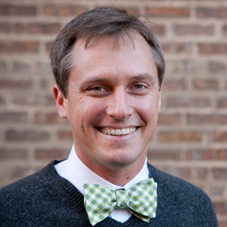**David Swanson • Pastor**

**New Community Covenant Church**

**David Swanson** is the founding pastor of New Community Covenant Church, an intentionally multi-racial congregation located in Bronzeville, and the CEO of New Community Outreach, a non-profit whose mission is to reduce causes of trauma and raise opportunities for community equity and individual flourishing in Chicago.

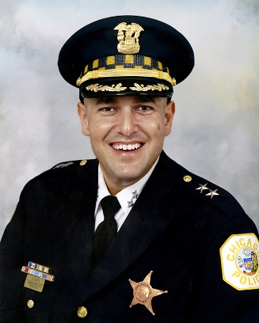**Jonathan H. Lewin, Chief**

**Bureau of Technical Services**

The Bureau of Technical Services is commanded by a chief who reports directly to the First Deputy Superintendent. The Bureau is responsible for coordinating services and activities related to information systems, technology, and program development; receiving, storing, and disposing of inventoried property; and the management of Department records and police reports. Additionally, the bureau is responsible for coordinating and directing Department activities which specifically relate to facilities management; and various general support functions.

**The Chicago PD’s Top Tech Officer Is Betting on Sensors and Smartphones to Help Curb Shootings**

[**https://www.thetrace.org/2017/01/chicago-homicide-rate-shotspotter-curb-shootings/**](https://www.thetrace.org/2017/01/chicago-homicide-rate-shotspotter-curb-shootings/)

**Noel Sanchez, Chief**

**Bureau of Organized Crime**

The Bureau of Organized Crime is commanded by a chief who reports directly to the First Deputy Superintendent of Police. The bureau also consists of an executive officer the rank of deputy chief, who reports directly to the chief. The bureau initiates and conducts investigations of certain types of organized crime. Bureau members provide information and investigative assistance to all units of the Department and to outside agencies, as well as participate in various federal and state task forces.

**Governor Bruce Rauner**

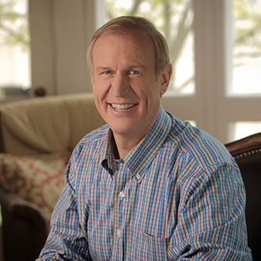Bruce Rauner (Republican) was sworn in as the 42nd Governor of Illinois on Jan. 12, 2015.

His goal as governor is to create a more prosperous state, where everyone has an opportunity to succeed.

Bruce will remain focused on delivering value for taxpayers, creating a pro-jobs economic climate, ensuring world-class schools and educational options for every Illinoisan, and bringing term limits and greater accountability to state government.

Bruce was born in Illinois and is a self-made businessman who had no inheritance or family wealth.

A dedicated and diligent student, Bruce worked while he attended Dartmouth College, where he graduated with top honors. He went on to earn an M.B.A. from Harvard.

Returning to Illinois in 1981, Bruce began working at then startup investment company Golder, Thoma, Cressey (later GTCR). As one of its earliest partners, Bruce helped build the firm into one of the most successful and respected businesses in Illinois.

GTCR has been trusted for decades to oversee the retirement investments of first responders, teachers and other Illinois workers and has created tremendous returns for them - far surpassing the stock market's performance - providing exceptional value for taxpayers.

Bruce has reinvested much of his success into the state he loves through supporting education, the YMCA, local hospitals and community organizations. His greatest passion is education. Bruce and his wife, Diana, have devoted a tremendous amount of their personal time and resources to improving education throughout the state.

Bruce has never let his success change him. He still drives a 20-year-old camper van, wears an $18 watch, and stays in the cheapest hotel room he can find when he's on the road. He is the proud father of six children - two boys and four girls - and Diana is the love of his life. He hunts birds, hikes, loves riding his Harley, and jumps at every opportunity to fish.

[**Fourth U of I, Israeli university agreement signed**](https://www2.illinois.gov/Pages/news-item.aspx?ReleaseID=15011) **, GOV - Thursday, November 2, 2017**

BEERSHEBA, **Israel** (Nov. 2, 2017) — Officials at Ben-Gurion University of the Negev, one of Israel’s world-renowned institutions of research and higher learning, today signed a Memorandum of Understanding (MOU) with the University of Illinois to explore joint education and research activities.



[**Gov. Rauner: Technion research accord signed**](https://www2.illinois.gov/Pages/news-item.aspx?ReleaseID=15006) - **GOV - Wednesday, November 1, 2017**

HAIFA, **Israel** (Nov. 1, 2017) — The U of I System today reached an accord with Technion, Israel’s most prominent technology university, to participate in joint research projects — the third such alliance announced on Gov. Bruce Rauner’s trade mission to the Middle East country.



[**Gov. Rauner, U of I delegation continue science, tech partnership initiative in Israel**](https://www2.illinois.gov/Pages/news-item.aspx?ReleaseID=15001)

**GOV - Tuesday, October 31, 2017**

JERUSALEM (Oct. 31, 2017) — The president of the University of Illinois System today signed a new research partnership agreement with the Hebrew University of Jerusalem, one of Israel’s oldest and most prestigious universities. The Memorandum of Understanding is the second signed this week during Gov. Bruce Rauner’s trade and education mission to the State of **Israel**.



[**Gov. Rauner advances tech initiatives during first of five days in Israel**](https://www2.illinois.gov/Pages/news-item.aspx?ReleaseID=14996)

**GOV - Monday, October 30, 2017**

TEL AVIV, **Israel** (Oct. 30, 2017) — A new, first-of-its kind partnership between the University of Illinois and Tel Aviv University in **Israel** will advance groundbreaking engineering and technology initiatives and foster economic growth in Illinois and abroad, Gov. Bruce Rauner said today during a visit to the Middle Eastern nation.

**June 12th**

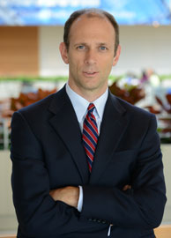**Austan D. Goolsbee is the Robert P. Gwinn Professor of Economics.**

He previously served in Washington as the Chairman of the Council of

Economic Advisers and a member of the President's cabinet.

His research has earned him recognition as a Fulbright Scholar and an

Alfred P. Sloan fellow. In prior years he was named one of the 100 Global

Leaders for Tomorrow by the World Economic Forum, and one of the

six "Gurus of the Future" by the *Financial Times*. His ability to

explain economics clearly has made Goolsbee popular in the media.

Jon Stewart describes him as "Eliot Ness meets Milton Friedman" and he has twice

been named as a "star" professor by *BusinessWeek*'s "Guide to the Best Business Schools."

Goolsbee serves on the Economic Advisory Panel to the Federal Reserve Bank of New York

and has previously served on the Panel of Economic Advisors to the Congressional Budget

Office, the U.S. Census Advisory Commission and as a special consultant for Internet Policy to

the Antitrust Division of the Department of Justice. He joined Chicago Booth in 1995.

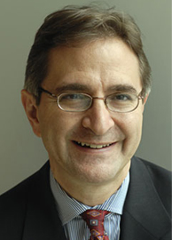**Steven Neil Kaplan**

**Neubauer Family Distinguished Service Professor of Entrepreneurship and Finance**

Steven Neil Kaplan conducts research on issues in private equity, venture

capital, entrepreneurial finance, corporate governance and corporate

finance. He has published papers in a number of academic and business

journals. Kaplan is a research associate at the National Bureau of Economic

Research and an associate editor of the *Journal of Financial Economics*.

He ranks among the top 60 in paper downloads and in paper citations (out of over

280,000) on SSRN (Social Science Research Network). He is the co-creator of the Kaplan

Schoar PME (Public Market Equivalent) private equity benchmarking approach.

A Fortune Magazine article referred to him as "probably the foremost private equity scholar in

the galaxy.”

Kaplan teaches advanced MBA and executive courses in entrepreneurial finance and private

equity, corporate finance, corporate governance, and wealth management. *BusinessWeek*

named him one of the top 12 business school teachers in the country.

Professor Kaplan co-founded the entrepreneurship program at Booth. With his students, he

helped start Booth’s business plan competition, the New Venture Challenge (NVC), which has

spawned over one hundred companies that have raised almost $600 million and created over

$4 billion in value including GrubHub and Braintree/Venmo.

Kaplan serves on the boards of Morningstar, Zayo Group and the Illinois Venture Capital

Association. He has been a member of the faculty since 1988.

He received his AB, *summa cum laude*, in Applied Mathematics and Economics from Harvard

College and earned a PhD in Business Economics from Harvard University.

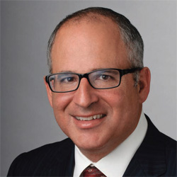**John Lowenstein**

**Vice President for Campus Affairs and Student Engagement, JUF/JF, and Executive Director, Hillels of Illinois.** He is a former YLD president and has served on the JUF/JF Board of Directors since 2005.

His major responsibilities have included Vice Chairman, member of the Executive Committee and the Overall Planning and Allocation Committee, Chairman of the Israel and Oversees Commission, Chairman of the Community Building and Continuity Commission, and a lead solicitor for Jewish Day School Guarantee Trust Fund as well as the End of Year JUF Campaign Chairman.

Beyond his work with JUF, John has served as chair of the Midwest Region of Friends of the I.D.F. and as chairman of the capital campaign for the Ida Crown Jewish Academy. John has served on the boards of both Hillel at Northwestern University and the Hillels of Illinois Governing Commission. John received his B.A. from Tufts University and his J.D. from the Northwestern University School of Law.

His varied professional background includes eight years at Sportmart, where he rose to be its Executive Vice President and Chief Operating Officer. Through these significant professional and volunteer roles, John has demonstrated strong management and fundraising skills and an abiding commitment to building a Jewish identity that is imbued with strong ties to the community and to Israel among today’s college youth.

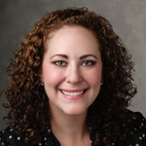**Emily Briskman** **is Assistant Vice President/Executive Director of the Jewish United Fund/Jewish Federation of Metropolitan Chicago’s Israel Education Center (IEC).** Her responsibilities include oversight of IEC’s diverse programs for high school and college students which engage the next generation with Israel through education and advocacy and inspire them to build a strong commitment to the Jewish state. Her mission is to ensure every Jewish student leaves campus with Israel at the heart of their Jewish identity and every non-Jewish student has an opportunity to make Israel personally meaningful to them. Emily’s portfolio includes policy setting and curriculum development; strategic planning for tackling the delegitimization of Israel on college campuses; relationship management with faculty/administrators and on-campus/national Israel organizations; and educational resource development. Emily is a graduate of the University of Florida with a Bachelor of Arts degree in Political Science.

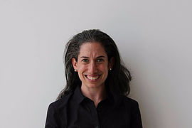**Anna Levin Rosen**

**Executive Director, U. Chicago Hillel**

Anna Levin Rosen serves as the Rabbi and Executive Director at UChicago Hillel. Having served UChicago Hillel for five years, Anna’s work is part of the fabric of the University. With a passion for Jewish life and social justice, Anna has served as a guest educator for a spectrum of organizations in Chicago including Mishkan, Anshe Emet, Spertus and Interfaith Family. Committed to social justice, Anna served as a community organizer with JCRC in Boston and Fairmount Temple in Cleveland.

Anna has a Rabbinical Degree from Hebrew Union College- Jewish Institute of Religion in Cincinnati, where she earned Maste’s degrees in Hebrew Letters and Educational Administration.  She was the recipient of a Dean’s research grant for her thesis project entitled: Thinking Outside the Tzedakah Box.  She received her BA from University of Virginia in Religious Studies, Anthropology and Jewish Studies.

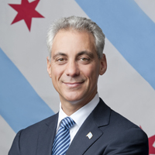**Rahm Emanuel is the 55th Mayor of the City of Chicago** and has served since 2011. During that time, he has made the tough choices necessary to secure Chicago’s future as a global capital. The Mayor lengthened the school day and added more than 200 hours to the school year, taking Chicago from having the least educational time of any large school district in the country to being on par with its peers. He implemented full-day kindergarten for every Chicago child, and fought for and won new accountability measures to ensure that every teacher and principal had the necessary resources to succeed. The Mayor’s comprehensive public safety strategy is focused on expanded prevention programs for at-risk youth, smarter policing strategies, and empowering parents and communities to reduce violence in their neighborhoods. He attracted numerous companies to Chicago and helped to build the next generation of start-ups, while investing in the infrastructure, public transportation, open space and cultural attractions that make Chicago a great place to live, work, and play. And he has worked to make our government more effective, to deliver better services at a more competitive price, and to open government to the public.

Prior to becoming Mayor, Emanuel served as the White House Chief of Staff to President Barack Obama and served three terms in the U.S. House of Representatives representing Chicago’s 5th District. He previously served as a key member of the Clinton administration from 1993 to 1998, rising to serve as Senior Advisor to the President for Policy and Strategy.

Mayor Emanuel graduated from Sarah Lawrence College in 1981 and received a Master's Degree in Speech and Communication from Northwestern University in 1985. He is married to Amy Rule, and they have three children. **Article:** [**Mayor Emanuel Signs Agreement to Establish Innovative Partnership BetweenChicago's Current and Israel's Technion.**](https://www.cityofchicago.org/city/en/depts/mayor/press_room/press_releases/2017/september/TechnionCurrent.html)

**June 13th**

|  |
| --- |
| **Official PhotoMajor General Richard J. Hayes Jr.**  **The Adjutant General, Illinois National Guard**  Major General Richard J. Hayes Jr. is the 39th Adjutant General of the State of Illinois. He assumed the duties of the Adjutant General on June 8, 2015. He serves as a member of the Governor's Cabinet as the Director of the Illinois Department of Military Affairs and is the Governor's principal advisor on military matters. General Hayes is the senior officer in the chain-of-command for both the Illinois Army and Air National Guard. He is responsible for the operations of the Illinois National Guard and oversees approximately 13,000 men and women in uniform (2,200 full time) and 230 civilian employees in the Illinois Department of Military Affairs.   General Hayes was commissioned in 1987 from the Reserve Officer Training Corps program at the University of Kansas as a Field Artillery Officer. He was honor graduate at both the Field Artillery Officer Basic and Advanced Courses. He has had operational assignments at battery, battalion, brigade, and division. He participated in Hurricane Katrina and Rita Relief Operations, and Operation Joint Guardian, Kosovo. General Hayes most recent assignments were Deputy Commander Maneuver - Task Force Falcon, Operation Joint Guardian Kosovo, Director of Operations (J3) Illinois National Guard, Commander, 129th Regional Training Institute, Director of the Joint Staff, and Assistant Adjutant General - Army. *(See link in itinerary for full bio).* |