U N I T E D S T A T E S A I R F O R C E

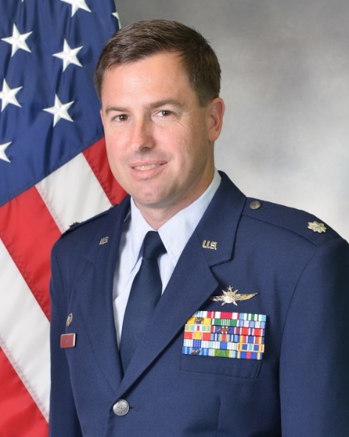
LIEUTENANT COLONEL RANDAL T. ALLEN

Lieutenant Colonel Randal T. Allen is a Foreign Area Officer (FAO) assigned as the Defense Security Cooperation Agency’s Country Portfolio Director for the United Arab Emirates. He leads a multi-agency team in the planning, programming, and execution of 95 foreign military sales cases valued at over $24 billion. He also develops and coordinates security cooperation strategies with the Department of State, Office of Secretary of Defense, and the government of the United Arab Emirates.

Colonel Allen grew up as an expatriate in Taif, Saudi Arabia and later graduated high school at Phillips Academy, Andover, Mass., in 1995. He was commissioned through Baylor University’s Air Force Reserve Officer Training Corps. Colonel Allen has extensive professional overseas experience and has held numerous Foreign Area Officer leadership positions, including command of the European, Middle Eastern, and African exchange program. He was recently selected for Senior Developmental Education at the Israel Defense College.

EDUCATION:
1999 | Bachelor’s in Business Administration, Economics; Management Information Systems, Baylor University, Waco, Texas
1999 | Basic Communications Officer Training, Keesler Air Force Base, Mississippi
2003 | Master of Business Administration, University of Texas at San Antonio, San Antonio, Texas
2005  2006  2008  2008  2009  2012  2012  2012  2014 | Squadron Officer School, Maxwell Air Force Base, Alabama  Arabic Language and Area Studies Immersion, Tunis, Tunisia  Advanced Communications Officer Training, Keesler Air Force Base, Mississippi  Master of Science, International Relations, Troy University, Shaw Air Force Base, South Carolina  Air Command and Staff College, by correspondence  Master of Arts, Security Studies (Middle East), Naval Postgraduate School, Monterey, California  Honor Graduate, Arabic Basic Course, Defense Language Institute, Monterey, California  Overseas Security Cooperation Management, Defense Institute of Security Assistance Management (DISAM), Wright-Patterson Air Force Base, Ohio  Air War College, by correspondence
ASSIGNMENTS:
1. | October 1999 – March 2001, OIC, Base Information and Web Management, Ramstein Air Base, Germany
2. | March 2001 – October 2001, Action Officer, Directorate of Communications and Information, Headquarters United States Air Forces in Europe, Ramstein Air Base, Germany
3. | October 2001 – May 2003, Chief of Architecture and Standards, Air Force Manpower and Innovation Agency, Randolph Air Force Base, Texas
4. | May 2003 – May 2005, Executive Officer, 728th Air Mobility Squadron, Incirlik Air Base, Turkey
5. | Jul 2005 – May 2006, Support Flight Commander, 20th Fighter Wing, 20th Communications Squadron, Shaw Air Force Base, South Carolina
6. | May 2006 – September 2006, Central Air Forces Liaison Officer to Coalition Forces Land Component Command C6 staff, Camp Arifjan, Kuwait
7.  8.  9.  10.  11.  12. | September 2006 – August 2007, Readiness Flight Commander, 20th Fighter Wing, 20th Communications Squadron, Shaw Air Force Base, South Carolina  August 2007 – September 2009, Kyrgyz Republic and Lebanon Desk Officer, United States Air Forces Central Theater Security Cooperation  September 2009 – March 2012, Student, Naval Postgraduate School, then Defense Language Institute, Monterey, California  April 2012 – March 2013, Security Assistance Officer, U.S. Embassy, Amman, Jordan  March 2013 – June 2015, Military Advisor, State Department Bureau of Near Eastern Affairs  June 2015 – July 2016, Air Force programs Officer and Chief, Office of Military Cooperation, U.S. Embassy, Doha, Qatar
13.  14. | July 2016 – July 2018, Commander, European, Middle Eastern, and African Personnel Exchange Program, Ramstein Air Base, Germany  August 2018 – present, United Arab Emirates Country Portfolio Director, Defense Security Cooperation Agency
MAJOR AWARDS AND DECORATIONS:
Defense Meritorious Service Medal with 1 Oak Leaf Cluster

Meritorious Service Medal with 1 Oak Leaf Cluster

Joint Services Commendation Medal
Air Force Commendation Medal with 2 Oak Leaf Clusters

Army Commendation Medal
Air Force Achievement Medal

Small Arms Expert Ribbon

EFFECTIVE DATES OF PROMOTION:
Second Lieutenant | July 8, 1999
First Lieutenant | July 16, 2001
Captain | July 16, 2003
Major | June 1, 2009
Lieutenant Colonel | November 1, 2014

