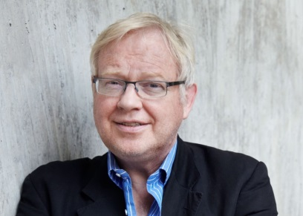**Roger Boyes (*Diplomatic Editor, ‘The Times’*)** was formerly Berlin correspondent for The Times, covering Germany and northern Europe, and had a column in the German newspaper Der Tagesspiegel entitled 'My Berlin'. Boyes entered journalism as a Reuters correspondent in Moscow (1976–1977), joined the Financial Times as an Eastern Europe specialist in 1978 and was the Bonn correspondent of the FT from 1979 to 1981. He then switched to The Times and became the Eastern Europe correspondent based in Warsaw where he covered the solidarity revolution and the imposition of martial law. He has been posted to Rome as a Southern Europe correspondent (1987–89), Bonn and Berlin correspondent 1993- 2010. Since 2010 Roger has served as the Diplomatic Editor of the paper. He is considered a senior, respected journalist.



**Philip Johnston (*‘The Telegraph’*)** has been with the Daily Telegraph for more than 20 years. He is currently assistant editor and leader writer and was previously home affairs editor and chief political correspondent. Johnston writes a weekly column providing analysis of UK politics and Brexit. His pieces have shed light on the various implications of Britain’s relations with the EU post Brexit.