**Joan Ryan MP, *Chair of Labour Friends of Israel***

*(Address as: ‘Ms. Ryan’)*

* 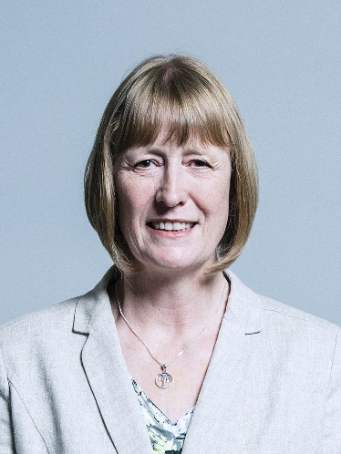Ryan has served as the Member of Parliament for Enfield North from 1997 to 2010 and since 2015.
* Born in 1955 in Lancashire, Ryan studied sociology and worked as a teacher before moving to London and entering politics. She served as a councillor for the East Finchley ward on Barnet London Borough Council, representing the Labour Party, and was the Council’s deputy leader until her election to Parliament.

**Parliament**

* Upon her election, Ryan was noted for representing the Greek Cypriots in her constituency. She was then appointed as Parliamentary Private Secretary to the Chief Secretary to the Treasury and an Assistant and Senior Government Whip from 2002 to 2006.
* In May 2006, she was appointed a Minister in the Home Office, with responsibility for Citizenship, Immigration, Refugees, Police Forensics, Extradition and the Passport Service. From June 2007 to September 2008, Ryan was the Prime Minister’s Special Representative to Cyprus. She was also a Member of the Committee of Selection.

**Outside Parliament**

* In the 2010 general election, Ryan was defeated by the Conservative candidate and left parliament.During her time away from Parliament, Joan was the Chief Executive of the Global Tamil Forum working on human rights and humanitarian issues in Sri Lanka.
* She served as the Chair of the charity Riders for Health, from 2011-2015, which has helped to improve access to life-saving treatment and medical care for 21 million people across seven countries in sub-Saharan Africa.
* She was the deputy director of the successful NO to AV national referendum campaign on the UK voting system. In addition, Joan worked as a training consultant strengthening democracy and parliamentary procedures with a number of organizations.

**Back in Parliament**

* Ryan regained her seat in Parliament in the 2015 general elections as the Labour candidate. In August 2015, Ryan became Chair of the Labour Friends of Israel. In the 2015 Labour leadership election, she urged voters to choose a leader who could play a constructive role in the crucial search for a two-state solution between Israel and the Palestinians. In particular, she noted the "deep concerns" that arose from the positions of Jeremy Corbyn.
* Ryan continued to be critical of Corbyn following his election, especially following allegations of anti-Semitism in the Labour Party which were mishandled by the party leadership. Tensions rose following Corbyn’s decision not to adopt the definition of the International Holocaust Remembrance Alliance (IHRA) for anti-Semitism in 2018, citing concerns to limiting the freedom of speech when criticizing Israel.
* Ryan’s opposition to Corbyn and anti-Semitism nearly cost her her seat in Parliament, when her Constituency Labour Party passed a motion of no confidence in her. It accused her of acting like an "independent MP in all but name", of making false accusations of antisemitism, and of smearing Jeremy Corbyn. She eventually retained her seat and swore to continue representing her constituency faithfully.
* However, in February 2019, following Corbyn’s perceived mishandling of Brexit and grave concerns over institutional anti-Semitism in the Labour Party, Ryan joined a group of Labour MPs who left the party and formed the so-called ‘Independent Group’. Despite her leaving Labour, she continues serving as Chair of Labour Friends of Israel.

**Noteworthy positions**

* Ryan is interested in education, health, home affairs and foreign affairs – including conflict resolution and strengthening political institutions and democracy, Israel/Palestine, Sri Lanka, China, Turkey and the Cypriot, Kurdish and Alevi communities.
* Ryan campaigned for the UK to remain in the EU during the 2016 referendum, and currently supports holding a second referendum on the subject. She opposes PM May’s Brexit deal.

**Israel**

* As stated, Ryan serves as the Chair of Labour Friends of Israel.
* Ryan is also vocal in criticizing incitement to violence and anti-Semitism in the Palestinian Authority, and has demanded that the Government investigates instances of incitement in Palestinian schoolbooks.
* Ryan has also spoken out against Iran’s destabilizing influence in the Middle East, sponsorship of terror and support for the Assad regime. She lobbied for the full proscription of Hezbollah as a terror group, and harshly criticized Shadow Foreign Secretary Emily Thornberry when the latter accused Israel of aggression against Syria and Iran. In light of these threats, Ryan has always supported Israel’s right to self-defence.
* That being said, Ryan opposes many of the Israeli government’s current policies, including demolitions, forcible transfers, settlement expansion and discriminatory legislation; she was also shocked by the death of many protesters in Gaza last May.
* Ryan supports a two-state solution based on 1967 lines, and lobbies the UK government to support coexistence projects between Israelis and Palestinians.