Israel National Defense College

46th Class, 2018-2019

**National Security Tour Booklet Jerusalem**  
**16th-17th January 2019**

**Team** **4**

Academic Advisor: Prof. Yossi Ben Artzi

Leading Instructor: Shay Fireaizen

Leading students: Guy Levy, Yariv Ben Ezra, Hadas Madmoni

**January 2018**

**The Purpose of the Tour**

**To deepen the understanding of the complexity of Jerusalem as a pillar of the national security of the State of Israel, while looking at the components of security: political, security, social and economic.**

**A secondary purpose, familiarity with the complexity existing in Jerusalem as a preliminary stage for political simulation.**

**Jerusalem of Gold / Naomi Shemer**

*The mountain air is clear as wine*

*And the scent of pines*

*Is carried on the breeze of twilight*

*With the sound of bells.*

*And in the slumber of tree and stone*

*Captive in her dream*

*The city that sits solitary*

*And in its midst is a wall.*

*Chorus:*

*Jerusalem of gold*

*And of copper, and of light*

*Behold I am a violin for all your songs.*

*x2*

*For your name scorches the lips*

*Like the kiss of a seraph*

*If I forget thee, Jerusalem,*

*Which is all gold...*

*Chorus:*

*We have returned to the cisterns*

*To the market and to the market-place*

*A ram's horn calls out on the Temple Mount*

*In the Old City.*

*And in the caves in the mountain*

*Thousands of suns shine -*

*We will once again descend to the Dead Sea*

*By way of Jericho!*

*Chorus...*

*How the cisterns have dried*

*The market-place is empty*

*And no one frequents the Temple Mount*

*In the Old City.*

*And in the caves in the mountain*

*Winds are howling*

*And no one descends to the Dead Sea*

*By way of Jericho.*

*Chorus:*

*But as I come to sing to you today,*

*And to adorn crowns to you (i.e. to tell your praise)*

*I am the smallest of the youngest of your children (i.e. the least worthy of doing so)*

*And of the last poet (i.e. of all the poets born).*

*For your name scorches the lips*

*Like the kiss of a seraph*

*If I forget thee, Jerusalem,*

*Which is all gold...*

*Chorus:*

*We have returned to the cisterns*

*To the market and to the market-place*

*A ram's horn calls out on the Temple Mount*

*In the Old City.*

*And in the caves in the mountain*

*Thousands of suns shine -*

*We will once again descend to the Dead Sea*

*By way of Jericho!*

*Chorus...*

**Table of Contents**

[Introduction and Schedule – National Security Tour Jerusalem 4](#_Toc534538107)

[Basic Law: Jerusalem, Capital City of Israel 8](#_Toc534538115)

[Jerusalem - Data 10](#_Toc534538108)

[Area: 10](#_Toc534538109)

[Population 10](#_Toc534538110)

[Welfare 15](#_Toc534538111)

[Employment 15](#_Toc534538112)

[Education 17](#_Toc534538113)

[East Jerusalem 18](#_Toc534538114)

[Jerusalem - History in Brief 24](#_Toc534538119)

[Maps 31](#_Toc534538120)

[Map of the Jewish neighborhoods and the security fence:](#_Toc534538121) 33

[Rehavim Zeev , Soon Prophecy Will Come True/ Shaul Arieli 34](#_Toc534538116)

[Jerusalem - Between East and West / Shaul Arieli (2006) 36](#_Toc534538117)

[Trump's declaration of recognition of Jerusalem as the capital of Israel 40](#_Toc534538118)

[Sites 43](#_Toc534538122)

[Nabi Samuel - The Battle 43](#_Toc534538123)

[Nabi Samuel - Antiquity 46](#_Toc534538124)

[Mount of Olives 46](#_Toc534538125)

[City of David 52](#_Toc534538126)

[Shuafat 56](#_Toc534538127)

[Supreme Court 56](#_Toc534538128)

[Jerusalem walls 58](#_Toc534538129)

[Tower of David 62](#_Toc534538130)

[The Temple Mount 64](#_Toc534538131)

[Players and interests: 71](#_Toc534538132)

[The Western Wall 72](#_Toc534538133)

[Mea Shearim neighborhood 74](#_Toc534538134)

**CVs** …………………………………………………………………………………………………………………………………..…………..……….77

The Wall Watchman………………………………………………………………………………………………………………………..86

# Introduction and Schedule – National Security in Jerusalem

1. **Time frame: 16-17 / 1/19, Wednesdays-Thursdays.**
2. **Main goal: Deepening the understanding of the complexity of Jerusalem as a pillar of Israel's national security, while looking at the components of security: political, security, social and economic pillars.    
   A secondary purpose: familiarity with the complexity existing in Jerusalem, as a preliminary stage for political simulation.**
3. **Goals and components of the tour:**
4. **Political** **Route** - Sovereignty and Boundaries, Tour of the Jerusalem Envelope /Road 443 / Mount Scopus / Mount of Olives.
5. **Security** **axis** - Borders, a refugee camp.
6. **Religions and national security** - An extension of the issue of sanctity - a visit to the Temple Mount, Solomon's Stables, the mosques and the Western Wall.
7. **Social axis** Orthodox sector, conversation with young social entrepreneur / Hapoel Katamon Jerusalem visit. Panel of sectors
8. **Leadership** and Urban Vision - A conversation with the Jerusalem Police commissioner, a conversation with the chairman of Hapoel Katamon Jerusalem.   
   **Demography** And planning - a conversation with the city engineer.
9. **Economic axis** - will be discussed less, will be integrated into the other echelons with an emphasis on my society (ultra-Orthodox - secular).
10. **Processing question for the Jerusalem tour:**
    1. **Jerusalem as the capital of Israel -** an Israeli capital "or" the holy city **"(socio-economic axis).**
    2. **"The city that was united together" - was it?** Situation report and a view for the future **(political-security axis)**

**A required product -** a written answer to the question of processing, as well as a document of lessons learned and conclusions.

1. **Preparation for the Jerusalem Tour 14/1:**

|  |  |  |  |
| --- | --- | --- | --- |
| 08:30 - 09:10 | Tour briefing |  |  |
| 09:10 - 10:00 | Briefing of Jerusalem |  | Dr. Neri Horowitz |
| 10:30 - 11:15 | Demography and Development - | Engineer of the city | Shlomo Eshkol |
| 11:15 - 12:15 | Security Challenges in Jerusalem | The Jerusalem tax office | Major General Yoram Halevi |
| 13:15 - 14:45 | Social Panel - Sectors |  |  |
| 15:15 - 16:15 | Jerusalem - Where to? | Ha'aretz Reporter | Nir Hasson |

**6. Tour Schedule**

**Wednesday 16/1**

|  |  |  |  |  |
| --- | --- | --- | --- | --- |
| **Time** |  |  | **Pillar** | **Emphasis** |
| 06:30 | Gathering at the INDC |  |  |  |
| 07:15 | Adam facility - parking |  |  |  |
| 08: 15 | Nabi Samuel -breakfast + observation | Levi - Col. Shaul Arieli, Prof. Yossi Ben Artzi | Borders - security |  |
| 09:30 | Ride |  |  |  |
| 10:00 | Mount of Olives | Shaul Arieli - observation point  Davidella Beeri - City of David  Chief of Staff Doron Turgeman | Borders -security  Vision and fulfillment  East Jerusalem |  |
| 12:00 | Shu'fat refugee camp | BG (INP) Doron Turgeman | Political-political axis  (Police, Authority, Ministry of the Interior, Welfare)  Blue - green enterprise |  |
| 13:15 | Ride |  |  |  |
| 14:00 | Lunch | Theresa Restaurant (Dairy) Cinema City |  |  |
| 15:00 | Supreme Court | A tour and a conversation with a judge | Political,  Government institutions |  |
| 16:30 | Driving to the hotel |  |  |  |
| 17: 0 0 | Hotel + regrouping | Accommodations at Hotel Caesar |  |  |
| 18:30 | Ride |  |  |  |
| 19:00 | Sightseeing Walls | Commander (INP ret.),Gidon Mor |  | Colddddddd |
| 20:30 |  | Dinner around tables |  | Menza restaurant |
|  |  | Jerusalem show - Jacki Levi |  |  |
| 22:30 | A drive to a Mahane Yehuda Market | For those interested -free evening |  |  |

**Thursday 17/1**

|  |  |  |  |  |
| --- | --- | --- | --- | --- |
| **Time** |  |  | **Pillar** | **Emphasis** |
| 06:15 | Training for those interested |  |  |  |
| 07: 0 0 | Breakfast | At the hotel |  |  |
| 07:45 | Traveling to the Western Wall |  |  |  |
| 08: 15 | Entrance to the Temple Mount | Training - Ofer Or,  Shay Fireaizen,  Commander (INP) Haim Shmueli | Political-religious  Security | 2 groups  Modest dress, socks without holes ☺ |
| 10:15 | A conversation with the rabbi of the Western Wall | The Western Wall Tunnels | The status of the Wall |  |
| 11:00 | A conversation with attorney Yizhar Hess | Davidson Center | Religious and political |  |
| 11:45 | City of David | Sightseeing | Religious, and social |  |
| 12:30 | Lunch | City of David |  |  |
| 13:30 | A trip to Mea Shearim |  |  |  |
| 14:30 | A visit to Mea Shearim | Local Guide | Social (economic) |  |
| 15:45 | Ride |  |  |  |
| 16:15 | Hapoel Katamon Jerusalem | Meeting with the Group Manager - Entrepreneurship /Integration | Social |  |
| 17: 00 | Traveling to Adam facility |  |  |  |

**Basic Law: Jerusalem, Capital of Israel**

|  |  |  |  |
| --- | --- | --- | --- |
| Jerusalem  Capital of Israel | 1 | Jerusalem, complete and united, is the capital of Israel. | |
| The seat of the President is the Knesset, the Government and the  Supreme Court | 2 | Jerusalem is the seat of the President of the State, the Knesset, the Government and the Supreme Court. | |
| Preserving the Holy places | 3 | The Holy Places shall be protected from desecration and any other violation and from anything likely to violate the freedom of access of the members of the different religions to the places sacred to them or their feelings towards those places. | |
| Development  Jerusalem | 4 | (A) | The Government will promote the development and prosperity of Jerusalem and the welfare of its residents by allocating Special resources, including a special annual grant to the Jerusalem Municipality (capital grant) With the approval of the Finance Committee of the Knesset. |
|  |  | (B) | Jerusalem will be given special priorities in the activities of the state authorities for the development of Jerusalem on economic and other issues. |
|  |  | (C) | The Government shall establish a body or special bodies for the implementation of this Article. |
| Domain area  Jerusalem [[2]](https://translate.google.com/translate?hl=en&prev=_t&sl=iw&tl=en&u=https://main.knesset.gov.il/About/Occasion/Pages/JerusalemCapitalLaw.aspx%23_edn2" \l "_edn2)  (Amendment No. 1) | 5 | The jurisdiction of Jerusalem includes, as pertaining to this basic law, among others, all of the area that is described in the appendix of the proclamation expanding the borders of municipal Jerusalem beginning the 20th of Sivan 5727 (June 28, 1967), as was given according to the Cities' Ordinance. | |
| Prohibition of  Transfer  Powers [[2]](https://translate.google.com/translate?hl=en&prev=_t&sl=iw&tl=en&u=https://main.knesset.gov.il/About/Occasion/Pages/JerusalemCapitalLaw.aspx%23_edn3" \l "_edn3)  (Amendment No. 1) | 6 | No authority that is stipulated in the law of the State of Israel or of the Jerusalem Municipality may be transfered either permanently or for an allotted period of time to a foreign body, whether political, governmental or to any other similar type of foreign body. | |
| Rigidity  (Amendment No. 1) | 7 | The provisions of sections 5 and 6 shall not be changed except by a Basic Law passed by a majority of the members of the Knesset. | |
|  |  | **Basic Law: Jerusalem Capital of Israel (Amendment)** | |
| Purpose | 1 | This Basic Law is intended to establish in the Basic Law: Jerusalem, the capital of Israel, a restriction on the alteration of the area of ​​Jerusalem and a change in the application of the law, jurisdiction and administration of the State of Israel in this area, and is intended to prohibit the transfer of any type of authority, governmental or municipal, that relates to the area of ​​Jerusalem, to anybody that does not operate by virtue of the law of the State of Israel. | |
|  | 2 | [The amendment was incorporated into the main law]. | |
| Compliance with laws | 3 | The provisions of this Basic Law shall not derogate from the provisions of the Law for the Implementation of the Interim Agreement on the West Bank And the Gaza Strip (Restriction of Activity), 5755-1994, or from the provisions of any law. | |

**Jerusalem – Data**

## Area:

**Jerusalem is the largest city in its territory compared to the large cities in Israel** (in fact only Dimona in bigger in its territory). Jerusalem's area of jurisdiction as of 2013 is 126 km.

For comparison, the area of the city of Be'er Sheva is 117 square kilometers, of Haifa 69 square kilometers, of Rishon Lezion 59 square kilometers, of Tel Aviv 52 square kilometers and of Ma'aleh Adumim 49 square kilometers.

Built-up area and open area as percent of total jurisdiction in Jerusalem and in the big cites

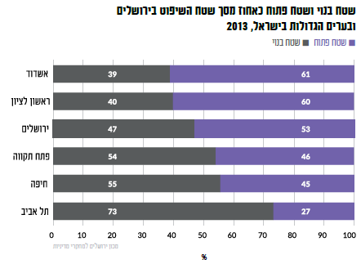

Rishon LeZion

Open area s

Built-up area

Tel Aviv

Haifa

Petah Tikva

Jerusalem

Ashdod

## Population

Jerusalem is the largest city in Israel and at the end of 2016 its population was **882,700 residents**, which constituted 10% of the population of Israel. Jerusalem has the largest Jewish population in Israel - 550,100 residents and the largest Arab population in Israel - 332,600 residents.

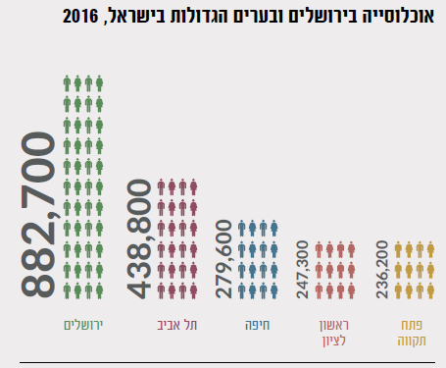

Rishon LeZion

Jerusalem

Petah Tikva

Tel Aviv

Haifa

Population in Jerusalem and the big cities of Israel, 2016

Distribution of Jewish residents according to religious identity:

Of the Social Survey conducted by the Central Bureau Statistics among persons aged 20 and over indicate that In the years 2016-2014 ( average years ) 20% Of the Jews in Jerusalem defined themselves as secular, 26% traditional ( traditional-religious and traditional not all Religious ) , 19% religious, and 34% ultra-Orthodox (Haredi).

**The secular percentage in Jerusalem** **(20%**) **was low** **compared to Israel** (44%), Tel Aviv (66%) and Haifa (57%). Some of the traditional In Jerusalem it stood at 26% and it was lower than that Israel (35%) and Haifa (32%) and similar to Tel Aviv (27%). Some of those who defined themselves Orthodox Jews in Jerusalem (19%) was higher in comparison To Haifa. The **percentage of Haredi in Jerusalem was also high** **the largest of the large cities in Israel**. Tel Aviv 2% defined themselves Haredi, 4% in Haifa, and in Israel as a whole 9%.

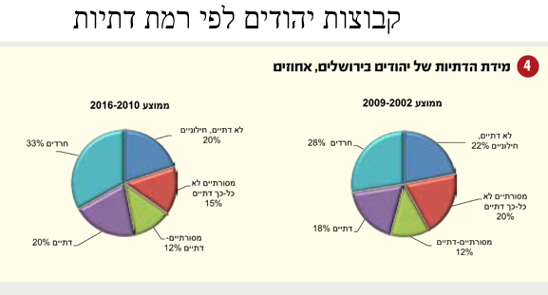

**The degree of religiousness of Jews in Jerusalem, %**

**Average 2002- 2003**

Not religious. And secular 22%

Traditional- not so religious 20%

Traditional – religious 12%

Religious (18%)

Haredi 28%

Not religious. And secular 20%

Traditional- not so religious 15%

Traditional – religious 12%

Religious (20%)

Ultra-orthodox (Haredi ( 33%

**Average 2010- 2016**

**Groups of Jews by level of religion**

Haredi Distribution by Neighborhoods:

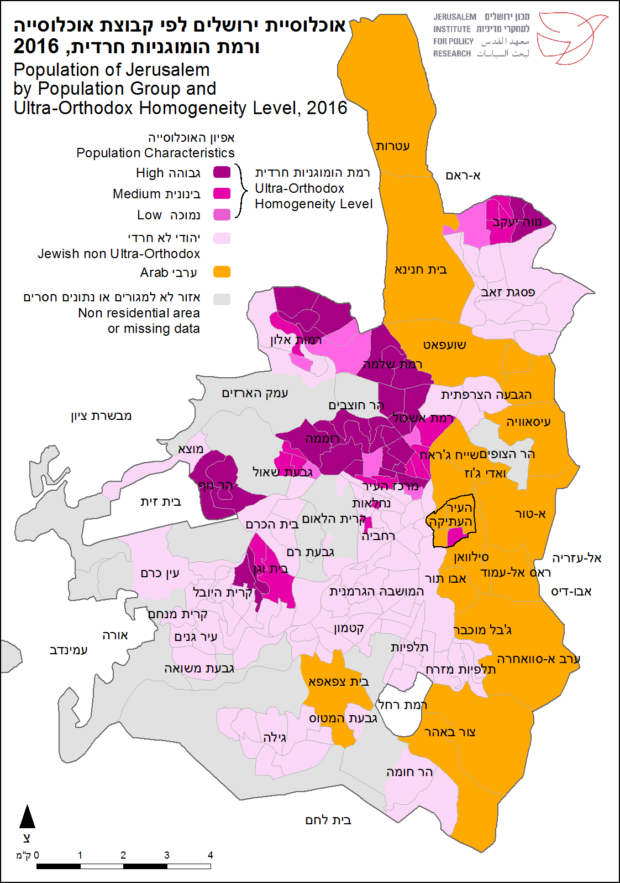

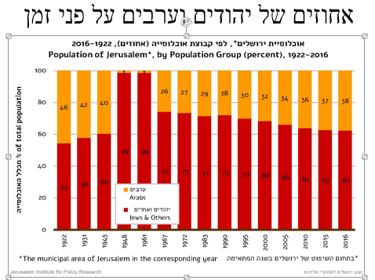

**Percent of Jews and Arabs over time**

**It is now estimated that some 350 thousand residents live in East Jerusalem**

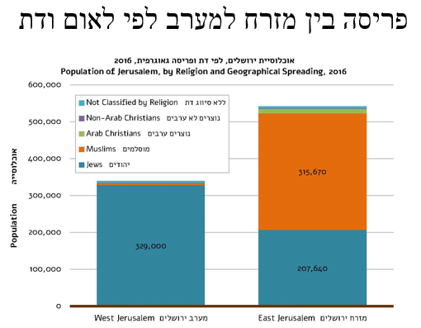

**East- West distribution by nationality and religion**

**Population in Areas added to Jerusalem in 1967, Selected Neighborhoods 1965-2016**

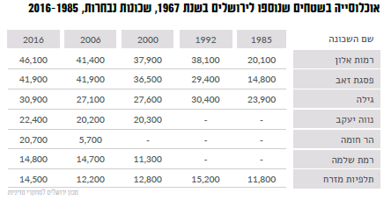

East Talpiot

Ramat Shlomo

Har Homa

Pisgat Zeev

Gila

Neve Ya’akov

Ramot Alon

Names

**Migration balance of Jerusalem with major localities 2016**

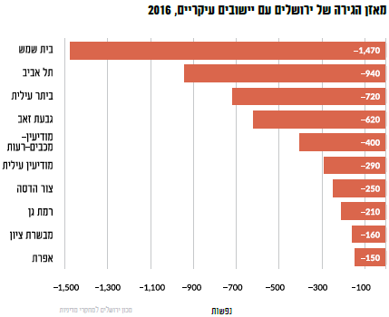

**Ramat Gan**

Modi’in Ilit

Efrat

**Mevaseret Zion**

**Tsur Hadassah**

Modi’in Macaabim- Reut

Giv'at Ze'ev

Beitar Ilit

Tel Aviv

Bet Shemesh

**The population of Jerusalem is characterized by a young age structure**. In 2016 the median age of its residents was 24 years. In other words, half of the population is younger than 24 and the other half is older than 24. For the sake of comparison, the populations of the cities of Tel Aviv and Haifa are significantly older than the population of Jerusalem and the median age of those in them was 36 and 38, respectively. The median age of the entire population of Israel was 30 years.

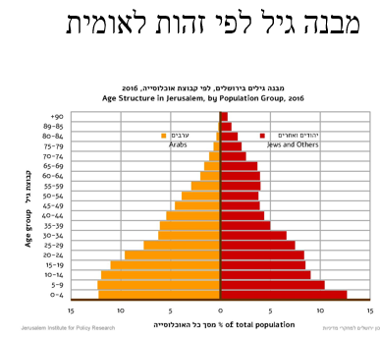

**Age structure according to national identity**

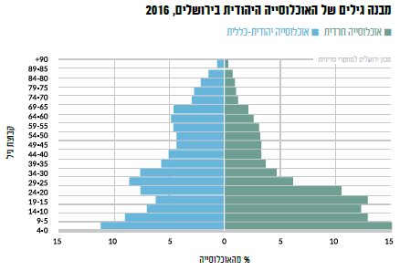

**Age structure of the Jewish population in Jerusalem 2016**

Of the pupation

Determination of age

Jewish population – general

Haredi population

## Welfare

**The incidence of poverty in Jerusalem (46%) is high compared to the rest of Israel (22**%) and the large cities. In 2016, the incidence of poverty among the Arab population in the city (75%) was significantly higher than among the Jewish population (29%). Among the Haredi population in Jerusalem, 49% of the population lived below the poverty line. In 2016, the average housing density among the Jewish population in Jerusalem was one person per room. Among the Arab population, the housing density was almost double - 1.8 persons per room.

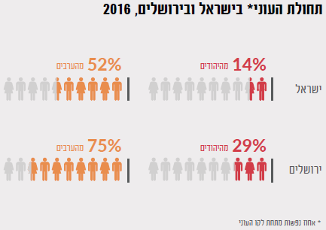

**Incidence of Poverty in Jerusalem, by Population Group, 2016**

**Incidence of poverty\*in Israel and Jerusalem 2016**

Israel

Jerusalem

Of the Jews

Of the Arabs

Of the Jews

Of the Arabs

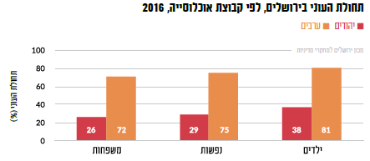

Jews J

Arabs J

Children

People

Families

The incidence of poverty

## Employment

In 2016, the rate of participation in the labor force in Jerusalem in the main working ages (aged 25-64) was 68%, and it was considerably lower than that in Israel (81%), Tel Aviv (88%) and Haifa (85%). Among the Jewish population, both in Israel and in Jerusalem, **there was a significant gap in the rate of participation in the labor force among those who defined themselves as members of the general population (secular, traditional and religious) and those who defined themselves as ultra-Orthodox.** The higher the degree of religiosity, the lower the participation rate in the labor force.

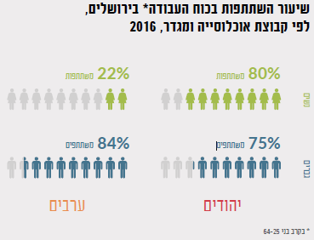

**Participation Rate I the Labor Force in Jerusalem, by Population Group and Gender 2006**

Families

Families

Jews

Arabs

**Participation I the Labor Force among Jews of Religious and Gender Characteristics, 2016**

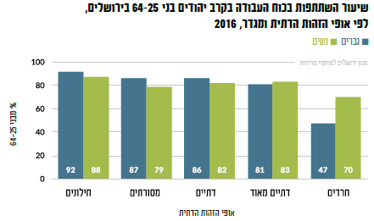

The nature of religious identify

Women’s

Men’s

Religious

Very religious

Haredi

Secular

Traditional

The average wage in Jerusalem is also lower than the average in Israel and even more than the average wage in other large cities.

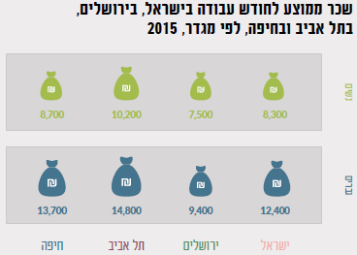

**Average wages per work mount in Israel, Jerusalem, Tel Aviv and Haifa by gender**

Women

Men

Israel

Jerusalem

Tel Aviv

Haifa

In Jerusalem there is a significant difference in the rate of participation in the labor force by level of education. In 2016, the highest participation rate was among graduates of institutions of higher education: academic (82%), post-secondary non-academic (77%) and teacher-training colleges (74%). Among those with high school education, the participation rate was 62%. An especially low rate of participation in the labor force was recorded among those with elementary and junior high education (43%) and among yeshiva graduates (42%). In general, **there is a correlation between the level of education and participation in the labor force** - the higher the level of education, the higher the participation rate in the labor force. The exceptions in Jerusalem are the Arab men, among whom there was no connection between their level of education and their participation in the labor force. The rate of participation in the labor force is similar and higher among those with a high school education or higher. The reasons for this are varied, among other reasons, cultural reasons and barriers such as lack of knowledge of the Hebrew language.

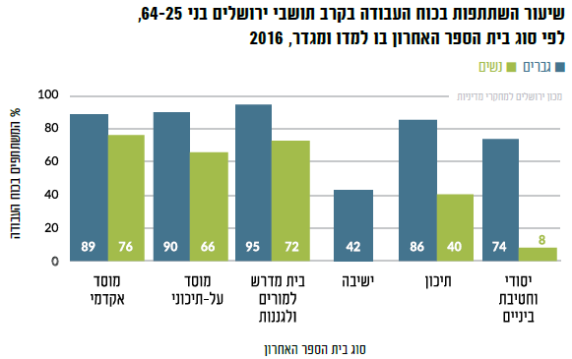

% Of Participants in the Workforce

Last School Attended

**Academic**

**Institution**

**Post High**

**School**

**Institution**

**Yeshiva for**

**Teachers**

**Elementary**

**And Middle**

**School**

**High school**

**Yeshiva**

**Men Women**

**Rate of Participation in the Workforce, Jerusalem Residents, Age 25-64, by Last School Attended and Gender**

## Education

**Jerusalem school system is the largest system, the most complex and diverse country.** This system is required to respond to a variety of populations with different characteristics. The four main educational sectors in the city are **public education, public-religious education, ultra-Orthodox education, and Arab education**. The educational institutions in the city differ in the legal status to which they belong - the system includes official schools, recognized non-official, independent and exempt institutions. The students in both the public and the public-religious sects constitute **less than a quarter** of the students in Jerusalem.

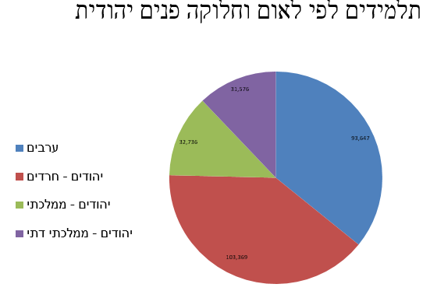

Jewish – Religious National

Jewish – National

Jewish – Ultra Orthodox

Arabs

**Students by Nationality and Inner Jewish Divisions**

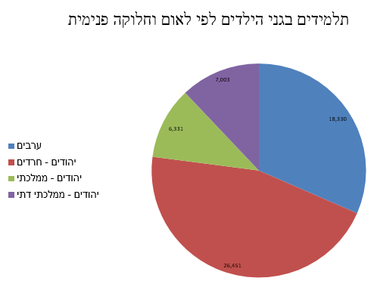

Jewish – Religious National

Jewish – National

Jewish – Ultra Orthodox

Arabs

**Preschool Students by Nationality and Inner Jewish Divisions**

## East Jerusalem

East Jerusalem (in Arabic: القدس الشرقية) or Eastern Jerusalem is a political name for an area of approximately 70 square kilometers that is within the municipal boundaries of Jerusalem and is located beyond the Green Line. **After the Six Day War, Israel subjected the area to Israeli law.** This geographically includes not only the eastern areas of the city, The area includes, in addition to the area of Jerusalem occupied by the Jordanian army and controlled by Jordan in the years 1948-1967, also towns and villages that had not previously been considered part of Jerusalem. Subject to the Jordanian municipality of Jerusalem included only 6.4 square kilometers. In other words, 91% of East Jerusalem was not included in this area prior to June 1967.

Immediately after the Six Day War, Israel annexed East Jerusalem and distributed ID cards to its residents. However, the legal status of East Jerusalem identity card holders remains vague until a 1988 Supreme Court ruling in the case of Mubarak Awad (HCJ 282/88 Awad v. Prime Minister and Minister of the Interior et al.), Palestinian residents of East Jerusalem are those who received an implied license for permanent residency (permanent resident) under the Entry into Israel Law.

A permanent resident may apply for a citizenship if he meets the following conditions:

* The applicant is in Israel and must prove that he has spent at least three of the five years preceding the submission of the application in the country (for example, by paying municipal taxes and registering his children to educational institutions).
* He is entitled to reside in Israel permanently (and in particular his permanent residency permit has not expired).
* He knows the Hebrew language (he is tested via a casual conversation with a clerk).
* Renounced his previous citizenship (especially Jordanian) or proved that he would cease to be a foreign citizen when he became an Israeli citizen.
* Commits the following: "I declare that I will be a loyal citizen of the State of Israel."
* The authorities check that there is no security impediment to the citizenship, such as involvement in terrorism.

In the first years of the annexation of East Jerusalem, the number of applications for naturalization was relatively small. Since the Oslo process, and in particular the second intifada and the construction of the separation fence, parts of Jerusalem have been cut off from the rest of the city (especially the Shu'afat refugee camp) and increased the separation of Jerusalem from the rest of Judea and Samaria. This means that the residents of East Jerusalem have ended up in a lack of clarity and tend to decide in favor of Israeli citizenship. **According to the survey, most residents of East Jerusalem say that if the choice between full citizenship in Israel and full citizenship in a Palestinian state is met in the future, they will prefer Israeli citizenship.** However, the process is long and not easy for applicants.

According to recent data, some 350,000 Arabs live in the Arab neighborhoods of East Jerusalem.

At the same time, some 200,000 Jewish citizens live in the eastern part of the city (data for 2014).

Arab residents of Jerusalem numbered 350,000 (about 37 percent of the city's total population). 98 percent of them live in East Jerusalem neighborhoods. 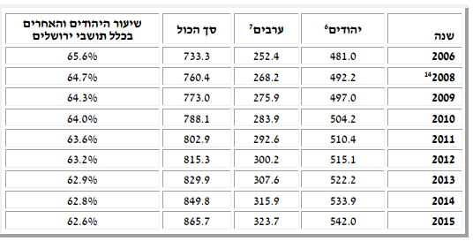

**Rate of Jews and Others**

**Total**

**Arabs**

**Jews**

**Year**

According to the "Ir Amim" (2014) survey, the proportion of Jerusalem Municipality's relative investment in East Jerusalem for its Palestinian residents is only 1.10% of its budget, in the budget for the implementation of 2013. In five divisions, the municipality's relative investment is only 5% of its budget. 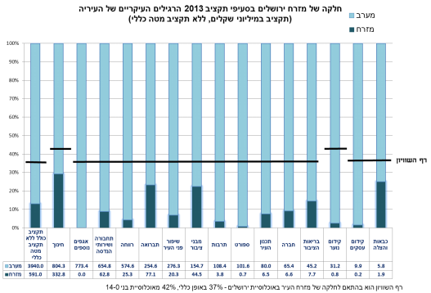

Equality Line

East

West

**The Eastern part of Jerusalem in the 2013 Municipal Budget**

**(In Millions of NIS)**

**The relocation of East Jerusalem residents to the Jewish neighborhoods:**

Whereas in 2011 only 60 residents of East Jerusalem migrated to the Jewish neighborhoods, in **2016 1,322 people made the crossing**. The desired neighborhoods: the German Colony and Talpiot. The reasons are: The main ones are better infrastructure and escape from checkpoints (improving quality of life).

**"This is a significant phenomenon to pay attention to,"** said Merrick Stern, a researcher at the Jerusalem Institute. "This is a new trend, and it's no accident that it's happening now." According to him, the trend stems from several factors, including government policy and the municipality, alongside changes in Arab society. He noted that the high density of neighborhoods in East Jerusalem, along with housing shortages and rising prices are some of the reasons for the phenomenon. Jerusalem has some 220,000 apartments, but only about a quarter of them (53,000) are in East Jerusalem neighborhoods. This is in spite of the fact that Arab residents constitute about 38% of the city's population. According to Bimkom-Planners for Planning Rights, from 1967 until the end of 2012, only about 4,300 building permits were issued in the East Jerusalem neighborhoods, while some 20,000 housing units were estimated to have been built there without a permit.

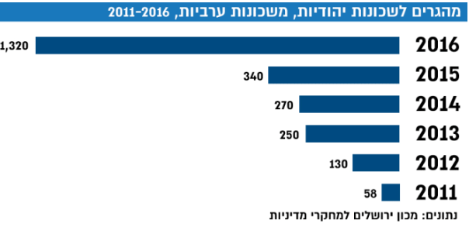

**Immigrants to Jewish Neighborhoods from Arab Neighborhoods, 2011-2016**

***Demographic Trends***

An updated demographic forecast prepared by members of the Jerusalem Master Plan for Transport shows that in 2040 the ratio of Jews to Arabs in the capital is expected to be 56%, compared with 44% for Arabs. According to this population projection, the number of Jerusalem residents will reach 1.35 million this year. Of them, 756,000 were Jews and 596,000 were Arabs.

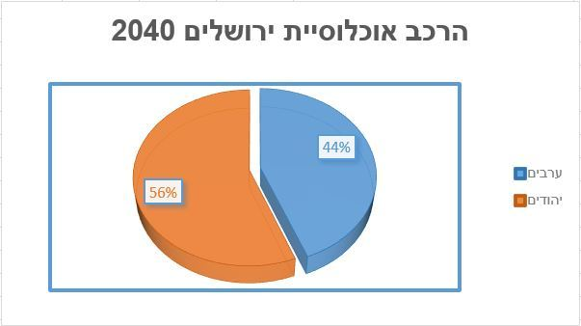

Jews

Arabs

**Projected Jerusalem Population 2040**

East Jerusalem in Numbers (Report of the Association for Civil Rights in Israel, 2014):

***Jerusalem, United Forever?***

Findings from public opinion polls indicate that at the end of 2014, a large part of the public objected to the transfer of the Arab neighborhoods in East Jerusalem to the Palestinian Authority, even within the framework of a final status agreement (56 percent vs. 38 percent). On the other hand, a survey conducted in 2015, immediately after the escalation began, received the opposite picture: 69 percent of the public wanted to disconnect from Arab neighborhoods in East Jerusalem, and only 24 percent wanted to leave these neighborhoods under Israeli sovereignty.

A comprehensive public opinion survey conducted by the Institute for National Security Studies during the violent events reflects these changes in a more profound manner. To the question "**What do you think is the right solution in the present situation to the Jerusalem question?**", only 19 percent of the public said they were in favor of leaving the existing situation in Jerusalem. The rest of the respondents prefer a certain change in Jerusalem that includes a concession or a new solution - 35 percent in favor of maintaining the status quo while increasing physical separation in East Jerusalem, 21 percent in favor of transferring the Arab neighborhoods (excluding the Old City) To the Arab neighborhoods of Jerusalem under Israeli sovereignty. The last figure is particularly interesting, since this is a completely new idea from the public's point of view (it has already risen in the past in the political and military echelons) and is not recognized.

**Interesting findings are also raised regarding the issue of the Temple Mount.** In the framework of the survey, the question was asked, "What do you think should be Israel's policy today regarding the Temple Mount?" Only 27 percent of the Jewish public supports allowing Jews to go up and pray on the Temple Mount freely. 28 percent of the public believed that Jews should not be permitted to go to the Temple Mount at this time, 25 percent opposed the possibility of going up to the Temple Mount, but not to pray there, while 20 percent thought that the Temple Mount should be allowed to visit besides from public figures. It seems that the latter see the rise of public figures to the Temple Mount as an unnecessary provocation.

**Map of the Arab Neighborhoods in East Jerusalem:**

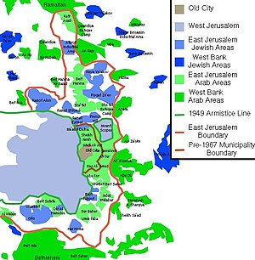

**Typical problems, a follow-up village as an example (according to the Jerusalem Institute for Policy Studies report):**

* Lack of personal security and lack of governmental presence and operational body
* Management of services and infrastructure in the neighborhood by remote control
* The construction is wild and overcrowded without supervision, while trampling public areas and infrastructure
* Water supply only two days a week
* Sewage pipes do not meet the load
* A shortage of roads and sidewalks in all the internal roads in the neighborhood
* Poor sanitation
* The education system is lacking
* Lack of public services and lack of public facilities
* The lack of public facilities such as a public playground for children's games and a suitable sports field
* Health services and rescue services are lacking

# A Brief History of Jerusalem

**Antiquity**

According to the Bible, Jerusalem was a Jebusite city until it was conquered by King David, who used it as the capital of his kingdom.

His son, King Solomon, built the first Temple there. Jerusalem was first located on the hill, identified as the City of David, and later spread northward to the Temple Mount. In 598 BC, the Kingdom of Judah was conquered by the Babylonian Empire, after King Zedekiah's rebellion against the Babylonians, Nebuchadnezzar the Babylonian king, besieged the city, and conquered it in 586 BCE. About a month later, Nebuzaradan, his army minister, destroyed the city and the First Temple.

After the exile of the people of Israel to the Babylon, Jerusalem was full of local peoples, mainly Samaritans (or Cuthaits). About seventy years after the destruction of the First Temple, with the rise of the Persian Empire and the publication of the Cyrus Declaration in 538 BCE, Jerusalem was rebuilt as the capital of the Jewish Province. Many of the exiles returned to it and established the Second Temple there.

In 332 BCE, Alexander the Great conquered Judea without a battle and imposed a Hellenistic regime on Jerusalem, which was characterized by legislation and subordination of draconian laws to the Jews, including those that violated the principles of the Jewish religion, such as an attempt to force conversion of their religion and eating non-kosher foods. This coercion led to the Hasmonean revolt, which erupted in 167 BCE At the end of this revolt, the Hasmonean family conquered Judah from the Hellenic regime and ruled Jerusalem until its conquest in 63 BCE by the Roman army.

In 37 BCE the Romans appointed the Rhodesian king of Judah. Herod expanded and glorified the city and built Herod's temple there. In 66 CE the "Great Revolt" broke out against the Romans. This revolt was brutally suppressed in 69, with the arrival of Titus at the gates of Jerusalem, at the head of a large Roman army. In 70 CE, Titus conquered Jerusalem, burnt it and destroyed the Second Temple.

During the suppression of the Great Revolt, many Jews were killed and exiled. The city underwent a demographic upheaval and became a center of Roman rule. It was occupied mainly by soldiers of the Roman armies and other nationalities. The few remaining Jews lived on Mount Zion. At the same time Christianity began to spread throughout Palestine and Jerusalem in particular. After the Bar Kokhba Revolt, which took place from 132 to 135, Jerusalem was almost completely emptied of its Jewish inhabitants, and for 500 years researchers had no evidence of a Jewish community there.

Jerusalem was in ruins until the time of the emperor Adriana, who rebuilt it in 130. The city bore a Roman character and was called Ellia Capitolina. In the framework of his rule in the city of Assar Adrianaus on the entry of Jews into its territory. In 133 Jewish rebels led by Bar Kokhba took over Jerusalem in an attempt to topple Roman rule. The revolt was brutally suppressed by the soldiers of the Roman army and the city returned to Roman rule in 136.

The high status of Ellia Capitolina began to fade from the middle of the third century CE, with the gradual evacuation of the Tenth Legion Pratensis, which was stationed in the city. Beginning in 324, when the Roman Empire became Christian (the beginning of the Byzantine period), Jerusalem was full of Christian clergy and monks for at least 300 years.

From the time of the Emperor Constantinus, at the beginning of the Byzantine period, the city became a symbol of holiness and became an important religious center during the fourth century CE. This is due to the establishment of the Church of the Holy Sepulcher and other churches in the area. The conquest of Jerusalem by the Persians, in 614, brought about a brief respite from the Christian-Byzantine rule that prevailed in it. In 628, the Byzantines returned to rule Jerusalem for only ten years, until it was conquered by the Arabs.

**Middle Ages**

In 636, following the Byzantine defeat in the Yarmouk, Arab-Muslims reached the gates of Jerusalem, which fell after a six-month siege. In the framework of the terms of surrender agreement between the occupiers and the citizens of the city at the time, the safety of the Christians and the integrity of their churches were assured. In 691, the Caliph Abd al-Malik built the Dome of the Rock on the Temple Mount. Jerusalem moved to Umayyad rule until 750, followed by the Abbasid Caliphate until 969. In that year Jerusalem moved to the Fatimids.

The Middle East and the Land of Israel entered a period of instability, which was exploited in 1071 by the Seljuks, who conquered Jerusalem and held it for a short period. The Arab-Muslim occupation created a demographic transformation in Jerusalem. The Christian settlement in the city shrank greatly, and there were many Muslim immigrants from the Arabian Peninsula who were allowed to return after many years.

In 1033, an earthquake destroyed the southern walls of Jerusalem. As a result, the wall was reduced, the southern part of the city was abandoned and its Jewish residents were forced to relocate to the northern part of the city.

Until 1099 most of the population of the city was Arab, and at the same time large Jewish and Christian communities operated there. The Jewish community in Jerusalem concentrated mainly on Mount Zion.

With the fall of the city to the Crusaders in 1099, Jerusalem returned to Christian control for a hundred years, in two separate periods: 1099-1187, and again in 1244-1229.

During the Crusaders' conquest of the city, most of its Jewish and Muslim inhabitants were slaughtered, and for a while it became a ghost town. The Crusaders found it difficult to fill them with Christians, and therefore encouraged Christians from Armenia and Eastern Europe to immigrate to the abandoned city. The Crusaders developed the city's array of markets.

During the Crusader period in Jerusalem there was an increase in its Christian population. Muslims and Jews were not permitted to live in it, and visited it only rarely.

In 1187 Saladin conquered Jerusalem, and most of the Christian population was expelled from it. It still has a predominantly Eastern Christian community. The city received a Muslim character for about 700 years. Some of the families of the Muslim nobility in Jerusalem, who settled there at that time, survived to this day: Hosseini, Nashashibi, Khalidi, Dajani, Nusseibeh and others.

In the spring of 1219 the walls of Jerusalem were destroyed and for the next 316 years Jerusalem remained without walls. After the Sixth Crusade the city returned to the control of the Crusaders, and they held it until it was destroyed again, in 1244, this time by the Hughes.

In 1260, after the end of the rule of the Quraysh, the city fell to the Mamelukes, who took over the land of Israel. They held it until 1516. During the Mameluke era, Jerusalem was strategically unimportant and remote from the postal route. The Mamelukes built many government and religious buildings there, as well as palaces and magnificent buildings, which served as centers of study for the Koran.

The population of Jerusalem at the time was mostly poor. Even the Jewish population, which was allowed to return to Jerusalem at the beginning of the Mameluke occupation, took a long time to establish itself there. The description of the Ramban (Nahmanides), who visited Jerusalem in 1267, indicates that there were about 2,000 inhabitants in the city, of whom about 300 were Christians, while the Jews were few: "And there is no Israel among them, but for two painter brothers who would buy paints from the regime." (The Ramban's Letter, 1267). Later, the city's Jewish population grew.

During this period, Jerusalem's status in the Islamic consciousness was determined as a holy city, the third at its holiness, after Mecca and Medina.

**The Modern Age**

In the 15th century, the Old City began to form into the four quarters known to us today. Most of its residents were Muslims at the time. Population censuses conducted in the city during the 18th and 19th centuries attested to the culture of the city's Jewish population, while the Christian population declined.

In 1517 the city and the land were conquered by the Ottoman Empire. Sultan Suleiman the Magnificent built the walls of Jerusalem that stand today and renovated the fortress and the Tower of David. However, due to the long decline of the Ottoman Empire, the demographic situation of Jerusalem and large parts of the Old City deteriorated. In the 18 th and 19 th centuries, the Jewish community began to grow stronger, and by the end of the century there were about 11,000 people, the largest community in the city.

Rabbi Yehuda HaChassid's group, members of Ashkenazi Jewry, who immigrated to the Land of Israel in 1700, was expelled from the city due to a large financial debt to Muslim builders. However, the economic situation of the city's Jews improved at the beginning of the 19th century, following the immigration of the Vilna Gaon's (Rabbi Elijah ben Solomon Zalman, or the GRA) students, headed by Rabbi Menachem Mendel of Shklov, as well as the assistance of the Rothschild family, which enabled the members to return to Jerusalem safely.

In the 19th century, the European colonial powers began to show interest in the Land of Israel in general, and in Jerusalem in particular. Various studies and publications about them have been published and raised awareness of them regarding their religious, cultural and historical significance. As a result, the superpowers began building religious and cultural institutions, education, research, health and tourism in the city, as well as consuls and clerics on their behalf. At first the powers built their buildings in the territories between the walls, and after a while outside them. In the second half of the 19th century the European influence increased.

The Christian population of Jerusalem at that time included Arabs, European-born, temporary residents, and clergymen.

The exodus from the walls also encompassed the Jewish community. In 1860 the Jewish neighborhood of Mishkenot Sha'ananim was founded by Moses Montefiore, and became the first Jewish neighborhood to be built outside the walls of Jerusalem. Other Jewish neighborhoods were built behind it, especially "courtyard neighborhoods", which are now the center of the city and were the cornerstones of the new city. Among other things, Machane Yisrael was built, Nahalat Shiva, Beit David and Mea Shearim.

In the article "New Buildings and Suburbs" published in the Hamelitz newspaper on the 19th of Av, 1880, it was reported that "the number of houses in Jerusalem has tripled."

**The 20th Century, until 1967**

In 1917, Jerusalem was transferred to the British Mandate, which established it as the capital of the Land of Israel and concentrated its institutions, including the seat of the High Commissioner, the Ministries, the Supreme Court, and the Central Prison.

At that time, Jerusalem served as the political center of the Jewish community and the Zionist movement, and housed its national institutions: the Committee of Delegates, the Jewish Agency for Israel, the National Council, the Jewish National Fund and the Keren Hayesod. In addition to these institutions, the Hebrew University was built on Mount Scopus.

On November 29, 1947, after the partition of Palestine was declared at the UN General Assembly, the War of Independence broke out. According to the UN Partition Plan, Jerusalem and Bethlehem were to be included in a neutral zone under international control, but both sides - both Jewish and Arab - ignored it and sought to control the city and its environs.

The Arab fighting forces in the city included local residents, as well as auxiliary forces of volunteers sent to it by the Arab countries. These forces included the Arab Legion, the Muslim Brotherhood, and an army from Egypt. The forces imposed a siege on the entry of Jews to it, and stopped the water supply to its inhabitants. After the fierce and bloody battles, the armored caravans managed to break through the siege that was imposed on the city, and they paved a way through which they provided food, Water and equipment.

In Latrun heavy fighting took place between the sides. As part of Operation Nachshon, Arab villages were conquered on the way to Jerusalem, but access to the city was completely blocked from the end of April, and the city was under siege.

In May 1948 the British left the city and the war intensified. The Old City fell in the hands of the Jordanian forces, who took control of the east of the city. At the same time, Jewish forces took control of the Arab neighborhoods in the western part of the city, including Katamon, Talbieh and Baka. The siege of the city continued the pavement of the Burma road in July 1948, after which convoys, which provided food and equipment for the city's residents, could travel continuously and with relative security on their way to it.

In November 1948 a cease-fire was declared in the city and the war ended. A year later, on December 5, 1949, David Ben-Gurion declared Jerusalem the capital of the State of Israel.

Between 1948 and 1967, the city was divided. The municipal line was the armistice line, as agreed in the Rhodes agreements, as part of the Green Line. It was seven kilometers long and divided the city between East Jerusalem, then part of the Hashemite Kingdom of Jordan, and West Jerusalem, which was controlled by the State of Israel. On both sides of the line, the two countries deployed fortifications and obstacles, and various buildings along its length served as military posts. The entire Old City, the neighborhoods north of it, and the Mount of Olives were included in Jordanian control. West of the city, as well as an enclave on Mount Scopus in the north-east of the city - were included in the area of Israeli control. The Armon Hanatziv area was a demilitarized zone controlled by the United Nations, and the palace itself was designated as the headquarters of the UN observers. The Mandelbaum Gate separated the two parts of the city, through which it was possible to pass from one half of the city to another. The transition was conducted by members of the Israeli and Jordanian Customs, was used primarily to enable diplomats and UN staff, as well as the passage of Christian pilgrims at Christmas. From that gate a convoy of soldiers and policemen would travel bi-weekly, to the Israeli enclave on Mount Scopus [clarification needed].

The western neighborhoods of Jerusalem along the line were to border neighborhoods, where Jordanian soldiers occasionally sniped; therefore, these neighborhoods became distressed and characterized by poverty. These neighborhoods included: Samuel the Prophet, Mea She'arim, Musrara, Mamila and Yemin Moshe.

**From 1967**

With the outbreak of the Six-Day War on June 5, 1967, the Arab Legion shelled Jerusalem. The IDF responded by taking control of East Jerusalem.

Since the Six Day War, many neighborhoods have been built in the area that was added to the city (some of which were Jewish settlements that were abandoned during the War of Independence). Today, a large part of the Jewish population in Jerusalem lives in these neighborhoods.

Since the 1990s, there has been a marked trend of ultra-Orthodoxy in Jerusalem. Every year since the mid-1990s, the number of secular Jewish children has steadily declined, while the percentage of children in the ultra-Orthodox population has steadily increased during these years. In 2010, 13% of all applicants to first-grade schools in the city, Jews and Arabs, registered in the State-secular education system. The relative share of the Arab-Christian population in the city is declining due to the migration of residents, especially to other countries.

In the city there was a struggle over its religious character. Among the prominent struggles in this field are the demonstrations on the Bar-Ilan road, the opposition to the Teddy Stadium building in the north of the city, the opening of the Karta parking lot on Saturday and the holding of events there.

During the first intifada, which broke out in 1987, attempts to sabotage and ignite vehicles occurred in East Jerusalem and in the neighborhoods along the seam line. During the second intifada, which broke out at the beginning of the 21st century, there were suicide attacks, including the attack at the Subarro restaurant, the attack on Cafe Moment, the attack on the Ben Yehuda pedestrian mall, the attack on the Mahaneh Yehuda market, the Cafe Hillel bombing, and the attack on bus 32A.

In the first decade of the 2000s suburban construction was reduced on the outskirts of the city and the city center was renovated. In addition, a light rail was constructed, serving tens of thousands of people daily.

During Operation Pillar of Defense, in 2012, rockets were fired from the Gaza Strip towards Jerusalem for the first time, sirens were sounded and residents were forced to enter the shelters. This reality was repeated during Operation Protective Edge, which took place in 2014.

From the end of 2015 until the end of 2016, the city, like other places in Israel, has seen a wave of terror. This wave was characterized by attacks on bystanders and security forces by Arabs, especially in the eastern part of the city, using gunfire, stabbing and running.

**Important Dates**

*1000 BCE - King David conquers Jebus and makes it his capitol.*

*960 BCE - King Solomon builds the first temple.*

*586 BCE - The first temple is destroyed by Nebuchadnezzar. The Jews are exiled to Babylon.*

*538 BCE - The Persian Empire allows the exiles to return to their land*

*516 BCE - The second temple is built.*

*445 BCE - Nehemiah, Governor of Judea, rebuilds the city's walls.*

*332 BCE - Alexander the Great, conquers the Middle East. Beginning of the Hellenistic rule.*

*167 BCE - Hasmonean Revolt against the Greeks.*

*63 BCE - The Roman army, led by Pompous, captures Jerusalem. Beginning of the Roman rule.*

*19 BCE - King Herod renovates the temple,*

*33 CE - Jesus Christ is crucified.*

*66 CE - The Great Jewish Revolt begins.*

*70 CE - Titus destroys the temple.*

*135 CE - Bar Kokhba's Revolt is squashed by Emperor Hadrian. Jerusalem is destroyed and rebuilt as a Roman city, Elia Capatolina.*

*313 CE - Emperor Constantine declares Christianity as a legal religion within the Empire.*

*335 CE - Church of the Holy Sepulcher is built.*

*380 CE - The Roman Emperor, Theodosius I, declares Christianity as the formal religion of the Roman Empire.*

*638 CE - Jerusalem is conquered by the second caliph, Omer Even Alhateib.*

*691 CE - The Dome of the Rock is built by Caliph Abed Almalech Even Marwen.*

*705 CE - Al-Aqsa Mosque is built.*

*1099 CE - The Crusaders conquer Jerusalem and turn the Temple Mount into a Christian religious center.*

*1187 CE - Salah A-Din defeats the crusaders.*

*1260 CE - The Mamelukes conquer the city.*

*1517 CE - The Ottomans conquer the city.*

*1917 CE - The British, led by General Allenby, conquer Jerusalem.*

*1948 CE - The Jordanians take the Old City.*

*1967 CE - The unification of Jerusalem under Israeli Rule.*

# Maps

**Map of the Holy Places, 1946**

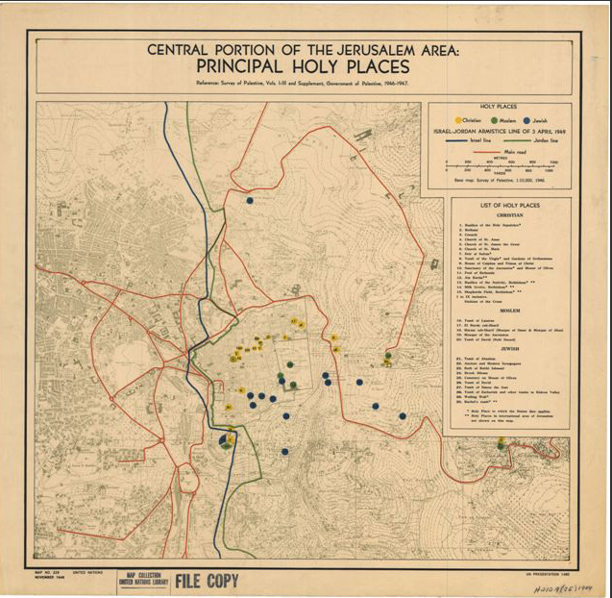

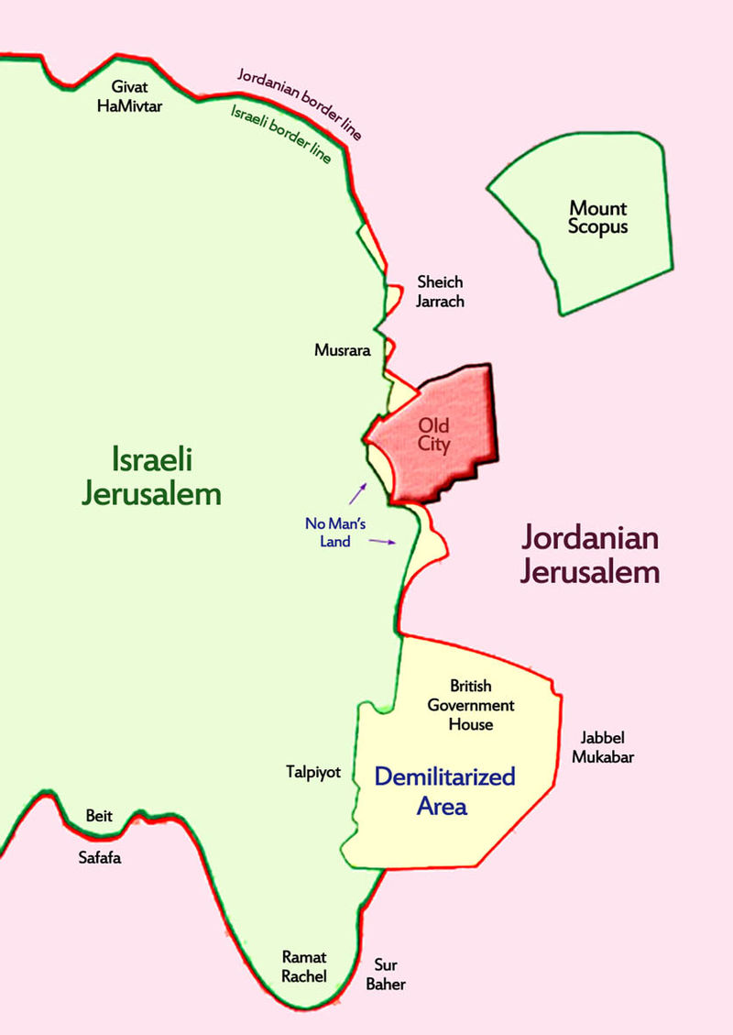**Map of Jerusalem, 1948-1967**

**Prime Minister Ehud Barak's Solution, 2000**

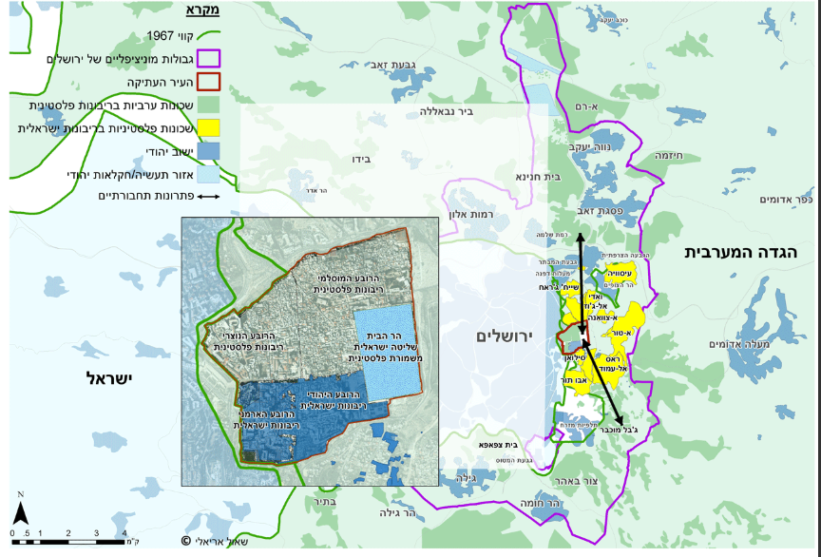

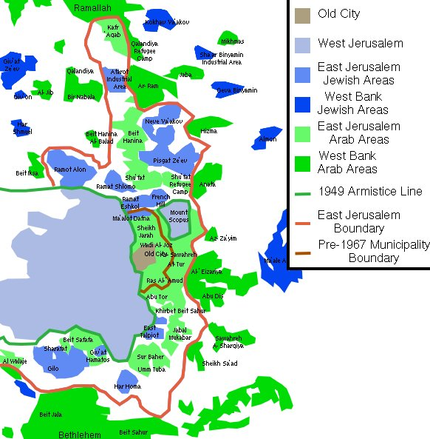

## Map of the Jewish Neighborhoods and Separation Fence

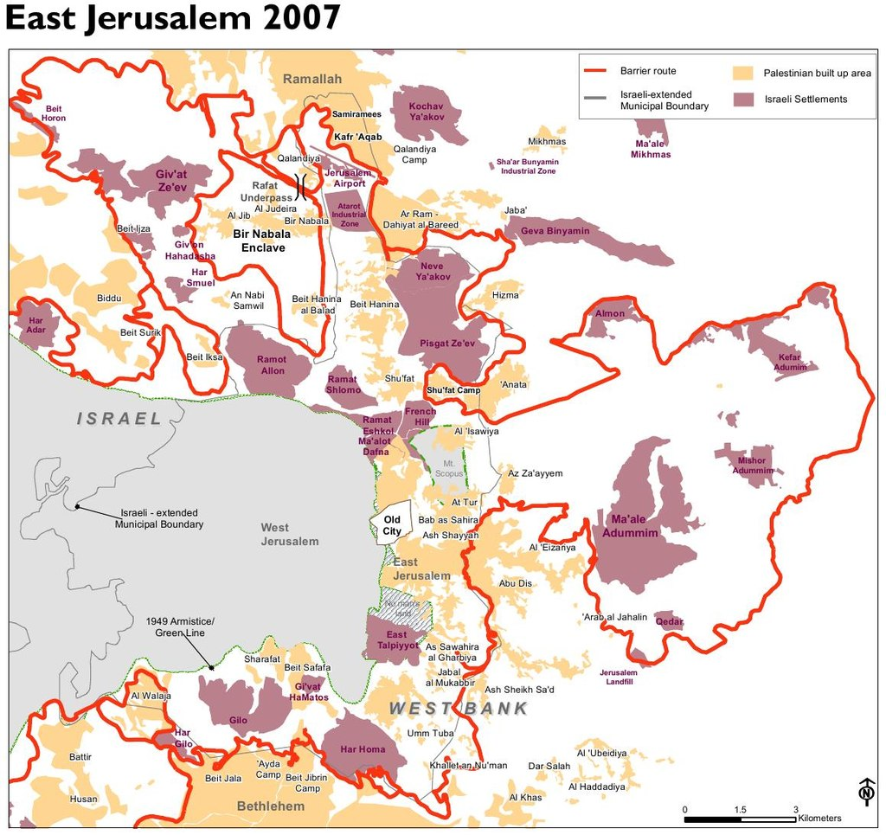

**Rehavam Ze'evi, Your Prophecy Will Soon Come True / Shaul Arieli Ha'aretz, Shaul Arieli January 2, 2018**

In the coming weeks, Rechavam Ze'evi ("Gandhi") is expected to win the status of prophet or at least the fortune teller of the New Jerusalem. The prospective candidates to reward him this prize are ministers Naftali Bennett and Zeev Elkin. They managed to hold a lengthy debate in the Knesset before the final approval of the law, which would allow the separation of the Palestinian neighborhoods beyond the separation barrier from the Jerusalem municipality and their transfer into a new Israeli local authority.

Ze'evi, a central figure on the committee that was appointed immediately after the Six-Day War by the Eshkol government to determine the new borders of Jerusalem, was asked by Justice Minister Yaakov Shapira what logic is behind his new proposed boundaries. Ze'evi's reply is about to become prophetic: these were aimed at "maximizing the area added to Jerusalem, allowing it to become a large metropolis," but added: "If it becomes clear in the future that we have gone too far in including territories and population, then Jerusalem proper could be separated from the outlying areas, which would receive the status of a regional council."

This answer, which was given exactly 50 years ago, naturally raises the memory of another, truly important "prophecy" - the decision to establish the State of Israel, exactly 50 years after Benjamin Ze'ev Herzl envisioned it. But with the dimension of time the similarity between the two ends.

Ze'evi's original proposal was to expand Jerusalem by no less than 200 square kilometers, a vast area east of the city that extends to Wadi Kelt. This decision would have led to the loss of the precious Jewish majority in Jerusalem that had been created there for the first time since 1870. This was a messianic proposal that even Ze'evi himself doubted. At the cabinet meeting, it was Defense Minister Moshe Dayan who knew how to block the destructive idea: "I know the Jewish appetite, if you add the airport and Ein Prat, rather than annexing the other half of Jerusalem, we would be dividing the West Bank in half and I am against it."

It turns out that the government's decision to be content with the annexation of "only" 70 square kilometers did not render Ze'evi's prophecy irrelevant. We still went too far by annexing 11 times the area of Jordanian East Jerusalem, which covered only 6 square kilometers. We went too far by turning 70,000 Palestinians into Israeli permanent residents, who constituted 26 percent of the united city's population and have now grown to almost 40 percent. We went too far by coveting the territories while ignoring their Arab residents for 50 years, as the mayor and former prime minister, Ehud Olmert, admitted in an interview in 2012: "No Israeli government since 1967 has done anything to unify the city ... Although we invested in Jerusalem, we consciously invested mainly in the western part of the city and in the new neighborhoods like Har Homa, Pisgat Ze'ev, Ramot and Gilo, and we did not invest in the areas that in my opinion will not be under Israeli sovereignty in the future. "

We went too far by making "united" Jerusalem into a city characterized by negative security, economic and social trends that harm all its residents and threaten to turn the capital of Israel into a poor, terror-stricken city with a weak Jewish majority. We went too far by creating a situation that causes an average of 8,000 Jews to leave the city each year.

50 years before the decision to establish the Jewish state, Herzl concluded the First Zionist Congress thus: "Zionism aspires to establish a home for the Jewish people in the Land of Israel, which will be guaranteed by public law." In other words, the Jewish state will be built on the basis of international recognition, both political and legal, of the justice of its demand to establish a national home for the Jewish people in the Land of Israel. Therefore, it was Ben Gurion who insisted on adding the following sentence to the Declaration of Independence: "On the basis of the resolution of the United Nations Assembly." On the other hand, recognition of the annexation of East Jerusalem and other areas of the West Bank was then and now denied by the entire international community. Even Trump's last statement does not relate to the current boundaries of Jerusalem.

While the Zionist movement was certain of the justice of its claim and morality, the Israeli government tried at the time to conceal the act of annexation with all sorts of pretexts. As Foreign Ministry official wrote to Prime Minister Eshkol's chief of staff: "I suggested to Dr. Herzog (the governor of the West Bank) that immediately after the adoption of the law for the unification of municipal areas, a number of villages would be annexed to Nablus or Bethlehem, for the sake of 'administrative efficiency', in order to camouflage the main intention."

The Zionist movement saw the state as being democratic and liberal, but Ze'evi and his current heirs regard the Palestinians as stateless and underprivileged people, whose sole purpose is to disappear from the Promised Land. After all, there is no municipal logic in establishing an authority consisting of two refugee camps, neighborhoods and villages that are miles apart. The messianic and racist ideology of these thinkers prevents them from considering transferring these neighborhoods to the jurisdiction of the Palestinian Authority under a fair, ongoing program of rehabilitation, development and compensation program. There is but one logic: "let them go to hell" and not influence our municipal elections.

The lesson of Dayan's "Jewish appetite" has apparently not been learned. Evidence of this was given to us this week when about 1,500 members of the Likud Central Committee voted in favor of a resolution requiring the party to support the application of Israeli sovereignty in Judea, Samaria and the Jordan Valley. The political, demographic, economic, social, and moral realities are transparent and have no effect on these voters. All warnings of the forced annexation of millions of Palestinians with national aspirations recognized by the international community fall on deaf ears. Not even half a prophet is needed to understand that if this move is adopted, it is the end of the State of Israel we know and want to raise our children and their children in.

Jerusalem - Between East and West / Shaul Arieli (2006)

Adding a maximum area to be included in Jerusalem, which would enable the expansion of Jerusalem into a large city. If it becomes clear in the future that we have exaggerated the inclusion of territories and populations, it will be possible to separate the municipal area of ​​Jerusalem from an external area with the status of a regional council. "This was General Rechavam Ze'evi's reply to the question of Yosef Shapira, then Minister of Justice, Of Jerusalem, which indicated the lack of thorough planning for this historic process, which in just 17 days chose to add 64 square kilometers of the West Bank, including 22 Palestinian villages, to East Jerusalem, covering six square kilometers, Neighborhoods only.

The future that Gandhi spoke of has arrived, and it turns out that we have indeed exaggerated. A short-sighted political, economic, and social policy that was engulfed by the military victory of the Six-Day War and the "powerlessness" that enveloped the country's leadership gave rise to the bitter fruits that Israeli society in general and Jerusalem in particular face. The current reality in "united Jerusalem" is characterized by negative security, economic and social trends that harm all of its residents and threaten to turn the capital of Israel into a city with an Arab majority, terribly poor and terror-stricken.

The first and most important objective was territorial demography - the annexation of large areas to Jerusalem, but refraining from including densely populated Arab towns within the city limits, in order to maintain a solid Jewish majority. The number of Palestinians who became residents of Jerusalem and Israel came overnight to 69,000 people, who constituted 26% of Jerusalem's population. Today the number of Palestinians stands at 316,000, constituting more than 37% of the city's population. This is a continuing trend that already in 2005, the head of the National Security Council, Major General (res.) Giora Eiland, told Prime Minister Sharon that "in light of the demographic predictions ... there is great significance when we go to the final status agreement. In the capital they are Palestinians. "The return of these villages to their former monastic status will immediately remove the threat of the loss of the Jewish majority in Jerusalem that has existed since 1870."

The second objective was economic separation between Jerusalem and the West Bank. In practice, for four decades, East Jerusalem has remained the economic and economic heart of the West Bank. It was only with the construction of the barrier around Jerusalem that Israel succeeded, but created with its own hands trends that were opposite to its interests. It prohibited the entry of Palestinians from the West Bank to Jerusalem, thereby causing economic collapse of various businesses in East Jerusalem and forcing its residents to work in the western part of the city, in professions different from their areas of specialization. Reconnecting the Palestinian villages to the West Bank will rehabilitate their economy, block existing trends and bring about their transformation through the Palestinians' return to preferred employment in their area of ​​residence

The third target was strategic security. The committee members sought to include within these borders a large part of the mountain ranges surrounding Jerusalem, but ignored the future implications of the existence of the Palestinian population in the city itself. The national aspirations of the Palestinians in East Jerusalem and their continued discrimination have driven waves of violence and severe terrorism on their part. It was the former prime minister and former chief of staff Ehud Barak, who understood that this could not be ignored, and in 2000 he approved the need for a "security wall" between most of the Palestinian neighborhoods of the West Bank and Israeli neighborhoods in East Jerusalem and the Holy Basin, "The proposed new barrier between the Palestinian villages and Jerusalem will prevent the passage of terrorists into the Israeli neighborhoods, and will enable the Palestinian police to enforce law and order in the villages in coordination with the IDF and the security forces.

The fourth objective was to include important facilities within the city, such as the Atarot airport and the Shuafat slaughterhouse. In practice, the airport has not been operating for economic reasons since the summer of 2000, especially since its absence is not noticeable, and the slaughterhouse has also stopped operating.

The fifth objective was to take into account land ownership, especially when land was owned by Jews, such as in the Neve Yaakov area. In practice, additional areas were annexed to the municipalities of Bethlehem, Beit Jala and al-Bira. Since the annexation of the area was intended to facilitate the construction of Jewish neighborhoods, it was accompanied by the expropriation of 24,500 dunams out of the 70,000 dunams that were annexed, with 51,000 housing units for Jews and only 600 for Palestinians. The rest of the area was quickly filled with a Palestinian population. Restitution of the lands that remain under the control of the villages and the Palestinian Authority will enable their development for the Palestinians.

We must recognize the fact that despite the 49 years of the "unification" of Jerusalem and the "promise" of Abba Eban to the Secretary-General of the United Nations in 1967 "to equalize services to all the residents," Arab East Jerusalem is discriminated against and is actually managed almost separately from the western part of the city, Life: 50% of the East Jerusalem area suffers from water and drainage problems, and 160,000 of the Arab residents are not connected or poorly connected to the water network, and 70 km of sewage pipes are lacking, and 50% of East Jerusalem has no detailed, Since 1967, the Jerusalem Municipality has issued less than 4,000 building permits to the Palestinians, by virtue of which 8,000 housing units were built in Mazar In 1967, there were 12,500 housing units in East Jerusalem, while today there are more than 40,000, which means that 50% of the Palestinian housing units were built without a permit.

Until the construction of the wall, it was possible to determine that despite the almost free access of an Arab labor force to the Jewish employment market in Jerusalem, two sectors of the labor market existed in both parts of the city. The same applies to transport and education to this day. Two-thirds of the Arab families are below the poverty line - a population that includes 85% of the city's Arab children. Over 1,600 classrooms are missing in the Arab sector in the city, and the dropout rate from Arab schools is 40%.

The Palestinians pay taxes and receive transfer payments from the National Insurance Institute that are given to every Israeli resident, but they apply to the Israeli state authorities only if they have no alternative. However, the municipal services granted to the Palestinians are dramatically lower than those of the Jews. Despite the fact that 37% of Jerusalem's residents are Palestinians, only 12% of the city's budget is invested in Palestinian neighborhoods.

As the public opinion polls show, and as the everyday behavior shows, the Palestinian residents of East Jerusalem do not see themselves as connected to the political institutions of the State of Israel and not to its municipal institutions, because these institutions operate on the basis of the Municipal Ordinance Amendment Law (No. 6) 1967, which is unacceptable to them, and only a small minority of 13,000 Arabs have taken advantage of the possibility of choosing Israeli citizenship following the status of resident of Israel.

The percentage of participation of Palestinian residents of the city in the Jerusalem municipal elections is negligible. In the 2008 elections, in which Nir Barkat won, the participation rate was only 1.7%. In 2013 this rate dropped to 0.7%. The leaders of the Palestinian public consistently reject even the idea of ​​calling on the Palestinians to vote for a joint list of Israelis and Palestinians that will promote the granting of political rights to residents of East Jerusalem.

Israel's discriminatory attitude towards the Palestinians in East Jerusalem was well summarized by former Prime Minister Ehud Olmert, who served as mayor of Jerusalem at the time. In an interview he gave in May 2012, Olmert said: "In many ways I think that Jerusalem is progressing." Immediately, he said: "I am talking about Jerusalem, which is west of Jerusalem, in relation to other parts of Jerusalem, where Jews do not live. Jerusalem as a united city ... No Israeli government since 1967 has done even the bare minimum of what is needed to unify the city in practice ... We invested in Jerusalem, but we have invested mainly in the western part of the city and the new neighborhoods like Har Homa, Pisgat Ze'ev, Ramot and Gilo, And we refrained from investing in areas that I think will not be part of Jerusalem under the sovereignty of the State of Israel. "

The unification of the city from Israel's point of view was the unification of lands and sites, but not a union of residents. Therefore, the political, economic and social future of the Palestinians must be given to them, subject to the security situation and the political process.

The argument voiced here and there as if the movement for Jewish Jerusalem proposes to "transfer" the residents of the villages and camps is baseless. No legal or conceptual definition of the term "transfer" is similar to the motion of the movement, either in international law or in human history. Certainly, all the countries of the world will not see this as a concession of sovereignty, which they have never recognized, or that the Palestinians have been forced to "transfer."

The claims of the illegality of the plan are invalid. First, the movement's plan includes the amendment of the Basic Law: Jerusalem, the capital of Israel, and additional legislative changes in the fields of law and justice. And there is no dispute that the relinquishment of sovereignty will match the legal position of all the countries of the world and the UN institutions

Second, the new status of the villages and camps that will no longer be included in Jerusalem will be identical to the status of the other villages near Jerusalem, which were not annexed to it. Din Jabel Mukaber and Sur Baher will be the same as those of Abu Dis and Al-Azariya.

And thirdly, the claim that the assumption of the right of permanent residency of these Palestinians is contrary to the "Entry into Israel Regulations" is the baseless claim. On the contrary, the validity of a permanent residence permit will also expire if the Minister of the Interior permits the validity of the residence permit in certain areas only and decides to expropriate it in cases where the licensee does not live in accordance with the provisions of the Entry into Israel Regulations, Section 11 (a) (4) ). And in any event, all legal proceedings shall in any case be based on a change in the Basic Law by the Knesset.

Israeli society must internalize the fact that not everything that has been surviving for 50 years is necessarily right, right or beautiful. It is impossible to annex territory without annexing the residents living there and granting them full rights. Also, it is impossible to separate the residents from their national desires. The attitude and behavior of the Palestinians in East Jerusalem for decades attests to their desire to be residents of the capital of the Palestinian state. The separation of the proposed villages is another step towards achieving this goal, while at the same time serving the interests of the State of Israel.

The Movement for the Rescue of Jewish Jerusalem does not pretend to present a plan without any drawbacks, but it refers to the existing trends threatening the future of the capital of Israel, and seeks, with the help of the proposed plan, to block them and even to turn them into a new one. The risks in the plan are negligible compared to the risks in the current reality, and its advantages are sufficient to move the parties in the future out of the diplomatic deadlock. The government of Israel must take these steps, before Kollek's statement to Barak before Camp David 2000: "Your government, all drunk, will one day be sober, but it will be too late."

# Trump's Declaration Recognizing Jerusalem as Israel's Capital

When I came into office, I promised to look at the world’s challenges with open eyes and very fresh thinking. We cannot solve our problems by making the same failed assumptions and repeating the same failed strategies of the past. Old challenges demand new approaches. My announcement today marks the beginning of a new approach to conflict between Israel and the Palestinians.

In 1995, Congress adopted the Jerusalem Embassy Act, urging the federal government to relocate the American embassy to Jerusalem and to recognize that that city — and so importantly — is Israel’s capital. This act passed Congress by an overwhelming bipartisan majority and was reaffirmed by a unanimous vote of the Senate only six months ago. Yet, for over 20 years, every previous American president has exercised the law’s waiver, refusing to move the US embassy to Jerusalem or to recognize Jerusalem as Israel’s capital city.

Presidents issued these waivers under the belief that delaying the recognition of Jerusalem would advance the cause of peace. Some say they lacked courage, but they made their best judgments based on facts as they understood them at the time. Nevertheless, the record is in. After more than two decades of waivers, we are no closer to a lasting peace agreement between Israel and the Palestinians. It would be folly to assume that repeating the exact same formula would now produce a different or better result.

Therefore, I have determined that it is time to officially recognize Jerusalem as the capital of Israel. While previous presidents have made this a major campaign promise, they failed to deliver. Today, I am delivering. I’ve judged this course of action to be in the best interests of the United States of America and the pursuit of peace between Israel and the Palestinians. This is a long-overdue step to advance the peace process and to work towards a lasting agreement. Israel is a sovereign nation with the right like every other sovereign nation to determine its own capital. Acknowledging this as a fact is a necessary condition for achieving peace. It was 70 years ago that the United States, under President Truman, recognized the State of Israel. Ever since then, Israel has made its capital in the city of Jerusalem — the capital the Jewish people established in ancient times. Today, Jerusalem is the seat of the modern Israeli government. It is the home of the Israeli parliament, the Knesset, as well as the Israeli Supreme Court. It is the location of the official residence of the Prime Minister and the President. It is the headquarters of many government ministries. For decades, visiting American presidents, secretaries of state, and military leaders have met their Israeli counterparts in Jerusalem, as I did on my trip to Israel earlier this year.

Jerusalem is not just the heart of three great religions, but it is now also the heart of one of the most successful democracies in the world. Over the past seven decades, the Israeli people have built a country where Jews, Muslims, and Christians, and people of all faiths are free to live and worship according to their conscience and according to their beliefs. Jerusalem is today, and must remain, a place where Jews pray at the Western Wall, where Christians walk the Stations of the Cross, and where Muslims worship at Al-Aqsa Mosque.

However, through all of these years, presidents representing the United States have declined to officially recognize Jerusalem as Israel’s capital. In fact, we have declined to acknowledge any Israeli capital at all.

But today, we finally acknowledge the obvious: that Jerusalem is Israel’s capital. This is nothing more, or less, than recognition of reality. It is also the right thing to do. It’s something that has to be done.

That is why, consistent with the Jerusalem Embassy Act, I am also directing the State Department to begin preparation to move the American embassy from Tel Aviv to Jerusalem. This will immediately begin the process of hiring architects, engineers, and planners, so that a new embassy, when completed, will be a magnificent tribute to peace.

In making these announcements, I also want to make one point very clear: This decision is not intended, in any way, to reflect a departure from our strong commitment to facilitate a lasting peace agreement. We want an agreement that is a great deal for the Israelis and a great deal for the Palestinians. We are not taking a position on any final status issues, including the specific boundaries of the Israeli sovereignty in Jerusalem, or the resolution of contested borders. Those questions are up to the parties involved.

The United States remains deeply committed to helping facilitate a peace agreement that is acceptable to both sides. I intend to do everything in my power to help forge such an agreement. Without question, Jerusalem is one of the most sensitive issues in those talks. The United States would support a two-state solution if agreed to by both sides.

In the meantime, I call on all parties to maintain the status quo at Jerusalem’s holy sites, including the Temple Mount, also known as Haram al-Sharif.

Above all, our greatest hope is for peace, the universal yearning in every human soul. With today’s action, I reaffirm my administration’s longstanding commitment to a future of peace and security for the region.

There will, of course, be disagreement and dissent regarding this announcement. But we are confident that ultimately, as we work through these disagreements, we will arrive at a peace and a place far greater in understanding and cooperation.

This sacred city should call forth the best in humanity, lifting our sights to what it is possible; not pulling us back and down to the old fights that have become so totally predictable. Peace is never beyond the grasp of those willing to reach.

So today, we call for calm, for moderation, and for the voices of tolerance to prevail over the purveyors of hate. Our children should inherit our love, not our conflicts.

I repeat the message I delivered at the historic and extraordinary summit in Saudi Arabia earlier this year: The Middle East is a region rich with culture, spirit, and history. Its people are brilliant, proud, and diverse, vibrant and strong. But the incredible future awaiting this region is held at bay by bloodshed, ignorance, and terror.

Vice President Pence will travel to the region in the coming days to reaffirm our commitment to work with partners throughout the Middle East to defeat radicalism that threatens the hopes and dreams of future generations.

It is time for the many who desire peace to expel the extremists from their midst. It is time for all civilized nations, and people, to respond to disagreement with reasoned debate –- not violence.

And it is time for young and moderate voices all across the Middle East to claim for themselves a bright and beautiful future.

So today, let us rededicate ourselves to a path of mutual understanding and respect. Let us rethink old assumptions and open our hearts and minds to possible and possibilities. And finally, I ask the leaders of the region — political and religious; Israeli and Palestinian; Jewish and Christian and Muslim — to join us in the noble quest for lasting peace.

Thank you. God bless you. God bless Israel. God bless the Palestinians. And God bless the United States. Thank you very much. Thank you.

## Sites

***Nabi Samuel - The Battle (Tomb of the Prophet Samuel)***

The village of Nabi Samwil is located on a high peak north of the Tel Aviv-Jerusalem road, and is controlled by the village of Butzer in 1948. In the course of Operation Nachshon and Operation Harel, Yitzhak Sadeh and Yohanan Ratner planned a move Northern "area in the Jerusalem area, which was intended to create a territorial contiguity within the city and to take control of the Arab territories north of it.For the operation called Operation Yevusi, the Harel Brigade was transferred to Jerusalem and on the eve of the Passover Seder, on April 22-23, its forces attacked Shuafat, Beit Iksa and Nabi Samuel, the brigade commander, Yitzhak Rabin, imposed the conquest of Shuafat on the Fifth Battalion, under the command Menachem Rusk. At the same time, occupying the villages of Beit Iksa and Nebi Samuel was assigned to the Fourth Battalion - Battalion Command burglars Joseph Tbnkin.nbi Smoal- battle (tomb of the Prophet Samuel) The night of the battle was a heavy fog that made it difficult to get around. The fourth battalion commander, including the battalion commander Tabenkin, settled on the Jerusalem-Tel Aviv road near a dirt road that descends towards Nabi Samuel.

Company D set out on the dirt road toward Beit Iksa. The three infantry companies left the castle and headed toward Beit Iksa. The conquest of this village was a condition for the conquest of Nabi Samuel. Company D's movement was blocked by excavations on the dirt road, armored vehicles returned to the road. The occupation of the village of Beit Iksa was delayed due to a mistake in navigation and the village was occupied by C-for-Charlie much later than planned. Companies A and B arrived late at the foot of Nabi Samuel. According to Ben-Ari and Yosef Tabenkin, Poznansky insisted on an assault on the army, And refrained from carrying out the withdrawal order by severing the connection Uri Milstein confronts this description, claiming that there was no Tabenkin withdrawal order, Company B was hit by the fire of our forces, and that the delay at the beginning of the operation was deliberately caused by Ben Ari, Ari attempted to whitewash his responsibility for failure.

When the company was about to storm, the fog faded away and was exposed in broad daylight in an area exposed to Arab fire, which was in the fortified mosque building at the top of the hill. The company's onslaught encountered fierce fire; Poznanski, the attached officer, Yochai Bin Nun, and two armored personnel carriers were injured, and a hasty and unsecured retreat took place, in which the whole of Poznanski's company was injured (except for three fighters).

At this stage, the battalion commander decided to send the armored personnel company under the command of Perry to cover up the withdrawal and reach the area around Nabi Samwil on the way out of Ma'ale Hahamisha and through the hill of Hadar and the village of Bidu, which was blocked by stones blocking the road. The commander of the company, Micha Peri, surrounded his armored vehicle and went to call for help, but did not return as promised, and some of the wounded were left in the area and were not evacuated, and their remains were collected and buried in a mass grave at home. The military cemetery on Mount Herzl at the end of 1949.

**The Reasons for the Raid Failure**

• Bad Commandment: Company B, despite the fact that it was headed by experienced commanders, consisted of new recruits who had not had time to train before the fighting began, and on which the difficult task of conquering Nabi Samwil was imposed. On the other hand, C-for-Charlie was composed of experienced fighters.

• The location of the battalion headquarters far from the action zone, on the Jerusalem-Tel Aviv highway near Motza, prevented good control of the force.

• Of all the forces available to the brigade, the fighting against the target itself was assigned to Company B alone.

• The delay in opening the assault, which exposed the power to the fire, controls the dispersal of the fog at dawn.

• The movement of the company, in a withdrawn formation, was suitable for night-time stealth and not for rushing up terraces exposed in broad daylight. Many members of the company were hit by the first fire.

• The movement of all the commanders at the head of the force led to neutralization of almost all of them (the company commander, the deputy company commander and two armored personnel carriers were injured), and the attack was not organized, and the continuation of the assault instead of a retreat under fire would have ended with the takeover of the target And fewer dead.

* The pursuit of the commander of Company B Haim Poznanski to complete the original mission and storming under conditions of inferiority, contrary to the order of withdrawal claimed to have been transferred to him and it is unclear whether it reached its destination. Military historian Meir Pa'il stated that there was "severe negligence by a company commander combined with tactical folly and even a breach of discipline."

**The Results of the Battle and Its Consequences**

* Thirty-eight of the battalion's fighters were killed, among them many commanders and 40 wounded, including almost all members of Company B.
* Some of the dead and wounded were left in the field, contrary to the values of the Palmach's brotherhood, and were brought to burial only a year and a half later at the mass funeral on the 25th of Cheshvan 5710.
* The failure of the attack forced the Harel Brigade to evacuate the villages of Biddu and Beit Sourik.
* Following the failure of the battle, Harel ordered the Fifth Battalion, which successfully attacked Shuafat village, and began to demolish its houses, withdrawing, fearing that it would remain isolated in the area. The order was taken with indignation by the company commander who conquered the village, Issachar (Yaska) Shadmi.
* The failure was a moral blow to the Harel Brigade. However, that same week they were sent to Jerusalem to participate in the battles of Katamon and San Simon.

## The Nabi Samuel area and Giv'at Ha-Radar remained under Jordanian control and were occupied only in the Six-Day War by the Israeli armored brigade Harel, commanded by Uri Ben-Ari, who participated in the original battle • The failure was a moral blow to the Harel Brigade, Jerusalem to participate in the battles of Katamon and San Simon.

***Nabi Samuel - The Site***

Nebi Samuel Park is a fascinating combination of an antiquities site, agricultural terraces, a mountain spring and orchards. At the heart of the site is a large building from the Crusader period, with the tomb of Samuel the prophet. The elevated place is a spectacular view from Israel

Site Highlights:

**Ma'ayan Chana:** An ancient road leads down to a grove of strawberry, olive and fig trees. The orchard is located next to a small spring, which flows from a cave. In the rocks above the cave were the opening of burial caves from the First Temple period. In the shade of the fig trees there were picnic tables and this is a pleasant relaxation area.

**A Residential Quarter from the Time of the Second Temple:** Two rows of buildings that were part of a street in a large residential quarter from the Hasmonean period (2nd century BCE) were exposed in the excavations and were preserved at a rare height of c. 4 m. The Hasmonean kingdom was abandoned.

Remains of a settlement dating to the Persian period (4th-6th centuries BCE) were found below these remains, which contained Yahad impressions on jug handles, suggesting that the site was an administrative center of the Yehuda Ptahava, as well as potsherds from the time of the Kingdom of Judea.

**The Western Moat:** In the western wing of the Crusader fortress, a section of the fort was seen, whose quarrying was incomplete. The large blocks of stone, separated from the rock, are very impressive.

**The Quarry:** north of the main building, which today looks like a large bedrock surface. The Crusaders quarried building stones here, thus creating an upright wall at a height of 5 m, on which the stones of the wall were placed. At the northern end of the flat surface they built a stable and the horses' horses remained there. A smaller stable was hewn east of the stable. Three rock-hewn pillars of about one meter high remained in the center of the quarry. Their role is unclear.

Some speculate that many years prior to the Crusader period, in the biblical days, the bama was located here in Giv'on. In the Bible it is told that King Solomon went to the stage in Giv'on to sacrifice a sacrifice: "The king of Giv'ona went to the altar there, because it is the great stage" (I Kings 3: 3). The village of al-Jib, about a kilometer north of the stage, is identified as the biblical Giv'on. Is the sanctity of Har Shmuel today an echo of those distant days?

**Ancient Industrial Installations:** In the area of the main building, in the area of the Crusader fortress, remains of a Byzantine winepress are visible, alongside the remains of an oven that was used in the Mamluk period to spelch metals. Remains of a pottery kiln - an industry that developed here during the Byzantine period and continued in the Early Arab period - were discovered in the southern mouth of the fortress.

**The Tomb of the Prophet Samuel:** Since the Byzantine period, the Christian tradition has identified Ramah, the burial place of Samuel the Prophet. This tradition is accepted by Jews and Muslims alike. The tomb was found in a rock-hewn cave, below the main building.

The main building is part of the church of the fortress built by the crusaders in the 12th century. In the hall, the vaults and massive walls that characterize the Romanesque building of the Crusaders remained. A mosque from the Mamluk period (14th century) was incorporated in the church building. The building underwent extensive renovation at the beginning of the 20th century.

The place of prayer for Muslims is in the hall after the foyer. The place of prayer for the Jews is in the cave where the tomb of Samuel the prophet is located. A staircase descends to the side of the lobby hall.

***Mount of Olives***

**First Temple Period**

The Mount of Olives is not mentioned in the bible. In the explicit name, it is mentioned only in Zechariah's book. In Samuel 2 it is described how King David fled from Avshalom through the Mount of Olives: "On the mount of Olives he rose up and cried, and his head was hidden ... and David would come to the head, which would bow to God there" (15: 30-32). In the book of Kings it mentions twice in the death of King Solomon was on a hill over which Jerusalem, and more precise identification of the stages in describing the reforms of Josiah: The king also desecrated the high places that were east of Jerusalem on the south of the Hill of Corruption--the ones Solomon king of Israel had built for Ashtoreth the vile goddess of the Sidonians, for Chemosh the vile god of Moab, and for Molek the detestable god of the people of Ammon. (II Kings 23:13). The destruction of the Temple Mount is seen as the disruption of another name given to the entire Mount of Olives: the Mount of Ointment, after the olive oil on which the oily oil was applied, and the kings and the great priests were smeared on it.

**Second Temple Period**

During the Second Temple period there were probably shops on the Mount of Olives that provided the public with various sacrificial goods that needed for work of the Temple: "Two cedars were at Mount Hamashah: one of them sold four pure stores, one of them was taken out of forty sows every month and month, There were enough nests for all of Israel "(Talmud Yerushalmi: Taanit 4: 5 St (.

**Red Heifer**

The most important site on the Mount of Olives for a Jew of the Second Temple period was the place where the burning of the red heifer was performed, purifying people of impurity. According to the Torah, the red heifer must be taken out of the camp, slaughtered, and beheaded in front of the Ohel Mo'ed. The priest who insults the blood burns the cow and casts a cedar and moss and a second worm into the fire. After the burning ceremony, a pure man gathers the ashes of the cow and places a pure place outside the camp. In 1975, Asher Kaufman suggested locating the exact place where the Red heifer was burned on the Mount of Olives in the courtyard of the church of Dominus Flevit

**The Destruction of the Temple and Its Aftermath**

During the Great Revolt, Titus set up the tenth legion of Pretenses, who came from Jericho, in addition to the camp and the headquarters he established on Mount Scopus. After an attack by the besieged who left the city on the Legion fighters who were busy building the camp on the Mount of Olives, Titus ordered the establishment of a fortress on the top of the Mount of Olives. Even after the destruction of the Temple, the Mount of Olives continued to play an important role in the religious, public and national life of the Jewish people in the Land of Israel and in the Diaspora. Since the Mount of Olives is located in front of the Temple and the Holy of Holies, the mountain was considered a "temporary substitute" for Mount Moriah when Jews were forbidden to enter the city. Many Jews would go up to the mountain, especially in the month of Tishrei, and perform hakafot (encirclement) on Hoshana Rabbah. The mountain is perceived as the place where the Divine Presence stood in front of the Hall of God, and therefore it is the proper place to pray during the holidays. According to the Midrash, the Divine Presence was exiled from the Temple Mount to the Mount of Olives.

**Mount of Olives in Judaism**

According to the parable, Noah's dove brought him the olive leaf from the Mount of Olives.

End of Days: The last prophecy in the Book of Zechariah deals with the Day of Judgment at the End of Days. According to this description, God will gather all the nations to fight for Jerusalem. The Gentiles will capture the city and destroy its houses and reveal its half to the Diaspora. At this low hour the Lord went out and fought the Gentiles. Feet of God will stand on the Mount of Olives hatch; mountain splits north-south and between the two parts creates a giant valley:

*"וְעָמְדוּ רַגְלָיו בַּיּוֹם הַהוּא עַל הַר הַזֵּתִים אֲשֶׁר עַל פְּנֵי יְרוּשָׁלַ‍ִם מִקֶּדֶם וְנִבְקַע הַר הַזֵּיתִים מֵחֶצְיוֹ מִזְרָחָה וָיָמָּה גֵּיא גְּדוֹלָה מְאֹד וּמָשׁ חֲצִי הָהָר צָפוֹנָה וְחֶצְיוֹ נֶגְבָּה. ה וְנַסְתֶּם גֵּיא הָרַי כִּי יַגִּיעַ גֵּי הָרִים אֶל אָצַל וְנַסְתֶּם כַּאֲשֶׁר נַסְתֶּם מִפְּנֵי הָרַעַשׁ בִּימֵי עֻזִּיָּה מֶלֶךְ יְהוּדָה וּבָא ה' אֱלֹהַי כָּל קְדֹשִׁים עִמָּךְ" (יד, ד–ה).*

The Mount of Olives is also mentioned as the site of the end of days (under the influence of Zechariah's vision) also in the compilation of the will of Naphtali (the days of the Second Temple): "And in my fortieth year I saw a vision on the Mount of Olives advancing to Jerusalem because the sun and the moon were silent."

Resurrection: Until the story of Daniel (10th century), the Mount of Olives is not mentioned as a place where Elijah will blow the shofar and resurrect the people. The idea of the resurrection of the dead on the Mount of Olives is found only in Midrash Pesikta Rabbati (11th century): "And those who swallowed in the covenant of the Lord make them men who are made of melamine. And they rustle them until they reach under the Mount of Olives in Jerusalem, and the Holy One, blessed be He, stands on it and it cleaves to them and they rise from it. As Zechariah says and stood on that day on the Mount of Olives, which is on the face of Jerusalem. "The idea of reincarnation and the resurrection of Jerusalem appears in the Talmud but not in the context of the Mount of Olives.

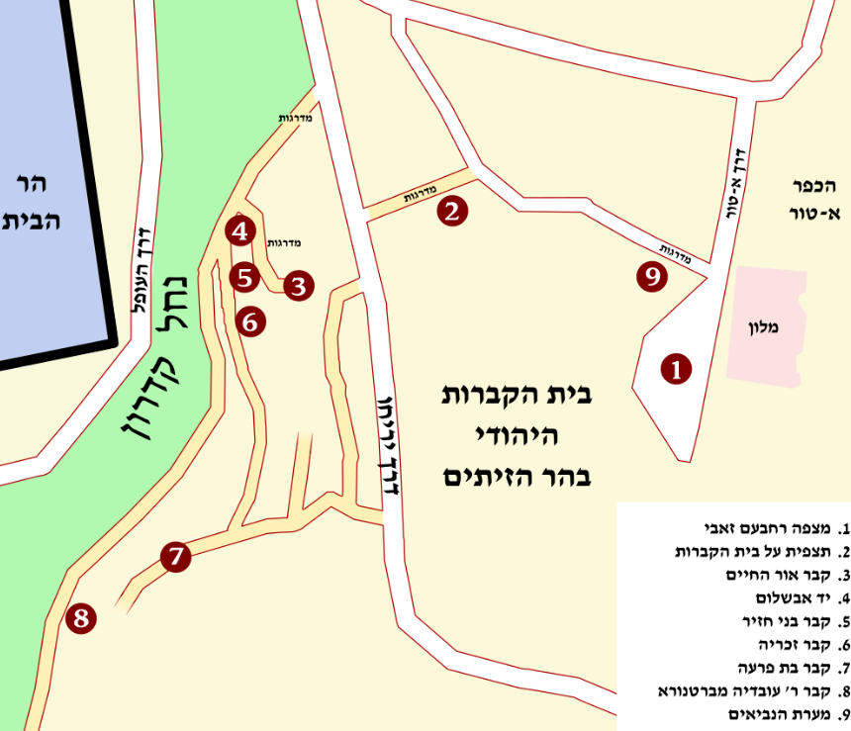

The Nahal River

The Temple Mount

Jewish cemetery in Mount of Olives

**The Jewish cemetery on the Mount of Olives**

The fact that the Mount of Olives is close to the Old City of Jerusalem and that it is built of rocks that are easy to quarry caused the Jews to choose the Mount of Olives as a burial site from the time of the First Temple (according to Jewish law, burial in the city was prohibited). The sanctification of the mountain and the traditions that developed around it led to a continuum of burial on the Mount of Olives that continues to this day.The Jews used to bury their dead on the slope below the Temple Mount, but under the pressure of the Mamluk authorities, the burial place at the Mount of Olives slopes had apparently been forced in the 14th century. The Jewish cemetery on the slope of Mount Moriah was replaced by a Muslim cemetery. In the 19th century, the Jewish cemetery began to take on a communal character, with the establishment of separate burial plots and burial societies for the various communities. Until about 1868, the cemeteries were shared by all communities - Sephardim and Ashkenazim. Then the Ashkenazim parted and bought a plot of land up the mountain to a special cemetery for the Ashkenazim. A few years later the various Jewish institutions parted and bought special plots for their own Jewish institutions.The ancient cemetery on the Mount of Olives is a national-Jewish pantheon: not only rabbis, but also intellectuals (such as writers) and public figures. Among the known figures who were buried on the Mount of Olives are the Ramban, Rabbi Ovadia of Bartenura, Rabbi Yehuda HaChasid, Rabbi Chaim Ben Attar, who headed the Yemenite community in Jerusalem and established a cemetery for the Yemenites on the Mount of Olives Mary Abraham Alandaf, Rabbi Menachem Mendel of Shklov Yaakov Shaul Elishar, Rabbi Gershon Makitub, the brother-in-law of the Baal Shem Tov, Rabbi Chizkiyahu de Silva, the Rashash the great Kabbalist in the 18th century, Rabbi Yehudah Hai Alkalai, the Virgin of Ludmir, Rabbi Yehosef Schwartz, Yoel Moshe Salomon, From Luntz, Eliezer Ben Yehuda and his son Itamar Ben Avi, Boris Schatz, Rabbi Shmuel Salant, David Yellin and his family, among them his father Yehoshua and his son Eliezer Yell , And the son of Palmach fighter Yehiam Weitz, who is named after Kibbutz Yehiam, Meir Feinstein and Moshe Barazani, Rabbi Natan Tzvi Finkel, and all the heads of the Hebron Yeshiva Rabbi Meir Zadav, the brothers Eliezer and Yeshayahu Goldschmidt, Rabbi Eliyahu David Rabinowitz, twins - the Aderet, and his son-in-law Rabbi Avraham Yitzchak HaCohen Kook alongside His father and son Rabbi Tzvi Yehuda Kook, Rabbi Shlomo Goren, and close to him his father-in-law Rabbi David HaCohen known as "the Nazirite Rabbi", Rabbi Eliyahu Eliezer Mishkovsky, R 'Chaim Dovid Rosenthal, Rabbi Avraham Shapira, Rebbe of Gur Yisrael Alter and his brother Rabbi Simcha Bunim Alter, Reuven Bareket, Cantor Yossele Rosenblatt, Ministers Chaim Moshe Shapira, Zalman Aran, Zevulun Hammer and Michael Hazani, SY Agnon, Uri Zvi Greenberg and next to him are Israel Eldad, Haim Hazaz, poet Zelda, Aharon Zeitlin, David Shachar, Eliezer Livneh, Menachem Begin, the first Rebbe of Toldot Aharon Avraham Yitzchak Kahn and more.

During the Jordanian rule (1948-1967) the cemetery was desecrated; many of these tombstones were taken and used as building materials, among other things for the construction of the tomb camp. In addition, the InterContinental Hotel (now the Seven Arches Hotel) was built at the top of the mountain, partly on top of graves, and the "Jericho Road" road, which was paved in the area of ​​the cemetery, destroyed many graves that were along the road. After the Six Day War, the Ministry of Religious Affairs renovated the cemetery and the burial site was renewed. Even today extensive areas in the Russian cemetery and the damage to tombstones and graves continue, using gravestones for the renovation of apartment floors [2]. The establishment of the Ma'aleh Zeitim neighborhood near the cemetery increased the sense of security in the area and reduced vandalism. During the years when the Mount of Olives was outside the borders of the State of Israel, Har HaMenuchot was established as an alternative cemetery for the residents of Jerusalem. Today it is difficult to buy a burial plot on the Mount of Olives due to lack of space.

**Mount of Olives in Christianity**

Mount of Olives and sites connected to the Mount of Olives in the Christian tradition are mentioned in the New Testament. A number of traditions were connected to Beit Ania, a Jewish village that was located there during the Second Temple period (today's Alazariya) on the eastern slope of the Mount of Olives. Where Jesus had resurrected Lazarus (Elazar) (John Chapter 11). The place is mentioned as a place where Jesus lived before his imprisonment. According to Lucas, Bethany is the place where Jesus ascended to heaven after he was resurrected and spent 40 days among his disciples. According to a later Christian tradition, to which Jesus would return at the end of days.

The Peggy house is mentioned in the place where Jesus cursed the fruitless fig tree. Jesus asked his disciples to bring him the city from the house of Peggy, and the village was remembered as the place from which the triumphal procession of Jesus began to Jerusalem (Matthew, chapter 21). On the Mount of Olives stood the house of Simon the leper, also mentioned in the New Testament.

The Mount of Olives is described in the Christian tradition as the place where Jesus stood weeping for the destruction of Jerusalem, the place where he predicted the destruction of the Temple and the end of the world. Gethsemane, identified at the foot of the Mount of Olives, is mentioned as the place where Jesus passed the last night before his arrest and the place where he was arrested after being betrayed by one of his disciples, Judas Iscariot.

According to Cyril's description, in 351 a shining cross appeared in the sky of Jerusalem ("a great light appeared in the sky of Jerusalem that stretched between Calvary Hill and Mount of Olives, and was visible to all the inhabitants of the city"). This light lasted several hours and aroused great excitement in Jerusalem. A late Christian tradition placed the burial place of Mary, mother of Jesus, at the foot of the Mount of Olives. Another tradition associated with Mary relates to the area on which the Seven Arches Hotel is currently built. According to tradition, in this area, known as the "shelf" or "Al Qa'ida" (the place of residence), Miriam sat to rest as she made her way to the Mount of Olives and Bethany.

**Churches on the Mount of Olives**

In the 19th and 20th centuries knowledge mountain intensive construction of churches and monasteries. This process contributed to the great sanctity of the mountain in the Christian tradition and the view from it.

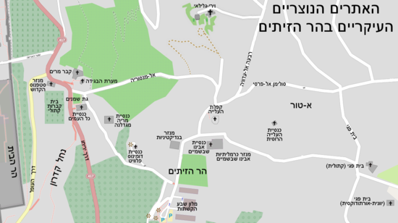

The temple Mount

Important Churches on the Mount of Olives:

Mount of Olives

• The Church of Our Father in Heaven (Peter Nostar), which is owned by the Carmelites and includes the Byzantine Church of the Alona

• Church of the Russian Aliyah

• Church of Ascension - a church that preserves the memory of Jesus' ascension to heaven; Now in the hands of Muslims

• Dominus Pluit Church ("The Lord's Cry") - a Franciscan church that preserves the memory of Jesus' lamentation of Jerusalem and the Temple

• The Church of Mary Magdalene - a Russian church established in the 19th century

• The Church of Gethsemane which is in the hands of the Franciscans and preserves the memory of the suffering and imprisonment of Jesus

• Tomb of Miriam, at the foot of the Mount of Olives in the wadi; Is now in the hands of the Greek Orthodox and the Armenians

• The monastery and the church at the Peggy house

• Church of Lazarus and his grave in Bethany

St. Abraham's Monastery on the Temple Mount.

**Mount of Olives in Islam**

According to Muslim tradition, at the end of days the scales of justice will stand on the Mount of Olives to weigh the good and bad deeds of men. The bridge over hell will be installed between the Mount of Olives and the Temple Mount, and everyone will pass over the bridge, which is numbered as the number one; the wicked will fall from him to hell and the righteous will pass him by. The bridge will begin in the a-Sahera Valley (eternal revival), located between the Church of the Galilee and the Church of the Ascension, where the resurrection will be gathered on Judgment day. (In the Middle Ages, the tradition wandered to the area north of the Flower Gate, above the Cave of Jeremiah, where a Muslim cemetery is now known as a-Sahera, and hence Bab al-Zahira). The seven arches of the former Jordanian hotel, Intercontinental, hint at this tradition because the bridge on the Day of Judgment is supposed to lean on seven arches.

## City of David

The City of David is an archaeological site where ancient Jerusalem was located from the beginning of its days, during the Middle Bronze Age, and continued to be inhabited until the middle of the middle Ages. At the end of the Ottoman period the settlement was renewed, and today the site is part of the Wadi Hilweh neighborhood of Silwan or the "City of David" neighborhood, as it is known in Hebrew since the 1990s. The site is part of the "Around the Walls of Jerusalem" National Park. The site is managed by the Israel Nature and National Parks Protection Authority and is operated under a contract by the Elad Association.

The City of David began its existence in the days of Abraham, as a fortified and impressive Canaanite city, around the famous Gihon spring of ancient Jerusalem. About 3,000 years ago, David decided to leave his hometown of Hebron and go up to Jerusalem to unite the Jewish people around a single capital city. With the conquest of Jerusalem by the Jebusites, David made it the capital of a prosperous and powerful kingdom. Shlomo, his son, established the Temple on the summit of Mount Moriah, the site of the binding of Isaac, and thus Jerusalem became a political, religious and spiritual capital for the entire Jewish people.

The visit to these ancient and impressive sites is now possible at the City of David National Park, located on a charming little hill near the Western Wall, south of the Dung Gate.

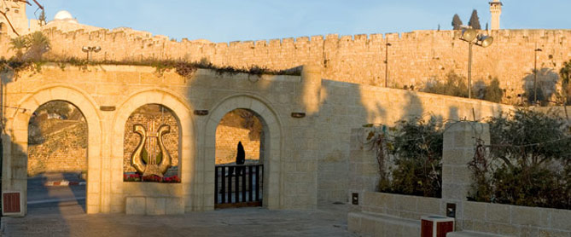

The City of David is located on the Ophel Hill, the southeastern hill of the Old City Basin. The peak of the hill is 743 meters above sea level. The hill is currently located to the south and outside the walls of the Old City, in the heart of the Arab neighborhood (Silwan village) north of the Hinnom Valley and west of the Kidron Valley.

**First Temple**

The choice to establish a settlement, let alone a city, on this hill, which is significantly lower than the surrounding mountains (Mount Scopus, Mount of Olives and the Armon Hanatziv Palace) may seem puzzling, but in the City of David the conditions necessary for the existence of a settlement in the earlier periods are largely fulfilled.

The beginning of settlement in Jerusalem during the Iron Age is described extensively in the Bible; With the entry of the people of Israel into the land and the settlement of Jerusalem was conquered twice (by Joshua Bin Nun and the tribe of Judah), but despite the conquests, the Jebusites lived in Jerusalem and ruled it. King David decides upon his conversion from the King of Judah to the king of all the people of Israel to transfer his capital from Hebron to Jerusalem. He conquered Jerusalem and made it the capital of the United Kingdom of Israel.

In the Bible, David is mentioned several times in the city.

The area of the City of David was approximately 60 dunams. In preparation for the construction of the Temple, David brought the Ark of the Covenant to the City of David, and in the last year of his reign he purchased the Goren Arona, a site known today as the Temple Mount, to build an altar on it. The altar was cut off from the city, on top of the hill. In the days of Solomon the Temple was built on the hill and the hill was added to the city. The Temple and the King's Palace were outside the populous city, and a new district was established in the north, the Ophel, with which the area of Jerusalem reached 130 dunams soon. Until the eighth century BCE it was the boundaries of Jerusalem.

After the death of Solomon, the kingdom divided into the Kingdom of Judah and the Kingdom of Israel, with Jerusalem remaining the capital of the Kingdom of Judah only. Following the Assyrian conquest of the Kingdom of Israel and the exile of the Ten Tribes, a large influx of refugees arrived in Jerusalem, spreading throughout the entire western hill, and apparently included the areas known today The Jewish Quarter and the Armenian Quarter, as well as Mount Zion outside the walls of the Old City of Hezekiah During the reign of Hezekiah the city was surrounded by a wall and Hezekiah's tunnel was dug into the city. (The Jewish Quarter of today) are not part of the City of David Time. With the destruction of the First Temple was also destroyed the City of David and the entire city.

**Second Temple**

*נחמיה מתאר בספרו: "וָאֵצְאָה בְשַׁעַר הַגַּיא לַיְלָה... וָאֱהִי שֹׂבֵר בְּחוֹמֹת יְרוּשָׁלִַם אֲשֶׁר הֵם פְּרוּצִים, וּשְׁעָרֶיהָ אֻכְּלוּ בָאֵשׁ. וָאֶעֱבֹר אֶל שַׁעַר הָעַיִן וְאֶל בְּרֵכַת הַמֶּלֶךְ, וְאֵין מָקוֹם לַבְּהֵמָה לַעֲבֹר תַּחְתָּי". בעקבות כך בנה נחמיה חומה שהקיפה חלקים מעיר דוד.*

Nehemiah A wall surrounding parts of the City of David.

Only later on when the Hasmoneans rule Jerusalem, the city expands and becomes a very large city. The Hasmoneans expand Jerusalem and return the City of David Hill as part of the city of Jerusalem, but unlike the First Temple period in which the City of David was the center of the city, the City of David becomes a poor suburb of Jerusalem, At the bottom of the hill, Jerusalem is divided into the upper city - the ancient city of today, where the rich and upper classes live, and the lower city, where the simple people and workers live, is located on the City of David hill.

The entire city of Jerusalem, along with the City of David, was destroyed in the destruction of the Second Temple in 70 CE and was not resettled until 135 CE, when the Roman emperor Hadrian established Jerusalem as a pagan Roman city and renamed it Aelia Capitolina. It seems that the area of the City of David remained outside the boundaries of the Roman city.

During the Byzantine period, the city expanded and spread to Mount Zion and the City of David. Residential buildings from the Byzantine period were exposed in the northern part of the City of David. Most of the remains from the Byzantine period lie west of the ancient gate of the City of David, Sha'ar Hagai. The residential buildings of the Late Byzantine stratum were outstanding in the quality of their construction and were well preserved.

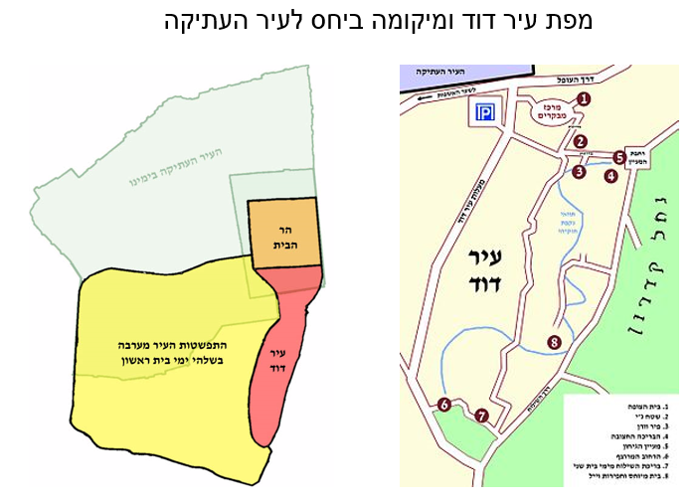

City of David

City of David

Map of the City of David in relation to the old city

***Shu'fat***

Shuafat is a large Arab neighborhood in northern Jerusalem. The Shuafat neighborhood extends along the old Jerusalem-Ramallah road, between French Hill in the south and Beit Hanina in the north. The Shuafat refugee camp lies east of the neighborhood, and is the only Palestinian refugee camp within the municipal boundaries of Jerusalem. As of 2014, the neighborhood has some 36,000 residents.

**Ancient settlement**

Archeological evidence indicates the existence of a settlement there for generations, probably dating back to 2000 BCE the archaeologist Hanan Eshel identified here the location of the city of Nov, the city of the priests, from the time of the First Temple. After the destruction of the city by the Roman authorities, shows that the area of ​​Jerusalem was not completely emptied of the Jewish population as a result of the destruction, according to archaeological evidence that the population was a well-to-do Jewish population and that this was the largest Jewish settlement of this period, , During the laying of the infrastructure Light rail project in the neighborhood of Shuafat remains of the Jewish community held in place after the Great Revolt and the destruction of the Second Temple. Work performed instead of the Israel Antiquities Authority uncovered 400 acres in the community, including residential buildings, streets, ritual baths, public buildings, as well as stone tools and coins.

A local tradition in Shuafat says that an Arab village was established there by immigrants from the Hijaz after the Muslim conquest of the Land of Israel, and since then it has existed continuously for hundreds of years.

**Period of the State of Israel**

During the War of Independence, at the beginning of 1948, Abd al-Qader al-Husseini tried to persuade the residents to attack nearby Neve Ya'akov. The villagers refused for fear of being hit by a counter-strike that would destroy their village. They said they would agree to an attack if it was ensured that "there would be real occupation." In April, the village was conquered by the Fifth Battalion of the Palmach Harel Brigade during Operation Yevusi, or April 23, 1948. The village was evacuated from its inhabitants and the Palmach force began to blow up its houses, but was ordered to evacuate and retreat due to the failure of the 4th Battalion, Samuel. [6] On 13 May, the village was evacuated by the Arab Legion, apparently for military reasons connected with the planned invasion.

The end of the war left the village in Jordanian territory and is reoccupied. In 1954, a building boom began by well-to-do Christian and Muslim families who built large houses, and Shuafat became a prestigious suburb of East Jerusalem, on the road between Jerusalem and Ramallah. King Hussein used to stay in one of Shuafat's luxury villas during his visits to Jerusalem, and in the 1960s began building his Jerusalem palace in Tel el-Ful, in the north of the neighborhood. The Six-Day War cut off construction, and the unfinished skeleton still stands at the top of the hill.

The Shuafat neighborhood was occupied by the IDF on June 6, 1967. At the end of the war, after the unification of Jerusalem and the significant expansion of its borders, Shuafat became a northern neighborhood in the united city. , Its population grew steadily, and along its main street - Shuafat Road (the northern continuation of Nablus Road) - many businesses, shops and restaurants were opened, and through the neighborhood the movement moved from the center of Jerusalem to the northern parts of Neve Ya'akov and Atarot, As a result of the reduction in traffic to Ramallah and the opening of new roads, which are preferable to its current location North of the city. Shuafat population in 2014 numbered about 33,000 people (not including the Shuafat refugee camp).

**Shuafat refugee camp**

The Shuafat refugee camp was established east of the Shu'afat neighborhood between 1966 and 1965, in order to evacuate the residents of the al-Mu'askar refugee camp located in the Old City of Jerusalem, within the precincts of the abandoned Jewish Quarter. The camp was established on land allocated to UNRWA by the Jordanian authorities, and was the last camp established for the 1948 refugees.

The camp is bordered by the Shuafat neighborhood in the west, in the Jewish neighborhood of Pisgat Ze'ev in the north, in the Palestinian village of Anata in the east, and on French Hill in the south. The fence around Jerusalem surrounds the camp to the north, west, and south, while leaving it outside of Jerusalem - despite the fact that it is officially included in the territory of Jerusalem and whose residents mostly carry Israeli identity cards. According to the UNRWA site, there are about 24,000 residents.

***Supreme Court***

**About the Supreme Court**

The Supreme Court of Jerusalem stands at the head of the judicial system in Israel and is the highest court in Israel. There are fifteen judges and two registrars. The Supreme Court is headed by the President of the Supreme Court. In this role, President Esther Hayut is currently serving as president.

According to section 20 (b) of the Basic Law: The Judiciary, "a ruling that was handed down in the Supreme Court requires every court, except the Supreme Court." This is reflected in the principle of binding precedent (in relation to lower courts) and the principle that the Supreme Court is not bound by its precedents and can deviate from them.

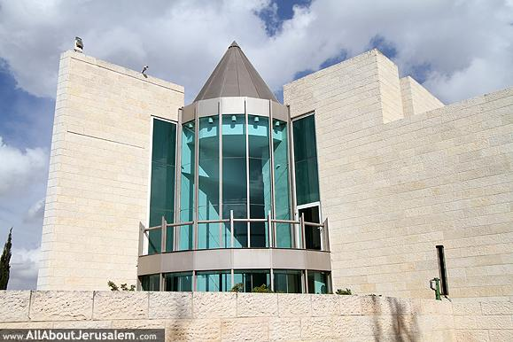

**The powers of the Supreme Court**

The Supreme Court has two parallel hats: one, the supreme appeal court in the State of Israel; The second is the High Court of Justice (HCJ), which hears petitions against various public authorities as a first instance, as well as against rulings of appellate courts.

In its capacity as the Court of Appeals, the Supreme Court discussed appeals in the right and in requests for permission to appeal, mainly on verdicts and decisions handed down by the District Courts:

1. Applications for permission to appeal civil, criminal and administrative verdicts issued in the District Courts as sitting as an appellate court and in the Military Court of Appeals; And requests for leave to appeal "other decisions" (which are not judgments) of the District Courts.
2. The authority to appeal will usually be granted in cases where a general legal question arises that deviates from the scope of the specific proceeding, as well as in cases where there is a substantial error in the judgment or in the decision.

As the High Court of Justice (HCJ), the Supreme Court discussed the petitions of every person (not only citizens or residents) against public bodies and governmental authorities, in which the Supreme Court discussed, inter alia, the following matters:

1. Constitutional and administrative petitions to carry out judicial review of the decisions and actions of the authorities;
2. Petitions directed against judgments handed down by the National Labor Court, the Rabbinical Court and other religious courts.

**A panel**

Generally, the Supreme Court sits in a bench of three judges. However, a single judge of the Supreme Court may rule on certain cases, including interim applications, temporary injunctions and requests for leave to appeal. In matters of particular importance, the Supreme Court can hear an expanded panel of a larger number of judges.

The president of the Supreme Court (and in some cases, even another Supreme Court justice) may order the existence of:

1. An additional hearing was held in an expanded panel in a ruling handed down by the Supreme Court. This authority will be exercised in rare cases where a ruling of special importance or contradicts a previous ruling of the Supreme Court has been ruled out.
2. A retrial in a criminal case that was finally adjudicated, in exceptional and rare cases in which new facts were discovered or if there was a suspicion that the defendant had suffered a miscarriage of justice.

**Quantity of Files**

Approximately 10,000 procedures are opened each year in the Supreme Court. Approximately 40% of these cases are the main proceedings, ie proceedings generally heard before the vehicle (criminal, civil and administrative appeals, petitions to the High Court of Justice), and the remaining files (about 60%) are files heard by a single judge.

***Jerusalem walls***

The walls of Jerusalem were part of the landscape of the city of Jerusalem for most of its existence. The wall was meant to protect it from enemies, and almost every time the city was conquered and destroyed, its wall was also destroyed. The wall was usually built again by the new occupier or by the city's residents. The first wall was built around Jerusalem in the Canaanite period more than 4,000 years ago, and the last one, to date, was established by Sultan I, Sultan of the Ottoman Empire, in the middle of the 16th century.

During the years between the destruction of the first wall and the construction of the last wall, many walls were built in Jerusalem. Most of the walls were built according to the natural topography of the city and its weak points, and therefore many of them have a similar route, sometimes even identical. A secondary wall was sometimes used as a foundation for the construction of a new wall, to the extent of creating walls that are sometimes composed of several layers according to periods. In the mid-19th century, with the process of leaving the walls, the wall of the city lost some of its security importance. Today, the wall serves as a tourist site and as a symbol of the Old City of Jerusalem.

**The Jebusite Wall**

Ancient Jerusalem (the city of Yevus) was established by the Canaanites in the Bronze Age on a small hill, south of the Old City of today, within the boundaries of the City of David. The small Jebusite city, about 50 dunams of its territory, was surrounded by a fortified wall, whose remnants, in the form of a wall, watchtower and gate (probably 'the' eye gate 'of the 18th century BCE) were discovered on the eastern slope of the hill.

The city of Yevus remained an enclave on the border of the Tribes of Judah and the tribe of Binyamin, after the settlement of the tribes in the days of Yehoshua Bin Nun, and therefore its wall was not destroyed at that time. According to the Bible, [2] after the city was conquered by King David and became the capital of the united kingdom of Israel, its wall was not destroyed and it seems to have continued to serve the new rulers, During the reign of King Solomon, the city's borders were expanded to the north, including the Temple Mount, and the wall was extended and encompassed the entire eastern hill of the Kidron Valley. The city.

**Hezekiah's Wall**

At the end of the First Temple period large demographic changes took place in the area of ​​ Israel state, which brought about significant geographical changes in Jerusalem: Sennacherib king of Assyria conquered the kingdom of Israel in the north, which led to the large escape of refugees to the Kingdom of Judah in the south. The city was filled to the brim and spread to the western hill, outside the narrow city walls. When Sennacherib threatened to conquer Judea, too, King Hezekiah prepared for the siege, and surrounded the western hill with the wall. The route of this wall surrounded Mount Zion to the south and west and connected to the Temple Mount along the cross river. The prophet Isaiah described how houses on the western hill were intentionally destroyed, in order to make room for the most appropriate route to the wall: and the houses of Yerushalayim were scattered, and the houses were cut to the south.

**The walls of Jerusalem during the Second Temple period**

The reason why Jerusalem has three walls surrounding the city is directly related to the development of the city. During the Second Temple period Jerusalem was surrounded by streams and valleys to the south, east and west. The Kidron Valley and the Gehenna were natural barriers to the city's development in these three directions, and therefore the city developed and was built to the north. Each time new neighborhoods were built in the city they were surrounded by a new wall, and the previous wall remained on a fence. The first wall surrounded the upper city (where the wealthy neighbors lived), and the lower city (where the lower classes lived). When Jerusalem spread to the north and a new quarter was established bordering the Temple Mount from the east, the new quarter was surrounded by another wall, the Second Wall. Later, the new neighborhood of Beit Zeita was built north of the new quarter, named after the stream near it - the Beit Zita stream. This neighborhood was surrounded by the third wall that surrounded it on all sides, and connected to the eastern wall of the Temple Mount.

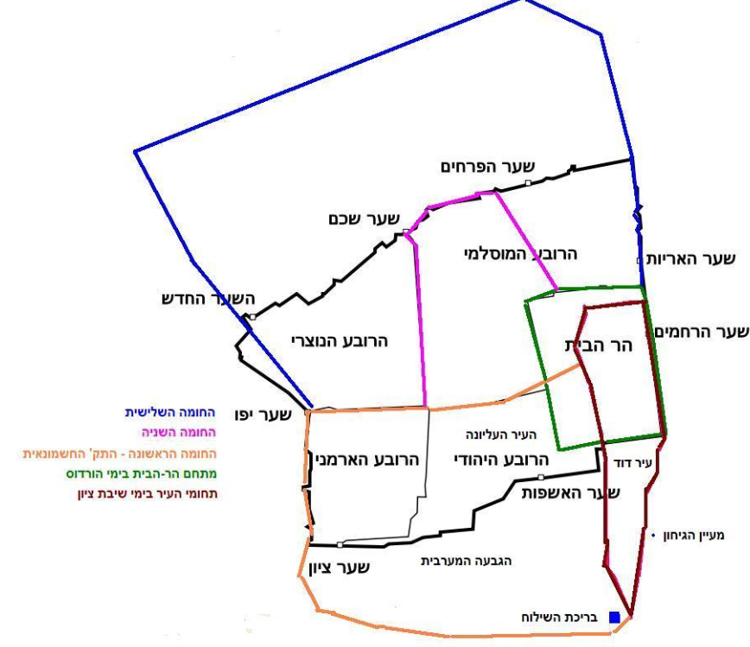

The temple mount

Christian quarter

Muslim quarter

Jewish quarter

Armenian

Quarter

The **earliest** wall from the beginning of the Second Temple period, which is not described at all by Josephus, was built by Nehemiah on the day of the return to Zion. Nehemiah, one of the leaders of the Babylonian exiles, was astonished at the description of the walls of Jerusalem, and prayed to God to help return the people of Jerusalem to Jerusalem. A short while later, King Cyrus, King of Persia, went to Jerusalem and examined the state of the walls himself. He realized that the testimony he had heard was reliable, and that the walls were so devastated that the animal on which he rode was barely able to cross the stones

:וָאָקוּם לַיְלָה אֲנִי וַאֲנָשִׁים מְעַט עִמִּי... וָאֵצְאָה בְשַׁעַר הַגַּיא לַיְלָה... וָאֱהִי שֹׂבֵר בְּחוֹמֹת יְרוּשָׁלִַם אֲשֶׁר הֵם פְּרוּצִים וּשְׁעָרֶיהָ אֻכְּלוּ בָאֵשׁ... וְאֵין מָקוֹם לַבְּהֵמָה לַעֲבֹר תַּחְתָּי.

As the years passed, the population of Jerusalem grew and the city spread again outside the walls to the western hill. Jerusalem again had the Old City on the eastern hill, and a new suburb on the western hill, which stood demilitarized without walls. In the second century BCE, with the expulsion of the Greeks from Jerusalem and the establishment of the Hasmonean Kingdom, the suburb was surrounded by a wall, so that the city returned to its full size within the walls as of the end of the First Temple period. Of the ancient wall, and to protect those topographic weaknesses, which have not changed over the years.

The period of Herod was filled with Jerusalem until it was "squeezed" between the two deep valleys - the Kidron Valley to the east and the Hinnom Valley to the west and the south. The city then spread again to the broad plain to the north of it, to the western side of the Temple Mount, across the cross river, so that once again Jerusalem became a demilitarized suburb outside the wall. The large market adjacent to the Western Wall of the Temple Mount continued to expand to the north, and a new quarter was created around the markets that were formed in the area as the trade grew. The area that developed from the west and north of the Temple Mount and adjacent to it was, during the first century BCE, surrounded by a wall that was attached as the "ear" of the Hasmonean Wall **(the "First Wall")** and extended from north to west to the Temple Mount. Attributed the construction of the **Second Wall** to King Herod, but it is possible that the builder was one of the last kings of the Hasmonean dynasty.

During the first century CE Jerusalem continued to grow toward the north, and again some of its inhabitants resided in demilitarized neighborhoods, apparently of a more agricultural nature. In the 1940s King Agrippa I came to protect the inhabitants of these neighborhoods and began building a long peripheral wall (the Third Wall). Construction was halted by order of Emperor Claudius, who feared that the fortification of Jerusalem would harm the Roman rule in the Land of Israel. The completion of the construction was done hastily only 25 years later by the residents of Jerusalem, as part of preparations for the Great Revolt. The quality of the wall as a result was much lower than planned, although there were about 90 guard towers according to Josephus. In the end, it did not stand up to the siege machines of the Romans.

The most comprehensive account of the appearance of Jerusalem at the end of the Second Temple period appears in the writings of Josephus, a military man and historian who lived in the Land of Israel at that time. In his book The History of the Jewish War, the Romans describe three walls surrounding Jerusalem, each of which protected another part of the city. [16] He calls the walls "first" or "old", "second" and "third", and in archaeological research it is still accepted to use these epithets for the walls of Jerusalem during the Second Temple period.

When Jerusalem was destroyed, its walls were destroyed to the ground. The information on the state of the city during this period is vague and fragmentary; from the sources it appears that the city was for decades destroyed and prose. Around 130 CE, the Roman general Ilyus **Hadrian** began to rebuild Jerusalem as a pagan city and changed its Jewish name to **Aelia Capitolina**. However, despite the reconstruction, no new wall was built for the city, which is evidenced by the complete absence of any finds of fortifications from the period. Jerusalem, therefore, remained prose and was only under the care of the Tenth Legion, Pratensis, who sat in it as a garrison.לאחר Adrianus defeated Bar Kokhba in the revolt in 135, and he built several gates of victory in Jerusalem, one of which stands today at the base of the Damascus Gate, but as far as is known, none of these gates were incorporated into any wall. Thus, during the centuries of Roman rule in the Land of Israel, Jerusalem was prose **without walls.**

Only in the fifth century, at the height of the Byzantine period, did a turning point occur in Jerusalem: Elia Odokia, wife of Byzantine Emperor Theodosius II, a devout Christian, ordered the construction of a long and strong wall around the city. At the same time she lived in Jerusalem, and saw in the verse "Hittibah Bironzon the Zion, build the walls of Jerusalem" (Tehillim chapter, verse 20), a divine decree calling upon her to fortify the city, for its Greek name - **Eudokia** –

The Eudokia Wall lasted nearly 600 years, deep into the Early Arab period, but was eventually destroyed by a severe earthquake that hit Jerusalem in 1033. The southern wall, which was almost completely destroyed, was particularly damaged. For several decades, Jerusalem remained without walls, and the southern part of the city (the City of David and Mount Zion) stood in ruins. The Fatimids, the rulers of Jerusalem, sought to rebuild the walls, mainly because of the fear of the Seljuk invasion of Jerusalem, but due to lack of resources and more urgent needs in the kingdom, the plans were rejected.

In 1055 the Seljuks conquered Baghdad, the capital of the Abbasids. The act stunned the countries of the region and greatly increased the urgency of rebuilding the walls of Jerusalem. The Fatimid Caliph al-Mustansir began the work and forced the Christians and Jews of Jerusalem to give their money to the project. The Christian historian William Siege says that the Christians turned to Emperor Bizanz, Constantine Monomucus, and with his help they raised the money they were required to pay.

By the end of the 11th century Jerusalem had moved from one Muslim to another; the wall was built and repeatedly broken by the Fatimids and Seljuks, until it became patchy with loopholes and repairs.

Faced with this rickety wall, the Crusaders stood in the First Crusade in 1099, breaking it up within a month alone through a few weak points. The Crusaders, who brought with them a very developed technology of building walls and fortifications from Europe, restored and strengthened the breaches in the wall of Jerusalem. In the middle of the 12th century, the Crusaders thoroughly changed the Jaffa Gate area (the "Gate of David" in the language of the period). The original gate that stood at the eastern end of the Citadel River (today - at the entrance to the market on David Street) was moved westward to the current location of the Jaffa Gate. In this manner, the Citadel River was introduced into the city and turned into a moat, which still serves the fortress. The Ottoman wall therefore "rides" on the Crusader gate. Another gate that underwent a fundamental change is the Damascus Gate: the original Fatimid gate was thickened, and even before it was preceded by a barbican, designed to ensure the perfect protection of the gate. [23] Pilgrims who visited Jerusalem at that time often described the city's walls and gates. Quite a few maps of Jerusalem were drawn at the time, and they provide a great deal of information about the appearance of the city and its walls.

The wall was strong until 1187, when it was breached and disused by Saladin al-Ayyubi. Saladin's army specialized in fighting in an open area with cavalry regiments, and therefore saw fortified walls as an obstacle rather than a means of defense. This difference between an offensive fighting technique in the open field of the Ayyubids against a static fighting technique under the protection walls of the Crusaders led to the implementation of Saladin's "scorched earth" policy and the destruction of most Crusader fortifications in Palestine in order to deter future crusades.

For 300 years Jerusalem stood in the Mamluk period prose and its walls were prostituted. The Mamluks, like their predecessors, preferred to fight cavalry in an open area, and because of their fear of a crusade they refrained from rebuilding the walls. Jewish, Christian and Muslim travelers who visited Jerusalem described Jerusalem as abandoned by its inhabitants' fear of occupation and robberies.

At the beginning of the 16th century, after the rise of Sultan Suleiman I, the Ottoman authorities decided to surround Jerusalem with a wall. Perhaps the motive was religious - they sought to glorify the Holy City, and perhaps the reason was security - to protect it from robbers and, moreover, to secure their rule against it in the face of a new crusade. Perhaps it was an economic consideration - estimated that building a wall would attract residents to Jerusalem, thereby improving its commercial and demographic situation.

The length of the Ottoman wall reaches four and a half kilometers and it closes on a square of about one square kilometer (the old city of today). Its height is about 10 meters, and its thickness is about two and a half meters on average. The wall was built quickly between 1538 and 1542, taking advantage of the route of ancient walls and secondary use of local stones. Thousands of workers, including professionals such as expert builders from Cairo, Aleppo, and Istanbul, worked under its supervision under the supervision of Muhammad Chalabi al-Nakash, a high-ranking Ottoman official who was also responsible for collecting taxes for construction. The identity of the architects who planned the wall is unknown, but an urban legend identifies their resting place with the tombs of the engineers at the Jaffa Gate. According to this legend, the two architects were executed because they forgot to include Mount Zion, which has a strategic location, along the route of the walls. According to another version, the two were killed to ensure that no other ruler could hire their services to build such a magnificent wall.

***Tower of David***

The Tower of David is the name given to the citadel which for thousands of years defended the city of Jerusalem. Despite the name of the fortress, there is no connection between it and King David, and this name was given to it thousands of years after its presumed existence.

The citadel is located in the highest place in the Old City, above the starting point of the Valley of Hinnom and the Cross River. This strategic point constituted a pretext for building a fortification in the area, in order to protect the city from the west. Throughout history, the fortress has played a central role in the city's defense, and served as a military and military center. Today there is a museum of the history of Jerusalem. The citadel is adjacent to the entrance to the wall near the Jaffa Gate.

The name "The Tower of David" originates in a misinterpretation of the writings of Josephus, as well as in the Muslim name of the citadel "Marhab Nabi Daoud" (the mihrab of the Prophet David). During the 19th century, visitors from Western countries caught the wrong name on the turret of the Turkish mosque, and the turret is still known today.

**History**

* King Herod built three watchtowers there, of which only one survived, probably the Phasael Tower, the largest of the three. During the Great Revolt, this fortress was the last point facing the Romans (the wall was split on the 17th of Tammuz, the Temple was burned on Tisha B'Av, the upper city fell on the eighth of Elul, and the tower of David fell on the 28th of Elul). On the ruins of Herod's towers, after the destruction of the Temple, the Romans established the tenth legion of the Fratensis, which was found in trenches and white archeological excavations with the seal of the Legion.
* In the early Arab period, a large fortress with an inner courtyard was built there, and the Crusaders added large halls for use by the guard corps
* During the Ayyubid and Mamluk periods, the walls of the fortress underwent massive thickening and were surrounded by huge towers. The Turks turned the fortress into a barracks, adding a cannon plaza, and in the 17th century it was adorned with a minaret (the minaret), which became a Jerusalem symbol. The Turks also surrounded the fortress in the moat, which was meant to protect it from the outside, and from the insurrection of the city's residents from within. In 1898, this abominable part was filled with soil, in the section adjacent to the Jaffa Gate, and a small section of the moat wall was removed to create a convenient passage to the carriage of the German Kaiser Wilhelm II.
* The British were the first to use the fortress for peaceful purposes, turning it into a small museum. Between the years 1921-1932, a number of exhibitions, now known as "The Tower of David," were exhibited in the building, which presented the young Israeli visual art.
* The State of Israel continued this line, and to this day the citadel serves as a cultural and tourist center.

***The Temple Mount***

The Temple Mount is a sacred compound in the southeastern part of the Old City of Jerusalem. Today, the complex is mostly flat, almost rectangular, and covers an area of ​​140 Acres and reaches a height of 743 meters above sea level at its summit.

The Temple Mount is the site where the most sacred building for the Jews - the Temple (the first and the second) - and the only place, according to Halakha , where the Temple could be housed in the future. It contains the third building in its holiness for the Sunni Muslims - the Al-Aqsa Mosque. The Jews turn to him in prayer three times a day, and pray for the establishment of the Third Temple. According to the various religious traditions, the Temple Mount is the place from which the world was created ("the foundation stone"), where the binding of Isaac was held, and mostly the commentators of the Muslim Quran, from which Muhammad ascended to heaven with the angel Gabriel on his night journey.

The Temple Mount is considered a place of high international political sensitivity, and the compound has been the backdrop to many Muslim-Jewish conflicts since the 1920s. The compound is under Israeli sovereignty, but is officially administered by the Waqf office in Jordan.

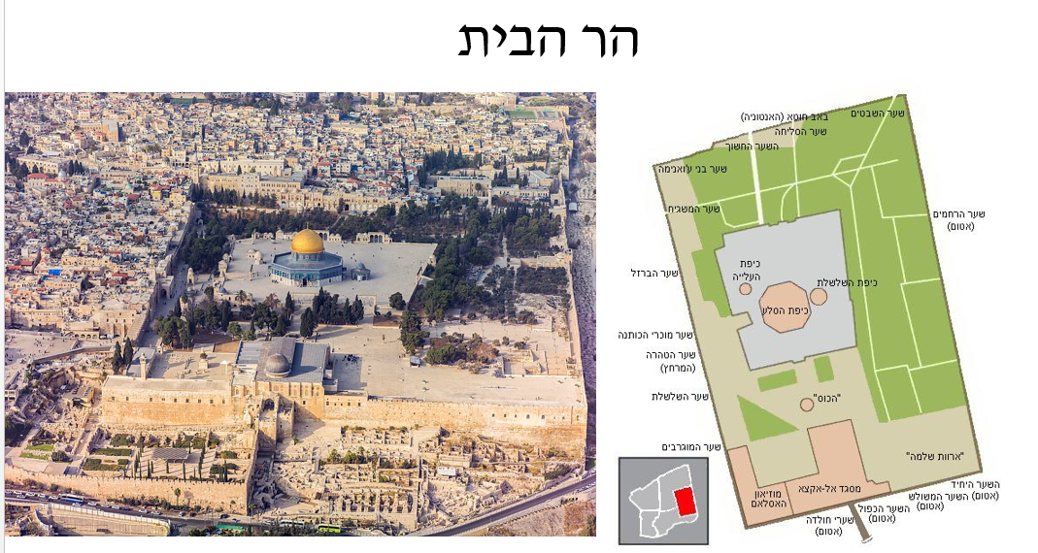

**The Temple Mount**

**Measurements**

The area that is now visible to the eye is in fact a huge building built by Herod at the end of the first century BCE and the beginning of the first century CE and was the largest sacred complex in the ancient world. The building was built to serve as a base for the temple he built on it. The bare walls of the huge building are retaining walls known as walls, the most famous of which is the Western Wall. The length of this wall is 478 meters, the southern - 277.75 meters, the eastern - 452.25 meters, and the length of the northern side is 305.75 meters and therefore the area of the complex is 135,495 square meters.

The Herodian building embraces the earlier complex and hides it. The ancient complex, according to Jewish tradition, was 500 to 500 cubits, probably built by the Hasmoneans and the Second Temple, which was called "Mount Moriah" during the First Temple period and at its peak stood the First Temple.

The Dome of the Rock, the Al-Aqsa Mosque and other secondary structures are built on the Temple Mount. The Temple Mount is divided into two main levels: the lower level, known as the "perimeter pier", is located at an altitude of 740 meters above sea level; The upper level, known as the "main surface", rises about 4 meters above the level around it, at an elevation of 744 meters above sea level. The upper level measures about 140 by 160 meters. At its center is the Dome of the Rock.

**First Temple Period**

According to the Bible, after the conquest of Jerusalem by David, King David **purchased** the vineyard of Araunah the Jebusite with great money, built an altar there, and sacrificed there to stop the pestilence that struck the people as a punishment for David's census, The Torah in the very same place (called "Mount Moriah"), according to Sefer Divrei Ha-Yamim, built his first Temple in about 967 BCE.

According to the Bible, the First Temple was built on the Temple Mount as a temple to the God of Israel by King Solomon. The Temple served as a center of ritual, religious, and national, where priests and sages were found. The structure of the Temple was based on the pattern of the Mishkan that Moses established in the wilderness of Sinai, but on a larger scale and with greater perfection and splendor. Various archaeologists have found parallels in several parameters between the temple and other temples in the ancient Levant. According to the Bible, the temple was built in certain periods during the period of King Menasseh, and the First Temple stood until 586 BCE when Nebuchadnezzar king of Babylon conducted a campaign against Jerusalem, which destroyed the city and the Temple, The vessels of the Temple and exiled the remnant of the Jewish people who remained in the land after the exile of Jehoiakin.

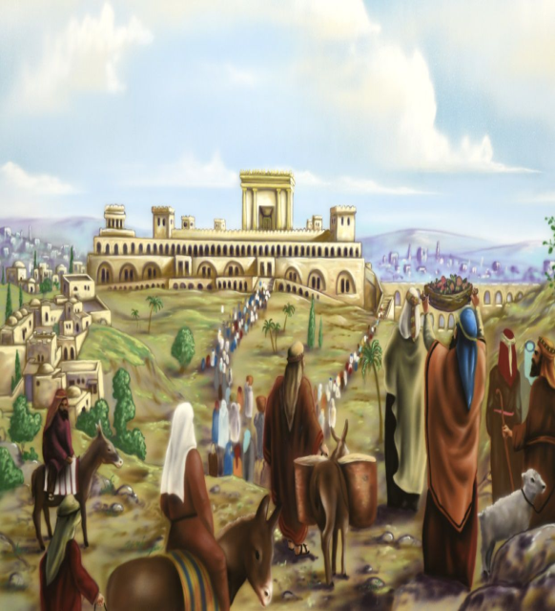

**Second Temple period until the Muslim Conquest**

Cyrus, king of Persia, who granted religious freedom to many peoples, published the Cyrus Declaration, which according to the Bible specifically mentions the rebuilding of the Temple in Jerusalem. In this declaration Cyrus allowed the return of Zion - the return of the Jewish community from its exile in Babylon to the Land of Israel.

According to the Bible, the rebuilding of the Second Temple (which was suspended in the wake of the hateful letters sent by the Writings to King Peres) was in the second year of the reign of Artaxerxes, King of Persia. According to Chazal it was in 3410 from the creation of the world, and according to the study it was in 516 BCE. The structure of the Second Temple, at its inception, was relatively small for the First Temple, and similarly, it served as a spiritual, public, legal and economic center in which the various small and large Sanhedras lived. For most of its existence there was Jewish worship, even under foreign rulers.

An exception was made by Antiochus IV, the Seleucid, in 169 BCE, when the deposed High Priest Jason attempted to reoccupy Jerusalem with the help of the house of Tuvia: Antiochus stopped the siege of Alexandria, Egypt, ascended Jerusalem and the Temple Mount, changed its name to Antioch, The Temple was transformed into a place of worship for the Greek god Zeus, a cult that included the raising of pig sacrifices, an unclean animal in the eyes of the Jews and forbidden to be sacrificed according to the Torah.This phenomenon of sacrificing a pig is one of the causes of the Hasmonean revolt, which led to Jewish independence in the Land of Israel, .

Following the inheritance dispute between the descendants of the Hasmoneans in the spring of 63 BCE, the Roman commander of Asia Minor ascended from Damascus, Gnaeus the Roman commander of Asia Minor, after deciding the question of the monarchy in favor of Hyrcanus II over his brother Aristobulus II. After Aristobulus and his followers in Serteba surrendered, his men continued to barricade themselves on the Temple Mount, which led the Romans to besiege the mountain, to set fire around it and pour batteries into the north and west of the city. And enabled the continuation of the priestly work under occupation.

In the last century of the Second Temple (in the second half of the 1st century BCE), King Herod greatly expanded the Temple Mount and built the complex that has the trapezoidal shape to this day by quarrying, building arches and retaining walls, In the center of the compound, the Temple was rebuilt as a grand and magnificent building - the crowning glory of the engineering plants in Jerusalem and throughout the world until that time.

Herod completely changed the topography of the Temple Mount area in order to expand the Temple Mount compound. Prior to the expansion, the Temple Mount was square, and its dimensions were 500 cubits on 500 cubits (250 by 250 meters). In the southern part of the Temple Mount there was a fortress (probably the Akra). Herod extended the area of ​​the Temple Mount in three directions (most of the expansion was to the south and north, and the expansion was to the west). Herod flattened the mountain that was to the north of the Temple Mount and higher than it, filled the small valley that separated them, thus enabling the construction of a straight square to the north. Herod also destroyed the structure of the southern fort to the mount (another fortress - the Antonia - was built by Herod north of the Temple Mount) and built on the arches the broad plaza**.**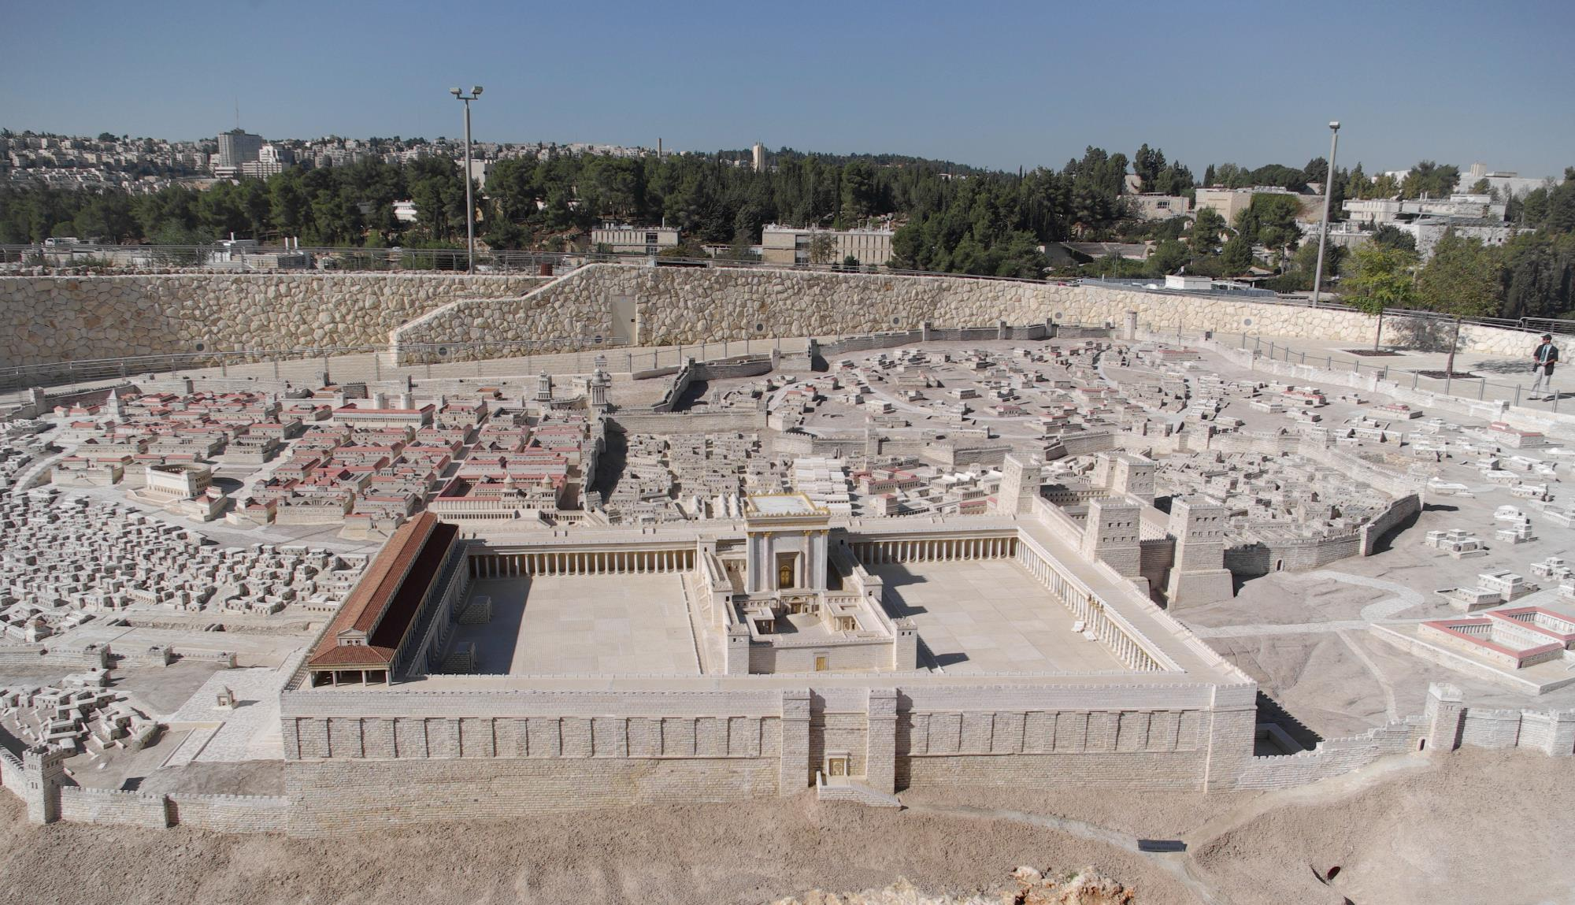

The Second Temple stood until 70 CE. This year, on the 17th of Tammuz, Jerusalem was conquered by Titus the Roman commander during the Great Revolt, which destroyed and burned the Second Temple.

According to the central opinion in the study, the Temple Mount in the Byzantine period was desolate, and even served as an urban dump. All the passengers' literature during this period does not mention any activity on the mountain, religious activity or commercial activity. In the Madaba map, the Temple Mount does not appear in the Jerusalem area, and since the size of the elements on the map reflects their importance, its absence reflects its insignificance during this period. According to the central opinion in the study, the mountain remained desolate because it had no role in the Christian story (which focused the center of holiness in the Church of the Holy Sepulcher, to which the traditions relating to the Temple Mount, such as the center of the world, wandered). The desolation of the mountain also served as evidence of the righteousness of Jesus' prophecy about the total destruction of the Jewish Temple. Remains that were found in the soil filtration project indicate that there was a hostel or church, at least for a short period of time.

**Muslims and Crusaders**

With the Muslim conquest of 638 AD, the **Muslims** began building mosques and Muslim buildings on the Temple Mount. In the south or south-east of the Temple Mount, a mosque was initially built as a structure with a wooden ceiling known as the "Jerusalem Mosque". Its exact date of construction is unknown, and certain traditions precede it until the days of Omar ibn al-Khattab. The last possible date precedes the year 679, when the monk Arculf attests that he saw a large building adjacent to the eastern wall, which can accommodate 3000 worshipers with a wooden ceiling. Recently, some scholars have suggested that the structure of Solomon's Stables be identified as the first mosque to be built in the compound prior to the establishment of the Al-Aqsa Mosque during the days of the Al-Malik and Al-Walid caliphs. Construction on the Temple Mount intensified especially during the Umayyad dynasty, led by Abd al-Malik, who founded the Dome of the Rock in 691. The original buildings collapsed due to earthquakes over the years, were rebuilt and restored. Dome of the Rock is the oldest Muslim building in the world still in use.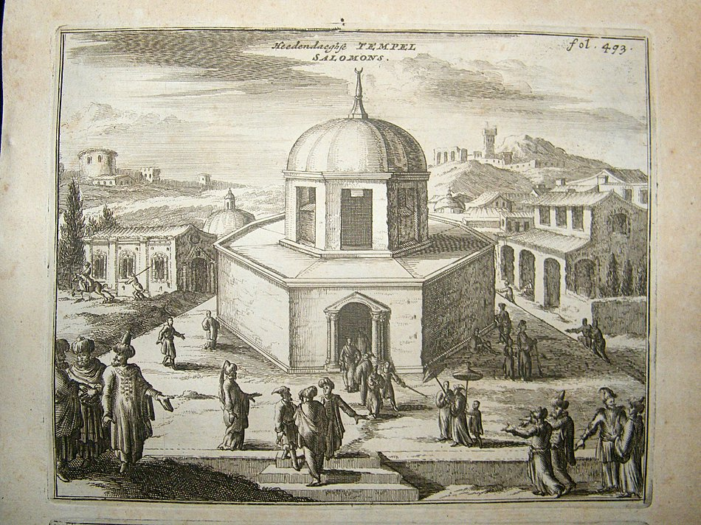

In 1099 the Crusaders conquered Jerusalem during the First Crusade. **The Crusaders** turned the Dome of the Rock into Templum Domini and the Temple of Templum Solomonis, after which the name of the Templar Order was later named (1118). Of the Al-Aqsa Mosque and their headquarters, with the palace of King Solomon. On the Dome of the Rock the Crusaders laid a large golden cross that later became the symbol of the Kingdom of Jerusalem and later the symbol of the Franciscan Order. In the southern part of the Temple Mount, they established their main headquarters in the Land of Israel, and the great space in the south-eastern corner of Mount Crow called Solomon's Stables.

After the conquest of Jerusalem by Saladin, the place returned to serve as a mosque and a Muslim religious center. However, according to the marginal status of Jerusalem in the Muslim world at the time, the importance of the place declined greatly. During the Mamluk period, elevation arches were built on the slopes of the mountain, on the exterior of the Western Wall. These arches formed the infrastructure for the construction of various structures in the area between HaGai Street and the Temple Mount. In fact, to this day, most of the Western Wall was covered under the houses of the Muslim Quarter (the Western Wall tunnels that expose this section). The Temple Mount itself was the center of the Mamluk construction activity in Jerusalem. Construction on the mount was done by the Mamluk rule, and almost no buildings were built in private personal sanctuary.

Jerusalem, and the Temple Mount in general passed to the Ottoman Empire and Sultan Selim I in 1517, without many shocks. Salim's son, Suleiman the Magnificent, was involved in construction projects around Jerusalem, the most important of which was the construction and renovation of the city wall, including the walls of the Temple Mount. In addition, the walls of the Dome of the Rock were decorated with Iznik ceramic tiles in 1552, as indicated in the inscription above the northern opening of the building. During most of the Ottoman rule, non-Muslims were prohibited from entering the Temple Mount. It was not until the end of the period, in 1839, following the Tanzimat reforms in the Ottoman establishment and legislation, that non-Muslims were allowed to enter the Temple Mount compound, but this required obtaining special permission from the city. This enabled the Temple Mount to be explored for the first time.

**From the 20th century**

With the British conquest of the Land of Israel and Jerusalem as a whole during the First World War, control over the Mount passed to a Christian state, for the first time since the Crusader period. During this period, against the backdrop of the Balfour Declaration and the Zionist rise, the Palestinian national movement developed, under the influence and inspiration of the Mufti of Jerusalem, Haj Amin al-Husseini, who received an increasingly religious character. The mufti turned the Temple Mount into one of the main symbols of Palestinian nationalism, and in his fiery speeches he often described a Zionist intention to take control of the Temple Mount. Friday sermons in the Temple Mount mosques became a central arena for inciting religious hatred, which developed into a political organization for the struggle against British rule and the Zionist settlement, and contributed to the consolidation of the Palestinian national identity. However, the Mufti did not deny the fact that the Temple Mount was the site of the Jewish Temple.

In the 1920s, the mufti initiated the renovation of the mosques on the mountain. This mission was also a means of drawing the attention of millions of Muslims to the Palestinian problem. In 1923 and 1924, the Supreme Muslim Council issued delegations to the Hijaz, India, Iraq, Kuwait, and Bahrain to collect funds for the renovation of the mosques. The delegations also emphasized that they were in danger, as it were, of the Zionists who were planning to take control of them. The response was great. The renovations continued until the end of the 1920s, and the crowning glory of the factory was a gold coating of the Dome of the Rock mosque. In addition to the basic renovation of the mosques, a religious library and an Islamic art museum were set up nearby.

The Mufti sought to establish a Pantheon on the Temple Mount for the greats of Islam, the Arab nation and the Palestinian people, and in this framework he worked to bring him to burial in the place of Maulana Muhammad Ali, the Muslim leader of India who died in London in 1931. Later in the year, a similar gesture was made to the king of Hijaz and the father of the Hashemite dynasty, Hussein ibn Ali, who died in exile in Amman. In 1934, the uncle of the mufti, the leader of the Palestinian national movement and the mayor of Jerusalem, Musa Qatam al-Husseini, was buried.

During the War of Independence in 1948, the Jordanian Legion took over the Temple Mount compound and the Old City. Following the failure of the occupation of the Old City by the IDF, the Old City remained under the control of the Legion and was transferred to the domain of the Kingdom of Jordan .The practical control over the Temple Mount was transferred to the Muslim Waqf, controlled by Palestinian clerics. The house was in front of his grandson Hussein when he was about to enter the Al-Aqsa mosque, and was assassinated by a group of Palestinian assassins who were in contact with the former mufti of Jerusalem, Haj Amin al-Husseini, in light of the resentment of the Palestinian refugees and residents of the West Bank. Extensive renovation work in the Dome of the Rock in the center of the Temple Mount, with support The dome of the Muslim world replaced the gray lead dome of the building with a golden aluminum dome, which gave the building and the entire Temple Mount the glamorous facade. In the beginning of the Six-Day War, the Jordanian Legion established a sniper position in the minaret of Al-Aqsa mosque, Too.

In the Six Day War, the IDF paratroopers conquered the Temple Mount, and their commander, Motta Gur, declared this in a statement that was engraved in the national memory: "The Temple Mount is in our hands." During the summer of 1967, Headed by Rabbi Shlomo Goren During this period, the Government of Israel, at the recommendation of Defense Minister Moshe Dayan and under various pressures, **decided to transfer control of the Muslim** Waqf area and to remove Israeli symbols of sovereignty in the area. To conduct a public struggle against this decision, but without success.

The principles of the status quo

• Religious civil administration - Waqf Jordanian.

• Jews - visitors only.

• The Israel Police - responsible for security

• Israeli sovereignty and law apply to Mt.

• The entrance of Jews - the Mujrabi only.

• The agreement will not be anchored in writing.

The Temple Mount since 1967

• 1967-1990 Overcoming difficult tests.

• 1990-2000.

• The Northern Branch.

• 2014 - Today - Morbitton Publishing, signing the Washington Agreement.

**Players and Interests:**

**The Israeli actor**

* Quiet on the Mount" in view of the understanding that this is a factor in security instability.
* Maintaining the "status quo" and allowing Jews to visit the mountain.
* Respect for Muslim freedom of worship rights.
* Strengthening the Kingdom of Jordan and its status in the Arab world.
* Preservation of a Jewish approach to the mountain, given a peace agreement.
* Tensions: Religious / Civil / Sovereignty / Strengthening Jordan ...

**The Palestinian actor**

* The Muslim religious heart in Palestine, a claim to the right of fathers and continuity in Palestine.
* Control of the third most important site in Islam - prestige and discourse in the Arab world.
* A significant card in any negotiations with Israel.
* A national and religious symbol in the Palestinian society.
* Muslim freedom of worship - the preservation of the status quo.
* Tensions: Jordanian, religious / national status.

**The Jordanian actor**

* Jordan - "Custodian of the Holy Places in Jerusalem".
* A component in the stability of the Hashemite Kingdom.
* Blocking the "Jordanian option".
* A position of strength in the negotiations to solve the "Palestinian problem" - a source of international financial assistance.
* A significant card for state security as an Israeli interest.
* Built-in tension between the people Parliament and the King.

**The Muslim Brotherhood (Islamic Brotherhood / Islamic Movement)**

* "Al Aksha in Danger" is a religious symbol that enlists the ideas and ideology of the MB.
* The accumulation of significant political power to prevent normalization between Arab society and the Israeli government.
* Blocking the idea of ​​the Jewish Temple.

**Player (Regional)**

* Harm to Israel.
* Building power against the Sunni community (Turkey).
* Crumb of the Sunni community (Iran).

**The unexpected player**

* Apocalyptic messianic.
* Changing reality by "burning" the mountain.
* Has an extreme religious interest..

***The Western Wall***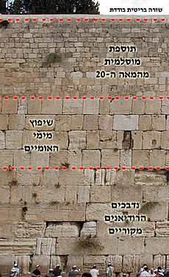 ;

The Western Wall (in short: the Western Wall) is one of the four wall The support surrounding the Temple Mount has been around for two thousand years, from the end of the Second Temple period to the present. In the Jewish tradition, the Western Wall is very holy, and it seems that already in the 14th century, a place of worship was erected next to it, which is still used today.

The Western Wall was built as part of a comprehensive renovation plan initiated by King Herod on the Temple Mount in the first century BCE. Until the time of Herod the Temple Mount was quite small and stretched over the natural area of ​​Mount Moriah. Herod extended the complex to the valleys and mountains surrounding the mountain. To support the large plaza, whose margins were planned to be above the ground, Herod built four huge retaining walls, which together formed a trapezoid structure, and in the space between them and the mountain he built arches and vaults. The Western Wall, which is the longest of the walls, extends for about 488 meters, and its original height probably reached about 30 meters above the level of the second Temple street. Due to a Muslim ban on archeological research on the Temple Mount, the thickness of the wall cannot be measured, but according to various measurements, the thickness of all the walls varies from 4 meters in the lower part to 2 meters in the upper part.

In 2011, under the first layer of the Western Wall, in the Robinson Arch area, coins were discovered that were apparently minted 20 years after the death of Herod; this discovery undermines the assertion that the Western Wall was built entirely during Herod's reign. With the end of the siege of Jerusalem and the conquest of the city by the Romans, the legionnaires destroyed the walls of the Temple Mount and dismantled the stones that formed them, until the dismantled stones covered the remaining rows.

The renovation of the Western Wall was later carried out by the Muslim Umayyad dynasty in the eighth century or by the Fatimid Caliphate

. As part of this renovation, the Muslims built a number of courses over the original Western Wall stones and re-occupied the Temple Mount.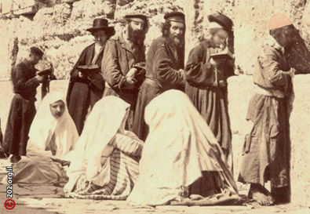 In the Bible, the place of the Temple is considered a place Holy, and even on the Temple Mount various holy laws apply. According to these laws of sanctity, various parts of the Temple Mount were forbidden to enter, not in purity or in the presence of additional special conditions. Even after the destruction of the Holy Temple still exists in those places and since it is not possible to purify oneself of dead impurity today, according to Jewish law, the entry into certain parts of the Temple Mount (the Temple area and the assistance) is prohibited by the prohibition of karet. Since for a long time Jews could not be in Jerusalem and on the Temple Mount, there was no clear tradition of where exactly the places were permitted. Prayer in front of the various walls of the Temple Mount was the closest place to which there was no doubt. Later, under various historical circumstances, the western wall of the Temple Mount received a special status (the 1875 photo

***Mea Shearim neighborhood***

Mea Shearim is an old Haredi neighborhood in the center of Jerusalem, close to the city center and the Old City. This is one of the first Jewish neighborhoods built outside the walls of Old Jerusalem. Mea Shearim was the fifth neighborhood built outside the walls of the Old City, and was then the largest and most remote. Was established by members of the Old Yishuv who leave the Old City. It was preceded by Mishkenot Sha'ananim, Camp Israel, Nachlat Shiva and the House of David.

The neighborhood was founded by the Jerusalem Builders Company. The founding group included Ben-Zion Leon, Yosef Rivlin and Yoel Moshe Salomon, who was one of the founders of Nahalat Shiva and David's neighborhoods. The group was headed by Rabbi Shlomo Zalman Baharan and Rabbi Shmuel Huminer, who built the first house there and was the first to dare to move there at night, which was one of a number of neighborhoods that were then built by an association of residents who wanted to build homes under social and economic conditions One hundred of the members of the association were far from wealthy - most of them made their living from the distribution funds, and therefore apparently purchased a plot relatively distant from the main road of Jaffa at that time - land prices were higher. , A total of about 32 dunams.

The founders of the neighborhood chose a name from a verse from the story of Toldot, which was the story of the week at the time of the founding of the group: "And Zera shall laugh in this land, and he shall find this year from the gates of the city, and the Lord shall bless him" (Genesis 26:12). The name was also chosen because "Mea She'arim" is equal in gematria to 666. This number symbolizes, according to the Vilna Ga'on, that the founders of the neighborhood were descendants of his disciples, Mashiach ben Yosef and Kibbutz Galuyot.

In the year 1890, the neighborhood included 200 houses and about 800 residents, and three years later the number of houses rose to 300 and the number of residents rose to 1,500, due to the high birth rate and waves of immigration from Eastern Europe. Became a crowded and neglected place to live in. The fact was that after the War of Independence and the division of Jerusalem, the neighborhood became a neighborhood near the Jordanian border.

Neighborhood management was entrusted to a committee which numbered 7 members and enforced the strict rules of the neighborhood. In addition to its strict adherence to the cleanliness of the neighborhood and the establishment of regulations regarding the drainage of water through gutters to the cisterns, the committee also preserved its strict character in regulations such as "It is forbidden to rent an apartment to someone who is not being held kosher." In order to prevent the fear that over time the population will change, it was determined in advance that the regulations are for generations and should not be changed.

Rabbi Shaul HaLevi Horowitz, who founded the Mea She'arim Yeshiva together with Rabbi Zerah Braverman, served as the neighborhood rabbi and head of the yeshiva during the years (1855-1835), as well as his nephew Rabbi Yosef Gershon Horowitz, In these positions for about 46 years (1855-1911). In recent years, the stores in the neighborhood have grown and Mea Shearim has become a commercial avenue. There are those who are trying to fight the phenomenon and prevent the sale of apartments to businesses.

The neighborhood now consists of an absolute majority of ultra-Orthodox Jews who belong to various streams, mainly **Hasidim and Lithuanians,** and includes dozens of yeshivas, synagogues and kolels. As of 2016, about 9,400 people live there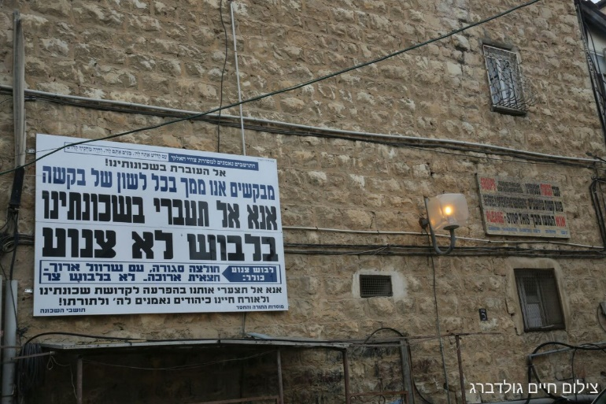 Alongside the presence of adherents associated with Agudath Israel, such as the Karlin Hassidim and Slonim Hassidim, constitutes the neighborhood Also a stronghold of the communities belonging to the ultra-Orthodox community: Toldot Aharon, the history of Abraham Isaac, Satmar and others, as well as Neturei Karta. These groups are known for their strong opposition to the State of Israel and to Zionism. They chose a way of life of seclusion and seclusion, a kind of voluntary "ghetto." The members of the Eda Haredit sometimes organize demonstrations against the "Zionist regime" against the backdrop of topics such as archeological excavations by archaeologists, the enlistment of yeshiva students into the IDF and the lack of Sabbath observance in the city

.**Religious tension**: The special nature of the neighborhood attracts groups of tourists who come to see her or buy religious books, religious objects and Judaica in stores on the main street. These visits sometimes cause friction between the visitors and some of the residents, who oppose mainly the entry of women in clothes that they perceive as immodest. On Saturdays and holidays, the neighborhood is closed to the entrance of vehicles. Egged does not enter the neighborhood due to demonstrations by an extremist minority claiming that the company violates the Sabbath. In October 2011, the High Court of Justice ruled that in the neighborhood it would no longer be possible to erect fences, stretch jute or set up private ushers to enforce separation between men and women, To the residents, who will coordinate complaints to be filed in the matter.

***Hapoel Katamon Jerusalem;***

The club was founded by Hapoel Jerusalem fans who opposed the club's management, and is the first football club in Israel owned by its fans. The club is named after a Katamon lot that was used by Hapoel Jerusalem.

The club is managed by a board of seven members, four of whom are representatives of the fans, who are elected annually in democratic elections among all members of the association, from which the committee chooses the chairman. .

Since the end of the 1990s, there has been a dispute over the ownership of the Hapoel Jerusalem team between owners Yossi Sasi and former chairman Victor Yona, and in 2007, after several unsuccessful attempts by Hapoel Jerusalem fans, A new investor who will acquire the group from Yona and Sassi, some of the fans headed by journalist Uri Sheratzky decided to buy part of the ownership of the group, through a company established for this purpose. After it failed to reach an agreement with Yossi Sassi, it was decided to establish a new alternative group. The fans turned to the management of Hapoel Mevasseret Zion / Abu Gosh from League A, which was on the verge of liquidation, and after receiving its consent, they merged it with the company that established and changed the name of the group to Hapoel Katamon.

Hapoel Jerusalem criticized the move, and some of its fans claimed that true fans do not abandon a group even when it is in a bad state. Until the start of the group's first season, the 2007/2008 season, about 1,000 subscribers were sold. The team coach was Miro Ben Shimon. The team's debut game, which took place on October 19, 2007 at Givat Ram Stadium, attracted about 3,000 fans, and ended with a 2-1 win over Hapoel Nachlat Yehuda. At the beginning of the season, the team encountered several administrative problems that prevented it from playing its home games in Jerusalem and was forced to play in other fields, but was later allowed to play its games at Teddy Municipal Stadium. The team qualified for the seventh round of the National Cup, was eliminated by Maccabi Ironi Kiryat Ata of the national league, and finished the season in second place, a point away from the first place leading to the national league.

With the founding of the group, fans of the group declared the principles of combating racism and violence and in 2015, the fans and management of the group also began to emphasize their struggle against homophobia on football fields. And the activities that were called "**The Social Initiative**" at the beginning of which they began volunteering as mentors in schools in Katamonim and Talpiot. In its second year of activity, it was expanded to include Hebrew learning among Ethiopian immigrants and the bilingual school "Hand in Hand". After that, the project expanded significantly when the group and its fans began running the Neighborhood League project, in which groups of **boys and girls from Jerusalem, Arabs and Jews**, train every week and arrive once a month for a tournament run by the team's fans and supporters. During the 2015-2016 season more than 1,000 children and children participated in the project.

Each year the group supports a tournament called "The Katamey Conquerors Tournament" organized by the Malcha Brigade (a group of fans of the group). The first tournament was attended by small groups of fans of the group, children and adults, Arabs and Jews, as well as members of the "**Social Initiative**" and veteran players from Hapoel Jerusalem who won the State Cup in 1973. The first team was made up of fans and other players. A significant portion of the audience consists of supportive families (including women and children), some of whom are members of the association.

# CVs

***Mr. Nir Hasson***

Journalist, **Jerusalem correspondent and archeologist in Haaretz.**

Born in Jerusalem**, married with three children.**

**Studied at the Hebrew Gymnasium Rehavia.**

**Holds a BA in International Relations from the Hebrew University.**

And a master's degree in geography from the Hebrew University.

In 2001 he began **working for the local weekly Kol Ha'ir** as a welfare and health correspondent.

In 2004 he moved to **Ha'aretz as the correspondent for the South**, covering the disengagement plan and the evacuation of settlements from the Gaza Strip.

Later on, he was **a law correspondent** in Tel Aviv and deputy head of the newspaper's news system.

Since 2009 he has served as Jerusalem correspondent and archeologist in Ha'aretz.

In his role as a reporter in Jerusalem, he dealt, inter alia, with the trial of former **prime minister Ehud Olmert**. Has extensively surveyed the events in East Jerusalem, including a **number of major public struggles**, including the **struggle against the settlement in Sheikh Jarrah, the exclusion of women, the ghostly apartments and the struggle of the restaurants in Jerusalem** against the Chief Rabbinate for kashrut certificates.

Published an investigative report on the **Museum of Tolerance**, which dealt with the removal of bones of Muslim deceased in the old Muslim cemetery that was part of the Mamilla cemetery for the purpose of building the Museum of Patience.

In April 2011, he published an article entitled "**Jerusalem Mateh**" which deals with the underground tunnel system in the Old City of Jerusalem.

From November 2012, he writes the **Jerusalem Blog**, which deals with stories about Jerusalem.

And in 2017 his book **"Orshalim**" - Israelis and Palestinians in Jerusalem 1967-2017

***Rabbi Dr. Binyamin (Benny) Zvi Lau***

**Rabbi of the Ramban community** in the Katamon neighborhood of Jerusalem,

**He grew up in Ramat Gan**, studied at **Yeshivat Har Etzion** and **enlisted in the service**

**Full military unit in the Golani Brigade.**

He holds a BA in **History and Talmud** from the Hebrew University,

And a master's degree and **doctorate in the halachic system of Rabbi Ovadia Yosef.**

In 1985 he **served as an educator in the joint high school in Kibbutz Yavne.**

In 1993 he and his family went on **a mission to London as Rabbi of Bnei Akiva in Europe.**

In 2000 he founded the **Beit Midrash for** Women in Beit Morasha.

In 2005 he founded the **Beit Midrash for Social Justice.**

In 2013 he began his work at **the Israel Democracy Institute** in charge of a human rights project in Judaism and is involved in accompanying public policy i**n government ministries and social organizations.**

**He heads the "929 Bible Together"** project, a Bible study project, one chapter every day.

In 2008 he received an **honorary doctorate from Bar-Ilan University.**

His method of study is based on a combination of the world of classical Torah with the world of academic research. He has written several books, including the series "Hakachim". Deals extensively with the attempt to bring the secular and religious communities closer together. The Halacha program at Beit Morasha, which he heads, is for men and women and deals with the relationship between halakha and modernity.

* He demands from the religious public full civic integration in the State of Israel.

**During the disengagement he appeared before the IDF** soldiers in order to convince them not to refuse orders and to describe to them the settlers' world view.

* In the Women of the Wall affair, it is not halakhic to wrap a prayer shawl and to put on tefillin in the hands of women.
* Call for a struggle for the right of Jews to pray on the Temple Mount.
* **On the subject of civil marriage**, he said that many Jews "choose paths of escape from the rabbinate only because they are deprived of the option of choice."
* In January 2018 he said that he **is encouraged to have a sexual tendency to establish a relationship.**

Married with six children.

***MG Yoram Halevi***

**Commander of the Jerusalem District** from February 2016.

**Born and raised in Jerusalem**.

**He joined the paratroopers** and served as a combat soldier in Battalion 202 during the First Lebanon War.

Upon his discharge from the IDF, **he enlisted in the Israel Police to serve as a combatant in the YMAT**. As commander of the team, he took part in the "Mother Bus" and in August 1989 he was wounded during a chase for a terrorist. Later he served as **a training officer and as an operations officer of the SWAT unit**.

He went on to **command the undercover unit of the Border Police in Judea and Samaria**

And later on the Gedonim unit. He later commanded the Central Unit of the Jerusalem District and in 2003 was appointed commander of the David region, which is responsible for the Old City.

In November 2005 he was **promoted to the rank of brigadier general and was appointed commander of the Border Police in Jerusalem,**

In January 2009, he was **promoted to the rank of commander of the Unit, and was also appointed commander of Lahav 433**.

In May 2010 **he was appointed commander of the Community and Civil Guard Division.**

A year later he was **appointed commander of the Border Police**. As part of his job he formulated the "**operational concept"** of the corps vis-a-vis the police districts, and carried out **organizational and structural changes.**

**In November 2012, he was appointed commander of the Southern District**. Under his command, the district faced security challenges in the Tzuk Eitan campaign.

In February 2016 he was appointed commander of the Jerusalem district. Within the framework of the position, he spearheaded a move to strengthen the response to the neighborhoods of East Jerusalem by establishing integrated service centers in the Arab neighborhoods, which combine various governmental bodies under one roof.

Was nominated for the post of police commissioner, and in December 2018 announced his **resignation from the police.**

**He holds a BA in Political Science and an MA in Education.**

**Halevi is married and has three children**.

***Dr. Shaul Arieli***

**Publicist and expert on the Israeli-Palestinian conflict,** the borders of Israel, Jerusalem and the separation fence.

Born in Ashkelon.

**In 1978 he joined the IDF** and began his long service in **the Paratroopers Brigade**.

Served as a **crew commander in the Paratrooper Company**.

A **company commander in the paratroop battalion that was parachuted into the first Lebanon war, and also wounded**.

He was then **commander of a Paratroopers Brigade**, a **battalion commander** from the Armored Corps course**. He commanded the training base of the Paratroopers Brigade and was the brigade commander.**

Upon receiving the rank of Colonel, he received command of **the northern brigade in Gaza**.

From 1997 to 1999 he served **as Deputy Military Secretary to the Prime Minister and Minister of Defense**. And headed the directorate of the interim agreement in the West Bank and as head of the permanent status administration. **In 2001 he retired from the IDF**.

Since his retirement he **has been active in a number of left-wing organizations working to advance a permanent status agreement with the Palestinians**. He is one of the **heads of the Geneva Initiative, a member of the board of the Council for Peace and Security,**

**Was involved in major petitions filed regarding the separation barrier and had a great influence on the route.**

**He is a senior researcher at the Economic Cooperation Foundation**.

In the **elections to the 17th Knesset** he was placed in the 12th place on the Meretz list for the Knesset, but was not elected.

He received a BA in Political Science and an MA in Management Sciences from the Tel Aviv University. He completed his doctorate at the Department of Geography and Environmental Sciences at Haifa **University, and his research was devoted to examining the development of Israel's borders in comparison to other conflicts in the world.**

Published a series of **articles and books**, in the field of the political process, and many articles of opinion in the press. His book "A Border Between Us and You" won the Chechik Prize for Israel Security Studies of 2013. In 2018 his new book, **"All the Boundaries of Israel"** was published.

**Married, father of three, grandfather of grandson.**

***Mr. David (Davidle) Barry;***

**Director of the Elad Association**, an Israeli nonprofit organization **that works to strengthen the organization**

**The Jewish connection to Jerusalem and the establishment of a Jewish presence**

And tourism in the City of David in Silwan and the surrounding areas.

**Born in Ramat Gan**, he studied at **Yeshivat Netiv Meir and Merkaz Harav.**

In 1973, **he enlisted in the Armored Corps as part of the Hesder Yeshiva** and later moved to Sayeret Matkal, completed an officers' course and became commander of the unit.

In 1979 he was discharged from the IDF, and for nine years **taught at the Ateret Cohanim yeshiva in the Old City of Jerusalem.**

In 1988, following the request of OC Central Command Ehud Barak, he returned to service and was **appointed deputy commander of the Duvdevan Unit.** After two years he was discharged from the IDF.

To this day, Davidella continues to volunteer for reserve duty, despite his age.

Since 1990 he has been active in renewing Jewish settlement in the City of David neighborhood, in the village of Silwan.

In 2006, with the help of ISA activity, a Palestinian terrorist attempted to assassinate him, after the terrorist failed to implement his plans to assassinate Prime Minister Ehud Olmert.

Supports maintaining good relations between Jews and Arabs and tries to minimize friction.

In 2007 he won th**e Jerusalem Prize.**

In 2017 he **was awarded the Israel Prize for Life Achievement.** According to the award committee,

The prize is awarded to him for his contribution to the state, in establishing his only factory that was a national enterprise - the City of David. The prize was given to him on the 50th anniversary of the city's reunification. He initiated, founded, led and led the blessed work that transformed the City of David into a heritage, education and national and international tourism site.

**Barry lives in the City of David in Jerusalem, married to Michal and they have six children.**

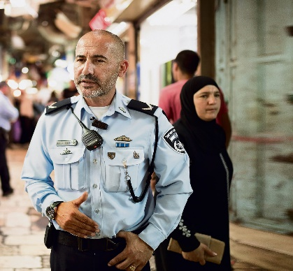

***Brigadier General (INP) Doron Turgeman***

**Commander of the Pre-District, Jerusalem District.**

He served in the IDF in the **Golani Brigade**.

After his military service he joined the Israel Police. During his service

**He held a number of senior positions in the core of the organization's operational activities**:

* Intelligence and detective officer in the Zion area
* Operations Officer of the Jerusalem District.
* Head of Operations Branch in the Jerusalem District, with the rank of Chief Superintendent.
* During the years 2010-2013 he commanded Lod Station.
* and then served as commander of the Netanya station.
* In 2015 he was appointed commander of the David District, in the Jerusalem District.

**And in July 2017 he was promoted to the rank of Brigadier General and was appointed commander** of the Pre-District.

During his service, **he received the Police Medal of Honor.**

**Married with five children*.***

***Commander Haim Shmueli:***

**Commander of the David Region.**

Born and raised in Jerusalem.

In the army, he served in the Givati unit until he became a lieutenant colonel.

He joined the Israel Police in **1993 for the Gidonim Unit**. Then he went to the tracking unit. In 2011, he was appointed commander of the Shaft station, two years later, as deputy commander of the David Region, and was promoted to commander of the pre-existing space.

Throughout his service he served in Jerusalem.

**Married with four children*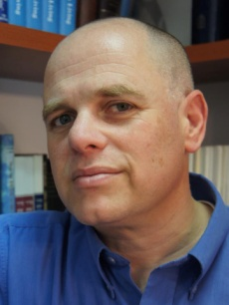****.*

***Dr. Yizhar Hess;***

**Born and raised in Jerusalem**, he studied at **the Hebrew Gymnasium Rehavia.**

He served as a combat soldier in the **Armored Corps** and as an information officer in the Education Corps

**The information unit for the commanders in Har** Gilo and was discharged from the IDF in **1990.**

He worked as a copywriter in an advertising agency and later as a journalist for the Friday newspaper.

During his studies at the Hebrew University, he joined the "Shorashim Institute"

Center for Jewish Studies, "which specialized in pluralistic Jewish practice in various fields of knowledge.

F**rom 1996 to 1999, he was the deputy director of the Institute** and one of the initiators of the Jewish Studies Festival in Kfar Blum, together with Elazar Shturm, edited the book Questions about God.

**In 2000 he set out on a mission** on behalf of the Jewish Agency in the United States. Served as community emissary and director of the Israel Center at the Jewish Federation of Tucson, Arizona.

**Between 2001 2003, he wrote a bi-weekly column in the** Jewish Jewish Post. He received an award from the Association of Jewish Centers in North America and an award from the Jewish Federation.

Upon his return to Israel he continued with the Jewish Agency and served as director of partnerships between Jewish communities abroad and regions in Israel.

Since 2007 he has served as the General Director of the Masorti Movement, and as part of his work he has taken part in promoting the Siddur and my prayer: Siddur Yisraeli, the rearrangement of the Masorti Movement.

Serves as a director of the Jewish Colonial Trust.

**He frequently publishes opinion pieces in the press in Israel and abroad**.

BA in Hebrew Literature and Political Science from the Hebrew University of Jerusalem. He holds a law degree from the Interdisciplinary Center Herzliya.

He holds **a master's degree in Jewish Studies from the Schechter Institute in Jerusalem and a Ph.D. from the Department of Philosophy of Education at Sussex University in Brighton, England.**

**Married to Colonel (res.) Yael Hess, former Head of Education at the Chief Education Officer Headquarters.**

***Rabbi Shmuel Ben Zion Rabinowitz;***

**The rabbi of the Western Wall and the holy sites**

Born and raised in Jerusalem. Studied at Yeshivat Kol Torah.

Served in the **IDF as part of the military rabbinate.**

After his military service, he was appointed regional rabbi in southwest Jerusalem.

In 1995 he was appointed by the Minister of Religious Affairs, Shimon Shitrit, to the post of rabbi of the Holy Places, and in 2000 (2000) was appointed by the Minister of Religious Affairs, Yossi Beilin, to serve as **Rabbi of the Western Wall**.

Rabbi Rabinowitz serves as Chairman of the Western Wall Heritage Foundation.

In addition, he serves in public and representative positions in various organizations and organizations:

* Was a member of the Committee for the Approval of Agreements to Carry Embryos
* Member of the Committee for Examination of Egg Donation.
* Member of the Public Council for the Environment.
* Member of the Committee for Supervision and Licensing of Burial in Israel.
* Vice President of the ELA Association for Children with Brain Injuries.
* Appointed by the Supreme Court as Chairman of the Committee for the Management of the Rashbi Tomb in Meron.

**Wrote several articles and two books**:

1) Sha'arei Zion Responsa - regarding the Western Wall and the Holy Places

2) The Western Wall - a book of customs and customs at the Western Wall.

In his capacity as rabbi of the Western Wall and the holy places, **he maintains a state line**.

**It also works to increase the publication of the Wall through interactive online sites.**

**Rabbi Rabinowitz is married to Yael and has eight children.**

***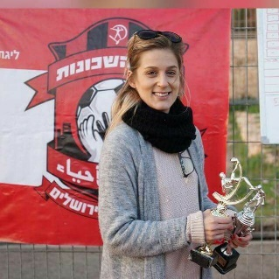Dafna Goldschmidt;***

**Dafna Goldschmidt**, aka Member of the Board of Directors of Hapoel Katamon Jerusalem Hapoel Katamon Jerusalem.

***Jacob Jackie Levy;***

**A journalist, a radio broadcaster, a television presenter,**

**A theater teacher, and a publicist**.

Born and raised in Bat Yam and later in **Kiryat Ono**.

He studied at the **yeshiva high school in Kfar Haroeh and served in the Nahal Brigade.**

For eight years **he volunteered at Kibbutz Beit Rimon**.

He **studied philosophy and theater** at the Hebrew University of Jerusalem**, taught theater at the university and is currently a theater teacher at Nissan Nativ Acting Studio** in Jerusalem.

Began his journalistic writing in the column "The Ladder of Jacob" in the local weekly Kol Ha'ir.

For nine years, he wrote a weekly column on the weekly Torah portion of Yedioth Ahronoth's "Supplement to Shabbat." And today writes a weekly column in the Shabbat supplement of Israel Today.

Has presented youth programs dealing with reconciliation and reconciliation between the religious and the secular, including the Tzav Pius program.

He submitted a travel program called "**The Wandering Jew**" on the Jewish channel "Tekhelet", and he was one of the creators and scriptwriter of the "Mixed Jerusalem" drama series.

In 2002, he began to broadcast on Army Radio the "Last Word" radio program together with Avri Gilad, and also presented the program "Jerusalem Night Birds."

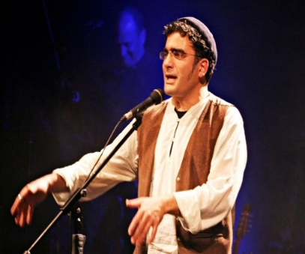Levy ran the entertainment show "**Ben Earth**".

And produced a **concert with Ariel Horowitz called "Go with them!"**

Since then, he has appeared with him throughout the country.

Since 2007, he has been directing the show "**Klevat Shabbat**".

And in 2014 he published a children's book called **Sweet Letters**.

Performs together with Merav Semen Tov in a show dealing with Jerusalem under the name **"Khovrla**".

Since 2015, **the program has been presenting a nuclear family.**

**Father of five, lives in the Katamonim neighborhood of Jerusalem*.*.**

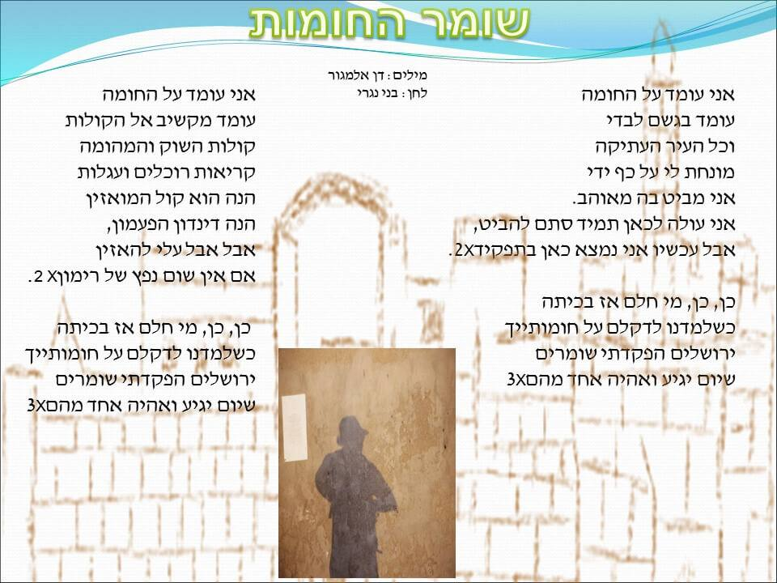

I stand on the wall

Alone in the rain

And the Old City

Lies on my palm

I stare at it, in love.

I come up here, just to look,

But now I'm here under duty X2

Yeh, who dreamt back then

When we studies your walls

I've put guards

I stand on the wall

Standing and listening to the sounds

The sounds of the market and racket

Here is the Mouasin,

The ring of the bell,

But I must listen

If there is no sound of grenades X2

Yeh, who dreamt back then?

Jerusalem, I've placed guards

One day will come and I'll be one of them

**The Wall Watchman**