January 2019

**INDC International Alumni Network**

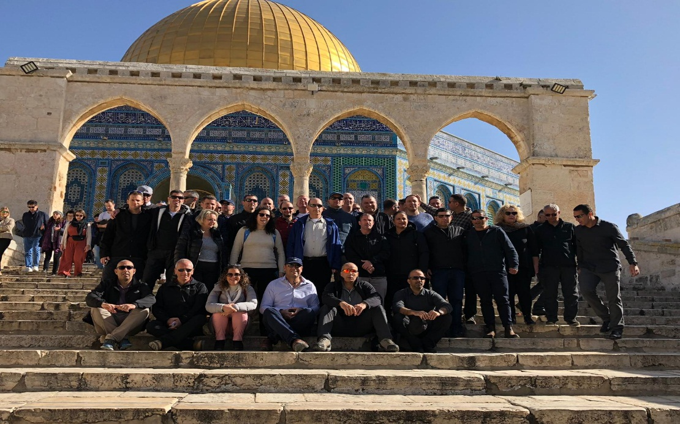

**Dear Israel National Defense College Alumni**

Warm greetings and a Happy New Year from us here at ISMO! We hope you are all doing very well. Here are some updates from us at the Military Colleges from this last month.

Our students visited the Ministry of Foreign Affairs where they met with the head of the MFA, toured through various departments, and discussed Israeli Diplomacy abroad. On the following day our students visited the Old City of Jerusalem and took part in a tour that highlighted the many sights Jerusalem has to offer. Places included in the tour were the Mount of Olives, the neighborhood of Mea Shearim, and a tour of the walls. In the evening, students were given the option to roam freely in the Yehuda Market where entertainment was available.

We started this month with the first strategic experience which was deemed a complete success and with high hopes we tackled the Economics test and the Approaches and Schools of Thought test. During the first strategic experience students were split into different groups, each group representing a different country, and the goal with this experience is to bring the students together to discuss and understand global issues. This will prepare the class for the future-to-come Political Security Simulation that they will be participating in during February.

In IDF news, a team of 130 soldiers from the Home Front Command were sent to Brazil to aid the people and the country after the Dam Collapse on the 27th of January. The IDF remains dedicated to provide humanitarian aid and assistance to its allies across the world.

With the warmest regards,

**MAJ Ido Soceanu**Head of the International Fellowship  
& International Relations Desk  
Israel Defense Forces