Subject: IDF Roster for in-country integration – JSMC K

1. The list enclosed in appendix a comprises the IDF roster for integration in Germany during TAC-1 of Exercise JUNIPER FALCON 2021, Out of JSMC-K.
2. Please note the following COVID mitigation measures we will be taking:
   1. All personnel will arrive in Germany after receiving **two** dosages of COVID-19 vaccines.
   2. All personnel will be abiding restriction on movement – essential work and life support activities, in accordance with Israeli law.
   3. All personnel will monitor medical vitals (i.e fever, COVID symptoms and etc).
3. As always, I am grateful for your ongoing cooperation and friendship. But moreover, your commitment to the assistance of the defense of Israel.

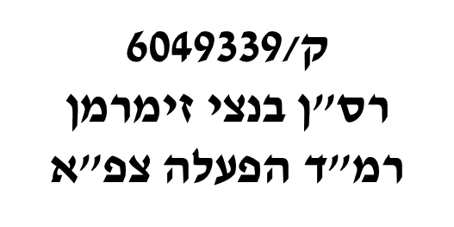

Benzi Zimmerman, Major, IDF

Head, US Operation Cooperation Desk (J53)

Copy:

* JOHN W. LECLAIR, JR., Colonel, USAF - Chief, Forces Management Division (A3F)
* Seth MacCutcheon, LtCol, USMC - Southern Flank Branch Chief and Israel Desk
* Brian R. Miletich, LTC, USA - ECJ-35 Plans, Levant Branch Chief, U.S. European Command
* Pat Vongsavanh, LtCol - ECJ7 JtrEx, JFHQ Branch Chief
* William Haag, Lt Col, USAF - ECJ7-JTrEx, Joint Training and Exercise Planner
* ALEXANDER SAYRE, GS13, DAF-C - USAFE-AFAFRICA 603 AOC / A37H
* Michael L Huff - JFHQ Exercise Branch, G37 TREX, USAREUR
* THOMAS M. HOOPER - Valiant Inte grated Services, Joint Exercise Planner, HQ EUCOM ECJ7 (JTrEx)

|  |  |  |  |  |  |
| --- | --- | --- | --- | --- | --- |
| **Security Clearance** | **DOB** | **Passport** | **Rank** | **Name** | **Location** |
| IDF TS | 30/12/1973 | 32394248 | LtCol | Tal Kaduri | JSMC-K |
| IDF TS | 26/01/1970 | 31348030 | Col | Gershon Zlotnik | JSMC-K |
| IDF TS | 19/07/1990 | 32618809 | MAJ | Ben Zion Zimmerman | JSMC-K |
| IDF TS | 8/10/1970 | 34325708 | Col | Bar Zohar Aviv | JSMC-K |
| IDF TS | 19/12/1988 | 14769951 | Maj | Rami Rahamin Mazon | JSMC-K |
| IDF TS | 15/11/1964 | 22633633 | BrigGen | Doron Gavish | JSMC-K |