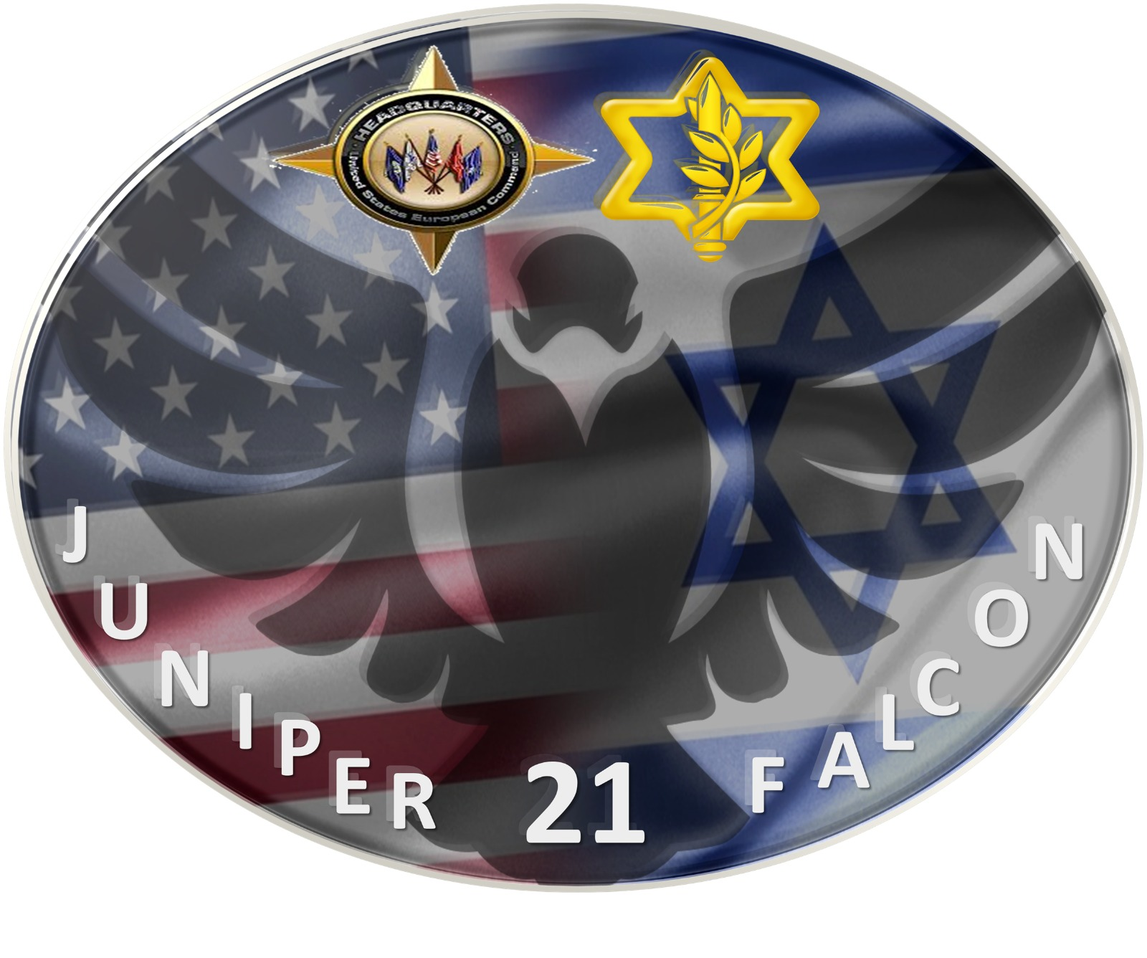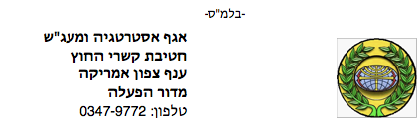

**IDF J5  
International Cooperation Unit  
North America Branch  
Operational Cooperation Desk**

**Juniper Falcon 2021**

List of Participants

|  |  |  |  |
| --- | --- | --- | --- |
| **Security Clearance** | **Birth Date** | **Passport No.** | **Name** |
| IDF TS | 30/12/1973 | 32394248 | Tal Kaduri |
| IDF TS | 09/09/1993 | 21707193 | Rimon Weiss |
| IDF TS | 26/01/1970 | 31348030 | Gershon Zlotnik |
| IDF TS | 02/08/1975 | 23648443 | Adir Avraham Brami |
| IDF TS | 17/03/1990 | 33257685 | Michael Pitchkhadze |
| IDF TS | 15/12/1974 | 31749318 | Adi Ben David |
| IDF TS | 21/10/1987 | 22194709 | Eitan Asher Cartier |
| IDF TS | 21/05/1974 | 22231319 | Sagiv Eugene Pazin |
| IDF TS | 08/08/1963 | 32487262 | Daniel Citron |
| IDF TS | 10/05/1970 | 23361454 | Gideon Freedman |
| IDF TS | 04/05/1977 | 14544195 | Tal Eisenberg |
| IDF TS | 18/04/1966 | 14160359 | Moshe (Moise) Besso |
| IDF TS | 19/09/1981 | 22699406 | Shahar Shoshana |
| IDF TS | 19/07/1990 | 32618809 | Ben Zion Yehoshua Zimmerman |
| IDF TS | 12/01/1998 | 23586441 | Gal Am-Shalom (Tzur) |
| IDF TS | 11/05/1986 | 14992458 | Lev Kolomietz |
| IDF TS | 08/10/1970 | 34325708 | Bar Zohar Aviv |
| IDF TS | 12/09/1968 | 3296600 | Barry Oren Zebrak |
| IDF TS | 25/09/1978 | 22871211 | Gil Elharar |
| IDF TS | 15/04/1970 | 32297150 | Noam Shlomo Assael |
| IDF TS | 11/09/1975 | 34585167 | Richard Hecht |
| IDF TS | 27/01/1985 | 32402486 | Gadi Gendelman |
| IDF TS | 30/09/1987 | 31702559 | Liran Bar |
| IDF TS | 29/05/1976 | 20638439 | Ram Alexander Menkes |
| IDF TS | 02/02/1977 | 33118599 | Roy Jacob Zadikov |
| IDF TS | 14/11/1984 | 32572363 | Joseph Sabag |
| IDF TS |  |  | Rami Rahamin Mason |
| IDF TS | 02/09/1983 | 22910428 | Nimrod Gross |
| IDF TS | 07/03/1994 | 22423469 | Shaked Elias Shaham |
| IDF TS | 25/06/1996 | 31800482 | Sivan Roda |
| IDF TS | 26/01/1960 | 33818405 | David Cesana |
| IDF TS | 15/11/1964 | 22633633 | Doron Gavish |
| IDF TS | 23/04/1988 | 33272654 | Alexander Milshtein |