Israel National Defense College

46th Class, **2018-2019**



**Information Booklet for the Internal Security Tour**

**Presenters: Yigal Hadad, Hadas Madmoni and Michael Shashak.**

**Guide: Eran Kamin.**

April 2019

**Police Tour**

* On April 15, 2019, a police tour will be held for the participants of the INDC.
* This tour is part of the investigation and learning of the 40th Infantry Course and the components of Israel's national security.
* This tour will focus on the role of the Israel Police in national security and will include an examination of economic, strategic, social and other aspects.
* The tour does not attempt to cover the entire activity of the Israel Police and does not pretend to present the complexity of the entire police confrontation. At the same time, we will try to touch as many topics as possible.

**The goal**

* To deepen the knowledge and discourse about the Israel Police, its role, the complexity of its service, and the understanding of the social and economic relations that bind it to society and the State and to be part of the national security of the State of Israel.
* Focus on the tour and meetings at each national security echelon that is relevant to the political, security, social and economic space, and the ability to understand and learn directly through them.

**Organizational Concept**

* Exposure to police activity in the field of global and national threats - public corruption, economic crime, international crime and cyber crime.
* Exposure to police activity in the field of global and national threats - public corruption, economic crime, international crime and cyber crime
* Familiarity with the implementation of the routine operation of the police in a situation involving the use of forces to protect personal safety, public order and quality of life, alongside direct contact with the public.

**The tour plan**

|  |  |  |  |
| --- | --- | --- | --- |
| **Hour** | **Activity** | | **Remarks** |
| **11:45** | | **Leaving the INDC by bus to Lod, Lahav 433** | Pick up at 12:00 from the ‘park and go’ parking lot and take highway 1 (fast lane) |
| **12:15-12:45** | | **Arrival and refreshments at Lahav 433** | Coordinated with Lahav |
| **12:45-13:30** | | **Opening – Head of Lahav 433 Yigal Ben Shalom** | A brief overview of the Unit's functions |
| **13:30-14:15** | | **Lecture by Chief Superintendent Sheli Harush - Unit 105** | Preventing online violence against children and youth |
| **14:15-14:30** | | **Break** | Refreshments |
| **14:30-15:15** | | **Lecture by Chief Superintendent Assaf Walpish** | Public corruption |
| **15:15-16:00** | | **Travel to the Operations Center in Tel Aviv** |  |
| **16:00-16:15** | | **Branch Head of the Tel Aviv Operations Center** | Tel Aviv District Overview: Main features |
| **16:15-17:00** | | **A visit to the Control Center in Tel Aviv in two groups** |  |
| **17:00-17:15** | | **Travel to Dr. Shakshuka in Yafo** |  |
| **17:15-18:30** | | **Dinner** |  |
| **18:30-19:00** | | **Drive to the Central Station** |  |
| **19:00-20:30** | | **A tour of the old central bus station and the activities of the station** | Division into 3 groups |
| **20:30-21:00** | | **Travel to the INDC and departure** |  |

**Introduction:**

The complexity of the role of the police and its influence on the social structure are further strengthened by the unique situation of the Israel Police. On the one hand, it reinforces within it elements of civil society, like most of the police in the western world; And on the other hand, it carries security functions that are not typical of other police, along with its police and civilian functions.

In this complex situation there is a basic difficulty in building the role of the policeman: the one in charge of carrying out police duties, and receives the authority to fulfill the mandate given to him. But the mandate given to the police is so broad and so abstract that it extends to many areas. Training is a great challenge, since a training system, however good, is limited in resources and cannot fulfill the broad range of needs.

On one hand, the policeman represents the police from the moment he wears his uniform and carries a policeman's certificate, but the policeman's entry into his position does not end with joining the organization and taking upon himself its I.D. This is a complex process in which the policeman acquires, gradually, the binding rules of conduct and the norms of the job. He integrates into the organizational structure of the police and assumes the authority and responsibility included in the position. In this process, the policeman also integrates into the value-based cultural system of the organization and the police, and shapes his views regarding his social relations with his surroundings. All these work to shape the perception of the policeman's role and to construct the patterns according to which he fulfills his role.

**Key elements of the policeman's work -**

A basic element in the role of the policeman is **the sense of mission**. **Policing is not just a profession, but a way of life. It is a role that its members fill for many years and see as the focus of their career aspirations**.

Unfortunately, the research in Israel supports the approach that the policing profession suffers from **relatively low social prestige**. Many researchers argue that the privileges granted to police officers in their capacity create an asymmetrical status balance, which generates an unsupportive and stereotypical attitude towards the policeman. The work of the policeman is often physical, often associated with contact with dirty, covered, vomited, urinated, and impugned people. The work of the policeman involves physical contact: in wrestling with people by pinning them to the floor or to the wall and by pushing them in the back seat of the police car.

An important element in the role of the policeman is the need and the authority to exercise discretion in order to make decisions in a given situation. Discretion is one of the main aspects that characterize the role, dilemmas and problems involved.

Policing in terms of maintaining public order, serving the public, and even enforcing the law involves **constantly making decisions**: defining the situations in which to intervene, the manner of intervention required, and in fact every aspect of the function required to deal with daily situations in the work of the policeman.

**This need to exercise judgment and make decisions is not optional, but rather a necessity that is an inseparable part of the role.**

**The uniqueness of the role of the policeman is that the margin of discretion in decision-making increases as the hierarchy of roles in the organization decreases, and although the exercise of discretion is a necessary necessity that constitutes an inseparable part of the position, the policeman does not have formal authority to exercise discretion.**

The policeman is expected to exercise greater discretion than his role. But he does not receive clear instructions regarding the length of the decision in the judgment.

**Mission of the Israel Police:**

**The Israel Police operates with a sense of mission to provide personal and public security to the citizens and residents of the country, and to improve their quality of life while enforcing the rule of law. The Israel Police also strives to strengthen the public’s faith in the police and safeguard the rights, dignity and freedom of all individuals**

**The values of the Israel Police:**

**The Israel Police acts to enforce the law, to prevent offenses, to strengthen the civil norm of compliance with the law, to safeguard the security of the mind and property, and to maintain public order, while respecting human rights and rights. The service of the Israel Police is based on the recognition of the state mission and the realization of identification with the values of the Israel Police and the spirit of the Declaration of Independence. The ethical code of the Israel Police is a moral and ethical compass that directs the behavior of the policeman in all circumstances.**

**Target values:**

* Protection of human life, safety and property.
* We, the policemen, will act to protect the life, safety and property of every person in the country - professionally, resolutely, wisely and courageously, whenever and wherever.
* Guarding and enforcing the law.
* We, the police, will act to enforce the law, within the framework of our duties and powers, to prevent offenses and to strengthen the norm of obedience to the law, and to conduct our proceedings in a state of law.
* Respect for human dignity.
* We, the policemen, honor every person as a person who is entitled to conduct his life freely in accordance with his worldview, within the limits of the law, and we shall do so in a state of law, equality, fairness and tolerance.

**Access metrics:**

* Responsibility and personal example: We, the policemen, will work to realize the mission of the Israel Police and will do our best to fulfill our duties and carry out our missions at all times with full success in every respect. We shall conduct ourselves in a way that is worthy of serving as an example to our colleagues and to the general at all times and everywhere.
* Honesty and integrity: We, the policemen, will be meticulous in our reliability, cleanliness and integrity and act as we would expect them to act in similar circumstances. We will act in all our ways so as to be naturally interpreted as a model for maintaining ethics, integrity and honesty.
* Service: We policemen will act as public servants, who come to protect the freedom of every citizen. We will do our best to increase the security and sense of personal security of each person and the public trust in the Israel Police.

**Performance values**

* Professionalism: We, the policemen, will act professionally, based on updated knowledge, advanced skills, integration, understanding of the organization's mission and goals, and strive for excellence in our position.
* Determination and commitment to the mission: We, the policemen, will carry out the mission at any time, everywhere, show dedication and determination. We will exercise judgment, courage and devotion, willing to take the necessary risks and strive to face the task.
* Restraint and proportionality: We, the policemen, will act as professional experts for the justified and proportionate operation of the force, within the powers given to us by law, and the means that the Israel Police makes available to us for the purpose of fulfilling the mission
* Comradeship: We, the policemen, will act as part of the team, and we will show a unique loyalty to our colleagues, in order to fulfill our duties, in every task and challenge, in routine and emergency situations, in the spirit of the law and the ethics of the Israel Police.

**The vision of the Israel Police**

**"**We will act out of a commitment to provide personal security and social security to the citizens of the state, its residents and guests, in order to provide them with quality and equal service and to improve their quality of life, together with our determined activity to enforce the law".

" Is aimed at strengthening the public's trust in the police, while protecting the rights of the individual, his dignity and his freedom, and we see the community and its leaders as partners in our way of strengthening the strength of society in Israel. "

"We shall strive together to nurture the human strengths of our policemen and commanders who constitute the source of our moral strength”

**Evaluation of the external environment of the Israel Police (2018)**

The assessment of the external environment of the Israel Police is conducted once a year, and it examines the political, social, economic, technological, environmental and legal trends in the world, the Middle East, and Israel. The purpose of the evaluation is to carry out a wide mapping to identify early phenomena and events that have the potential to have direct or indirect effect on the activities of the Israel Police in the coming years.

Evaluation of the external environment is a fundamental element in the strategic planning process of the Israel Police and must fulfill two main functions:

The study overshadows the assessed challenges of the Israel Police and their responses, in order to serve as a solid basis for the task of assessing the organizational situation and the work of the planning authorities.

**Analysis of the environmental assessment is carried out using the PESTEL model, which includes six elements:**

* Politics
* Economy
* Society
* Technology
* Ecology
* Law

Each of the six areas mentioned is examined by dividing into three circles of influence:

* The global cycle - a review of significant trends and events on an international scale
* The regional cycle - a review of events and trends in the Middle East and North Africa.
* The local circle - a review and analysis of processes taking place in the State of Israel and in Israeli society. This circle sometimes includes an explanation of the local context of an international super-trend.

**Focusing Research Directions for Policy Formation:**

**State & Politics**

An increase in violence on the Internet and an increase in political discourse

Damage to the status of human rights and strong opposition to immigration

Fluctuations in the rifts Israeli society

The victory of the right, a security agenda and political stability

Nationalism is growing stronger

Return of ethnic discourse.

**Economy and Society**

The population is aging

Generation Y and Generation Z

The proportion of the ultra-Orthodox and Arab population

Urbanization and overcrowding will intensify

New technologies will shake the employment market

**The rates of poverty and inequality are not reduced**

**Technology**

IoT is expected to continue to gain momentum

Improved capabilities and increased popularity of scavengers

Development of artificial intelligence

A change in the nature of cyber threats

**Ecology**

Climate change and extreme weather events

Traffic jams will worsen and exact a heavy price from the economy and the civilian population

Click on Natural Resources - Water and Land.

**The analysis of the environmental assessment is as follows:**

* Tools - one of the two legs on which the assessment of the organizational situation and the strategic planning of the Israel Police (along with the intelligence assessment)
* A basis for the work plan of the Israel Police, on the basis of which a policy is formulated in coordination with the Ministry of Public Security.

**Highlights of the organization's policy:**

In recent years, the weight of personal security has increased in the national strength equation. As a result, and **expanded the areas of activity and responsibility imposed on the organization**.

The foundations of a democratic society lie in its ability to provide personal security to its citizens and to promote the values of mutual partnership, the rule of law and public order, and the Israel Police considers itself to be trusted. The Israel Police sees itself as responsible for promoting a range of areas in the coming years, the purpose of which is **to increase personal security and the feeling of personal security in Israeli society**, with the aim of strengthening law enforcement, public order and sovereignty in the State of Israel.

**Strengthening Deterrence**

**The Israel Police will act with determination, impartiality and professionalism** to enforce the law. One of the most important aspects of law enforcement is **deterrence, and the Israel Police is required to act to improve deterrence against non-observance of the law.**

**The civil prevention effort**

**A central tool for improving personal safety and citizens' sense of security is the intelligent integration of the law enforcement effort**, the Israel Police and the local authorities, and the **prevention effort,** to reduce violence, anti-social behavior, drug consumption and uncontrolled consumption of alcohol through the Authority for Combating Violence and Drugs Alcohol and in cooperation with local authorities.

**Arab society and multiculturalism in Israeli society**

**The treatment of Arab society, both in terms of improving service and increasing law enforcement, will be at the center of the organization's efforts** to improve personal security in Arab society and to combat the phenomenon of crime and anti-social behavior among this population.

Israeli society is a multicultural society. **The internal security bodies must assimilate this multiculturalism in their encounters with the citizen and in the course of the training and in maintaining the qualifications of those who serve them**, so that the service given to the citizen will be equal and fair. In addition, **we will work to provide tailored service in unique communities**, such as Ethiopian Israelis, members of the Druze community and the Haredi community, with their unique characteristics.

**Expanding the Police Presence on the Streets**

**The police presence in the public sphere is a leading component of the policy.** The sense of security of Israeli citizens is of great importance in their quality of life and the presence of law enforcement agencies in the public sphere contributes greatly to the improvement of this feeling. Accordingly, the Israel Police will work to expand its presence in the field by using **foot patrols**, focusing on the relevant population centers, in accordance with the residents' time of life, while emphasizing attention to the needs of the citizens.

**Strengthening the security of Jerusalem**

**The multi-year plan to strengthen security in Jerusalem will continue**, with the aim of improving service and increasing law enforcement and governance in all parts of the city, with the emphasis on establishing integrated police centers in the eastern part of the city, establishing a technological control center, continuing the deployment of cameras in the city and strengthening personal security in the sensitive areas.

**Increased enforcement and deterrence on the roads**

Road accidents cost an expensive and painful price every year for citizens of the State of Israel. In the national effort, which consists of many areas, from infrastructure improvement to education to the public, **the Israel Police is responsible for focused and effective enforcement.**

Pedestrians, young drivers, truck drivers and motorcyclists should be monitored in order to prevent driving under the influence of drugs and alcohol and distracted driving. The Police Force aims to expand their activities in the urban and Arab sectors, and act to increase enforcement of the traffic laws.

The Israel Police will participate in the national effort within the framework of the "Shomrei Haderech (Guard the Way)" project and will work to develop technological directions that will support the strengthening of manpower and mobility.

**The struggle against property crime and agricultural crime**

In recent years, the Israel Police has achieved significant goals in the struggle against property crime. At the same time, several aspects of this phenomenon still need improvement.

**The Israel Police is required to place particular emphasis on the crime of property committed by Palestinian residents of Judea and Samaria and to focus special attention on agricultural crime,** which harms the personal security and personal security of citizens in the rural area. **As part of the response, the policing of the elected authorities will be activated.**

**Domestic violence**

The phenomenon of domestic violence, which includes cases of murder and severe violence between spouses and their children, is a very serious phenomenon that must be dealt with decisively. The Israel Police will place special emphasis on available responses and short timetables for each complaint, complete the establishment of family sections, cooperate with social welfare agencies and expand the implementation of the Police Social Worker Project and implement an electronic bracelet for the protection of threatened women.

**Proper behavior and behavior norms**

**The Israel Police and all internal security bodies must include activities of education, information and the assimilation of norms of behavior and discipline as a central component of their organizational culture**. They must deepen their ethical code and ensure that it is adapted among all those serving in their ranks. All those serving in the internal security bodies must be told that, as law enforcement organizations, **we must be a right-hand man in order to uphold the law and the proper moral standards**.

**Dealing with the Human Capital**

The employees serving in the Israel Police constitute the largest asset the internal security system has to fulfill its mission. **People are the core of activity and therefore must continue to struggle to improve their salaries and terms of service.**

**The civilian front and emergency situations**

In recent years, we have witnessed a significant change in the centrality of the civilian home front in emergency situations. The Israel Police as part of the Ministry of Public Security, through its bodies, plays a central role in the preparedness and national readiness to provide an appropriate response to these situations. **Therefore, we will work to consolidate the responsibility for managing emergency situations that require multi-disciplinary activity at the national level on the home front**, for which the Civil Defense Law does not apply under the Ministry of Public Security, and we will improve readiness and preparedness for the various emergency situations.

**Quality of life offenses**

**The Israel Police will continue its efforts to expand the municipal enforcement program ("urban policing"),** in partnership and in conjunction with local authorities, with the intention of expanding it to all state authorities**.**

**Teens**

**The focus of the Israel Police on the prevention of violence and the enforcement of the law among youth is an essential element** in instilling a culture of law-abiding by the future generation of the State of Israel. Accordingly, **the Ministry of Internal Security will become involved and will expand its prevention programs, will intensify the information and guidance regarding alcohol and drug damage, and will improve cooperation with government ministries to achieve these goals.**

**Nationalistic crime**

Nationalistic crime is a threat to governance and constitutes a blatant defiance of the rule of law in the State of Israel. **The Israel Police, in cooperation with the other security forces, will continue its focused efforts to expose, prevent, and capture violators of the law, with the aim of increasing deterrence and preventing such incidents from taking place.**

**Crime and cyberbullying**

Cybercrime and Cyberbullying pose a growing threat to the citizen's personal security. The extent of cybercrime, whether it is "new" crimes made possible by the new technology, such as computer theft and viruses, or "old" crimes that the technology allows for new ways of doing, such as pedophilia and illegal gambling, is growing. At the same time, cybercrime is expanding, including the publication of offensive images and the use of blunt language.

**The Israel Police, in conjunction with the Ministry of Internal Security's systems, with an emphasis on the National Network for the Protection of Children and Youth in the Network ("Safety Net") to increase their activity in these areas by using advanced technologies, continuing the development of the police units dealing with this matter, International action and the expansion of the range and scope of civilian prevention programs in the field.**

In this context, we must also note the growing threat of cyber attacks against which a concerted national effort has begun. **The Ministry and its bodies are required to improve the protection of the ICT infrastructure** in the face of cyber attacks, in cooperation, infrastructure and processes, among all the relevant office entities.

**The struggle against organized crime, serious crime and public corruption**

Serious crime and organized crime severely harm the personal security of the country's citizens.

The Israel Police will continue its efforts to significantly damage the crime organizations and root out the phenomenon of extortion. This is done, inter alia, by cooperating with the Prisons Service in reducing crime targeting from the prisons and with the Witness Protection Authority, which will continue to expand the ability to absorb witnesses, while continuing the activities of the combined task forces and focusing on the economic assault of crime generators and crime organizations, And other technologies as tools to eradicate this phenomenon.

The police will continue its efforts to expose crime and public corruption in various government institutions.

**Holding of weapons in the public sphere**

In addition to the uncompromising struggle against illegal weapons, additional tests will be advanced to allow the granting of a license to carry private firearms, in parallel with the expansion of training in order to increase the skills of licensees. The change in policy is carried out from a position that balances the need of the citizens to defend themselves and thus to increase security in the public sphere, and the fear of harming public security as a result of the illegal use of weapons.

In the meantime, the candidates for carrying weapons will continue to be updated, so that additional people will be able to enter the circle of eligible persons, alongside qualifying tests and expanding the requirements for training in order to increase their skills.

**Investigation of work accidents**

The number of casualties resulting from work accidents has increased in recent years. While the issue of work accidents as a whole is within the responsibility of the Ministry of Labor, Welfare and Social Services, **the Israel Police is responsible for thoroughly investigating these accidents**, **with an emphasis on accidents in which suspicion of negligence arises**. The Israel Police will increase its activity in this area, with the aim of creating deterrence and reducing the number of accidents, with an emphasis on those taking place at the construction sites.

**Improving services provided to the citizen**

Residents of the State of Israel look to the Israel Police in anticipation of receiving service and response at the highest level. Broadly speaking, **compliance with the law in a democratic society cannot be based solely on deterrence**. The public values ​​the legitimacy of the police and internal security agencies, both on the basis of their actual performance and on the basis of the **fairness of the proceedings** they are taking. The more the citizen comes into contact with the Israel Police, will feel that the processes through which they implement the policy are fair, his confidence in the Ministry and its bodies will increase. At the same time, it is very important that citizens be able to express their position before making a decision on the matter, neutral, discriminatory and transparent in the decision-making process, the respectful and courteous attitude of those who come into contact with the citizens and the sense of concern for their welfare and quality of life.

**Therefore, improving the service to the citizen** is a goal of the Israel Police, with the aim of providing the citizen with better, **more quality and available services.**

At the same time, we will work to make the services available, both physically and online, and increase the transparency and exposure of the organization's activities and bodies, in order to establish a process of fairness in all of the firm's activities.

**Public trust in the law enforcement system and increased transparency**

Public awareness of the activities of the Israel Police and the public's trust in it as a law enforcement agency are a necessary condition for our success in realizing the work plan, goals and organizational goals.

Therefore, **the Israel Police will work to formulate and implement a system-wide plan for the citizens of the State of Israel**, with the aim of increasing their confidence in the law enforcement system.

In order to mitigate the friction potential inherent in the encounter between a policeman and a citizen, and to increase transparency, **the implementation of the body cameras project will be promoted by the Israel Police.**

**Israel Police - Identity Card**

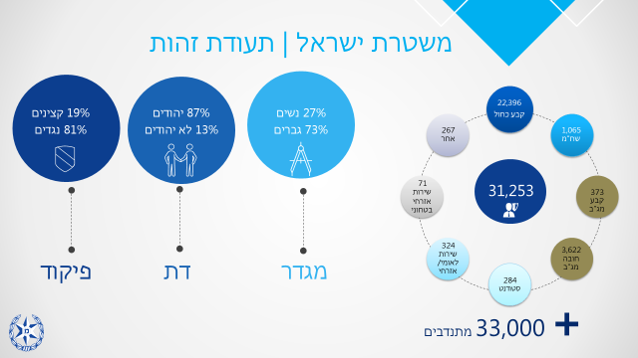

**Volunteers**

**National Civil Service**

**Civil defense service**

**Blue Contract**

**Magav( Contract)**

**Magav (Duty)**

**Students**

**Different**

**Shaham**

**NCO’s 81%**

**Officers 19%**

**Non Jews 13%**

**Jews 87%**

**Woman’s 27%**

**Men’s 73%**

**Command**

**Religion**

**Gender**

**Israel Police / ID**

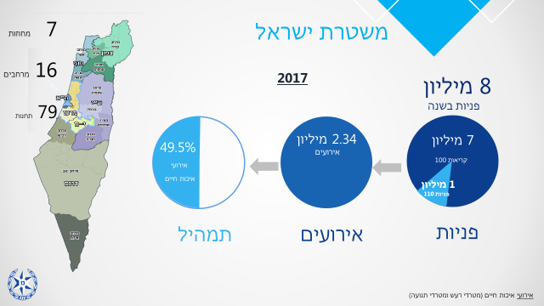

**49.5% of life quality events**

**7 Million 100 calls**

**Israel Police**

**2.34 Million Events**

**Mix**

**Events**

**Applications**

**8 Million Applications Each Year**

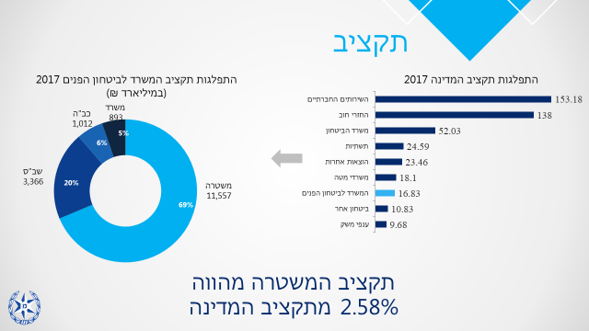

**Social services**

**services**

**Translations of services**

**NounFrequency**

**חֵילוֹת הַצָבָא**

**services**

**See also**

**service**

**Other Expenses**

**Headquarters offices**

**Different Security**

**The police budget constitutes 2.58% of the state budget**

**Distribution of the budget of the Ministry of Internal Security 2017 (NIS 1 billion)**

**Ministry of Public Security**

**Economic sectors**

**Infrastructure**

**NounFrequency**

**חֵילוֹת הַצָבָא**

**services**

**See also**

**service**

**Ministry of Defense**

**services**

**Translations of services**

**NounFrequency**

**חֵילוֹת הַצָבָא**

**services**

**See also**

**service**

**The holes are in debt**

**services**

**Translations of services**

**NounFrequency**

**חֵילוֹת הַצָבָא**

**services**

**See also**

**service**

**Distribution of the State Budget**

**Budget**

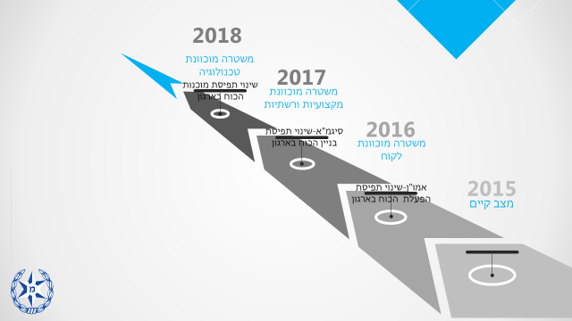

**Police degenerate technology**

**Professional police and networks**

**Client - oriented police**

**services**

**Translations of services**

**NounFrequency**

**חֵילוֹת הַצָבָא**

**services**

**See also**

**service**

**Current Situation**

**services**

**Translations of services**

**NounFrequency**

**חֵילוֹת הַצָבָא**

**services**

**See also**

**service**

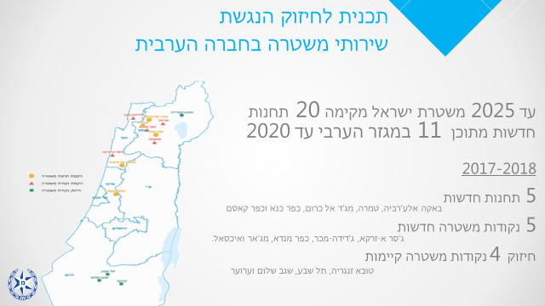

**Strengthening 4 existing police points**

**New police points**

**New stations**

**Until 2025, the Israel Police will establish 20 new stations in the Arab sector by 2020**

**Program for strengthening accessibility**

**Of Police services in the Arab society**

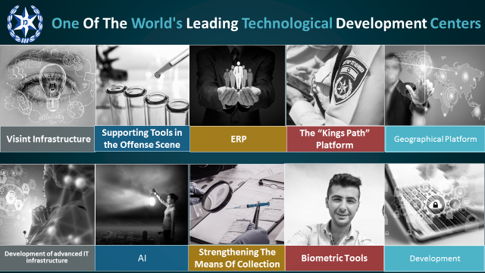

**Organizational Structure**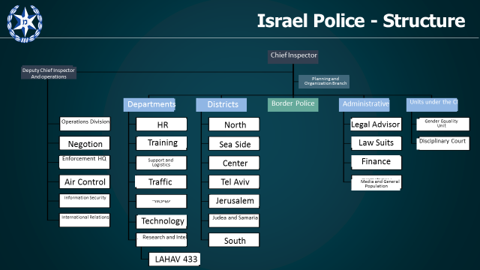

**Summary of the tour locations**

**Lahav 433**

Lahav 433 is an Israeli crime-fighting national organization within the Israel Police, created on January 1, 2008. Known as the "Israeli FBI", the unit is the merger of five law enforcement offices into one. It was established as an initiative of then-Minister for Public Security, Avi Dichter, and the Head of Police's Investigations Branch, Yohanan Danino.

It is tasked with investigating national crimes and corruption.[1]

The number four is for the four region departments that form the unit while the number 33 is for The Gideonites, a Mista'arvim unit. The Unit's Headquarters is located in the North Industrial Zone of Lod. The current chief commander is Yigal Ben Shalom, since March 2001.

**Vision**

The unit leads a systemic struggle to reduce the serious national, international, and public corruption phenomena and a determined struggle against crime organizations in order to protect public safety and security. The unit operates with unified forces and advanced methods of exposure, investigation and prosecution of perpetrators.

**Structure**

The Lahav 433 unit consists of six national units: the National Unit for Serious and International Crimes Investigation, the National Unit for Economic Enforcement, the National Unit for Fraud Investigation, the Identification and Perception of Vehicle Thieves (ATGAR) Unit 33 ("the Gideonites") and the cyber units.

Task Forces - Lahav has six task forces in which police officers are stationed alongside other enforcement authorities and work together on matters of interest determined by the Standing Committee.

Unit 105 (Maor) - The unit was established following the government's decision in January 2016 (1006) to establish a national system for the prevention of violence and crime against minors in the online space. The organization will work to implement the national policy on the subject by means of investigation and intelligence divisions and a national focal point where representatives from all the partner ministries will be integrated: internal security, education, welfare, health and law.

Lahav Headquarters - responsible for a number of areas that assist and facilitate the activities of the units in routine and emergency situations: operations (operational coordination and operation of a control center), technologies (communication and computer services, development of means), legal advice Logistical support (fleet of vehicles, catering, handling of equipment, etc.), human resources (power building, preservation, cultivation and development), security officer (security of the facility, field security and security classification.)

**Deputy Commissioner Yigal Ben Shalom – Lahav 433 Commander**

Yigal was born in 1964.

Ben Shalom joined the Israel Police - Tel Aviv District for the Central Unit.

He served as a researcher and head of the investigation unit in the Central Unit of the Tel Aviv District. Later, he served as the head of the Polling Unit of the Central Unit of the Southern District and head of the Investigations Division in the Central Unit of the Central District. During his time as head of the division in the Tel Aviv Central Command, he captured Benny Sela, known as the "serial rapist." During his time as head of the Central District Division, he headed a team investigating the murder of Rose Pizam.

In 2009, he was promoted to the rank of Commander and head of the infrastructure arm of the National Unit for Combating Economic Crime.

In 2010 he was appointed head of the Central Unit of the Central District. In 2014 he went to the INDC and in 2016 was promoted to Assistant Commissioner and was appointed head of the National Crime Investigation Unit and Deputy Head of Lahav 433.

In 2018 he was promoted to the rank of Major General and was appointed commander of Lahav 433.

Ben-Shalom holds a BA in Middle Eastern Studies, a Master's degree in Middle Eastern Studies and Political Science, and a graduate of the INDC. He is married and has two children.

**ID Sharet Station**

1. **The Sharett station is one of three stations in Yiftah area**
2. **Responsible for the South Tel Aviv area, including the Montefiore Neighborhood, Shapira, Neve Sha'anan, the Old Central Bus Station and the Old City.**

**The boundaries of the station are between Ayalon Highway in the east and Aliyah Street in the west and between Azrieli Towers in the north and Kibbutz Galuyot in the south.**

1. **Manpower Directorate**

**A total of 195 policemen at the station include 19 officers and 50 border policemen.**

|  |  |  |  |
| --- | --- | --- | --- |
| **Transport Department** | **Deputy Commander of the Station** | **Operations Branch** | **Investigations and Intelligence Division** |
| **Bureau of the Manpower Directorate** | **Management Offices** | **Patrol** | **Investigations** |
| **Office** |  | **Foot patrol** | **Intelligence Centers** |
|  |  | **NCOs** | **Detectives** |
|  |  | **Special Forces Patrol** | **The Evaluation Office** |
|  |  | **Operations** |  |
|  |  | **Recruits** |  |
|  |  | **Reinforcements** |  |

**General Data**

* **6074 Investigation files**
* **Service center for citizens - 6572 applications**
* **35,000 tour events**
* **An average of 2300 detainees per year**

**Significant characteristics at the station**

* **Old and new Central Bus Station**
* **Haganah Train Station**
* **Levinsky Park**
* **Leisure clubs**
* **Prostitution**
* **Bikes**
* **The issue of foreigners**
* **Adulan Distribution Center**
* **Neve Sha'anan**
* **Juvenile court and labor matters**
* **soup kitchens, drug trafficking, aid organizations**

**4. Population surrounding the Station**

|  |  |  |
| --- | --- | --- |
| Foreign population –Sudanese, Eritreans, Philippines, NIGERIANS | Some minorities are staying illegally | **Homeless** |
| **Drug Addicts** | **Elderly Populations** | **Rehabilitated General Security Services** |
| **Low socioeconomic status** | **High socioeconomic status** | **LGBT+ population** |

**5. Foreign main characteristics**

* **Most of them work in temporary / permanent jobs in the Tel Aviv metropolitan area.**
* **With families - usually stay in South Tel Aviv Shapira neighborhoods and Hatikva neighborhood.**
* **Most of the young people concentrate on the old central bus station.**
* **Most foreign nationals (Eritreans) do not have a license / driving vehicle.**
* **There is an increasing trend in drug use and trafficking - NICE Gay.**
* **Since the closing of the sand facility, there has been an increase in violence and street bullying.**
* **There is a trend of "acclimatization" within an Israeli community / society.**

**6. Crime phenomena**

* **drug dealing**
* **Robbery events focus on the crime of foreigners**
* **Criminal offenses**
* **Violent events**

**7. Unique activity**

* **Extensive community activity**
* **On robbery and drug buying**
* **Governance activities in cooperation with the Tel Aviv Municipality**
* **Models including "combining hands" with all government ministries**

1. **Challenges 2019**

* **Crime of foreign youth**
* **Trade in NICE GAI and its effects**
* **Creation of governance**
* **Supportive violent events and opponents of Eritrean rule**
* **Expanding intelligence among foreigners**
* **Cultivation of human resources**

**The Tel Aviv district of the Israel Police**

The Tel Aviv District is an urban district that bears territorial responsibility for the city of Tel Aviv and the surrounding cities (Gush Dan). In his area of responsibility, 22 local municipal authorities.

The geographical area of the district is the smallest of the police districts but it has the highest population density, with 1.2 million inhabitants in the district and about 1 million people entering and leaving the area every day (commuters).

**Map of the Tel Aviv District and its units**

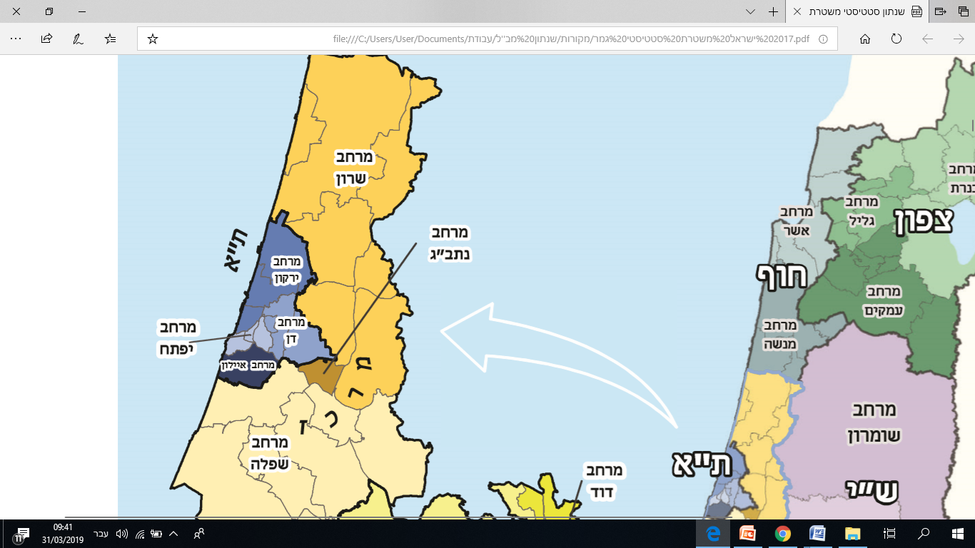

**Shfela District**

**Yiftach District**

**Dan District**

**Yarkon District**

**Sharon District**

**Tel Aviv**

**District units**

In the Tel Aviv District there are approximately 3,000 police officers and police officers, and includes 4 districts and regional units:

Yarkon District - Responsible for the center and north of Tel Aviv, Herzliya, Ramat Hasharon, Kfar Shmaryahu and Rishpon.

Dan Region - Responsible for Ramat Gan, Bnei Brak, Giv'atayim, Yehud, Kiryat Ono, Or Yehuda, Ganei Tikva, Givat Shmuel, Ramat Efal, Kfar Azar, Ramat Pinkas.

Yiftach District - Responsible for South Tel Aviv, Jaffa and Central Station area.

Ayalon District - responsible for the cities of Holon and Bat Yam.

Central unit (district) - responsible for the treatment of serious criminal offenses and criminal organizations throughout the district.

**Crime in the Tel Aviv District**

The volume of crime and indictments in the Tel Aviv District relative to the other districts of the Israel Police 2017: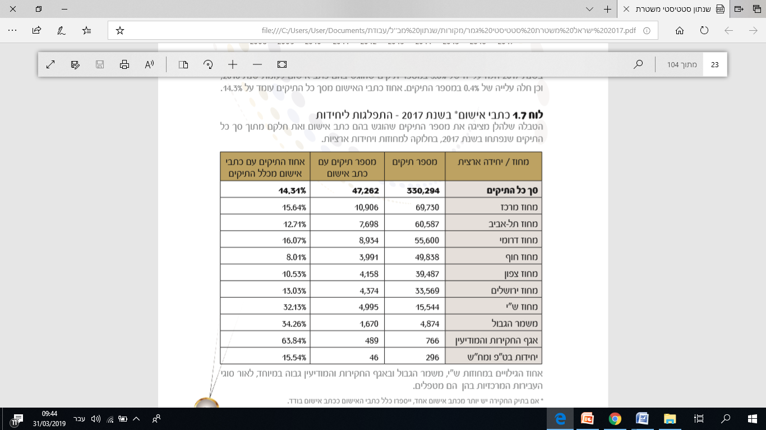

**West Bank District**

**Department for the Investigation of Police**

**Investigations and Intelligence Division**

**Border Patrol**

**Jerusalem District**

**North District**

**Beach district**

**Southern District**

**Tel Aviv District**

**Total cases**

**Central district**

**Percent of files with indictments out of all cases**

**Number of files with indictment**

**Number of cases**

**District / national unit**

**From the Statistical Abstract of the Israel Police.**

The crime in the Tel Aviv district is consistent with crime characteristics in an urban district, and includes numerous street crimes involving violence, property and public order, due to the high rate of daily commuters, a large proportion of those suspected of offenses are not residents of the district. There is a clear link between areas characterized by low socioeconomic status and crime rates.

In addition to street crime, the district handles serious and organized criminal offenses through the Central District and District Unit. This crime includes murder, drug trafficking, trafficking in arms, and more.

The District Fraud Unit handles "white collar" offenses and fraud and fraud offenses.

**Public order and movement**

The Tel Aviv District is characterized by many events that require extensive deployment for security and public order, including demonstrations, parades, entertainment shows, sporting events and more.

Controlling the district forces and dispatching the vehicles to events according to public calls, a high-tech provincial focus is being conducted and skilled manpower. The center operates advanced systems for event planning, connecting to cameras in the public space and providing real-time intelligence to a police force operating in the field.

**Calls to the Tel Aviv Police Department regarding the other districts:**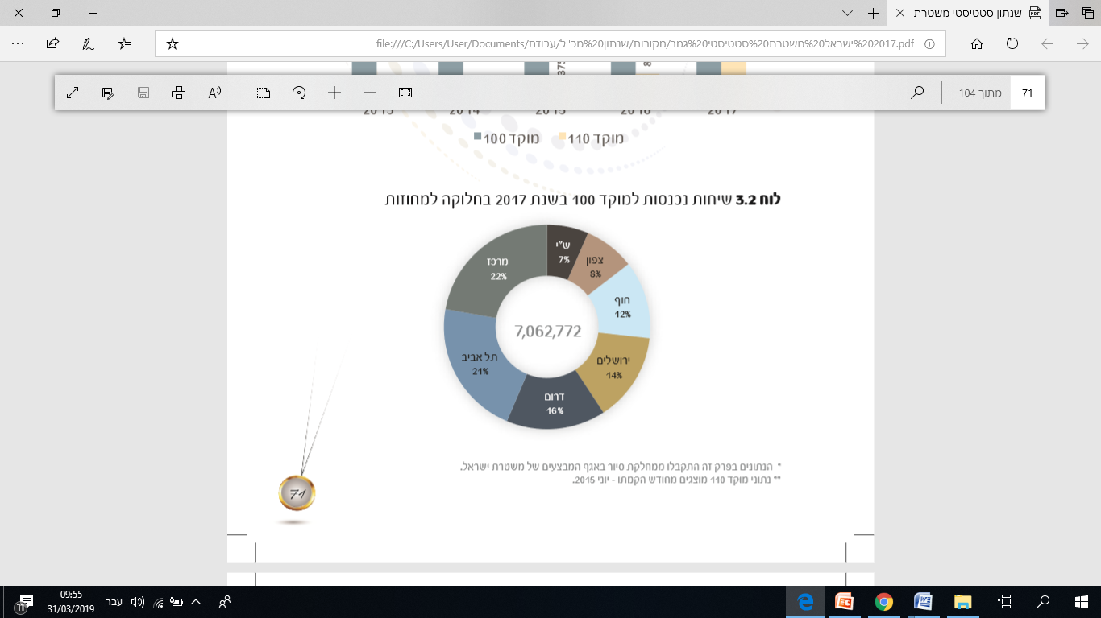

**Center**

**Tel Aviv**

**West Bank**

**North**

**South**

**Jerusalem**

**Beach**

The Tel Aviv district center handles 1.5 million calls a year.

**Training Division - The main component in preparing the force (not part of the tour(**

1. The Training Division was established in July 2017 as a central part in the implementation of the program for organizing the staff and increasing organizational effectiveness, the "Sigma Program." The establishment of an independent wing of the National College for Police, training, learning and education In the Israel Police.
2. The purpose of the training concept, to serve as a compass for the division's direction of action and to reflect its intentions and principles for its activity. The concept of training in essence constitutes an initial, strategic and optimal basis for the overall organizational activity in this field.
3. The field of training supports organizational activity, the purpose of which is to achieve the organizational goal by purchasing, improving and maintaining the preparedness and preparedness of the individuals and units as part of the force-building processes to realize the organization's vision, values, objectives and policies through the National Police College**.**

The purpose of establishing the training department - building the organizational strategic floor of the training. To lead and advance the field of training, to realize the concept of organizational training by distilling training circles with the professional and field units, to bring the policeman, the commander and the unit to professional, operational and ethical qualifications.

**Sigma-** In order to organize the national staff, it was decided to establish the training division first, based on the concept that the division will work in cooperation with the professional divisions and will be a leading and synchronizing body that receives the information and instructions from the divisions.

**The Division's strategy**: Achieving the professional, operational and ethical capacity and readiness of the policeman, the commander and the unit - a competency that will advance the ability of the Israel Police to fulfill its tasks.

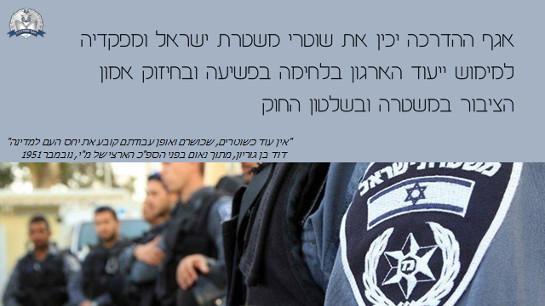

**The Directorate will prepare the guards of the Israel Police and its commanders to realize the organization's mission in the fight against crime and to strengthen public trust in the police and the rule of law**

**Vision of the Training Division:**

The training system of the Israel Police strives to be an advanced and leading training body in its concepts, methods and activities, which supports the achievement of the organization's goals and objectives.

**The activity outline of the Training Division:**

The training department of the Israel Police is essentially a support force for operational activity, which provides a response to the police units in everything related to the training of police officers. In the training of the police, the Training Division seeks to provide "doubt" to the area and the professional staffs. Officers and commanders are qualified, ready and ready to carry out their missions according to their purpose, including the descriptions of the activities required of them. As a service provider, the Training Division is required to maintain extensive interaction within and outside the police, so that it can realize its mission and objectives in the required quality. The divisions and districts are the main customers of the Training Division.

**National Police Academy**   
Responsibility for training, certification, leadership development, and improvement of professionalism in policing and management in the Israel Police.

**Functions of the National Police Academy:**

1. To train police officers throughout their service for professional positions in various fields.
2. To develop leadership and command values for commanders in the Israel Police.
3. To classify policemen as part of courses and advanced studies conducted at the college.
4. To train policemen and volunteers in courses, in-service training and in self-study.
5. Provide skills to develop, improve and strengthen operational fitness.
6. Lead the field of excellence in the Israel Police.
7. To impart the rules of conduct, professional ethics, and instill the organizational culture of Israel Police among college staff and students.

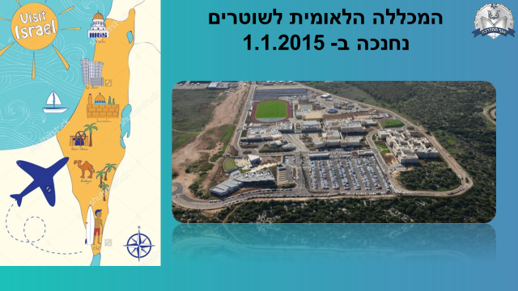

**National Policy Academy was inaugurated at 1.1.2015**