**Yarom India: 17 Indian restaurants from north to south**

**If you fancy real Thali and spices to remind you of the big trip, this list is for you. 17 Indian restaurants ranging from the north to the south.**

**Kiryat Shmona: Thali restaurant**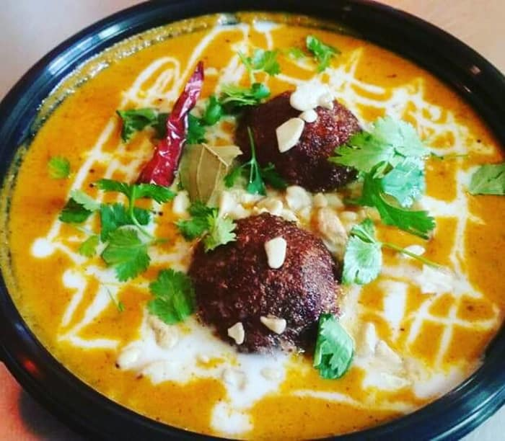

Sergio Hellman and Kahlo Baba's vegetarian restaurant opened about two years ago. Beyond spicy and authentic Indian food (Baba has lived most of his life in India), it offers an alternative to vegan vegetarians who prefer to give up the typical meat restaurants in the northern region. On the menu are classics like samosa, dal, palak paneer, soups and more. The highlight is the Thali meal, which includes a three-course dish and comes with basmati rice, cumin seeds, chapti and yogurt. On Fridays there are deals of Indian food with beer accompanied by bouncy Bollywood music.

**Thali. The scenery of Hermon, Kiryat Shmona. 04-6077764. Opening hours: Mon-Thu 12:00-22:00 and 11:30-16:00. Vegetarian, not kosher.**

**Or Akiva: Taj**

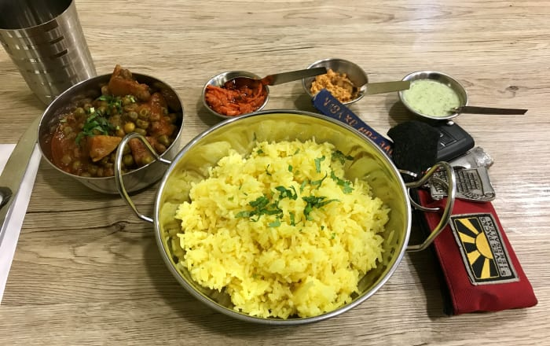

Taj Restaurant is a small, neighborhood and family restaurant opened by Moshe and his mother Naomi specializing in Indian Jewish food from the Mumbai area. On this menu are metar - peas stew, potatoes and masala sauce on a yellow rice bed; Chickpea and potato grits cooked with Indian spices and served with chopped onion and coriander; Vegetable tally; Basmati and chapati rice; Chicken tikka and more. Don't forget to put a lot of chutney aside.

**Taj, Rothschild 2 Or Akiva, 04-8388440 or 052-3322335. Hours: Sunday - Thursday: 11:30-21:00, Friday: 10:30-14:30. Kosher**

**Tel Aviv: Munnar**

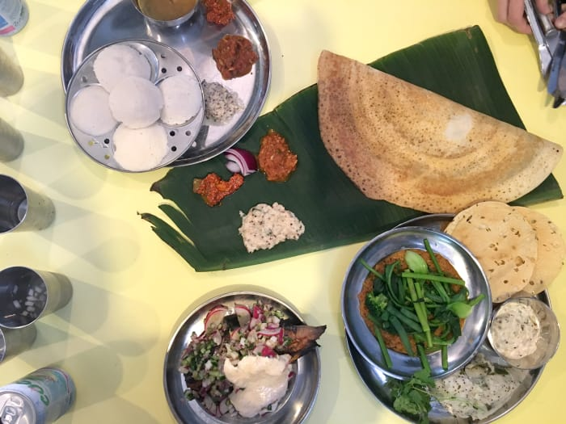

The Munnar restaurant is named after a southern Indian city and its style is called Daba. Many Southern India darlings serve masala dosa, a kind of large crepe made of rice and lentil fermentation, and therefore gluten-free. Here it comes with a potato filling and alongside a sambar stew of long-cooked vegetables. The restaurant also has surprising and interesting Indian dishes that play on the line between simplicity and freshness, with lots of fresh ingredients, greens and vegetables and fresh and seasonal fruits that blend in dishes like the cow's tongue, local pineapples and more.

**Munnar, Nahalat Binyamin 68 Tel Aviv, There is currently no telephone. Opening hours during the lecture period: Sunday to Thursday 10:00-16:00. Tuesday + Thursday is also open from 19:00-22:30 pm. Fri 10:00 am-15:00 pm.**

**Tel Aviv: Sundays at Taizu Restaurant**

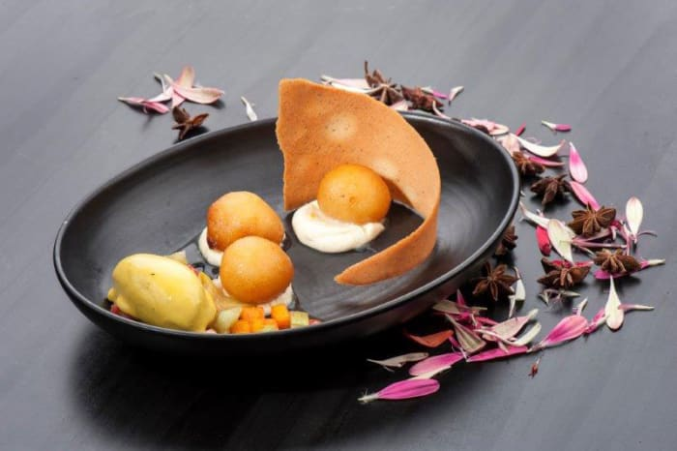

Within a list that is all made up of restaurants one cannot help but incorporate Taizu Sundays, which on Sundays becomes an Indian restaurant for everything. Concept evenings are often a trend, but in Taizu this evening has been working successfully for several years, and has managed to bring India's flavors to the highest levels. Starting with the traditional attire of the waiters and the kitchen staff, through Chef Yuval Ben Neria's cocktail, music and food, photogenic, interesting, and spicy. Of the restaurants on the meal list here is the most expensive but it provides an unforgettable gourmet experience.

**Taizu. Menachem Begin Road 23, Tel Aviv Yafo. 03-522-5005. Not kosher.**

**Tel Aviv: Indira**

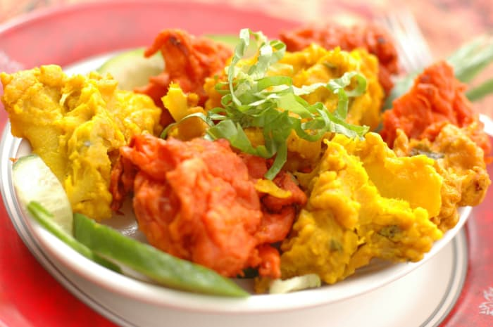In 1993, the Indira restaurant was opened in London's Ministore (where Rina Pushkarna's Ichikadana restaurant, now Tandoori, formerly operated). Not many things have changed in it over the years and the menu still retains the same flagship dishes like plaque paneer, pakura, traditional naan and more, with the restaurant remaining very family-friendly and warm ever since. Ordering by phone is available here.

**Indira. King Saul 4. 03-6954437 Opening Hours: Sunday-Saturday 12:00-23:00**

**Tel Aviv, Herzliya: Tandoori**

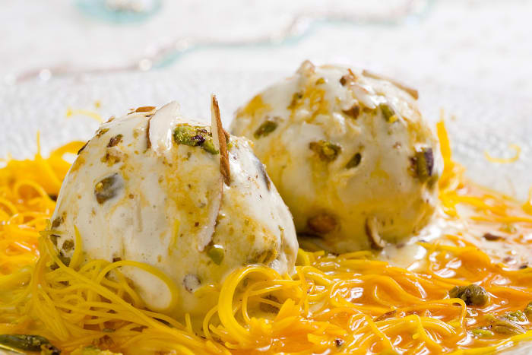

Tandoori was established in 1984, making it the oldest Indian restaurant in the country and to a large extent that it "educated" Israelis to love Indian food before travel to the East became a necessary transit point for military graduates. The restaurant opened many branches, the original branch and another branch in Herzliya. Among the dishes is a polygonal soup with lentils and rice, lamb samosa, tikka chicken and more. Most dishes remain the same since its inception 30 years ago, with occasional Pushkarna innovations. The restaurant also has deliveries.

**Tandoori. St. Zamenhof 2, Dizengoff Square Tel Aviv. Tandoori Herzliya, St. Maskit 32, Herzliya 09-9546702 Sunday-Friday 12:00-15:30 18:45-00:00. Saturday 13:00-16:30 18:45-00:00.**

**Tel Aviv: 24 Rupee**

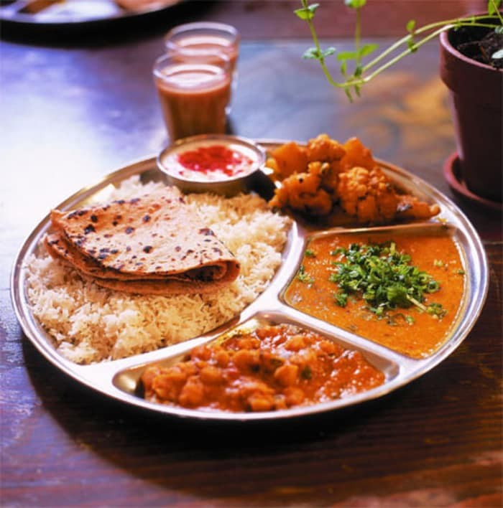

As a result of travel fashions to India which began to grow in the 1990s, Indian restaurants have also slowly flourished. One is Rupees 24, a Shanti-style restaurant with cushions on the floor and a vibe of Indian Workers Restaurant (Dhaba). The restaurant focuses on a colorful and satisfying thali meal, and slightly matches the dishes to the Israeli palate.

**24 Rupee. Shocken 16, Tel Aviv. 03-681-8066. Sunday to Thursday + Saturday, 12:00-00:00 and Friday 12:00-18:00.**

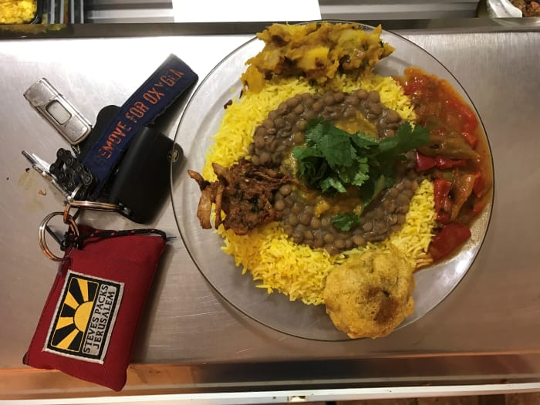**Tel Aviv: Slam Bombay**

Slam Bombay is a restaurant that has been operating quietly for over a decade on busy Allenby Street. The restaurant is owned by Shay Sorek, who prepares food there according to his grandmother's recipes, Esther, who made an Aaliyah from Bombay to Israel in the 1950s. There are classic dishes here like dal, chicken curry and more and you can buy dishes in commercial quantities to take home and even Indian spices.

**Slam Bombay. Allenby 124 Tel Aviv. 052-4846786. Opening hours: Mon-Thu 12:00-16:00 and Friday 12:00-15:30**

**Tel Aviv: Captain Curry**

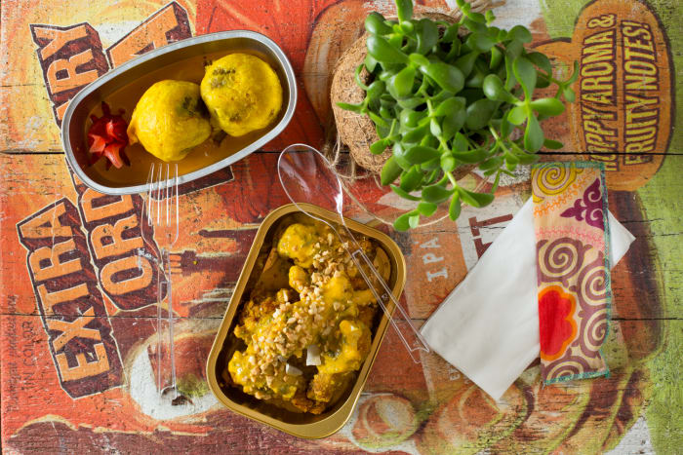

Captain Curry's second branch was closed, but Jonathan Rochfeld's original restaurant and Captain Curry's group is alive and kicking Sharona Market. The restaurant offers colorful and delightful Indian food with a twist, like chicken skewers soaked in red curry yogurt over white rice and orange lentil dal; Chicken Copta, Chicken Meatballs in Peanut Butter Masala; Tandoori trout, which is a fillet of yogurt, red curry and coconut sauce and more.

**Captain Curry. Sarona Market. Major General Kalman Magen 3, Tel Aviv Yafo. 03-6095960. Opening Hours: Sun-Sat 12:00-22:00 and Friday 11:00-16:00**

**Tel Aviv: Ma Pao**

Ma Pao (Bread Mother, Indian) was inspired by Mumbai’s food kiosks, presenting her version of an up-to-date street restaurant. Behind the restaurant are three siblings: Noah, Israel and Ronit, who are of course in Mumbai. Among the dishes in the restaurant are sweet potatoes with mustard seeds and coriander; Samosa - minced chicken patties in Frankie chutney dips - vegetarian chapati roll; Kaldal Dal casserole Tandoori chicken lentils with spicy yogurt and more. And there are Indian desserts as well.

**Ma Pao, Binyamin Nachat 59 Tel Aviv, 03-7739797. Sunday to Thursday 11am to 11pm and 11am to 5pm Closed Saturday. Hashmonaim 105, Tel Aviv. Sunday to Friday 11am to 11pm Saturday 12pm to 10pm**

**Tel Aviv: Dosah Bar**

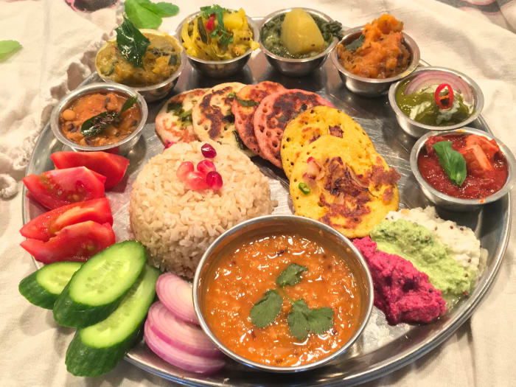

The restaurant's menu focuses on the Indian crepe that is so characteristic of the southern part of India. The rice is made from rice and black, is vegan and gluten-free, and the menu here is all about nutritious and as organic and natural as possible. The dosa comes in four varieties - yellow with potato, onion, carrot spice and purple onion; orange with sweet potato, carrot, onion, indian spice and green onions; green with mangold, dalorite, onion and ejuan; The dosas come with a sambar - lentil soup, cabbage and carrot salmon, and an excellent dip of coconut chutney, and organic desserts such as spirulina candy can be found here.

**Dosah Bar, Ben Yehuda 188 Tel Aviv, Sunday – Thursday Hours: 12:00-23:00, Friday: 12:00-16:00, Saturday: Closed. Vegan, not no kosher certificate**

Ramla: Maharaja

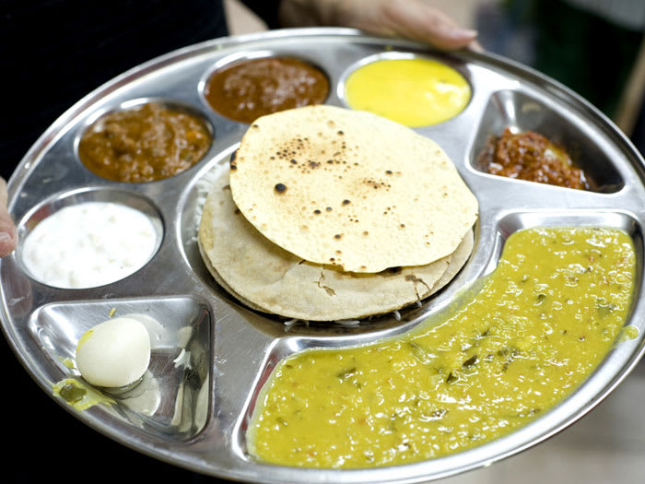

On the outskirts of Ramla Market, in the back of a quality spice shop, the Maharaja restaurant hides. Over 30 years ago, the workers' restaurant was founded by Elazar Astioker's parents, who still continue the tradition and cook it. During 2016, the restaurant closed for a period only to reopen with renewed powers. Here, Indians from all over the country flock to purchase from the dizzying assortment of spices, chickpea, chutney and other products that are not always easy to get as well as sweet. The vegetarian-vegan menu is rich in fried stews and loaf that characterize Indian cuisine.

**Maharaja. 87 Herzl Boulevard, Ramla. 08-9223534**

**Rishon Lezion: Chicken Tikka**

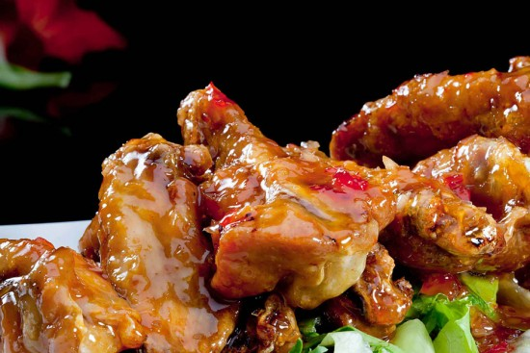

Indian restaurant opened by Daniel Sasson in Honker, who immigrated to Israel at the age of 30 from Mumbai. He spent a period in an Indian restaurant in Eilat (which was closed). In 2016, he opened the restaurant, which features classic dishes like dumpling, Ella Goby, vegetable samosa and of course, classic tikka chicken. The restaurant also makes deliveries.

**Chicken Tikka. Rothschild 85, Rishon Lezion. 03-5294757**

**Shderot: Daba**

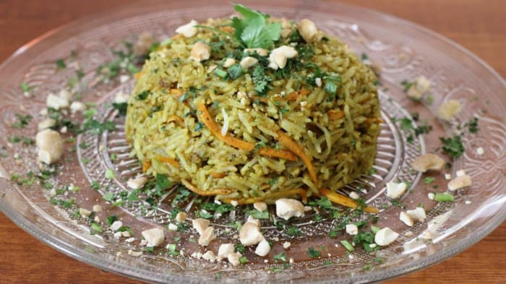

Daba Restaurant serves authentic Indian food with cool starters such as masala seasoning chips with spicy mayonnaise dip, naan bread from yogurt dough with garlic or onion pies. There is a classic Indian thali, and vegetarian main dishes like dumpling or paneer masala, which is a paneer cheese in tomato and cream sauce. The place is decorated a bit like India and some of the tables are low and with the option of sitting on pillows on the floor. Invite yourself to Chai and imagine you're on the big trip.

**Daba. Herzl 27 Sderot, 08-9404616. Kosher**

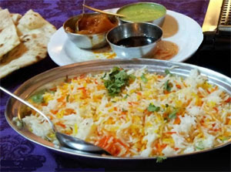**Ashdod: Namaste**

The restaurant that started as a booth has become a big space over the years and without notice you celebrated 27 years. The food served is North Indian style. Henan is baked here in a special tabun and comes in a variety of variations like Nan Garlic or Nan Onion, there are a selection of different types of curry, chicken tikka, tali and more. Since the restaurant is kosher meat, you will not find yogurt, beverages or milk desserts here.

**Namaste. Boardwalk 20 Ashdod. 08-8562437. Kosher**

**Beersheba: Hodoo Haktana (Little India)**

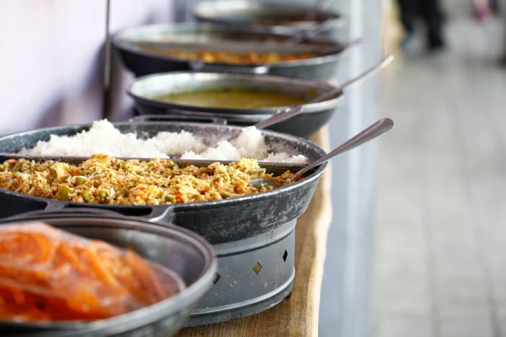

The kitchen of Little India Restaurant is packed with spice boxes to grind on the premises. Although it is a vegetarian place, the lack of meat is not noticeable at all. The richness of the raw materials, the colors, the smells and the flavors completely cements it. Hanoch Stemaker's small place, the chef and owner has become a well-known institution in the Southern Region, with a shanti atmosphere with lots of pillows on the floor and tables and dining that covers large parts of Indian kitchens and plenty of classics such as dumplings, roti, biryani and palak paneer.

**Little India, Ringelblum 15, Beer Sheva. 08-648-9801. Kosher**

**Eilat: Tika Masala**

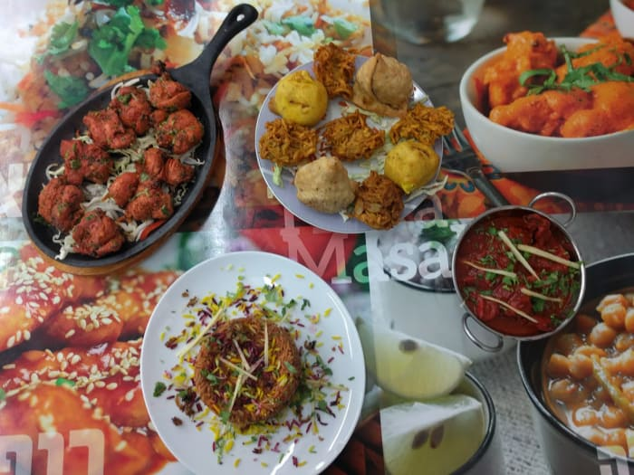

Two years ago, Raj Kumar and his wife opened a family restaurant in the industrial area of Eilat. Raj, who has worked for over 20 years in restaurant and hotel kitchens in the city, bought a Thai food stand, but soon expanded and introduced the menu to the Indian cuisine he grew up on. In the kitchen is a tandoori taboon brought by Raj from Delhi and all the meat and chicken dishes in the restaurant go first and foremost. On the menu are dishes like samosa, pecora and sweet potato wara; Chicken tika masala; Banana roll in tempura and more. If you want Indian food and don't want to get up from the seaside, there are also deliveries.

**Tika Masala, Weavers 2, Eilat. 08-6336631 Hours of operation: Sunday to Thursday 11am to 10pm, Friday 11am to 3pm. Not kosher**