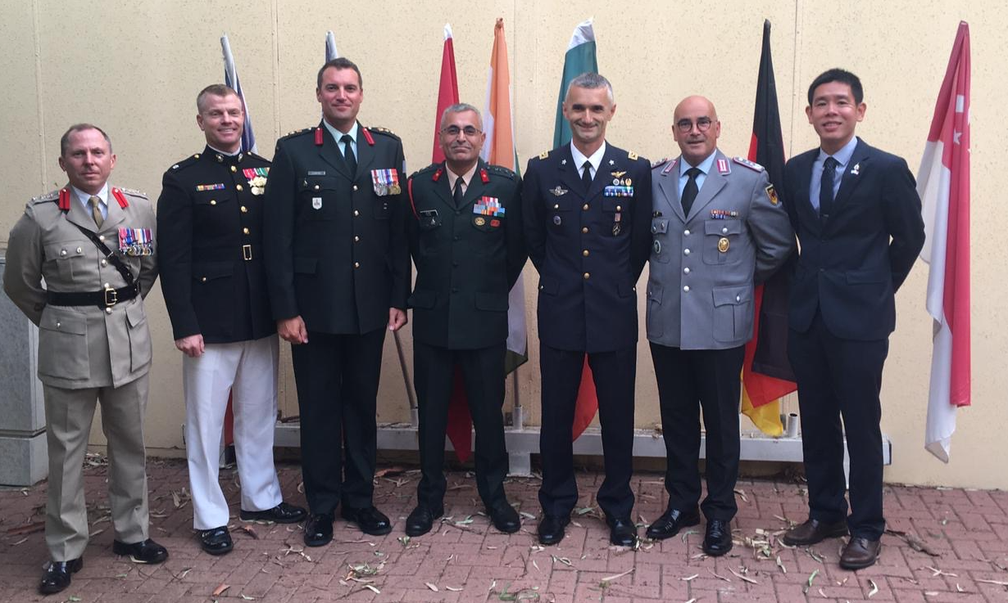

Presented to the Commander, Instructors, Staff and Soldiers of the INDC with gratitude from the International Students of the 46th Class (2018 – 2019)

L to R: Col Jim Priest (British Army), Lt Col Seth McCutcheon (USMC), Col Pat Lemyre (Canadian Army), Brig Raju Baijal (Indian Army), Col Eros Zaniboni (Italian Air Force),

Col Klaus Haller (German Army), Col Shin Fong Teng (Singapore Army)