Hanin Ghaddar
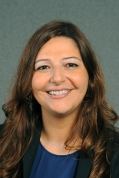
The Inaugural Friedmann Visiting Fellow at the Washington Institute's Geduld Program on Arab Politics
previous positions

2018 | Adjunct Professor Georgetown University
2015-2016 | Nonresident Fellow Atlantic Council
2012 | Public Policy Scholar - Middle East Program Woodrow Wilson International Center for Scholars
2002-2004 | Research Officer SURF-Arab States Program at the United Nations Development Program (UNDP)
1998-2000 | Journalist at Assafir Newspaper
1997-1998 | Journalist at Beirut Times Newspaper
Education
2004-2008 | M.A. in Middle Eastern Studies from the American University of Beirut
1991 | B.A in English Literature from the American University of Beirut
Personal Information

Languages- English, Arabic

