# Ambassador Spiros Lambridis

## Permanent Representative – Greece 2016

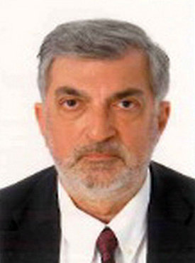

Born in Thessaloniki, Greece, May 1957

#### Studies

Economics and Political Science (BA) at the Law School of the University of Athens  
Studies on European Integration at University of Reading   
Master’s Degree (MA) in International Relations from Boston University.

#### Military Service

Second Lieutenant, Greek Army, 1980-1983 (Reserve Officer)

#### Diplomatic career

1983-1984:  Diplomatic Academy of the Ministry of Foreign Affairs  
1984-1989:  Directorate of European Political Cooperation, MFA   
1989-1991:  First Secretary, Embassy of Greece in Tel Aviv  
1991-1994:  Embassy Counselor, Permanent Representation of Greece to the European    
Communities and   
1994:          Head of the Council’s Committee for the Accession negotiations with the   
three Scandinavian countries and Austria.  
1994-1997:  Director of the Alternate Minister’s for European Affairs Diplomatic     
Cabinet, MFA  
1997:           Diplomatic Liaison of the Ministry of Foreign Affairs to the bidding    
Committee for the 2004 Olympic Games  
1997-2000:  Consul General in Geneva -Switzerland  
2000-2002:  Embassy’s Minister Counselor, Liaison Office of Greece to Skopje, fYROM  
2002-2004:  Diplomatic Advisor of the President of the Organizing Committee of   
the 2004 Athens Summer Olympic Games  
2004:            Head of the Global Olympic Torch Relay ‘’ATHENS 2004”  
2004-2008:   First Political Counselor to the Permanent Representation of Greece to NATO  
2008:-2011:  Promoted to Minister Plenipotentiary and to Deputy Permanent Representative,    
Permanent Representation of Greece to NATO  
2011-2012:   Director of the Ministry’s Directorate for North Atlantic Treaty (NATO)   
2012-2013:   Director of the Diplomatic Cabinet of the Minister for Foreign Affairs   
2013-2016:   Ambassador of Greece to Israel

#### Marital status

Married. Father of two.

#### Activities

Author of  historical novels, hiking.

#### Foreign Languages :

English, French, Italian (fluent). working knowledge of  Spanish and some Hebrew.