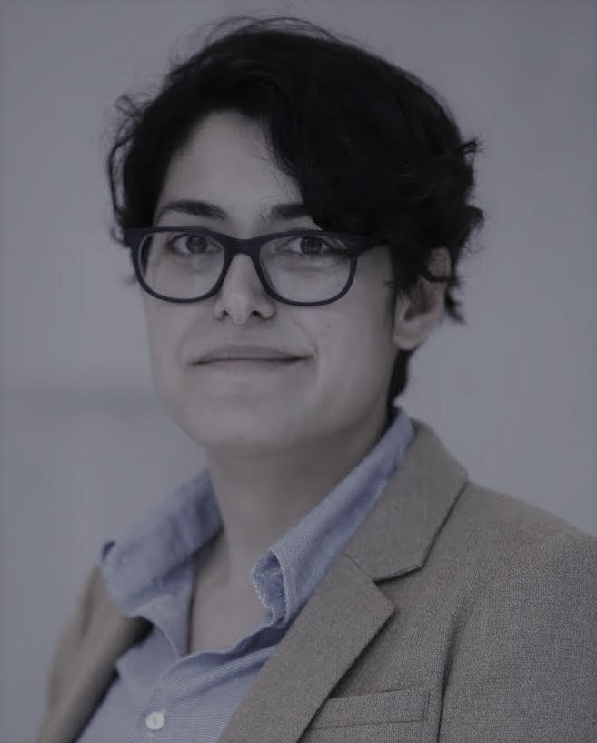

Israel and Iran

in a Nuclear Middle East

**November 17, 10am (US Central Time Zone)**

**Zoom Link:** [**https://wustl.zoom.us/j/94037739826**](https://wustl.zoom.us/j/94037739826)

Join us for a special guest panel with:

**Ambassador Merav Zafary-Odiz -** Israel National Defense College, former Permanent Representative to the International Atomic Energy Agency (IAEA)

**Dr. Ariane M. Tabatabai -** Middle East Fellow at the German Marshall Fund, senior researcher at Columbia University School of International and Public Affairs

**Dr. Or (Ori) Rabinowitz -** Assistant professor at the International Relations Department in the Hebrew University of Jerusalem

