**INDC 48th CLASS**

**FINAL ASSIGNMENT**

**" ΤHE EAST MED PIPELINE PROJECT: FROM DREAM TO REALITY? "**

**LtCol NIKOLAOS SKOURELLOS (GREECE)**

**LtCol TIMOTHY SCOTT (USA)**



**Professors**

**Dr. Elai Rettig**

**Accompanying Instructor: Dr. Besora Regev**

**FEBRUARY 2021**

**PAGE INTENTIONALLY BLANK**

CONTENTS

EXECUTIVE SUMMARY i

INTRODUCTION 1

CHAPTER 1: ENERGY SECURITY IS A CRITICAL ISSUE FOR GREECE 2

1.1 Definitions of Εnergy Security and Factors Affecting It 2

1.2 European Gas Demand 3

1.3 Greece Gas Demand 5

1.4 Feasibility of a southeast Energy Corridor in Europe focus on the East Med Project 6

1.5 The East Med Project 7

1.6 East Med’s Viability, Challenges, and Obstacles 7

chapter 2: energy security and energy policy: the formation of new alliances 8

2.1 The Greece-Cyprus-Israel Energy Agreement 8

2.2 Greece role in the South-East Mediterranean 10

2.3 The role of the U.S. in the South-East Mediterranean 12

CHAPTER 3: proposed measures and policies for the construction of the east med pipEline 13

**LIST OF FIGURES**

Figure 1: East Med pipeline project (source: IGI Poseidon, Greece Energy Ministry)

Figure 2*: Greek EEZ (source:* New Europe, AFP, Greece Energy Ministry

Figure 3*: Energy dependency rate EU-27,2008-2018 (source: Eurostat*)

Figure 4: *Total imports (entries) and exports (exits) in thousand terajoules (GCV)*[Source: Eurostat (nrg_124m), (nrg_134m)]

Figure 5: Percentage of extra-EU imports (entries) of natural gas by country of origin [Source: Eurostat (nrg_124m)

Figure 6: Natural gas final consumption, Egypt 1990-2018 (Source: https://www.iea.org/data-and-statistics?country=EGYPT&fuel=Energy%20consumption&indicator=NatGasCons)

Figure 7: Natural gas final production, Egypt 1990-2019 (Source: https://www.iea.org/data-and-statistics?country=EGYPT&fuel=Energy%20consumption&indicator=NatGasCons)

## EXECUTIVE SUMMARY

In less than a decade, the Southeastern Mediterannean has become a focal point of the global energy industry. This is primarily due to the discovery of gas reserves and their potential impact on the region's economic, geopolitical, and political balances. It is widely accepted that the new resources could have significant and positive effects on Europe's gas-diversification strategy. Although many analysts refer to the energy review of E.U. countries as one entity, we cannot accept that the same level of dependency or interdependence exists between the 27 that make up the E.U. and Russia because some countries are much more dependent on Russian gas than others.

Although Greece is not currently a central player in this energy-focused power game, Greece must realize that it is undoubtedly more than just an interested party in the context of its deep economic and political crisis. As a relatively small state, Greece plays a pivotal role in the local and regional arena. It knows its political influence is limited to the local rather than the international arena. A local force is defined as one whose requirements are limited to immediate neighboring areas. In addition to all the difficulties faced by a small state in the inter-political situation, it has endured an enormous economic crisis, which transcended mere budgetary issues. Moreover, Greece suffered a massive blow to its reputation as a reliable player in the international political scene and a reliable Western NATO partner and the E.U. Due to the lack of trust, the country risks being classified as a black sheep, which will make it extremely difficult to create an allied network that will restore the country to its prominent place in the inter-political arena.

Many believe that in times of economic crisis, such as Greece's recent economic crisis, movements on major political issues and national issues should be avoided. Frequently missed is the fact that there is no stillness either in life or in politics. "[T]he earth continues to turn," that is, that the broader region around Greece is changing and evolving. The country must maintain its place in the region. Everything and the leaders of each country will have to determine the mobility rate of its foreign policy. On the contrary, some outside it, "friends" and opponents, will either want to slow down or inactivate its foreign policy, or they will want to direct it. Greece must take advantage of the crisis, see it as an opportunity for a more "active democratic foreign policy" (Kotzias 2010).

In this context, energy-related projects can be instrumental in Greece's effort to repair its standing in the international arena, reacquire a leading regional role, increase its influence, accumulate diplomatic capital, and restart its medium and long-term economy. The emergence of the South-Eastern Mediterranean as an energy hub will help create a climate of security and stability, attracting international investment, resulting in the gradual de-escalation of the countries' economic difficulties in the region.

In that regard, the Eastern Mediterranean gas pipeline (East Med pipeline) provokes intense reactions. Its supporters consider it essential and transformative to bring non-Russian gas into Southeast Europe and, thus, cement a geopolitical arc from Greece to Israel while weakening Russia's gas hold on Europe. Its critics see it as a delusion and unrealistic project. Meanwhile, Greece, Cyprus, and Israel continue to meet to try and advance this project. If Greece wants to create the conditions to transform the so far virtual East Med pipeline into a real one, it must:

a) Declare an EEZ. Greece's current stance is that an EEZ declaration is only possible after Greece and Turkey solve all their problems. In principle, Greece may not be opposed to "win-win" solutions, even including joint exploitation of resources, provided, of course, those issues of borders and ownership are settled in advance.

b) Understand that Turkish participation in the project will not lead to an automatic improvement in relations between Greece and Turkey. However, the E.U. can incentivize Ankara by offering Turkey to join the regional cooperation project, including projects with pipelines that connect and benefit all countries in the region without reducing resource-driven mutual security considerations.

c) Take into account that neither Cyprus nor Israel have an extensive enough domestic gas market to accelerate gas field development. Both will continue to rely on export markets.

d) Turn the economic crisis into a new era. Greek foreign policy must move from one based on defensive isolation to a well-understood aggressive foreign policy that fulfills its mission to the fullest. Greece has many more "cards" that it can exploit, such as its strategic position, energy prospects, participation in Euro-Atlantic institutions, excellent relations with the USA, excellent relations with the Arab world, and the developed alliance with Israel, cooperation with Egypt. Further, Greece should consider that the Biden administration is in an excellent position to use the EastMed pipeline as a key component of its foreign policy toward Turkey to counter its Mediterranean approach. As Professor Evangelos Koufoudakis[1] stressed, we should understand our smallness, not as a weakness but as an objective factor in the dour strategy's design "***We're not the sphinx that became a hawk, but we know well what a bee can do***," he said characteristically.

e) Ensure its Security of supply with its participation in Europe's emerging Energy Union and its activity on various geopolitical issues in the Region of southeast Europe through broad energy diplomacy policies. As a member of all the European institutions and frameworks, Greece is actively involved in the Energy Union's security policies (e.g., solidarity mechanism) (European Commission, 2008).

f) Establish a long-term hydrocarbon research program and create a framework for the organization on an ongoing basis of International Round of Concessions aimed at discovering new deposits and the production of oil and gas from them.

***Key Words: Greece, Cyprus, Israel, East Med Pipeline, Energy security, Alliances, East Mediterranean sea.***

## INTRODUCTION

The Eastern Mediterranean region is one of the points that beats the heart of regional politics. Identifying significant hydrocarbon reserves in the East Mediterranean basin has led to a dramatic change in its energy map. Although the deposits discovered in Israel and Cyprus are not expected to be a game-changer in Europe's energy situation, E.U. nations can hardly ignore them. It is widely accepted that the new resources could have a significant, positive effect on Europe's gas diversification strategy. Furthermore, the future landscape may change with additional exploratory efforts underway in Cyprus, Israel, and Greece.

In the same period of great discoveries, Greece experienced the most severe economic crisis in its history since 2009, which worsens the fiscal imbalance and obstructs traditional foreign policy implementation. The severe financial crisis exacerbated by the covid-19 pandemic has seriously damaged its international standing. The government, fully absorbed by the effort to deal with the domestic turmoil, was absent from all international activity, postponed the opening of negotiations on national interest issues, and deemed the Ministry of Finance and the Ministry of Health higher priorities than the Ministry of Foreign Affairs.

Despite the turmoil caused by the economic recession, a bright light in Greece’s foreign policy development was the cultivation of strategic ties with Israel and the realistic prospects for a more visible Greek footprint on the regional energy map. Many believe that states should avoid movements on major political issues and national issues during economic crises. What is not perceived is that there is no stillness either in life or in politics, "the earth continues to turn," that is, that the broader region around Greece is changing and evolving. The country must maintain its place of prominence in the region.

Although Greece is not currently a central player in this energy-focused power game, it must realize that it is more than just an interested party in the context of its deep economic and political crisis. Energy-related projects are instrumental in Greece's effort to repair its standing in the international arena, reacquire a leading regional role, increase its influence, accumulate "diplomatic capital," and, in the medium to long term, restart its economy.

This paper explains why it is essential to promote the east med pipeline that connects Greece, Israel, and Cyprus. Simultaneously, the E.U. seeks to enhance its gas security of supply by implementing a strategy of diversification of counterparts, routes, and sources. Lastly, the paper focuses on the critical question: *What actions must Greece take to enhance the East Med pipeline project's viability and sustainability?*

## CHAPTER 1: ENERGY SECURITY IS A CRITICAL ISSUE FOR GREECE

### Definitions of Εnergy Security and Factors Affecting It

Energy security is a multifaceted concept that acts as a springboard to create complex interdependence relationships between different actors. In terms of energy sources and due to interdependence, two categories define countries. They are either energy producers or consumer countries. Producing countries rely on energy exports contributing to their economic growth while consuming countries are economically and strategically dependent on uninterrupted energy supply. Therefore, interdependent relationships are created between energy-producing countries and consumer countries that are neither symmetrical nor fully balanced dependencies.

Energy security is an integral part of any energy policy. A strong energy policy allows for the uninterrupted availability of energy resources in various forms, sufficient quantities, and reasonable and affordable prices in a stable future base. The concept of energy security in the post-Cold War period has expanded, covering a wide range of topics, including critical infrastructure, protection and reliable access to financially affordable energy, the security of energy supply at reasonable prices, and diversification of energy transit routes.

The International Energy Agency defines energy security as "the uninterrupted availability of energy sources at an affordable price(IEA, 2019)." Similarly, the E.U. 2014 European energy security strategy "emphasizes the critical importance of a stable and abundant supply of energy" for European prosperity and security. In general, all definitions include the concept of ensuring the availability of demand-related energy.

Four key elements comprise the energy security sector: (a) availability, (b) reliability, (c) affordability, and (d) sustainability. Availability refers to the extent to which users and consumers have access to energy. Availability requires an extensive network of marketers, sellers, buyers, proper use of natural resources, investments, technology development, and a legal framework defining the rules for actors within the process. Reliability is related to ensuring an uninterrupted power supply and protecting against network interruptions. Affordability includes stable energy prices to which the vast majority of citizens and the economy can respond. Sustainability is about minimizing the social, environmental, and economic costs of running each part of the energy chain (Winzer, 2011).

Defining energy dependence is another theoretical tool that the paper analyzes. The energy dependence rate shows the proportion of energy that an economy must import. It is defined as net energy imports divided by gross inland energy consumption plus fuel supplied to international maritime bunkers, expressed as a percentage. A negative dependency rate indicates a country is a net exporter of energy, while a dependency rate of over 100 % means that energy products have been stocked (European Environment Agency, 2014). In short, energy dependency shows the extent to which an economy relies on imports to meet its energy needs. The energy dependency index calculates the percentage of energy imports in total gross domestic final consumption.

On the other hand, we can't neglect that energy imports are just one of many indicators for energy security and are not sufficient to determine whether a country is secure or vulnerable. A country can be 100% dependent on imports but still very secure. In contrast, another country can be independent but not very secure because of poor grid development, poor regulation, susceptibility to extreme weather, etc. In this respect, the diversification of energy resources and transportations routes, efficient use of local resources, and the use of existing energy resources with various technological and strategic practices in the most efficient way possible are necessary to improve energy security and reduce dependence on foreign energy sources.

### European Gas Demand

Given that the E.U. will continue to rely heavily on fossil fuel imports for the foreseeable future, it must protect itself from supply disruptions. E.U. dependency on energy imports did not change much over the last decade, from 58.4 % of gross available energy in 2008 to 58.2 % in 2018 (see Figure 3). During this period, the E.U.’s net imports of energy were greater than its primary production. In other words, net imports supplied more than half of the E.U.’s gross available energy, and the dependency rate exceeded 50.0%. Between 2008-2018, the energy dependency rate varied from a maximum of 58.4% in 2008 to a minimum of 53.9% in 2013. According to Eurostat, crude oil maintained the highest rates in 2018 (94.6 %) and natural gas (83.2 %), while solid fossil fuels maintained the lowest rate available at 43.6 % (2018).

This is relatively straightforward for most fuels. For example, oil can easily be transported and traded across the globe. There is usually enough spare capacity to ensure that other exporters can take up the slack when necessary. However, gas is a very different story. Gas import infrastructure (pipelines, LNG terminals) is expensive; new pipelines take years to build and require all countries' consent along the route, which is often difficult to obtain. Therefore, relations between gas producers and importers tend to be long-term, based on contracts lasting several years or even decades(Chyong, 2019).

In 2019, European Union held 14.1% of the world’s natural gas consumption, reaching almost 554.1 billion cubic meters. The E.U. has only 1.7% of the world's total proved gas reserves. Suppose the analysis proceeds into a wider region, Eurasia, that holds 32.3% of the world’s proven gas reserves (64.2 trillion cubic meters). In that case, it comes as no surprise that Europe targets specific regions on its eastern borders to cover its energy deficit. In 2019, the European Union’s natural gas trade movements that took place by pipeline stood at 233 bcm (23.7% market share) while the LNG imports, via LNG vessels, stood at 119.8 bcm (12,2% market share). The E.U.’s primary natural gas importers, via pipelines, are Russia and Norway, which accounted for 188 bcm and 109.1 bcm, respectively. In terms of LNG imports, via vessels, Qatar supplied 32 bcm and Algeria 15 bcm, respectively(B.P., 2020).

Total E.U. imports (entries) of natural gas increased by 4.2 % to reach 26,730 thousand terajoules. The most significant increase in 2019 compared with 2018 in the main net importers, i.e., countries importing at least 1 000 thousand terajoules, was observed in the Netherlands (+17.6 %), followed by Slovakia (+17.4 %) and France (+11.1 %). In the E.A., imports of natural gas decreased by 3.4 % to 20,257 thousand terajoules in 2019 (See figure 4). Regarding import country of origin, Norway was the source of 24.0 % of the natural gas entering the E.U. (intra-EU trade and entries from Switzerland both excluded), followed by Ukraine (19.0 %), Russia (19.0 %), and Belarus (9.9 %) (See Figure 5). However, considering that most gas entering the E.U. from Ukraine and Belarus initially comes from Russia. The E.U. is practically more dependent on gas imports from this Russia than gas imports from Norway. Natural gas dependency in the E.U. increased, reaching 89.5 % in 2019, up from 83.8 % in 2018. Denmark became the only net exporter in the E.U. in 2018 when the Netherlands became a net importer. In 19 member states, natural gas dependency was higher than 90 % (Eurostat, 2020b).

It is evident that E.U. relies on a limited number of suppliers, and given that switching to new gas suppliers at short notice is difficult, it makes sense to reduce the risk of disruption by diversifying supplier countries and routes. Indeed, diversification is a cornerstone of the 2014 European energy security strategy (European Commission, 2014). However, the E.U. is still far from achieving this goal. Political instability in North Africa and the Middle East further limits the group of potential suppliers. The International Energy Agency expects the high level of dependence on Russian gas to continue until 2040 (Zeniewski, 2019).

Although many analysts refer to the energy review of E.U. countries as a whole, we cannot accept that the same level of dependency or interdependence exists between the 27 E.U. members plus Russia. Some countries are much more dependent on Russian gas than others. All Member States imported petroleum oils and natural gas in the first half of 2020. Countries from central and eastern Europe are more reliant on Russian Gas compared to Western European countries. Ten member states (Bulgaria, Czechia, Estonia, Latvia, Hungary, Austria, Romania, Slovenia, Slovakia, and Finland) imported more than 75% of their natural gas imports from Russia. In both cases, the main importers are predominantly countries close to Russia. Most countries with shares below 25% of Russia's imports in either product are further away from Russia (Eurostat, 2020a).

### 1.3 Greece Gas Demand

At this point, it is appropriate to look at the gas imports of Greece. The National Gas Transmission System uses three entry points to deliver natural gas. The three entry points into the country are the SERRES SIDEROKASTRO for the gas coming from the Russian Federation via Bulgaria, the Evros KIPI for the gas from Turkey, and the Agia TRIADA for the gas LNG from Revythousa (YPEN, 2020). Transmission users are received via 44 exit points throughout mainland Greece, including the reverse flow exit point of SIDEROKASTRO, which delivers quantities of natural gas to Bulgaria's Associated Natural Gas Transmission System.

The production of natural gas in Greece from the exhausted deposit of South Kavala was 0.01 bcm in 2018 (European Commission, 2020), which is negligible compared to the total consumption of 5.1 bcm (B.P., 2020). Therefore, our country is entirely dependent on imports, with Russia contributing 65% in 2016 and 50% in the first semester of 2020 (Eurostat, 2020a).

Greece plans to improve the security of its supply by diversifying sources and supply routes, strengthening imports of liquefied natural gas (LNG) through the active LNG terminal in Revythousa and the FSRU floating plant in Alexandroupolis (2022)[2] , and expanding its role as a transit center for southeast markets in Europe.

Unfortunately, Greece relies on a limited number of suppliers. According to the 2016 E.U. Reference Scenario (Capros et al., 2016), Greece's energy dependency is projected to remain high, at 69.6% in 2030. Given this high energy dependence of the country on imported gas, the question arises as to whether dependency can be reduced and how developing the East Med pipeline will improve Greece’s situation. The state could also plan and implement an appropriate policy to enhance the East Med pipeline project's viability and sustainability in the coming years.

### Feasibility of a southeast Energy Corridor in Europe focus on the East Med Project

The question of European energy security and the need to diversify Europe’s natural gas sources of supply has drawn attention to the strategic significance of Southeast Europe as a transport hub of natural gas from both the Caspian region and from the Eastern Mediterranean. To meet increasing natural gas demand and reduce East and Southeast Europe’s high levels of energy dependency on a single exporter, European authorities have been keen to promote projects contributing to the diversification of natural gas supply (Iana & Stang, 2014). According to the Second Strategic Energy Review –an E.U. Energy Security And Solidarity Action Plan (Commission of the European Communities), the southeast gas corridor is recognized as one of the E.U.’s highest energy security priorities for the E.U., namely, to enhance its supplies via diversification of counterparts, routes, and resources.

The first and primary concern of the Energy Union's security strategy is to diversify energy supply. This measure aims to build new natural gas pipelines and finalize those already planned to link central Asian countries (e.g., Azerbaijan) with Europe to export natural gas and address European high exposure energy markets to Russian natural gas.

The promotion of a Southeast energy corridor could implement two alternative options. The first one has to do with adopting a pipeline, the EastMed Project connecting Cyrpus and Greece’s potential deposits, which will probably face significant competition from the existing pipeline network and create conflicting interests in the region. The second option has to do with enhancing the appropriate Mediterranean LNG terminals network with a capability to store and regasify liquified natural gas, thus allowing Greece to take advantage of the regional maritime cluster, the geopolitical importance of local ports, and the sizeable Greek LNG shipping fleet.

### The East Med Project

The Eastern Mediterranean (EastMed) Pipeline Project (See figure 1) refers to constructing an offshore/onshore natural gas pipeline that directly connects Eastern Mediterranean gas resources of Cyprus and Israel to Western Greece via Cyprus and Crete. The project's fulfillment demands the additional construction of “The Poseidon Pipeline” that will connect the Epirus Region (North Ionian Sea) with the Italian Regions of Otranto. The project can transport up to 16 bcm annually through 1,300 km of offshore pipelines and 600 km of onshore pipelines from the offshore gas reserves in the Levantine Basin and potential gas reserves in Western Greece and Southern Crete (IGI Poseidon, 2021). (See figure 1)

### 1.6 East Med’s Viability, Challenges, and Obstacles

The cost of constructing EastMed Pipeline is the main obstacle that needs to be overcome by the involved stakeholders. The project demands a high capital investment estimated to be about $6b due to specific technical challenges such as the unprecedented depth in Southern Crete that the pipeline must reach. High infrastructure costs would jeopardize the final gas prices that must rival the Russian or Qatarian gas, creating a challenging condition.

Furthermore, the East Med project faces competition from many similar existing or planned energy projects such as [Trans-Anatolian Natural Gas Pipeline (TANAR), Trans Adriatic Pipeline (TAR), the projected Balcan Interconnectors (IBR, ITB, IBS, IGB), The Nord Steam Project, The Yamal - Europe, and Blue Stream Project]. Another consideration is that the East Med project may create conflicting interests in the region, especially with Turkey. At this point, the crucial issue of the demarcation of the Greek Exclusive Economic Zone arises, which will seal Greece's introduction in the energy map of the subsystem concerned either as a transit country or as a producer country.

The critical point in developing the EEZ of Greece is the discrepancy with the bordering countries in the Sea of South-East Mediterranean on the Greek islands' right to establish the EEZ. Of particular interest is the Greek island of Kastellorizo. It must be included in the EEZ for Greece and Cyprus to share a common EEZ boundary. The map (see figure 2) clearly shows Greece's EEZ's delimitation based on the United Nations Convention on the Sea's Law (UNCLOS). Turkey disputes the existing maritime borders and supports the existence of "grey zones" in the Aegean to safeguard its claims through NATO and suspend international law application to resolve the "Greek-Turkish disputes" bilaterally. All the above mentioned indicate that Turkey aims to apply international law conditional on its consensus and seeks to create a status quo regarding the joint exploitation and co-management of the region's natural resources.

Undoubtedly, the demarcation of EEZs will increase Greece's power and strengthen its position in the region. Therefore, the Greek EEZ establishment is an essential tool for formulating a national energy strategy and can define new data, new partnerships, and new alliances, both economic and non-economic. The notion that it must solve all its problems with Turkey and then declare an EEZ has hamstrung the Greek government. From the above, we conclude that Greece will have to take a completely different negotiating path to safeguard its interests and achieve its objectives by upgrading its position and its strength in the international arena.

On a positive note, during 2015-2016, IGI Poseidon (IGI Poseidon, 2021) has finalized studies and definitively confirming that the EastMed Pipeline Project is technically feasible and economically viable. Furthermore, many of the energy companies that have expressed interest in exploring the Levantine gas fields are supermajors of the global and gas industry that operate ultra-deep pipe laying vessels.

## chapter 2: energy security and energy policy: the formation of new alliances

### 2.1 The Greece-Cyprus-Israel Energy Agreement

The discovery of large energy reserves on Israel's shores at the end of the past decade has led the country to need decision-making, becoming increasingly complex due to internal and external factors. The large Leviathan and Tamar deposits, combined with the country's low domestic demand and the South-East Mediterranean situation, will determine the region's future. However, the unstable investment environment and the fall in hydrocarbon prices further complicate the situation. Israel should build alliances in the area and set its own energy goals and priorities, especially concerning the markets it chooses to export.

Israel's internal consumption of natural gas is not sufficient to cover investment costs, and the country is therefore looking for external markets to export. One option is to export natural gas to the Egyptian market and from there to the European one. Egypt’s natural gas infrastructure is the most developed in the Eastern Mediterranean, and the Suez Canal offers one of the easiest, if not the fastest, trade routes for oil and gas. In the previous decade, the low regulated gas prices in Egypt had made new developments unviable. After the 2011 revolution, investment dried up, and production plummeted. Insurgents repeatedly bombed the pipelines through Sinai to Israel and Jordan, and the lack of gas ultimately forced Egypt to suspend deliveries.

Additionally, the two liquefied natural gas facilities, built by Shell at Idku near Alexandria and Eni at Damietta in the eastern Delta, also had to suspend exports (Stergiou & Karagianni, 2019). This option is not a long-term consideration, as Egypt has signed many agreements with major energy companies. The likely discovery of large energy deposits will account for internal consumption and not import energy. (See figures 6 and 7.)

A second option is exceptionally advantageous but challenging to implement. It calls for cooperation within Turkey through a pipeline, which will meet Turkish needs and transfer energy to the European market. This seems to be the most economical route for several reasons. Once backed by the U.S., this option provides for undersea oil and gas pipelines connecting Israel with Turkey. From there, Israeli gas would feed into Turkey’s national grid, reaching the giant domestic Turkish market and join the Trans-Anatolia Natural Gas Pipeline (TANAP). Despite serious considerations about whether Erdoğan’s Islamist regime should be a linchpin in Israel’s natural gas export strategy (Ben Solomon, 2016), this option initially looked very appealing. However, the deterioration of relations between the two countries due to the Mavi Marmaras incident and the failure to resolve the Cyprus problem create obstacles to the two countries' approach since any pipeline between Israel and Turkey will necessarily cross the Cypriot EEZ.

A third option is for Israel to export its energy reserves to the states of Europe through cooperation with Greece and Cyprus as a safe source of supply for the E.U. Greece and Cyprus are stable and reliable countries for long-term contracts. Because Greece has between neutral to good relations with most states of the Middle East, has no colonial ties, and is an E.U. Member State that can very easily assume the role of "Honest broker," facilitating the conduct of overt or covert diplomatic contacts and discussions between parties, neither or which wish to take the first step (Issues, 2016). All three countries maintain relations with various countries and alliances, and the exchange of diplomatic services and facilities is an essential common benefit. The European and NATO dimensions of Greece, the European extent of Cyprus, and the internationally influential size of Israel are the best guarantees of security and credibility in a region rocked by ongoing instability. Besides, both Greece and Cyprus seek the support of the America Israel Public Affairs Committee (AIPAC), America's influential Jewish lobby (AIPAC), support which Turkey used to enjoy.

Due to the benefits that the project brings to Europe, the EastMed pipeline was confirmed as Project of Common Interest (PCI) in 2015 with the Cypriot, Greek, and Italian governments' support. The E.U. Commission included it in the second PCI list among the Southern Gas Corridor projects. In 2015, the Connecting Europe Facility (CEF) awarded the project 2 million Euros worth of grants. CEF is the program necessary to co-finance the pre-FEED activities. In April 2017, during the Ministerial Summit held in Tel Aviv, in the presence of European Commissioner Miguel Arias Canete, the Ministers of Energy of Italy, Greece, Cyprus, and Israel signed a joint declaration to reaffirm their support to the swift implementation of the Project (IGI Poseidon, 2021).

In December 2018, at a meeting in Be’er Sheva (Israel), the leaders of Greece, Cyprus, and Israel officially stated that they were ready to sign an intergovernmental agreement on the East Med pipeline project. The agreement's materialization will be contingent on an EU-funded ($100 million) feasibility study (the E.U. does not finance pipeline construction). At the meeting, the U.S. ambassador to Israel David Friedman expressed unambiguous support for the pipeline, labeling it as a project “of great importance for the stability and prosperity of the Middle East and Europe.” The United States long attached great importance to the region and is a driving force behind it (Stamouli, 2018). The following section analyzes the U.S. role.

### 2.2 Greece role in the South-East Mediterranean

Greece's role as a member of the E.U. and NATO may prove pivotal to a region's stability with ongoing turmoil, such as the South-East Mediterranean. However, even before the crisis, Greece lost the opportunity to form strategic alliances. Greece did not use significant initiative to characterize its foreign policy, which created difficulty and weakened its position in the region and the E.U.

The emergence of the South-Eastern Mediterranean as an energy hub will help create a climate of security and stability, which will lead to the attraction of international investment and, consequently, to the gradual de-escalation of the economic difficulties of the countries of the region. Economic growth and a reduction in unemployment will contribute to the region's political and social stabilization. Recent gas discoveries in the Cypriot EEZ have given Greece and Cyprus a more prominent geostrategic role. The two countries now talk as an integrated geopolitical system that holds the "keys" of stability in a critical region. The alliance they have formed with Egypt and Israel further strengthens this effort.

The severe financial crisis exacerbated by the covid-19 pandemic has seriously damaged Greece’s international standing. The government, fully absorbed by the effort to deal with the domestic turmoil, is absent from all international activity, postponed the opening of negotiations on national interest issues, and has identified the Ministry of Finance and the Ministry of Health as by far more critical Ministries than that of the Foreign Affairs. Perhaps the only positive foreign policy development during that period was the cultivation of strategic ties with Israel and the realistic prospects for a more visible Greek footprint in the regional energy map.

Although Greece is not currently a central player in this energy-focused power game, it must realize that it is undoubtedly more than just an interested party in the context of its deep economic and political crisis. Energy-related projects can be instrumental in Greece's effort to repair its standing in the international arena, reacquire a leading regional role, increase its influence, accumulate "diplomatic capital," and, in the medium to long term, restart its economy.

Even though the Greek government has taken all the preliminary steps to research and exploit hydrocarbons by tendering exploration and production licenses in different areas, there have been no official statements or documents outlining an articulated and comprehensive policy. At this moment, Greece prefers to avoid any turbulence in relations with neighboring countries. Athens needs stability on the foreign policy front to facilitate recovery from its economic crisis. One should not conclude this means that Greece would allow an aggressive move by another country that attempted to change its bilateral status quo. Greece plays strictly by the sea's international laws and rules, including bilateral consultations with countries with which Greece shares maritime zones. Talks have been held with Egypt, Albania, and Libya, despite the latter's chaotic domestic situation - leaving little room for substantive negotiations.

In this context, the construction of an EastMed pipeline enhances the European security of gas supply in developing the E.U.’s indigenous resources. Greece and Cyprus are devoted to the E.U.'s principles, consisting of essential pillars that provide sustainability in a fragile region -political unrest in Turkey, the civil war in Syria, etc. Furthermore, the East Med Project and its possible connection with other projects that transfer natural gas through Northern Greece (TAP Pipeline and IGB Interconnector) and the Poseidon Pipeline (Italy’s Interconnector) promotes the E.U.’s goals of route and energy source diversification. Greece is becoming an energy hub as it transits gas from Azerbaijan, Cyprus, and Israel’s reserves and potential reserves in Western Greece and Southern Crete. However, such a development presupposes the declaration of the EEZ between Greece and Cyprus.

### 2.3 The role of the U.S. in the South-East Mediterranean

The U.S. shows interest in South-Eastern Mediterranean for two main reasons. One reason is that the Southern Mediterranean's energy reserves countries can be an alternative source of E.U. power supply to no longer rely on Russian natural gas. The second reason has to do with the region's continuous developments and, particularly, the civil war in Syria and Egypt's political situation. For this reason, the U.S. encourages cooperation between Greece and Cyprus-Israel-Egypt, as it can be an essential step towards restoring normality in the South-Eastern basin. As Shaffer points out, investment in natural gas infrastructure requires a long-term commitment from investors; therefore, investors look very carefully at the political situations in the countries where the infrastructure is constructed and the natural gas reserves location (Shaffer, 2017). The relative stability of the democratic Greek, Cypriot, and Israeli governments should be recognized by the U.S. as a unique characteristic of the EastMed pipeline when compared to other regional initiatives that rely on gas reserves and infrastructure in potentially volatile, non-democratic countries.

The Biden administration’s policy toward Turkey is still a relative unknown. Some journalists posit that the Biden administration will pressure the Erdogan government over its jailing of critics, journalists, and academics (What might happen to U.S.-turkey relations under President Biden, 2020). Others believe that the Biden Administration will be less tolerant of Turkey’s adventurism, such as its recent purchase of the Russian S-400 missile defense system or illegal drilling in Cypriot waters (Dettmer, 2020).

The Biden administration is in an excellent position to use the EastMed pipeline as a key component of its foreign policy toward Turkey to counter its Mediterranean approach. As Demiryol explains, Turkey’s Mediterranean strategy is about more than just energy reserves and transit routes. In general, Turkey perceives itself as regionally isolated and uses its “forward defense,” a combination of hard power and assertive diplomacy in border areas  
( Demiryol, 2020). The yet undecided policy can be coercive, where the U.S. supports further isolating Turkey and supports Cyprus and Greece in enforcing exclusive economic zone rights in the Mediterranean. The U.S. could also take a less coercive approach and lead a multilateral approach to resolve border issues. Regardless of the method, the new administration has an excellent opportunity to use foreign policy to make the East Mediterranean region more stable. By doing so, Greece and Cyprus will be able to tout regional stability and their relationship with the U.S. when negotiating long-term natural gas contracts with clients.

This chapter's specific analysis concludes that energy can trigger the development of cooperative links between States because of its importance. On the other hand, conflicting interests may emerge, which will be a permanent source of tension. New energy discoveries will be an important factor shaping the region's future and the relations that neighboring states choose to develop with one another.

## CHAPTER 3: proposed measures and policies for the construction of the east med pipEline

One of the most critical factors that led to the creation of the allied relationship was discovering hydrocarbon deposits in the EEZs of Cyprus and Israel. Israel is a powerful player in the regional system, and when the national interest of survival comes in, there are no wavers and hesitations. Greek-Cyprus-Israel axis under development depends on Greece and Cyprus' ability to cope with Turkey's pressure, which now feels that it is "suffocating," will claim the "living space" in the Aegean and Eastern Mediterranean. If Greece wants to create the conditions to transform the so far virtual East Med pipeline into a real one, it should:

a) Declare an EEZ. Greece's current stance is that an EEZ declaration is only possible after Greece and Turkey solve all their problems. From the above, we conclude that Greece will have to take a completely different negotiating path to safeguard its interests and achieve its objectives by upgrading its position and its strength in the international arena. The demarcation of the EEZ must be a foreign policy priority. It will strengthen Greece's position in the region, redefine its relations with its allies and give it a stabilizer role. Greece’s proclamation of the EEZ should follow the extremely successful diplomatic maneuver carried out by Cyprus that managed to harmonize its interests with Israel, the U.S., with the backing of the E.U. and Russia, as evidenced by the diplomatic cover they provided it against Turkey's provocations. Problems with neighboring countries regarding the delimitation of maritime zones may arise, especially if substantial deposits are discovered in disputed areas. Even in that event, however, the international law of the sea offers solutions that could adequately satisfy the sides' objectives and, more importantly, allow them to "sell" such an agreement to their respective public opinions. Of course, a necessary precondition would be the adherence of the interested parties to the UNCLOS provisions. In principle, Greece may not be opposed to "win-win" solutions, even including joint exploitation of resources, provided, of course, those issues of borders and ownership have been settled in advance.

b) Understand that Turkish participation in the project will not lead to an automatic improvement in relations between Greece and Turkey. This is easy to understand, considering Greece has been importing gas from Turkey since 2007. While this trade relationship is essential, it has made no real impact on the broader bilateral political relationship. However, the E.U. can incentivize Ankara by offering Turkey to join the regional cooperation project, including pipelines that connect and benefit all countries in the region without reducing mutual security levels over resources.

c) Take into account that neither Cyprus nor Israel has an extensive enough domestic gas market to accelerate gas field development. Both rely on export markets. The monetization of their gas has become a very thorny issue: the existing energy resources need to attract several billion dollars of new investment to be commercialized. Israel and Cyprus do not have pipelines for large consumers or the facilities to liquefy gas to export it by ship.

d) Turn the economic crisis into a new era. Greek foreign policy must move from defensive isolation to a well-understood aggressive foreign policy that fulfills its mission to the fullest. Greece has many more "cards" that it can play, such as its strategic position, energy prospects, participation in Euro-Atlantic institutions, excellent relations with the USA, excellent relations with the Arab world, and the developed alliance with Israel, cooperation with Egypt.

e) Ensure its Security of supply with its participation in Europe's emerging Energy Union and its activity on various geopolitical issues in the Region of southeast Europe through the broadest possible energy diplomacy. As a member of all the European institutions and frameworks, Greece is actively involved in the Energy Union's security policies (e.g., solidarity mechanism)(European Commission, 2008). The participation in cross-border natural gas pipeline projects, LNG terminals, and international electricity interconnections enables it, by taking advantage of its geographical position, to become a secondary (but essential) regional hub of the Southern Gas Corridor. Moreover, Greece can benefit diplomatically and economically from implementing these policies, strengthening its economy's recovery.

f) Establish a long-term hydrocarbon research program and create a framework for the organization on an ongoing basis of International Round of Concessions aimed at discovering new deposits and the production of oil and gas from them.

**APPENDIX 1: MAPS**

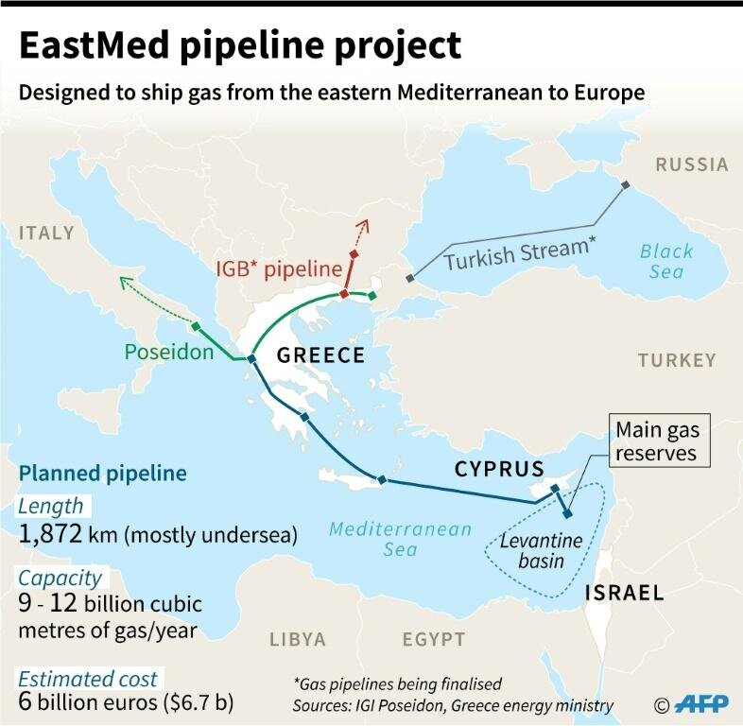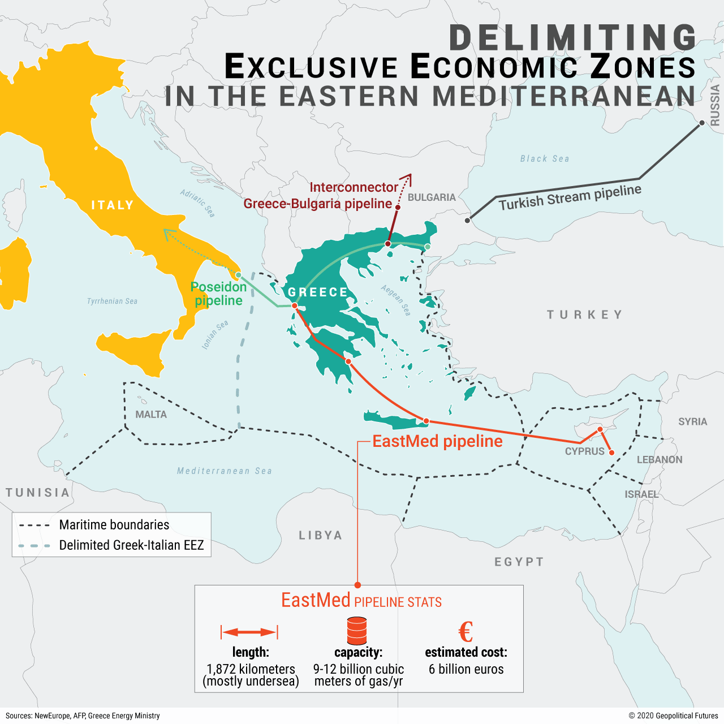Figure 1: East Med pipeline project (source: IGI Poseidon, Greece Energy Ministry)

Figure 2*: Greek EEZ (source:* New Europe, AFP, Greece Energy Ministry

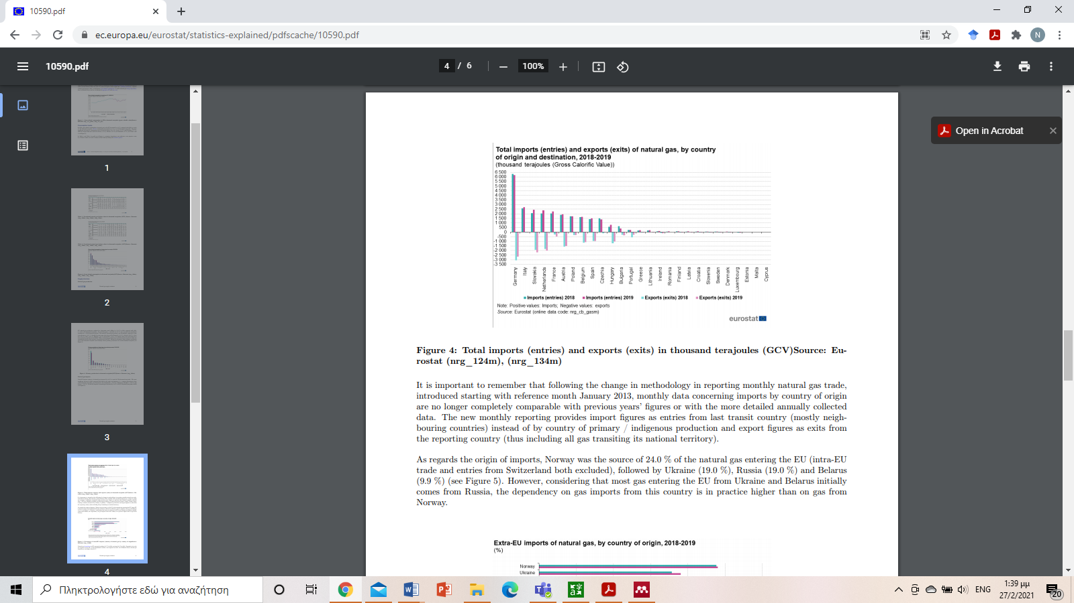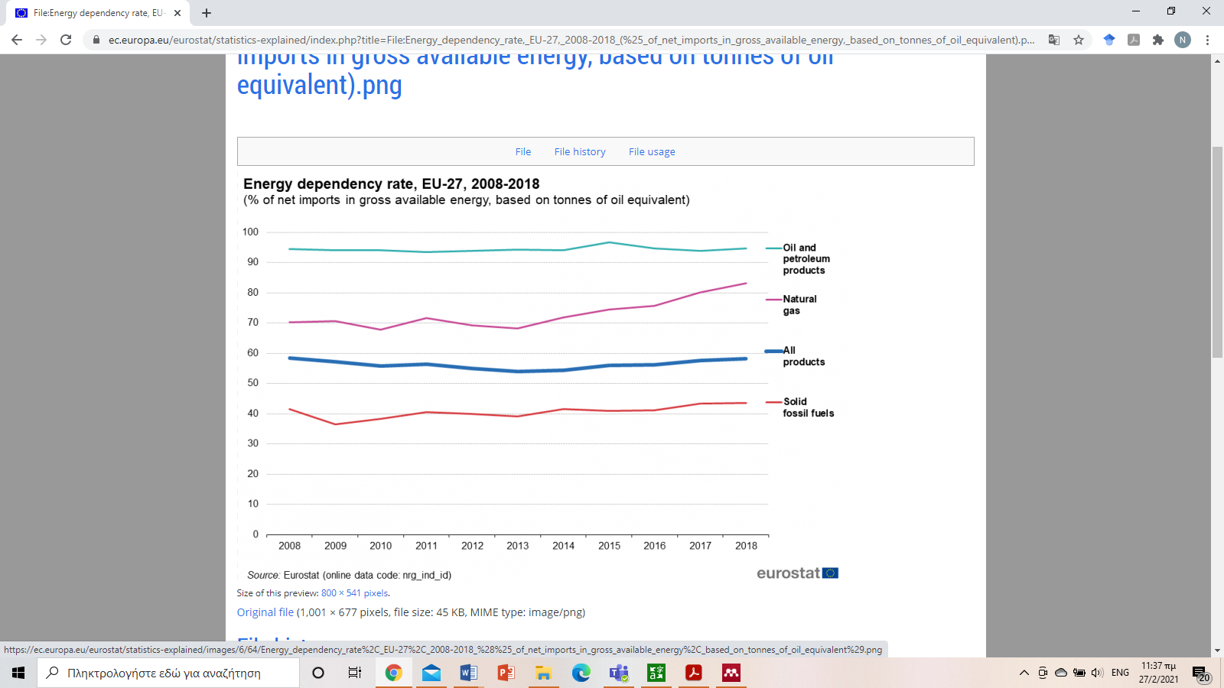Figure 3*: Energy dependency rate EU-27,2008-2018 (source: Eurostat*)

Figure 4: *Total imports (entries) and exports (exits) in thousand terajoules (GCV)*[Source: Eurostat (nrg_124m), (nrg_134m)]

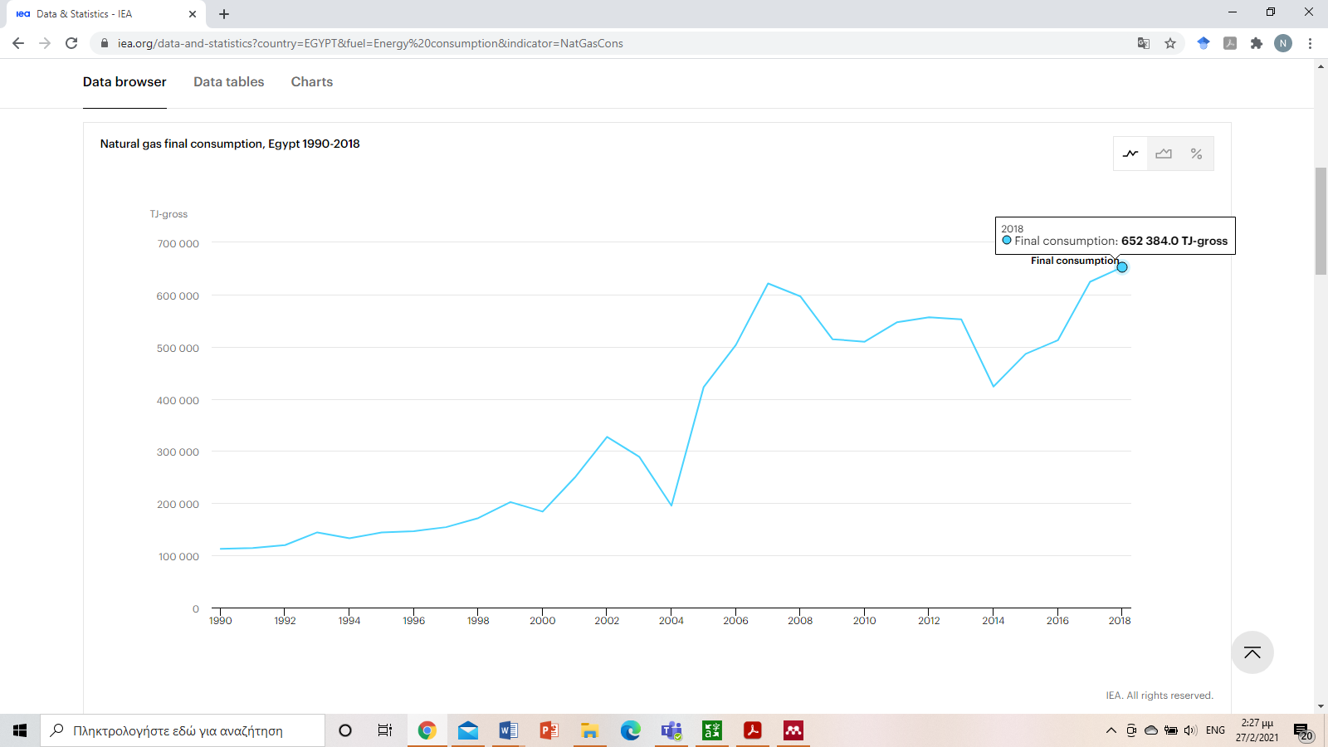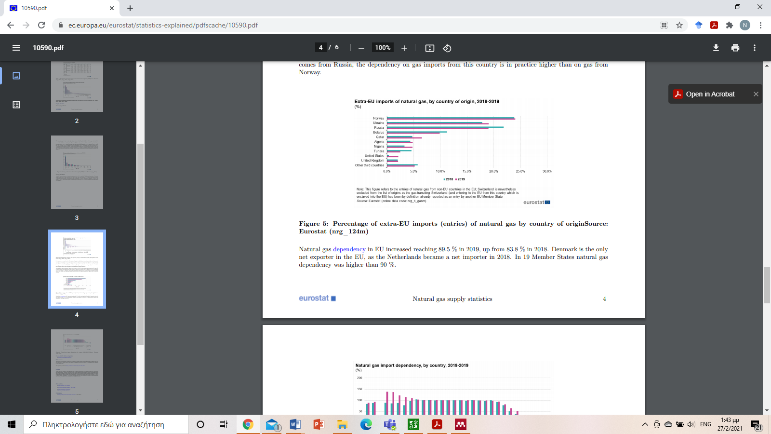Figure 5: Percentage of extra-EU imports (entries) of natural gas by country of origin [Source: Eurostat (nrg_124m)

Figure 6: Natural gas final consumption, Egypt 1990-2018 (Source: https://www.iea.org/data-and-statistics?country=EGYPT&fuel=Energy%20consumption&indicator=NatGasCons)

Figure 7: Natural gas final production, Egypt 1990-2019 (Source: https://www.iea.org/data-and-statistics?country=EGYPT&fuel=Energy%20consumption&indicator=NatGasCons)

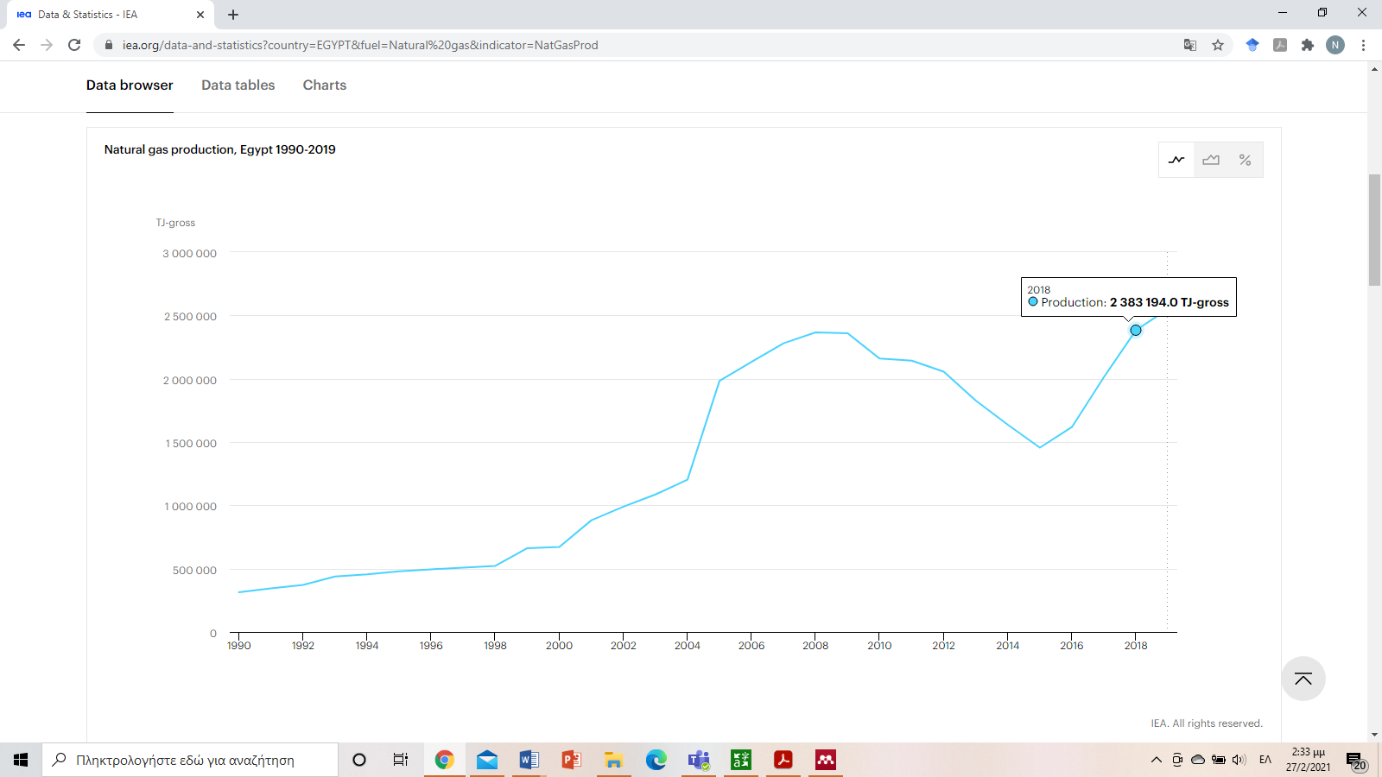

**Sources**

BP. (2020). Statistical review of world energy. https://www.bp.com/content/dam/bp/business-sites/en/global/corporate/pdfs/energy-economics/statistical-review/bp-stats-review-2020-full-report.pdf

Capros, E., De Vita, N., Tasios, P. Siskos, M., Kannavou, A., Petropoulos, S., Evangelopoulou, M., Zampara, L., Paroussos, K., Fragiadakis, S, Tsani, P., Fragkos, N., Kouvaritakis, L., Höglund-Isaksson, W., Winiwarter, P., Purohit, A., Frank, N. Forsell, H…, Witzke, M. K. (2016). EU Reference scenario 2016: Energy, transport, and GHG emissions trends to 2050*.* https://ec.europa.eu/energy/sites/ener/files/documents/20160713 draft_publication_REF2016_v13.pdf

Chyong, C.K. (2019). European natural gas markets: Taking stock and looking forward. *Review of Industrial Organization*, *55*, 89–109. https://link.springer.com/article/10.1007/s11151-019-09697-3

Demiryol, T. (2020). Beyond energy: The geopolitical determinants of Turkey’s Mediterranean policy. https://www.fpri.org/wp-content/uploads/2020/11/beyond-energy.pdf%0A%0A

Commission of the European Communities. (2008). Second Strategic Energy Review An EU energy security and solidarity action plan. Brussels. https://eur-lex.europa.eu/LexUriServ/LexUriServ.do?uri=COM:2008:0781:FIN:EN:PDF

Dettmer, J. (2020). Western frustration with turkey likely to build under a Biden administration*. Federal Information & News Dispatch, LLC*. https://search-proquest-com.marshall.idm.oclc.org/reports/western-frustration-with-turkey-likely-build/docview/2466915776/se-2?accountid=12281

European Commission. (2008). E.U. energy security and solidarity action plan: 2nd strategic energy review. https://ec.europa.eu/commission/presscorner/detail/en/MEMO_08_703

European Commission. (2020). E.U. energy statistical pocketbook and country datasheets. https://ec.europa.eu/energy/data-analysis/energy-statistical-pocketbook_en#country-datasheets

European Commission. (2014). E.U. Energy Security Strategy (No.14) https://ec.europa.eu/energy/sites/ener/files/publication/European_Energy_Security_Strategy_en.pdf). Brussels.

European Environment Agency. (2014). Energy dependence rate. https://www.eea.europa.eu/help/glossary/eea-glossary/energy-dependence-rate

Eurostat. (2018). Energy production and imports. https://ec.europa.eu/eurostat/statistics-explained/index.php?title=Energy_production_and_imports&oldid=498607#The_EU_and_its_Member_States_are_all_net_importers_of_energy

Eurostat. (2020a). E.U. imports of energy products - recent developments. Retrieved February 18, 2021, from https://ec.europa.eu/eurostat/statistics-explained/pdfscache/46126.pdf

Eurostat. (2020b). Natural gas supply statistics. Retrieved from https://ec.europa.eu/eurostat/statistics-explained/pdfscache/10590.pdf

Iana, D. & Stang, G. (2014). Energy moves and power shifts E.U. foreign policy and global energy security. Paris. https://www.iss.europa.eu/sites/default/files/EUISSFiles/Report_18.pdf

IEA. (2019). Energy security Reliable, affordable access to all fuels and energy sources. https://www.iea.org/areas-of-work/energy-security

IGI Poseidon. (2021). Eastmed. http://www.igi-poseidon.com/en/eastmed

ISSUES, G. O. S. (2016). *Ελλάδα, Κύπρος και Ισραηλ: Μεσοπροθεσμες ευκαιρειες και απειλές για την Ελληνική Εξωτρική πολιτική.* Αθήνα.

Kotzias, N. (2010). *Greece’s foreign policy in the 21st century.* (1st ed.). Athens: KASTANIOTI A.E.

National Public Radio. (2020) What might happen to U.S.-turkey relations under President Biden? https://www.npr.org/2020/10/24/926329337/what-might-happen-to-u-s-turkey-relations-under-a-president-biden

Shaffer, B. (2017). A Guide to the Application of Energy Data for Intelligence Analysis. https://www.cia.gov/resources/csi/studies-in-intelligence/volume-61-no-4/a-guide-to-the-application-of-energy-data-for-intelligence-analysis/

Stergiou, A. & Karagianni, M. (2019). *Does energy cause ethnic war? East Mediterranean and Caspian Sea natural gas and regional conflicts.* Cambridge scholars publishing.

Solomon, A.B. (2016). Israel Should Avoid Turkey, Include Cyprus in Gas Export Projects (No. 370). Retrieved from https://besacenter.org/perspectives-papers/370-ben-solomon-israel-avoid-turkey-include-cyprus-gas-export-projects/

Stamouli, N. (2018). Israel, Greece, and Cyprus back EastMed gas pipeline. *The Wall Street Journal*. Retrieved from https://www.wsj.com/articles/israel-greece-and-cyprus-back-eastmed-gas-pipeline-11545330357?mod=searchresults&page=1

Winzer, C. (2011). *Conceptualizing Energy Security* (No. 1123). https://www.repository.cam.ac.uk/bitstream/handle/1810/242060/cwpe1151.pdf?sequence=1&isAllowed=y

YPEN. (2020). Security of gas supply at national and European level. https://ypen.gov.gr/energeia/ydrogonanthrakes/fysiko-aerio/asfaleia-efodiasmou-fysikou-aeriou-s/

Zeniewski, P. (2019). A long-term view of natural gas security in the European Union. https://www.iea.org/commentaries/a-long-term-view-of-natural-gas-security-in-the-european-union

1. As part of the new initiative of the Laboratory seminars on International Relations & European Integration- Theory and Practice, the first seminar was held on Thursday 6 March on "Small Forces in Negotiations: The Case of Cyprus". The keynote speaker was the Emeritus Professor of the University of Indiana- "Purdue Fort Wayne" Mr. Evangelos Koufoudakis. Professor of the DES and Dean of the School of Social Humanities and Arts, Mr. Elias Kouskouvelis, as well as the President of the DEPARTMENT of DES, Associate Professor George Voskopoulos, were also placed. According to the Professor, whose research in recent times focuses on the International Relations of Small States, good preparation, know-how, lobbying, internal unity and cohesion, as well as victimisation (victims of bullying), on occasion, are among other things the components of success in the strategy of small states in negotiations. This is an 'intelligent strategy'. Referring to Greece, the professor stressed that we should understand our smallness, not as a weakness but as an objective factor in the design of our strategy. "We're not the sphinx that became a hawk, but we know well what a bee can do," he said characteristically.
2. The 5th gateway to the country is planned for the end of 2022, with the operation of the Independent Gas System in the Alexandroupolis region (FSRU of Northern Greece). The project includes the construction of a floating LNG station (FSRU), with a capacity of a maximum of 170,000 m3 LNG and an undersea pipeline, which will lead to the corresponding land section and will be connected to the ESMFA in the area of Amfiritis in Alexandroupolis. The average gasification capacity of the Station is 5.5 bcm per year and the maximum 8.3 bcm per year.