**INDC 48th CLASS**

**FINAL ASSIGNMENT**

**JERUSALEM TOUR**

**TEAM 1**



**Professors**

**Dr. Yossi Ben Artzi**

**Accompanying Instructor: Amb. Merav Zafary-Odiz**

**Word counting: 4865**

**MARCH 2021**

**PAGE INTENTIONALLY BLANK**

CONTENTS

iNTRODUCTION 1

CHAPTER 1: PREPARATION OF THE TOUR (PRINCIPLES – METHODS – RESEARCH QUESTION) 1

1.1 Principles 1

1.2 Research Question 2

1.3 Method 3

1.4 Pre- charging Lectures 5

CHAPTER 2: CARRYING OUT THE TRIP 6

1.1 Meetings 6

1.2 Conclusions 11

## iNTRODUCTION

The city of Jerusalem – in Hebrew Yerushaláyim, meaning the City of Peace, and in Arabic Al Quds, representing the Holy – is referred to as 'the Holy City' worldwide. This is due to its unique amplitude of religious sites of the three monotheistic religions, reflecting that Jerusalem faced the reign of Jews, Christians, and Muslims in its more than 3000-years old history. While Jerusalem today covers an area of 125,1km2, the Old City, bearing holy sites like the Dome of the Rock, the Western Wall, or the Church of the Holy Sepulchre, only amounts to 900m2. With Jews rushing to the Western Wall, Muslims hasted to the Temple Mount, and Christians walking down the Via Dolorosa; it is a kaleidoscope of the city's multi-faith character.

As Aristotle observed in the Poetics, the tragedy, "being crowded into a narrower compass," becomes more pleasing. Also, it shows more unity and can therefore attain its end "in a greater degree." This end of a drama should be surprising yet inevitable(DIMITRIOS LIPOYRLIS, 2008). If that is real, Jerusalem's question is one of the significant contention points in the ongoing Israeli-Palestinian conflict and undoubtedly one of the most difficult to solve. Apart from the political and territorial problems involved, the situation is further complicated because all three monotheistic religions, Islam, Judaism, and Christianity, lay claim to the Holy City. Although called the "City of Peace" in Hebrew (Yerushalayim) and "the Holy One" (al-Quds) in Arabic, tensions, and clashes over the holy sites in Jerusalem return periodically and bear the danger of sparking a fire in the whole Middle East.

On this background, the tour's research question was: *"To what extent the Abrahamic religions can be an instrument for enhancing Israel's national security and the harmonious coexistence in the challenging area of the Holy Basin?"*

## CHAPTER 1: PREPARATION OF THE TOUR (PRINCIPLES – METHODS – RESEARCH QUESTION)

### Principles

When we took over the specific mission, we discussed which principles the trip will be based on. Τo achieve innovation and at the same time stimulate the interest of the participants, we decided that we must forget what we know so far about Jerusalem, a thought that of its motion refers to Socrates Paradox "*All that know is that I know nothing.*" In other words, Socrates believes himself to be wiser than those he speaks to because, unlike them, he admits his ignorance(Jack Maden, 2020).

Besides, during the tour and to achieve the best knowledge, we decided to adopt the Socratic method of dialogue: a form of argumentative dialogue that uses incisive questioning to stimulate critical thinking and draw out presuppositions. That's why we made a great effort to formulate a unique research question.

### Research Question

Analyzing the Jerusalem legacy system, we found that one of the elements that dominate and influence Jerusalem's status quo is religion and, specifically, the three monotheistic religions that dominate the city's religious scene. Βy researching the issue of religions in a broader context, we found a direct link between religious beliefs and their national security impacts.

The correlation between religious persecution and national security threats is not just a 21st-century phenomenon ofpost–Cold War dislocations but also is present over the past century. Including World War II, every major war the United States has fought over the past 70 years has been against an enemy that severely violated religious freedom. Such was the case with Nazi Germany (persecution against the Jews), North Korea (persecution against the Christians), North Vietnam (persecution against Christians), and Saddam Hussein's Iraq (persecution against the Mesopotamian-Aramaic speaking Christians). This characterized other conflicts as well. Numerous smaller-scale military interventions, such as Lebanon in 1983, Libya in 1986 and 2011, Somalia in 1993, Bosnia in 1995, and Kosovo in 1999, were also targeted against actors that embraced religious intolerance.

The United States has struggled to find a framework to integrate religion into the post-September 11, 2001 (9/11) discussion of national security. Islam has been the central focus, with both the 9/11 terrorists and many of America's adversaries in overseas contingency operations sharing an Islamic heritage. The struggle to locate that framework has taken the United States down several roads since the turn of the millennium, none of which has been satisfactory. President George W. Bush viewed freedom as a universal value, with religious liberty as the preeminent characteristic of free, robust societies. He considered the post-9/11 conflict with the Taliban and al-Qaeda as a battle over freedom with this assumption. He believed that repressed Iraqis and Afghans would welcome the U.S. military as liberators bringing greater freedom, including freedom of religion. President Bush's beliefs were only partially validated. Part of the problem was the dissonance between a Western concept of freedom to choose and worship God against an Islamic idea to submit to God. Bush's construct of Religion as Freedom did not offer the optimal framework. Neither has President Barack Obama's Religion as Unity framework solved the problem. President Obama has asserted a universal value regarding religion-that all religions are united by a moral law to care for one's fellowman. Based on this assumption, President Obama has labeled radical Muslim terrorists as false Muslims and launched initiatives to honor Islam and resolve mutual misunderstandings through dialog with Muslim states(Shaw, 2011).

President Obama released his fifty-five-page plan in May 2010. The 2010 NSS reflects all instruments of national power used to achieve national security objectives. This NSS illustrates the intersections between religion and the four main tools of national power information, diplomacy, military, and economics—and introduces two separate but related topics: (1) strategy and the purpose that strategy serves and (2) how people understand and use religion. It approaches strategy as a grand, national strategy that includes a Clausewitzian definition and understands religion as a factor shaping and motivating behavior(Casey Lucius, 2013).

Taking into consideration the previous discussion and the fact that several negotiation efforts to solve the conflict, such as Camp David negotiations, failed in the end due to the disagreement about sovereignty over the holy places suggests that Jerusalem's status with its religious symbols and sacred areas to the three monotheistic religions seems to remain the heart of the conflict between Israelis and Palestinians.

In short, we formulated the following research question and subquestions:

*"To what extent the Abrahamic religions can be an instrument for enhancing Israel's national security and the harmonious coexistence in the challenging area of the Holy Basin?"*

* *Do they have an impact in the political sphere?*
* *Do they hold the potential to sow the seeds and change the population's mood towards a problem that must be solved on the political level?*

### Method

With the goal of combining innovation with the maximum educational outcome, we decided to proceed to the formation of mixed groups (see figure 1) in order to have participants from all organic teams in each group. In this way, we wanted to achieve the maximum outcome during the team processing as in all organic teams, there would-be participants who attended all the meetings.

One of the goals that had been set for the trip was to familiarize the staff with the Holy Basin and provide them the knowledge of the essential sights related to the three religions. Wanting to make the participants' partakers of Holy Basins' history, we developed an app that 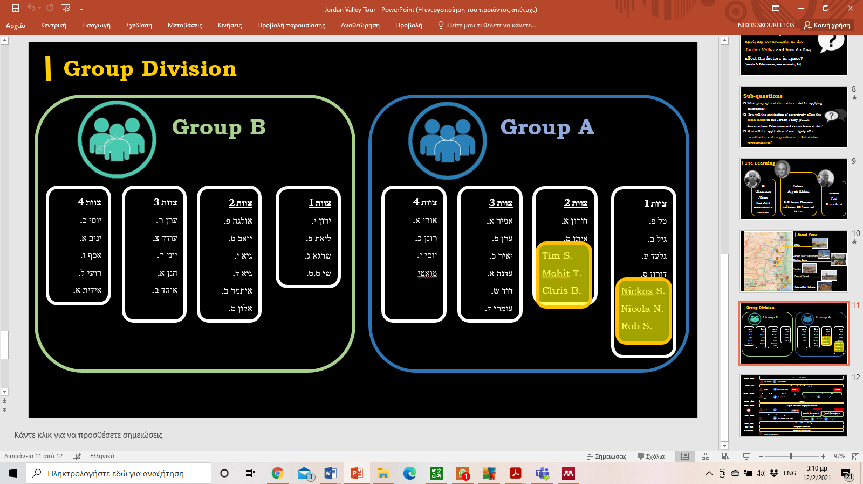combined knowledge with fun (see figure 2).

*Figure 1: Group Division*

*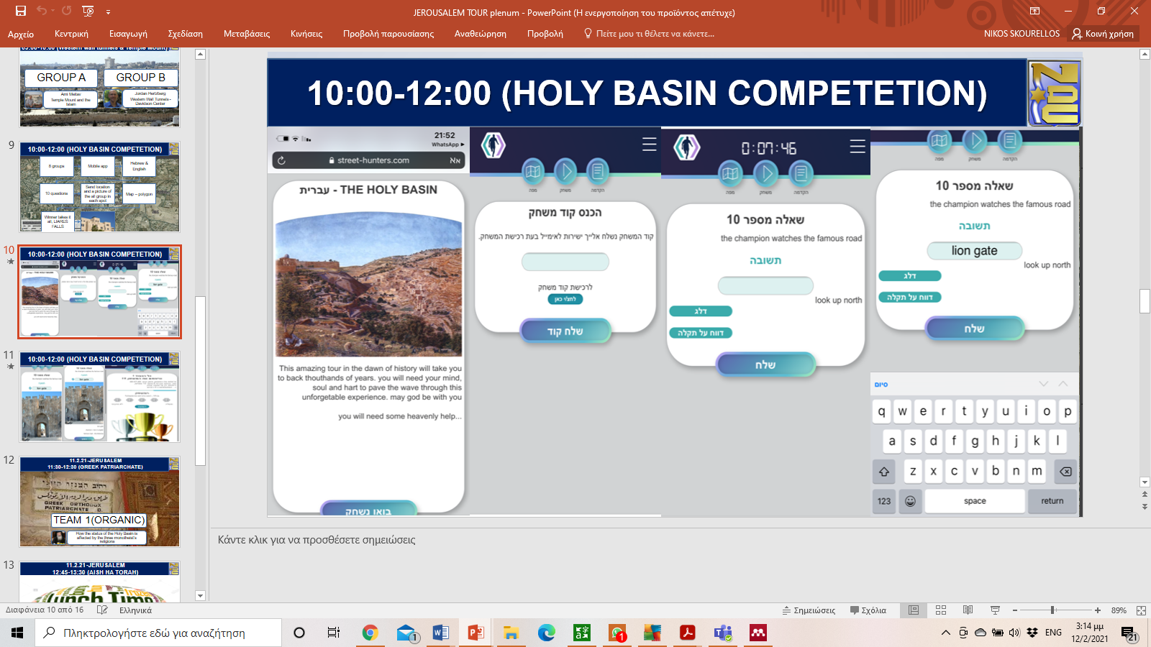Figure 2: Holy Basin Competition App*

### Pre- charging Lectures

|  |  |  |  |  |
| --- | --- | --- | --- | --- |
| **N/A** | **DATE** | **TIME** | **LECTURER** | **SUBJECT** |
| 1 | FEB 3nd | 11:00-12:30 | Ehud Olmert | The Jerusalem and the Holy Basin as a phenomenon |
| 2 | FEB 3nd | 14:45-15:45 | Ziad Ali Khalil Abu Zayyad | Religion and national security  The case of Holy Basin |
| 3 | FEB 3nd | 15:45-16:15 | Team 1 | Tour Briefing |
| 4 | FEB 4th | 08:30-10:00 | Ben Abrahami | Christians and Muslims in Jerusalem |

*Table 1: Lecture Program*

**Ehud Olmert**: In his opinion, a two-state solution is the best one. The Israel state has to think about the Palestinian state's existence based on the concept of 1967 borders. He argued that Israel made a mistake when it took over east Jerusalem in the six-day war. There is a natural assumption of most Israelis and identify Jerusalem as it is today. This is a false assumption. There is no connection and link to pre-1967 Jerusalem. In some years, the mayor of Jerusalem will be Palestinian.

The holy basin is vital to all three religions. There isn’t real Israeli sovereignty over the Holy places. There is no possibility to solve the Israel – Palestinian conflict without solving the Jerusalem issue. Furthermore, there is no way to reach an agreement if Israel wants exclusive sovereignty in Jerusalem. Even today, the belief that Israel has real authority is false due to its limited nature. The solution must include international inspection and divided sovereignty of the holy places (USA, Saudi Rabia, Jordan, Palestine, Israel).

As Prime Minister, he never sought religious leaders' opinions in all the negotiations and discussions he participated in. He does not, of course, know whether the Palestinian side did. The Holy Land and Jerusalem issue is a purely political one and must be resolved at the political level.

**Ziad Ali Khalil Abu Zayyad:** The term Abrahamic religions is a Trump invention to justify the Abraham accords. Furthermore, the term Holy Basin began to be used after the 19th century and is intended solely to serve political purposes. When we started to use those terms, there was room for negotiations. Today there isn’t room for negotiations nor a possible two-state solution. The existed settlements are the most significant barrier to the two-state solution. As far as the Holy Basin is concerned, an international intervention would be a mistake. The responsibility must rely on Israelis and the Palestinians.

**Ben Abrahami**: Jordan has a historical role; it is also a key player in Jerusalem. The Jordanian Jerusalem before 1967 was a tiny area. Israel annexed huge territories (75.000 dunams) that weren’t part of Jerusalem. The East Jerusalem population consists mostly of immigrants. Israel, from the first moment, choose de facto to share Jerusalem’s sovereignty.

East Jerusalem became the beating heart of the Palestinian movement. The residents have kept their culture, their identity, and their percentage is growing. If they vote for the Knesset in the future, they will earn seats. The trend today is one state – two nations. That process has opened the doors to other forces. Turkey, in recent years, has invested millions of dollars in East Jerusalem. Turkey tries to erode the Jordanians Hegemony in Holy Basin. In the Holy Basin, the Cristian church plays a key role. The Greek patriarch has demands, and Russia’s president supports him.

## CHAPTER 2: CARRYING OUT THE TRIP

### Meetings

1. **Davidson Center (Jordan Hertzberg)**

The lecturer gave a broader picture of the status of the Holy Basin. As far as the research question is concerned, he used the example of Camp David accord to connect how much religion affects national security and conflicts that must be solved at a political level. The lecturer claimed that one of the reasons that led to the Camp David negotiations' failure was the disagreement about sovereignty over the holy places. This suggests that Jerusalem's status with its religious symbols and sacred areas of the three monotheistic religions seems to remain the heart of the conflict between Israelis and Palestinians.

He also criticized the current arrangement of administration on the Temple Mount. According to the lecturer, there is no Israeli governance on the Temple Mount - the Jordanian-led Waqf does what it wants. He believes that the situation in which a Jew cannot pray on the Temple Mount is a disgrace. The Blue police do not enter the Arab neighborhoods in the east of the city without a border escort. Abu Tor is the home to 700 Jewish families - along with an Arab majority. They live in coexistence without particular frictions.

1. **Temple Mount (Yossi Ben Artzi - Ami Meitav)**

To understand the situation, it is appropriate to mention the importance of this hill located within Jerusalem's Old City, called the Temple Mount or Haram al-Sharif (meaning noble mountain), and how it is one of the most important religious sites in Jerusalem. The Temple Mount is the northern part of a very narrow and low hill that rises above the cedar valley to the east and the West's tyros valley. Mount is an important religious site for Jews, Christians, Romans, and Muslims. The bible scholars have identified it with two mountains, Mount Moria, where Abraham tied Isaac to sacrifice, and Mount Sion, where the Fort of the Jews was located.

For Jews, the biblical Mount Moriah, today is known as the Temple Mount, is the holiest place on earth. First mentioned in the book of Genesis, the Jewish people have always associated with the place where they are closest to God. It is where David's son, King Solomon, built the first temple, also known as Solomon's Temple. After the Babylonians' destruction, the Second Temple was rebuilt there and reached its most magnificent form during King Herod's reign. Both temples have been the center of Jewish life, and the sanctity remained with the site after their devastation. In today's daily practice, Jews are urged not to step on the Temple Mount due to the place's holiness. That is the reason they pray on the Western Wall, a relict of Herod's massive retaining wall, to get as close as possible to the place where the Holy Temple stood.

For Muslims, Jerusalem is the third holiest city in Islam, next to Mecca and Medina. The Temple Mount is assumed to be the destination of Mohammad's Night Journey, the Isra', that started from Mecca, and the Dome of the Rock is supposed to be the place of Mohammed's ascension to heaven afterward, called Mi'raj. Furthermore, it has been the original direction of prayer for Muslims before it changed to Mecca. Today the Al-Aqsa mosque is the site of Islam's third holiest shrine.

During our tour on the Temple Mount, ProfessorYossi Ben Artzi, using Abdullah I's assassination by a Palestinian nationalist at the Al Aqsa Mosque entrance in Jerusalem, managed to illustrate the correlation between religion and national security. He also referred to the current arrangement of administration and how that arrangement affects Israel's national security. Since the occupation of 1967, Israel claims full sovereignty over Jerusalem and its holy sites. Still, it allows de facto control of the Temple Mount's daily affairs to the Waqf, the Muslim religious trust.

Ami Meitav claimed that he sees no other option than to remain in Israel as for the Holy Basin's sovereignty. The Christian community is somehow crushed between Jews and Muslims in this conflict. This is due to the relatively small number of Christian believers living in the region compared to Jews and Muslims. Most of the visitors coming to the Christian Holy Sites in the Old City are indeed pilgrims. Both in Israel and in the Palestinian Territories the Christians only constitute a small minority of the inhabitants. Combined with the political dimension the relation between Jews and Muslims attained, this contributes to a marginalization of Christians regarding the attention they receive in this triangle. The Christian community lives in a state of fear, and the State of Israel offers them security because even today, they are still oppressed by Muslims.

All the above-mentioned show in the most distinctive way that culture, religion, and unique places of worship not only affect the cultural, political, and diplomatic relations of the peoples but define them to a necessary extent, so that any diplomatic effort to peace, agreement, transnational relations, etc., passes through these perceptions of the peoples concerned. The peculiarity of this small hill in Jerusalem, a place sacred to the Jewish and Islamic religion, proves this belief and is a crucial point for international relations and clearly in the resolution of the Palestinian issue.

1. **Greek Patriarch (His Beatitude Theophilos III)**

At the very beginning, his Beatitude referred to the role and history of Jerusalem's patriarchate.

In the history of the shrines at the Holy Land, the Greek Orthodox Patriarchate plays a primary role. Its formation is traced back to the day of Pentecost. According to the Apostolic authors' testimony, the first bishop of the Church of Jerusalem was James, the Lord's Brother. He systematized the divine liturgy and contributed significantly to the Apostolic Synod, which met in Jerusalem around 50-51AD, which proclaimed Christianity's self-containment and freedom from Moses's Law.

The Church of Jerusalem is the only self-sprouted and indigenous Church in the Holy Land. Being Orthodox, the Church has preserved the Orthodox Faith of the Apostles and Church Fathers, which has been maintained unaltered through the ages. The rest of the Christian confessions and communities, having their ultimate reporting to their national or centralized ecclesiastic administrations outside of the Holy Land. They obviously lack the critical role that the Jerusalem Church plays under the guidance of the Order of the Industrious Ones, namely the Hagiotaphitic Brotherhood (Brotherhood of the Sepulchre).

His Beatitude claimed that the Greek Orthodox Patriarchate, the only autocephalous, or ecclesiastically independent, Eastern Orthodox patriarchate, fourth in honorific seniority after the churches of Constantinople, Alexandria, and Antioch, plays a critical role even in the political life. Even though it is a religious institution for reasons that he claimed we easily can understand, it affects even political decisions.

Besides, he claimed that as early as 1948, immediately after the end of the second world war, world leaders began to explore ecclesiastical leaders' role in the world affairs, and the first conference under the auspices of the League of Nations was held with religious leaders as guests. Today more than ever, the issue is in the limelight. Religious leaders and the religious narratives are also inextricably linked to national security worldwide and consequently in the Jerusalem region. In the future, he sees a new form of administrative organization in which church leaders will also participate.

Regarding the status quo of Jerusalem, he replied that no one is ready to raise the hot issues, which is the main reason why not all negotiations have progressed. When the decision-makers decide to take seriously the issues that form the core of the conflict, then there is a chance that a solution will be found to the chronic problem of Jerusalem. Mutual concessions must be made available to Jerusalem's status, which can be done in the future. Younger generations are co-educated in various educational institutions, and this creates a new reality. In the Christian school that operates under the auspices of the patriarchate, most students are Muslims. The key to success lies in joint education.

1. **Rabbi Shmuel Rabinowitz**

There are no real relations between the Muslims and the Jewish on religious issues. Their concerns are based on solving only technical problems. There is better communication with the Christians. There is an interference of political figures in the holy places. In his perspective, there is no place for international intervention in the Holy Basin.

1. **Mrs. Maayan Raveh**

The term for shaping in the context of the Israeli-Palestinian conflict's sacred sites is the status quo. This is a situation where no agreement can be reached - neither party is willing to compromise. Neither side can take a step back. Therefore, anyone pushed back should respond aggressively and move forward. As a result, both sides agree to stop the fight. Any compromise will be seen as a religious concession, so the problem remains stagnant. Of course, political issues are also involved - the interests of countries in sacred places.

After establishing the state, the Christian world understands the religious significance of the Jewish people's return to the Holy Land (despite the fundamental belief that Christianity took the place of the Jews as the chosen people). In 1948 and as a result of the Holocaust, Christian theologians asked if there was anti-Semitism in Christianity and how another Holocaust could be prevented. That is why in 1965, a statement is issued that Jews are no longer guilty of the murder of Jesus, and the Jewish people are still the chosen people, and the Jews have a historical connection to the Bible. Judaism is seen as the older brother of Christianity - the more we explore them, the more we will understand Christianity.

In 1967, after the liberation of Jerusalem, Israel maintained its status quo. Because behind each of the parties stands God. There are several streams of Christianity. There are between 300-400.000 Christians in Israel. Of these, about 150,000 Arabs are Christians. Many Christians come to the pilgrimage, and the churches in Israel support them. The Bible is common to Judaism and Christianity.

The counter-reaction to this was the development of the "Palestinian Jesus" narrative. That is, the Palestinians are the descendants of Jesus and hence their right to the land. This is also a Palestinian use of the leaders' claim: If he were alive today, he would be detained at a checkpoint near Bethlehem. There are also sympathetic Christian approaches to the Israeli side in the conflict; however, it is essential to understand the impact of the Palestinian Christian perception on the conflict. The Palestinians - the PA sees Jesus as a Palestinian envoy for peace - if Jesus were alive today, he would be fighting the Israeli soldiers. This resonates with Christians who know the conquest through Christ today.

1. **Jerusalem Mayor (Moshe Lion)**

There is a broad demographic mix between populations in Jerusalem and supposedly functions as a capital with the inhabitants of all currents and religions. The inhabitants feel that they are treated as required. It was grown as a significant part of all the cities of Gush Dan. They will feel treated as needed. It was cultivated as an essential part of all the towns of Gush Dan. Jerusalem is divided into neighborhoods. In recent years, the influx of ultra-Orthodox people into secular communities has begun-which is a challenge. Jerusalem is the largest ultra-Orthodox city and Arab city in Israel. A neighborhood in Jerusalem can have about forty to fifty-thousand residents. There is tremendous administrative complexity in managing the city.

Regarding East Jerusalem, about three hundred fifty-thousand (350,000) residents, more than a third of the city's residents, is a very young population (35 percent aged 0-14). Eight thousand six hundred (8.600) babies are born in the east of the city each year. Fifty-nine percent (59%) of the residents in the east of the town are deficient, and every family consists of about five members (two or three children per family). Regarding the labor force participation rate, seventy–nine percent (79%) of men work and find employment within the city's east in the high-tech field. Only twenty–nine percent (29%) of the women are employed, and they try to find suitable employment while building daycare centers for children.

There is a neglect of the education system in the east of the city. There are about two hundred eighty thousand (280,000) students in the city - of which about one hundred and ten thousand (110.000) are Arabs. According to a Jordanian curriculum, about 95% of Arab students study, impairs their ability to integrate into the labor market and academia. Ninety-three thousand (93.000) of them in public education, of which 95 percent study the Jordanian education system that is not recognized in Israel - can not continue to higher education in Israel. The content there includes incitement. Attempts are being made to make changes in this system, following the government's decision, while changing the education system to the existing one in the Israeli education system in the areas located in the east of the city.

Because of the pandemic, ties with the inhabitants in the east of the city were strengthened. They are interested in enhancing sovereignty in all parts of the city and the Holy Basin. The municipality has a close relationship with the Waqf and tries to do everything in agreement regarding the Holy Places.

***The mayor believes that even in a future agreement, Israel's sovereignty over the city will remain.***

### Conclusions

**Duration:** The one day allocated for the trip was characterized by all participant's inadequate. The trip's duration downplayed Jerusalem's importance and did not allow us to explore the research question in depth. On the other hand, it was a challenge that led us to think of innovative methods to achieve tour objectives.

**Method**: The method regarding the mixed groups was described as useful because it achieved its primary aim of increasing educational benefit and increasing team processing effectiveness. In each organic group, some participants had attended all the lectures and not part of them. Furthermore, the application developed for the competition's conduct managed to combine the participants' fun with their familiarity with the historical and religious importance of the Holy Basin.

**Research Question:**

The relationship between religion and politics is not only about the Middle Ages but seems to be a structural feature of human civilization in general. Political scientist Andrew Heywood(Andrew Heywood, 2013) points out in this regard that "the most important aspect of the growing political importance of culture is undoubtedly the awakening of religion and the emergence of religious movements'. The radical religious revival in the militant form of fundamentalism from the 1970s onwards on a global scale, mainly around major monotheistic religions, Jewry, Christianity, and Islamism, has changed the traditional view of the relationship between religion and politics.

Under the Barack Obama administration, the issue of religion on international policy gained a distinct strategic interest in the White House and the US. As President of the United States, Barack Obama has highlighted the catalytic importance of religion's political and diplomatic role, thus signaling more generally the defining element of freedom of religion, especially in modern multicultural societies (Chane, 2013). From her position as US Secretary of State, Hilary Clinton gave central importance to the relationship between religion and international politics, both within the strict institutional frameworks of the State Department and through the institutionalization of relevant working groups(Chane, 2013). From the perspective of the United States, the value of religious involvement in international relations gradually acquires a prominent place in decision-making and, by extension, in the formulation of foreign policy in general. Although the link between religion and politics only recently began to concern political scientists and internationalists systematically, it is now a common assumption that religion has had and continues to have a significant impact on international relations at both structural and procedural levels.

The return of God, according to the expression of the notable scholar of the new religious movements for the recovery of the world Gilles Kepel(Kepel Gilles, 1992), in the 1970s, takes off literally through the Arab-Israel conflict. Radical religious fundamentalism is a vital issue of international politics in the sensitive and unstable geopolitical field of the Middle East (Spiropoulos Georgios, 2011), with the three dominant monotheisms in a constant state of holy struggle and exterminating conflict.

The Arab-Israel wars and successive waves of intifada cannot shadow the semantic fact that the Middle Eastern, as the epitome of post-war international relations, takes place on biblical land, exactly where the major monotheistic religions were born. Religion constitutes a contributing factor in the Israeli-Palestinian conflict. Since it is part of the problem, it also has to be part of the solution. But up to now, religion's capacity to the issue has never really been taken into account during the countless attempts to solve the conflict. Religion touches people in a much more emotional way than political arguments do. It always creates a tense mixture to interweave both spheres, politics and religion. But in the particular case of the Israeli-Palestinian conflict and the Jewish and Muslim claims over the Temple Mount, it is the most explosive combination imaginable.

As the Greek Orthodox patriarch claimed, the peaceful concepts of coexistence in Judaism, Christianity, and Islam are the key to decrypt the Jerusalem question that is politically stuck at the moment. Furthermore, the key to success lies in joint education.

**REFERENCES**

Andrew Heywood. (2013). *Politics* (5th ed.). New York: Houndmills, Basingstoke, Hampshire.

Casey Lucius. (2013). Religion and the National Security Strategy. *Journal of Church and State*, 50–70. Retrieved from https://academic.oup.com/jcs/article/55/1/50/807100

Chane, A. K. & B. J. (2013). *Diplomacy and Religion: SeekingCommon Interests and Engagementin a Dynamically Changing andTurbulent World*. Washington, DC. Retrieved from https://www.brookings.edu/wp-content/uploads/2016/06/Religion-and-Diplomacy_English_Web.pdf

DIMITRIOS LIPOYRLIS. (2008). *POETICS*. THESSALONIKI: ZITROS.

Jack Maden. (2020). Socrates and the Socratic Paradox: I Know That I Know Nothing. Retrieved February 12, 2021, from https://philosophybreak.com/articles/socrates-and-the-socratic-paradox-i-know-that-i-know-nothing/

Karen Amstrong. (2002). *The Battle for God: Fundamentalism in Judaism, Christianity and Islam*. Athens: Filistor.

Kepel Gilles. (1992). *THE REFERENCE OF THE GOD ISLAMIC, CHRISTIAN, EBRAIC MOVEMENTS IN THE RECOVERY OF THE WORLD*. Athens: LIVANIS.

Shaw, J. E. (2011). *The Role of Religion in National Security Policy Since September 11, 2001*. Retrieved from https://www.researchgate.net/publication/235019275_The_Role_of_Religion_in_National_Security_Policy_Since_September_11_2001Carlisle_Paper

Spiropoulos Georgios. (2011). *Middle East. Arab-Israeli conflict. History - politics - diplomacy.* (1st ed.). THESSALONIKI: University of Macedonia.