""Ambush from the Future  
On transformative force build-up

Eran Niv1

◆

The IDF, like any large organization, is in danger of over-reliance on existing solutions and the development of a conservative organizational culture. The problem is that when an organization freezes in its development, it may be surprised by a turnaround that should have been prepared for in advance. The author describes the three shortcomings in the IDF's innovation: lack of General Staff initiative, long and inflexible force build-up processes, and a hierarchical and risk-hating organizational culture. To overcome the aforementioned challenges, solutions are presented in several areas: conceptual design, architectural design, development of combat methods and strengthening of the IDF's ability to experience and learn. Through using these methods correctly, the IDF will be prepared for the next war, not just the previous one.

                             

A new book written not long ago makes a serious claim: in a future confrontation with China, all American communications and intelligence satellites will be taken out of operation. Precision missiles will neutralize the front bases in Guam and Japan, aircraft carriers will have to move away from space due to a similar threat, and therefore the attack aircraft will not be able to refuel and in fact, most American forces will find themselves incapable of moving quickly and collecting information.

Why did we become so vulnerable? He asks and answers: because we have lost the vitality required by military force, that is, the ability to realize the "Kill Chain", which means identifying the threat and taking determined action to thwart it.

How did this happen? He goes on to ask. He does not blame the intelligence, the political echelon, technological exploitation or lack of resources (after all there is about a trillion-dollar budget a year). Rather, he points to the bureaucratic inertia bound by fixed interests. The Pentagon, he claims, is very effective in realizing Yesterday, therefore, the force builders are "busy polishing and cleansing the 'legacy' systems and thus we have reached a situation in which **the US got ambushed by the future**". Most Western armies that are partners of the Americans share the sense of a gap of change, which has caused Americans to establish "Future Command" and the British to establish the "JHub Defense innovation." It is clear that a military organization, like any large organization, may fall into the trap of conservatism and find itself in a gap of relevance in the face of future challenges on the battlefield, of which there are countless examples. The IDF also needs to explain to itself how the great relative advantage it has over its enemies does not lead to a clear result in confrontation. The Shiloah Division was established as part of a number of solutions to this problem, and later on, how the division will deal with the need for change.

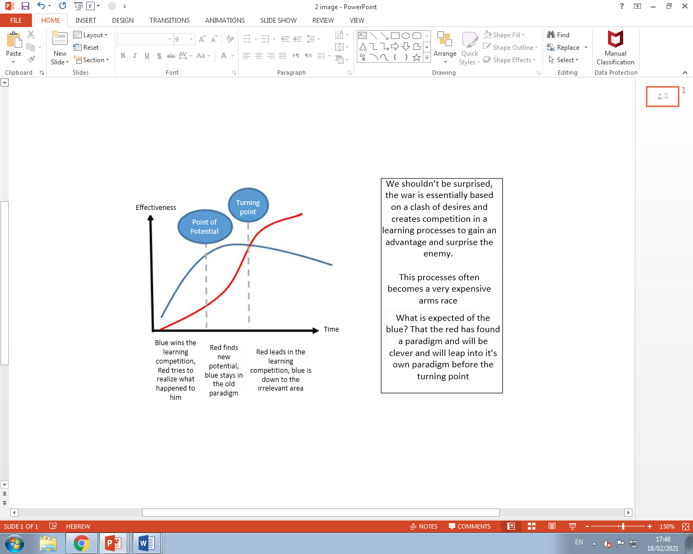

The first part of the "Victory Workshop" held in the IDF in 2019, dealt with identifying gaps, shifts between the army's force building and the enemy's assessments, and plans. In the draft "conception of victory" that followed the workshop, the following was written - "In the decades the latter has undergone a gradual change, which has become essential, in the nature of the military threats in the first circle, the main threat that was once a mechanized state army gave way to a threat of terrorist armies ... benefiting from their own territory and weapons and fire systems steps of the path that are becoming more sophisticated ... as a result of the partial response, the terrorist armies continued, encouraged by their successes, to develop the concept of attack in fire, and expanded it to trends of saturation, precision, cruise missiles, rum close to the ground and more. Alongside these continues the assimilation into the urban space, the decline to give land and the decentralization of power over the surface of large spaces."

The learning contest can be shown in the drawing above. The reader will ask himself why the army of the state of the Start Up Nation, an army that invented an advanced tank, "Iron Dome" and innovative fighting methods fails to change at the required speed in the digital age we are in? Well, our enemies have a variety of advantages including high availability of rapidly advancing civilian technologies , powerful back-up and an advantage for smallness and agility. In order to win the learning competition, it is necessary to find the mechanism for change. How do you do that? This article will address the question the relevance of the development of the military force while observing the learning competition in order to answer the basic question - how will the IDF maintain supremacy over the enemy in order to ensure a clear victory on the battlefield?

I will present three main problems that make it difficult for the IDF in the process of change:

The first problem - difficulty in general activism - the IDF was built on the basis of strong arms and wings that know how to implement in the best way the core power build-up. However, The Fourth Revolution introduces high digital capabilities of connectivity, processing and accessibility that are evolving very rapidly, requiring multi-arm transformation from top to bottom. In order to exhaust the connection between all the capabilities and in order to ensure that the capabilities reach the operational extremes, architecture and standards of communication must be imposed on all bodies. Such an organization would allow applications to "communicate with each other" and be based on databases and shared engines, and to optimize the operational processes and capabilities for multidimensional combat.

This transformation requires General Staff proactivity.

The second problem - building a force that is not flexible and not agile enough to respond to the emerging enemy and does not follow and change properly in the face of external developments. What would you say if in December 2019 someone asked you if it was possible that in a few months the whole world would be under a virus attack that would bring down hundreds of thousands of victims and put the world in economic chaos? The answer seems to have been no. This example shows how difficult it is to anticipate and plan long-term power building processes.

Building significant power can take years. In these years, the world is changing so fast that a new plan that ends after a few years will be outdated and irrelevant. Take, for example, the field of artificial intelligence. Today AI is a code name for a huge change in processing capabilities, the potential for this field lies in the ability to analyze huge databases, video images, processing natural languages, robotics and many other things that are changing the world. For example, the field of "deep learning", which is the leader in this world, began to flourish as early as 2012, but most countries in the world formulated a strategic policy regarding AI only in 2018-2017, In this medium it is generational. The world is changing very fast, and we need to formulate "antennas" and abilities that will match the pace.

The third problem - how to implement innovation within a hierarchical and large organization. In the Power Building Workshop (2017), the Deputy Chief of Staff addressed the issue - “The built-in expectations framework in this generation of servants includes the opportunity for everyone to 'change the world ’through initiative and talent. However, the military, hierarchical and clumsy organization, slow in its response and risk-averse, combines entrepreneurship that grows from below with high walls of invisible organizational barriers, both at the concept stage and in its implementation. "

If so, an innovative and forward-looking force building is needed that can cope with the changes in white, red, and blue (world, enemy, IDF, respectively), allowing a multi-armed and multi-dimensional force building, and making it accessible on the operational end. Of the Shiloah Division is as follows:

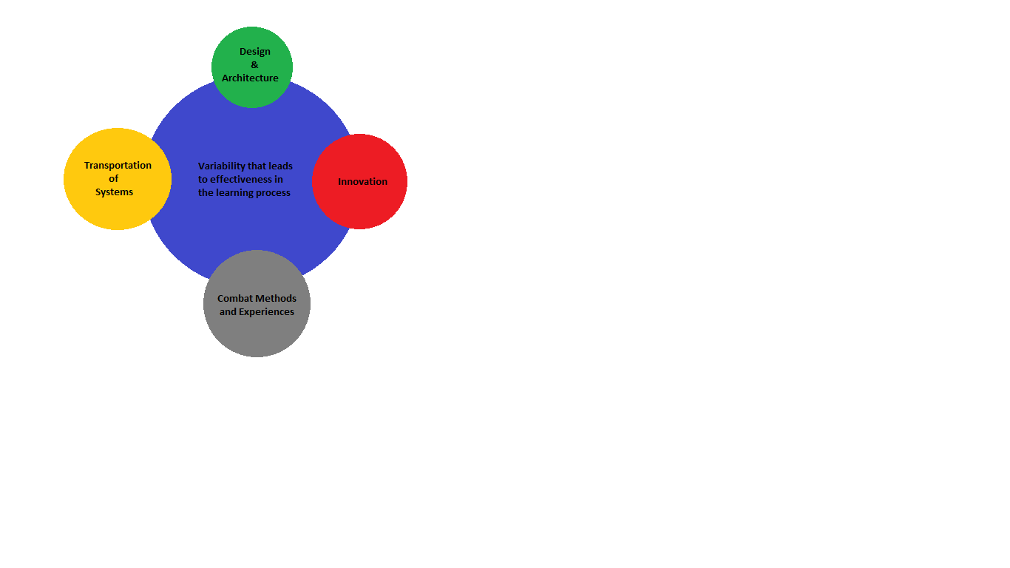

**Design and Architecture**

The question "Where did you come from?" (5) invites a thorough genealogical investigation that examines developments over time - the development of the enemy, our development, and the development of the world. The analysis will take an in-depth look at the perception that motivated us to deal with the problems facing us and examine whether we are on an offset, i.e. under a relevance gap that allows the enemy to jump in the learning competition. The investigation should also look in depth and say where this offset came from, whether it stems from a lack of knowledge, a wrong method choice, a continuous denial of the emerging reality, and so on (6).

The process of inquiry cannot be done with critical vision and sharp insights, it must **bring about change**. It is a difficult and sometimes painful process, it requires a departure from the frameworks of thought and action that were accepted in the organization, it makes us look in the mirror and not like what we see, but it is essential to produce change (7).

The products of the design process will be embodied in an operationally tricky conception that exploits the enemy's weaknesses, strengthens the organization's strengths, harnesses the development trends in the world and points the way to build the army to defeat the enemy. This perception must be robust enough in the face of the enemy's renewal, it must be clever, confront it with dilemmas, slow down its power structure and accelerate its own in order to increase the superiority gap continuously and in the long run (8). The immediate step after the design process, and can be said to be a part of it, is the stage of building a **multi-layered architecture**/

___________________________________

(5) "Akvia ben Mahalal says, look at three things and you will not be offended. Know where you came from and where you are going, and before whom you will give an account" (Mishnah, Tractate Avot, Chapter C, Mishnah A (the words "and before whom you will give accountability may be perceived as a kind of "push to the furrow", but Rabbi Akavia's history proves just the opposite. Rabbi Akavia was a sage from Eretz Israel who lived in the first century AD and dealt mainly with the laws of purity. The majority decided, "so that there would not be much controversy in Israel" and even promised him that if he did so he would be appointed father of a court. However, Rabbi Akavia refused their proposals and said - "I had better be called a fool all my days and not be evil for an hour." Due to this, the sages expelled him until the end of his life (client from "Pirkei Avot", a new Israeli commentary, Avigdor Shenan, p. 78). A deep discussion can be started as to whether Rabbi Akavia took the right path and fortified himself in this way. To look rather through the reflector of values ​​- the value of adhering to a task in the light of the goal and not in the light of authority or money.

(6) Meir Finkel and Eran Ortal, "Creative Mining from the Past", between the poles 21-20, July 2019.

(7) In the 'Land on the Horizon' process, the land arm recognized, for the first time officially, authoritatively and clearly, that the land maneuver was in a significant crisis ... For the first time, the arm recognized the fact that its existing power building trends, alone, do not lead to another line. 'More of the same' does not advance us to the required change "(General Aharon Haliva, from: Eran Ortal," Confused? We too! ").

(8) There are many examples of a design process, see articles in the booklets "Between the Poles" (knowledge on the transformation of the Home Front Command, Finkel on the power building for Operation Aretz 19, Kochavi and Ortal, "Act of the Armed Forces") and an interesting article on the paradigm of the use of force Shipping by the Marines -

"Expeditionary advanced base operations handbook” (Marine corps warfighting lab)

It is common to think of architecture because is the connector between abstract thinking and practical design. In our case, the design process ends with the presentation of the requirements arising from the concept, some will be functional requirements, those required for the process, for example, if the concept deals with denying enemy capabilities then at the end there is a functional requirement dealing with how many goals, how accurately of an attack is required and so on. In addition, there are requirements that are not functional but are basic to the system, for example, the requirement for unified fusion of all products, the requirement for connectivity between all digital systems in space and so on.

The architecture process will convert the requirements into a system that can be implemented. This definition is important because it is not just about technological architecture, it is also about unique organizations, the structure of the PUSH, the training and so on. The architecture is not a plan, it makes sense to connect the system components so that greater output is created from the components separately and, of course, it must provide an appropriate response to the requirements of the design process.

For example, in order to exert a deadly, fast, and accurate attack-exposure effort, a digital architecture is required that produces an information standard and sensor standard so that the exposure systems can communicate quickly and accurately with the attack systems and rely on accurate 3D mapping infrastructure. Architecture is also required to define the Command And Control system, for example, when an attack can be automatic and when a person must be in a circle, it must define the training required for office holders and the dedicated organizations for implementing the concept. The people who are engaged, what is the Command And Control and what are the affiliations, what is the budget route and what is the future development and so on.

One should know that in power building there are things that can be easily changed and there are things that are difficult to change after we have started. Architecture belongs to the second type, once determined it determines the required technologies, the regulation and the standards for the development of all the systems. Sometimes changing these settings means starting all over again, so you should invest in this process as a "bother on Saturday night."

**Who is the architect?** Is he the philosopher who understands the future and outlines it, is he the talented performer who can connect anything to anything or is he the commander who deeply understands the operational processes and methods of warfare and knows how to connect everyone but does not understand everything in detail? This should probably be defined in the context of the object of architecture, but as a rule, the architect should be a technologist or have a clear affinity for technology.

Take, for example, the design and architecture that developed in the face of the Thames threat. The fire threat to the home front has been relevant to the IDF since the 1970s. The learning competition in all arenas has developed in a similar way. The direct response to this understanding was to build a fire system that indirectly transports the war to our territory by threatening huge fire masses on the home front. The IDF in response developed sophisticated attack capabilities based on fire and intelligence to destroy fire capabilities. The enemy in response increased its array by camouflage, underground entry, extensive decentralization and redundancy so that the IDF could not overcome the entire array with one blow. The next perceptual step was to develop precise capabilities under the understanding that if you want to put substantial strategic damage onto Israel and in fact breaking the continuity of its state function in the war should be harmed by significant centers of gravity. In response, the enemy built large masses of precision in an attempt to "saturate" the detection and fire systems and additionally created innovative technological capabilities to bypass the defense systems.

So far the (very short) analysis of genealogy. What do we learn? That we are in a learning competition and an arms race. This race is very expensive, the enemy is required to develop missiles that will hit a static point on land, the detection and fire systems are required to locate the missile in the air and quickly launch an interceptor on it that should hit the sky while in motion and during evasive attempts. Of course, the defense system is much more complex than the attacking system and therefore costs more.

Now we have to stop for a moment the flow of assessments of the situation in the power building and look in depth at the system - can we win this arms race? How much will it cost us? It is necessary to embark on a design process that looks at the problem in all its aspects and seeks new, creative and original paradigms whose basic purpose is not to continue the arms race in the way it is conducted but to create another reality that breaks the enemy's learning process.

The system architecture will define a combination of layers of defense and offensive capabilities supported by covert operations in BAMB - all of these capabilities must be managed under an orderly POS, both for the power building and its operation, to the warning capabilities for the home front and so on.

**Combat methods**

It is not possible to jump directly from the architecture to the building of capabilities, the realization requires operational logic that ensures that the capabilities are built correctly and in a proper organization and they solve the problem for which they were created. The "operational glue" connects the problem operationally , solving tricky , building capabilities and organization, called **the method of fighting .** The methods of warfare are a mechanism of change that produces cunning ways to practically overcome the obstacles that the enemy poses and directs the power building under the architecture.

For example , you can develop capabilities of identify enemy territory is built, but it is not enough, the enemy can avoid being exposed to the learner the means of sensing our. To cause the enemy to produce a "signature" that can discover and then speed much time could fire damage to it - it requires a method.

Take, for example, the Syrians BMD channels Golan Heights after the First Lebanon War, the IDF" to understand that will not be able to manipulate depth easily as he did on the Day of Atonement. Several fighting methods were created, both to hit the enemy deep and to break through the barrier. The method for breaking the barrier called "the valley area of trouble" the ploy was to move troops walking alongside the other of the barrier to prevent under armor arrive, the bridge in the narrow and pass it the power maneuvering. The purpose of this constructed capabilities can mediation capabilities hacking fields of mines . To realize this created several organizations – 'Bridging' methods of engineering Brigade, Battalions in the brigade of armor and organizing Fu "as centralized ruled crossings level tool.

The complementary move to build the fighting methods is the **method of experiences**. System experiences there are two pracical aspects - improving capacity and creating confidence in the process. An example of this is an experience the intensity that exists Force - Air dealing with land-air missiles after the Yom Kippur War (Operation "Mole Cricket 19").

Another mechanism of system experience is setting up units in an experiment, for example, the only multi-dimensional arose a year past in favor of developing methods to combat long-arm, multi-dimensional. Sometimes he established the IDF "to conduct an experiment, for example, the director established in the - 90 for the purpose of developing capacity systematic destruction of masses of only " in using gearing fire and intelligence .

In a deeper view, the array experience has contributed to furthering the construction of methods of fighting, he needs to direct the building of power so that **what he build did not break under the pressure the opponent while the truth** .

On - to understand a statement that we look into the idea of the economist **Nissim Taleb**, in his book **"Anti fragile"**. **Taleb** presented an idea that in nature there are systems that are the **opposite of breaking**, and that there is no word in any language that knows how to define this concept. After all, the terms "durable" or " tough" are like the term "fragile" just needs to exert more force. Compared to this, a system of anti-breakage, as tortured her will break out. For example, Hydra mythology that every head that they beheaded from her it surfaced two instead, became stronger from injury as well as the system immune of the body - as you experiment more to go and maintain ( up to some level).

In this experience supporting the anti-brittle system - as experienced as more) to the level given (that built the system in a robotic. It connects to the problems presented initially - connection change,  as the experiences are relevant and challenging the systems that are forcing it to think, to be creative and to correct ailments and defects - and try again.

**The systems**

The term "campaign" is known and accepted in the world enabling power, we'll use it also to power buildup to describe the organization and management problem that is difficult or especially complicated. What are the particularly difficult and complicated problems? Those that produce the threat of substantial funds obtained by us in the competition learning, that position the building of power in confusion [[1]](https://translate.googleusercontent.com/translate_f#_ftn1) and the response to them carries within it elements Many things" to find it difficult to work coherently.

The term "act" from within even the concept of the "system" (that is it contains complexity and architecture that regulates and gives logic to the components under design and perception, and on the other hand it is customary to see it as part of the levels of war - strategy, campaign and tactics. Level systemic oriented way all commanders - General Staff " for as operators are running their efforts in various field of battle in accordance with the idea of system that serves the purpose of strategy.

The world of power building has never used this word, just as it has not used the words "operations" and "battles" to describe processes in power building. Equivalent in building power circumcision operation is to project the word campaign is a program, like the campaign also is to know to arrange and manage the complexities. However, contrary to the fray, is not part of the levels of the war and she did not recognize the decision of the enemy like the purpose.

The test campaign in building strength is to **create the capabilities to defeat the enemy**. If the concepts mentioned above (design, architecture, methods of warfare) engage in generic, the battle is engaged on the subject of concrete the heat objectives, time, resources and space.

In battle, in the exercise of power, the central orientation to the beginning of thought and planning process is the analysis of the enemy, since it is the main influencer on the fulfillment of the task. The process of building strength, PER "estate almost no role after ending the operational characterization and then when the enemy is changing (and why not change?) - The Intel Officer is already not there, there where weapon officers, organization and planning complementary missions and examines them not to the result - the decision of the enemy . The campaign "plays all over the field" - both power building and power activation. It directs an enemy - to its capabilities and plans, and produces an analysis of power building that identifies enemy trends years ahead. The campaign should engage in building " blue power' and also affect the building strength of the enemy ("bend the arrow Red"). Campaign has a range of time difference - if we look at the challenge of dealing with the enemy hiding in the sub - soil , then **the range of time in the immediate** (3-0 years) to maintain operations of building strength and running power designed to expose the enemy if the - by sensing or if the - by various promotions . In the time it is also possible to develop methods of warfare appropriate, Hcsrotobniit teams dedicated.

**In 3-9 years** to develop plans discovery widespread or ammunition knowing penetrate to - ground and connect it to the full, ie platforms, methods of warfare, to establish units and so on.

**Long term** (10 years and above ), directing the negotiations talking about ideas they considered the potential at the moment, for example, identifying sub - land distance large, the ability to infiltration and destruction of the technologies that are different from what there is today and develop them.

In each such layer one must follow the development of the enemy and know how to skip time between the layers so that in the face of any change, there will be a systemic organization at all layers of time .

If so, to sum up, the campaign is engaged in a dialectic between red and blue vision long term - the strategy, the development of technology and programs to the building power. The campaign will seek to enhance the "Arrow Blue " by the integration and optimization of the process of building strength vision for continuous and long-term and strive even " bend the arrow Red ", which means to hit the roads in various capacities buildup of enemy . The campaign will "play all over the field", both in terms of times and in terms of the encounter of power activation and power building.

**Innovation**

The word innovation has become a brand, groups who all want to flaunt it and show it off, but it seems that there is a long distance between the desire to be innovative and tendency to organizationally make the effort and take the risks that require. The main reason for this is that our organizational systems, arms and wings, are very good and suitable for their traditional tasks, but under noticed the need for change requires a transformation in the organization and this is a process that the system would oppose him because she was quite satisfied with the processes that exist.

I have to say, most of the time the objections are justified, you can assume that most of the innovative initiatives did not break through as its thinkers expected and aren't cabale for making quick and cheap as promised. Innovation does not come for free, it costs money and resources and requires hugh organizational effort and organizing widespread.  For those who take the risks - it is not simple at all, they are required to stand firmly in front of a wall of opponents.

Said this in a article from 2014 president of Amazon, c , Jeff Bezos [[2]](https://translate.googleusercontent.com/translate_f#_ftn2)

"Innovation requires a high degree of tolerance get to being a non- sense. You're doing something that you really and truly believe in it, that you absolute guarantee, but for a long time, people knowledgeable interest, will criticize, and when you are ready to receive words of criticism, you must consider - will they be right? If that is the case, you must change the method. If your opinion is wrong, should say, if you're sure they're wrong, then you are required to prepare to dismantle long term which will have the tolerance to accept his being an understandable".

On innovation to bring value to the organization, so it will be relevant for her to recognize the need for or the problems that have arisen and to create conditions applied to create something else.

Effective innovation sets the following principles:

1.  **The innovation being the context** , innovation in order to innovation is no value, in the army there are lots of fixtures of innovation, there are set tasks and challenges that the organization wants to accomplish and harness the accelerators of the innovation spaces.

2.  **Escape from the "Valley of Death   "** – very often the innovator finds itself in the "Valley of Death ", the area where the find themselves in initiatives do not have the energy to move forward, and there are dying. The organization should develop mechanisms who kill quickly and without suffering unnecessary initiatives that are practical or not cost value and contrast can develop initiatives on - by assistance resources or harnessing system to try initiative and to examine the necessity. **This is small money that makes a big difference.**

3.  **" half-managed Market" -** there are innovation islands in the IDF to convene them and focus on them as has already been explained, but the has to create a community and forums that which bring together ideas with people, needs with solutions. Space where you can think together and cope in ways other.

4. **The intensity of the - Ecosystem -**" No matter who you are, most people are wise men working for someone else" (Bill Joy, Founder - Partner with Sun Microsystems ). The power building system is closed within itself, it is precisely the main events that move the world that take place in the civilian space and the military attention to this space is low. You have to build **ecosystem** combination of units of the army, islands innovation, industry, academia, institutes of research, and more. The way this is to look at the perspectives multiple on the problem, and take advantage of the Human capital contained in each region, and not only our, which will be the size that will always be limited.

5.  **experimenter-** as explained in paragraph techniques of fighting, experimentation is not only a way to respond to answer the question but has a part significantly more than the creation of a system of anti-breakage. Developing experiments to prove an innovative idea sometimes requires the development of experiential abilities that do not exist and require a great deal of inventive power. For example, a development tool simulation type that does not exist or the creation on an enemy capable of responding in a reliable stimulus Sensorial running on the ground, and so on.

6.  **Infrastructure –** there is required infrastructure for innovation, spaces that invite the participants to leave patterns of thought, allowing convergence of anti-organized disciplinary action (aspects of J6) and enables experiences differ.

7.  **Resources -** the organization is required to allocate resources to stimulate the innovation, to carry out actions that encourage processes, reward his dealing with the fighting, and most important of all - to promote the initiatives of the main that can bring about a transformation in the IDF.

8.  **Attention Commanders -** In the articleLeading change [[3]](https://translate.googleusercontent.com/translate_f#_ftn3) Reviewer Joan and the diameter of a few mistakes common for which is not possible to sustain the process of change. Two of these mistakes, related to each other, are the creation of a sense of real need and the failure to form a coalition. Without the involvement of senior commanders and harnessing them to the energies required for a change process - it will be very difficult to bring it about.

**Summary**

IDF despite a rich history and impressive of innovation in a variety of fields, finds itself in recent years with a sense of failure - convenience versus rate variability of organizations opponents and a dragged on reluctant race of expensive armament and does not solve the problem . The article outlines areas of several ideas designed to be clever ways of the enemy and defeat the competition by learning - design concepts, developing architectures in accordance with the concepts of these, the development of methods of fighting mediate between perceptions projects and strengthening the ability to experience all of these presented also ways different to strengthening innovation and the extraction lever has value to the organization and its department renovation centers proposed in the article is building power based on systems ( both in system and in the sense of a campaign). The effect of the processes presented should come into manifestation programs building strength and running power of the IDF "to the strengthening of the blue arrow and bend the arrow in the red.

Finally we return to the school where we started, to tour concludes that - " There we have the money, technology and people trained, we lack the will to change". Sounds like a good starting point.

**List of sources**

Ortal , Eran . " Confused ? Even we " ,**Between the poles 17-16** , the IDF " to : Center Dado , July 2018.

I know , Tamir . " Walk the step first : the story of the transformation of Command neck " **between the poles 21-20** , the IDF " to : Center Dado , July 2019.

Finkel , Meyer . " Building power Operation Mole Cricket 19 ', **between the poles 21-20** , the IDF " to : Center Dado , July 2019.

Finkel , Meyer and Eran Ortal . " Mining Creative past ", **between the poles 21-20** , the IDF " to : Center Dado , July 2019.

Brose, Christian. *The Kill Chain: Defending America in the Future of High Warfare,* Hachette Books, 2020.

Ignatius, David. "Think we have military primacy over China? Think again", *Washington Post* , 12.05.20.

Kotter, John P. "Leading Change: Why Transformation Efforts Fail", *Harvard Business Review* , May-June 1995 Issue.

Yarow, Jay. "This Is An Awesome And Inspiring Quote From Jeff Bezos On What It Takes To Make Invention Happen", *Business Insider,* .31.80.41

[[1]](https://translate.googleusercontent.com/translate_f#_ftnref1) The use of the word embarrassment is a little daunting, with it is important. Use the term embarrassment meant three things - happen things not good, I do not know to explain and analyze the scene and I do not know what to do. Without a deep study of the embarrassment, a significant design process cannot take place.

[[2]](https://translate.googleusercontent.com/translate_f#_ftnref2) https://www.businessinsider.com/jeff-bezos-on-how-innovation-happens-2013-8

[[3]](https://translate.googleusercontent.com/translate_f#_ftnref3) https://hbr.org/1995/05/leading-change-why-transformation-efforts-fail-2