Exam – Version 1

The exam includes 20 questions.
Each correct answer earns 5 points.
You have two hours.

Good Luck!

- You are employed in an Israeli factory that manufactures spare parts for vehicles. The year is 1972, and Israel is a closed economy with a fixed exchange rate. The government announces a devaluation of the Israeli currency. The plant's CEO wants to set up a new production line to export spare parts abroad. What would you advise?
- I would not support the establishment of the assembly line because the devaluation will lead to inflation and the economic situation will deteriorate.
- I would not support the establishment of the assembly line, because the devaluation makes export less worthwhile.
- The devaluation should not have an impact on the CEO's decision.
- I would support the establishment of a production line, because the devaluation makes export worthwhile.
Explanation: Devaluation means receiving more shekels per dollar in exports.

- The overall size of the Israeli public sector today (as a percentage of the product):
- Is relatively small compared to European Union (EU) countries.
- Is significantly higher than the OECD average.
- Relatively high compared to the U.S.
- Answers A and C are correct.
Explanation: The European Union- about 43%, Israel- about 40%, the US- slightly below 40%

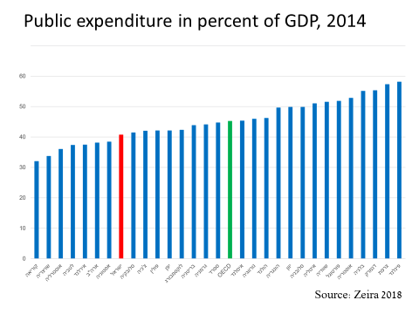
- Has the state budget been balanced over the past decade (on average)?
- No, there is a surplus of income from taxes on expenditures, as a result of economic growth.
- No, there is a deficit in the state budget.
- The budget is exactly balanced (on average) - there is no surplus and no deficit.
- It is impossible to know because the government does not publish the data in question.
Explanation: The red line indicates a small deficit - about 2-3% in the state budget
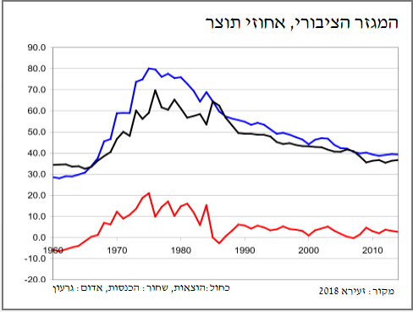
The Public Sector, Product Percentage

- What were the principles of the stabilization program that was introduced in the Israeli economy in 1985?
- Freezing of the exchange rate, export subsidies, freezing employees' wages and freezing prices.
- Freezing prices, encouraging investments from abroad, freezing wages of employees and reducing the deficit in the public sector.
- Freezing of the exchange rate, reducing the deficit in the public sector, export subsidies and the freezing of employees' wages.
- Freezing of prices, reducing the deficit in the public sector, freezing the exchange rate and freezing of employees' wages.

- What caused the economic crisis during the years of the lost decade?
- The global recession of 1973 led to an ongoing economic crisis in Israel.
- The global recession of 1973 led to hyperinflation, which was accelerated by the security situation in Israel.
- An increase in defense and social welfare expenses led to an increase in the public debt.
- The government wanted to solve the recession in the private sector and therefore increased the government budget and led to an increase in the public debt.
Explanation: Oil crisis + Increase in government deficit (both because of defense expenditure and welfare) => Deficit. => Printing money => hyperinflation

- As a result of the improved salary at the spare parts plant, you have managed to save a considerable amount, which you are interested in investing in shares, and you are not sure if you should invest in Israel or abroad. It is 2010 it was just announced that the Governor of the Central Bank of Israel raised the interest rate.
- I will choose to invest in Israel because raising the interest rate will lead to shekel appreciation, so the investment abroad is less attractive.
- I will choose to invest in Israel because raising the interest rate indicates the strength of the Israeli economy and the strength of Israeli companies compared to companies abroad.
- I will choose to invest abroad because raising the interest rate reduces the demand for shares and thus may lower the return on investment in shares.
- A and C are correct. You cannot know which is better.
Explanation:

- Your investments were successful, and you decided to buy the spare parts factory. Now you are debating whether to expand the plant. The year is 2011 and the Governor of the Central Bank of Israel decided to lower the interest rate. What are you likely to do?
- I will expand the plant.
- I will not expand the plant.
- You cannot know.
- There is no connection between raising the interest rate and my decision.
Explanation: Lowering the interest rate allows for a convenient loan (if needed for investment) is a good alternative to an interest-bearing deposit. And will also lead to depreciation in the shekel => increase in export profitability.

- In the open economy:
- If the Central Bank of Israel raises the interest rate, it will succeed in reducing inflation, but the dollar will weaken.
- The reduced interest rate by the Central Bank of Israel will increase inflation concerns, but the dollar will weaken.
- Raising the interest rate will harm the economy's growth and lead to a bubble in the housing market.
- Raising the interest rate will encourage individuals to save money and therefore increase the product.
Explanation: (graph on next page)
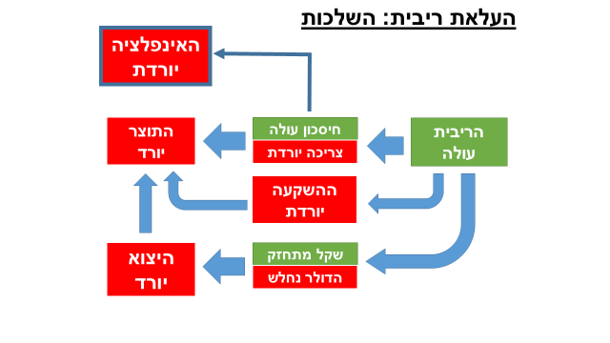
Inflation decllines
GDP declines
Export declines
Interest goes up
Saving goes up
Dollar weakens
Consumption declines

Investments declines

Shekel strengthen

Raising Interest Rates - Implications

- Why are there so many poor people in Israel?
- Due to a low participation rate in the labor force.
- Due to large wage gaps between educated and uneducated workers.
- Due to the high rate of new immigrants and a large number of elderly.
- Answers A and B are correct.
Explanation: Haredi men and Arab women rarely participate in the labor market, which explains some of the poverty. In addition, within the labor market there are wage gaps - particularly between the educated and the uneducated.

- Open economy inflation:
- Inflation causes a decline in the real wages.
- Inflation does not affect the exchange rate.
- Inflation leads to the creation of a bubble in the capital market because it reduces the profitability of investment in bank deposits.
- Inflation reduces the probability of creating bubbles in the real estate market because it is diverting demand to the capital market.
Explanation: Real wage = nominal wage divided by prices in the economy. When there is inflation (i.e. prices rise) the denominator rises so that the real wage decreases.

- Inequality and poverty - (Eyal suggests ignoring this question)
- National insurance benefits in Israel are not significantly lower (relative to OECD countries).
- The poverty rate in Israel is not significantly different from the OECD countries.
- Support for the weaker populations in Israel, as a percentage of the product, is not significantly lower compared to that of the OECD countries.
- Income support benefits in Israel are not significantly lower compared to OECD countries.
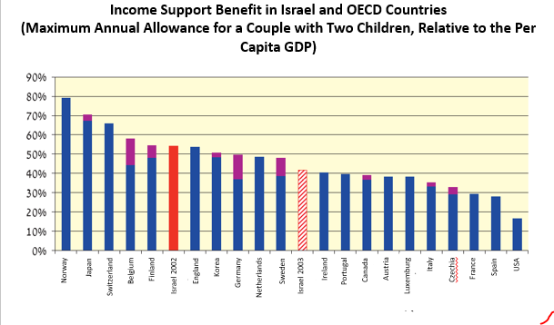

- The public debt in Israel, as a percentage of the product: (Eyal suggests ignoring this question)
- Was in the early 2000s higher than the average in EU countries.
- Is significantly lower than the EU countries' average debt.
- Is low relative to Israel's public debt in the past.
- Answers A and C are correct

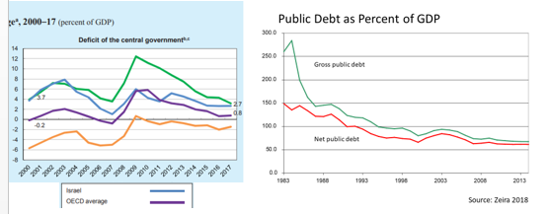

- Which of the following populations has the lowest participation rate in the labor force?
- Haredi women in the past
- Haredi women in the present
- Muslim women in the past
- Muslim women in the present
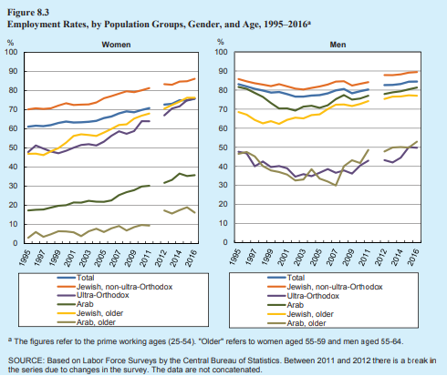

- The unemployment rate in Israel
- Was on the rise even before the economic crisis that began in 2008.
- Is high relative to European countries.
- Is very low in international comparison.
- Was in a downward trend before the economic crisis that began in 2008.

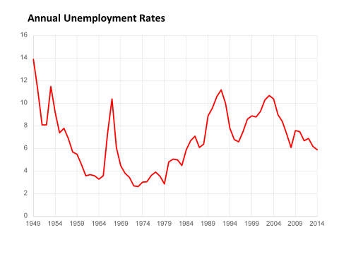
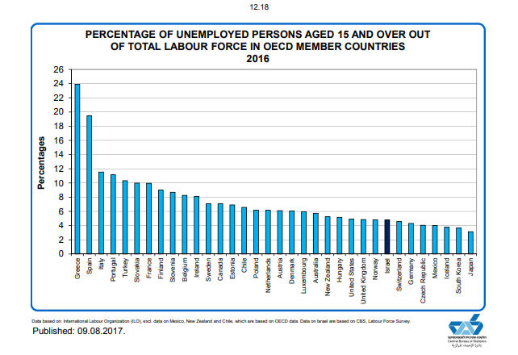

- The public sector in Israel in the early 1980s, as a percentage of the product
- Was relatively large compared to today's situation and also relatively large compared to other countries at the time.
- Was relatively large compared to today's situation, but was not unusual compared to other countries at the time.
- Was large relative to other countries, and continues to be large today.
- Was not unusual in comparison with other countries, and is still not unusual.
Explanation: There is no comparative graph for the 80's, or reference to it in lessons, but from the lesson of the lost decade we can assume that we exaggerated then.

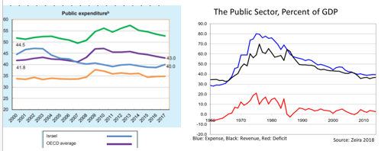

- When a fixed-exchange-rate regime prevailed in Israel, depreciation of the shekel led to-
- It encouraged imports but brought prices up.
- It encouraged exports and led to a drop in prices.
- Raised prices and hurt import.
- Lowered prices and hurt export.
Explanation: devaluation of the exchange rate => more NIS per product worth one dollar => Prices in NIS raise => Import less worthwhile

- Lowering the interest rates in the economy
- Is likely to raise both house prices and share prices.
- Is likely to raise housing prices but will not affect the price of shares.
- Is likely to raise the price of shares but will not affect housing prices.
- Will not affect housing prices and shares but will lead to an increase in yields on government bonds.
Explanation: Lowering the interest rate makes the savings at the bank less worthwhile and turns investors into other channels such as real estate and shares, and then the excess demand will cause price increases

Lowering Interest Rates - Implications
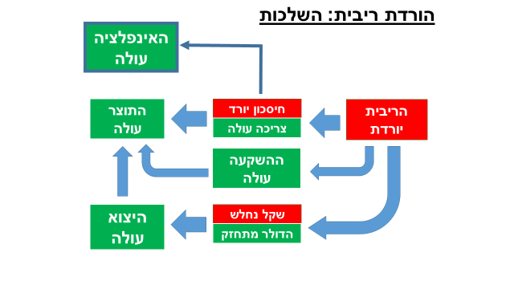
Inflation goes up
GDP goes up
Export goes up
Saving declines
Interest goes down
Consumption rises
Investment goes up
Shekel weakens
Dollar strengthens

- The Central Bank of Israel decided to lower the interest rate. Apparently it is worried about:
- The strengthening of the dollar
- An increase in inflation
- Increase in housing prices
- Increase in unemployment rates
Explanation: Lowering the interest rate will increase investment and GDP and will therefore increase demand for workers in the economy. (Concurrently - will strengthen the dollar and raise inflation)

- Complete the sentence: _____ the interest rate will cause the product to______
- Reducing, increase
- Reducing, decline
- Raising, increase
- Raising, stay unchanged
Explanation: Lower interest rate -> Decrease in the profitability of savings -> Increase in consumption -> Increase in GDP
-> Decrease in cost of loans -> Increase in investments -> Increase in GDP
-> Devaluation -> Increase in export profitability -> Increase in GDP

- Complete the sentence: ______ in export will cause the dollar to________
- Growth, strengthen
- Decline, weaken
- Growth, weaken
- Growth, remain unchanged
Explanation: Increase in exports => There is more $ convert to NIS => More demand for NIS => The dollar will weaken

- What characterizes the first decades of the establishment of the state (relative to today's situation):
- In the early decades there was a free market economy.
- In the first decades, government involvement was high in the economy.
- In the first decades, Israel's economy relied on exports.
- In the first decades there were no large waves of immigration.

- Real GDP per capita today:
- Is higher than that during the establishment of the state
- Similar to the one that existed at the time of the establishment of the state
- Lower than that of the establishment of the state
- All the answers are correct
Explanation: Real product per capita = product at constant prices (excluding the effect of inflation) divided by population. Real GDP per capita can certainly go down this year or another when there is a recession, but over the years real economic sizes tend to rise (to be on the rise).

- The peak of inflation in Israel was:
- With the establishment of the state
- In the 1960s
- In the mid-1980s
- Last year

- In anticipation of the upcoming elections, the Finance Minister announces the addition of a budgetary expenditure for the reinforcement of classrooms in the north. Assume that there is no change in other expenditure items or in taxes. What is expected to happen?
- Interest rates in the economy will decline
- Future government interest payments will rise
- The government deficit will decrease
- inequality in the economy will increase

Explanation: Increase in expenditure without tax increases -> Increase in deficit -> usually financed by increased debt -> more interest payments on debt.

- According to Zvika's expectations, the US is entering a recession. How is this expected to affect Israel?
- Growth in Israel will accelerate because other countries will want to buy from us more.
- Devaluation of the shekel exchange rate (dollar strengthening)
- The government deficit will decrease
- Israeli GDP will decrease due to a drop in exports

Explanation: Israeli exports depend primarily on the economic activity of our trading partners - the US, Europe.

- Continuing the previous question, how can we reduce the impact of the global recession on growth in Israel:
- Raise interest rates.
- Lower taxes.
- To dismiss civil servants.
- Instruct the Central Bank of Israel to stop buying US dollars

Explanation: Lowering taxes, increasing government spending, or lowering interest rates are classic examples of Keynesian steps to stimulate short-term growth in the economy.

- How is the GDP defined?
- The value of the total goods and services produced in the economy during a given year
- Value of all products consumed in the economy in a given year
- The embodiment of all products
- Total government expenditure minus tax revenues

- Which of the following factors reduces the credibility of the GDP as an indicator of the standard of living in the economy:
- Black economy
- Exclusion of services produced within the household
- Leisure is not part of the product (GDP)
- All of the above.

- Which of the following statements is true:
- Since the establishment of the State of Israel, the gap between the GDP per capita in the US and Israel has not narrowed.
- Up until 1973, Israel reduced the GDP per capita gap versus the US.
- GDP per capita in Israel is similar to that of the United States.
- In every decade since the establishment of the State of Israel, Israel has narrowed the GDP per capita gap with the US.

Israeli GDP per capita as a percentage of US GDP per capita

- Which of the following is not an example of a demand shock (in a business cycle):
- An increased optimism in investors.
- An increase in consumption due to an increase in employment security.
- Refraining from going out to restaurants as a result of terrorist attacks.
- Technological improvement in shoes manufacturing.

- which of the monetary sizes is larger - the monetary base or the money supply (means of payment):
- The base of money
- The amount of money
- You cannot know
- All of the above

Explanation:
The base of money: Cash in public + reserves in commercial banks
Amount of money (1M): Total means of payment = Cash held by the public + current account at commercial banks
In other words, both include cash held by the public. The money base also has the reserves that the commercial banks hold, which are a small percentage held compared to deposits current accounts in banks (and are counted in the amount of money).

- What is Israel's current inflation rate (2018):
- Negative rate
- About 1%
- About 3%
- About 6%

- Which of the following statements is true with respect to taxes:
- Income tax in Israel is high relative to the Western world.
- In Israel there is no VAT on food products.
- Indirect taxes in Israel are higher than in the Western world.
- Total taxes in Israel as a percentage of GDP are high from an international perspective.

- How is an unemployed person defined?
- Those who were fired from their place of work.
- Those who do not work.
- Those who don't work, want to work and are free to work.
- Those who work under 20 hours a week

- Employment rate in Israel?
- Has risen in recent decades.
- Has not changed in recent decades.
- Has declined in recent decades.
- Some lie.

- How will the reduction of income tax rates for high incomes earners affect the labor market?
- Will cause an increase in the participation rate in the labor market (more people will want to work).
- There will be an increase in the number of work hours per employed person among educated persons.
- Net wages will decrease.
- Gross wages in high incomes will rise.

Explanation: A decrease in the income tax in the high salary levels - working more hours is better because for each additional shekel a larger part goes to the employee.

- Government intervention by imposing taxes and paying pensions
- Reduces the inequality in available income compared to the (gross) economic inequality.
- Affects only economic inequality.
- Increases the poverty rate.
- Increases the inequality in disposable income.

