**Religion, culture and art in the holy land**

The program entails 5 meetups in which we will engage with various lifestyles, religions and cultures. We will be visiting museums, enjoy tastings and get acquainted with unique people and special places.

The following is the program for the first two meetups:

1. Louis Promenade, Haifa

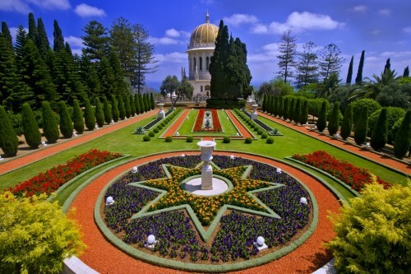

**Monday, January 6th, 2020**

**Program:**

**8:30** Gathering at Haifa University; coffee and cake

**9:00** Hecht Museum Observatory (with Prof. Yossi Ben Arzi)

**10:00** Head to the Bahai Gardens/Louis Promenade

**12:00** Lunch

**13:00** Tikotin Museum of Japanese Art/ [Mané-Katz Museum](http://www.mkm.org.il/eng)

**14:00** End of tour at Haifa University

1. **Life Around the Yarkon River**

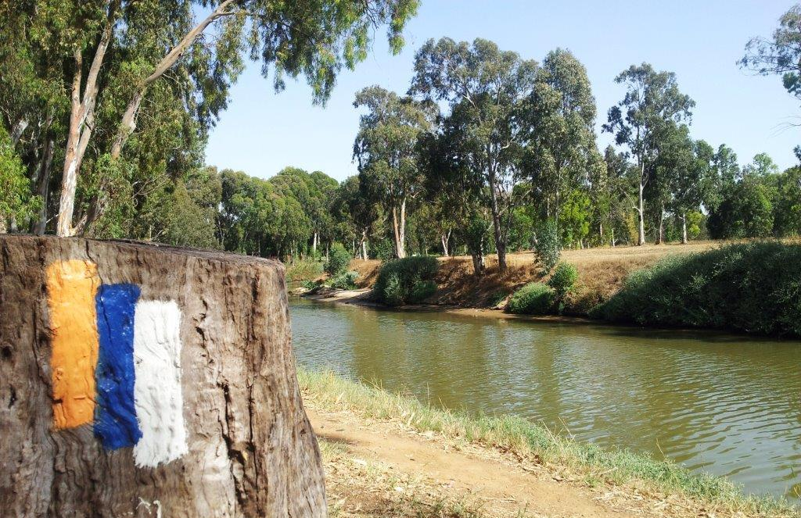

**Wednesday, February 5th, 2020**

**Program**

**8:30** Coffee and cake at INSC and explanation on the route

**9:00** Head towards Kibbutz Einat

**9:30** Tour of Kibbutz Einat; brief art workshop

**11:00** Meal at “Gingie’s Hummus”, Einat

**11:30** Tour along the Yarkon, Baptist Village

**13:00** The Land of Milk and Honey – Visit to Moshav Nehalim dairy farm

**14:30** Estimated arrival back to INSC

**Meetup 3: Akko (Acre)**

**Date: March 12th, 2020**

Visit to the halls of the Knights, the Treasures of the Wall Museum and the Hammam as well as sail along the shore.

**Meetup 4: Zichron Yaakov and Ein Hod**

**Date: April 22nd, 2020**

Ramat Hanadiv garden, Sara Aharonson House and the Dada Museum in Ein Hod.

**Meetup 5: Caesarea**

**Date: May 14th, 2020**

Herod’s construction projects; Kibbutz Sdot Yam, Hannah Szenes House and the Recanati Museum