**Religion, Culture and Art in the Holy Land**

The program entails 5 meetups in which we will engage with various lifestyles, religions and cultures. We will be visiting museums, enjoy tastings and get acquainted with unique people and special places.

**The following is the program for the first two meetups:**

**Meet Up No 1: Louis Promenade, Haifa**

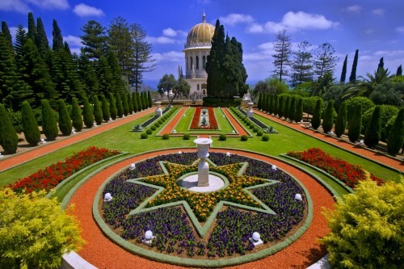

**Monday, January 6th, 2020**

**Program**

**8:30** Gathering at Haifa University; coffee and cake

**9:00** Hecht Museum Observatory (with Prof. Yossi Ben Artzi)

**10:00** Head to the Bahai Gardens/Louis Promenade

**12:00** Lunch

**13:00** Tikotin Museum of Japanese Art/ [Mané-Katz Museum](http://www.mkm.org.il/eng)

**14:00** End of tour at Haifa University

**Meet Up No 2: Life Around the Yarkon River**

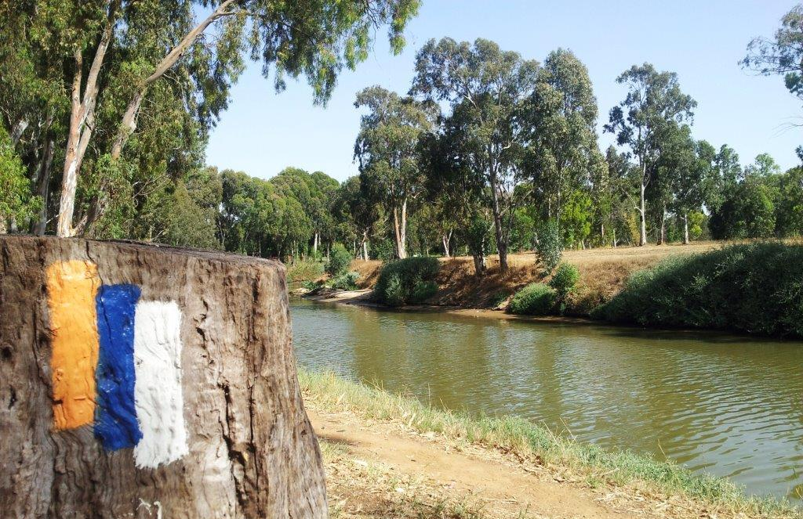

**Wednesday, February 5th, 2020**

**Program**

**8:30** Coffee and cake at INSC and explanation on the route

**9:00** Head towards Kibbutz Einat

**9:30** Tour of Kibbutz Einat; brief art workshop

**11:00** Meal at “Gingie’s Hummus”, Einat

**11:30** Tour along the Yarkon, Baptist Village

**13:00** The Land of Milk and Honey – Visit to Moshav Nehalim dairy farm

**14:30** Estimated arrival back to INSC

**Meet Up 3: Akko (Acre)**

**Date: March 12th, 2020**

Visiting Acre: tour to the Halls of the Knights, the Treasures of the Wall Museum and the Hammam as well as a sail along the shore.

**Meet Up 4: Zichron Yaakov and Ein Hod**

**Date: April 22nd, 2020**

Ramat Hanadiv Garden, Sara Aharonson House and the Dada Museum in Ein Hod.

**Meet Up 5: Caesarea**

**Date: May 14th, 2020**

Herod’s construction projects; Kibbutz Sdot Yam, Hannah Szenes House and the Recanati Museum