**Meet Up No 2: Life Around the Yarkon River**

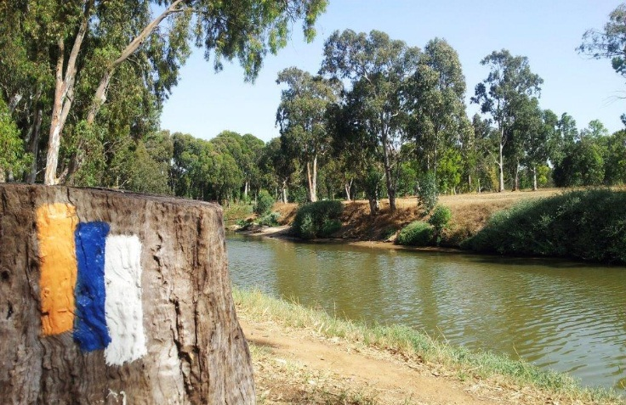

**Wednesday, February 26th**

**Program**

**8:30** Coffee and cake at INSC and explanation on the route

**9:00** Head towards Kibbutz Einat

**9:30** Tour of Kibbutz Einat; brief art workshop

**11:00** Meal at “Gingie’s Hummus”, Einat

**11:30** Tour along the Yarkon, Baptist Village

**13:00** The Land of Milk and Honey – Visit to Moshav Nehalim dairy farm

**14:30** Estimated arrival back to INSC