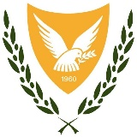 | REPUBLIC OF CYPRUS  MINISTRY OF DEFENSE  NATIONAL GUARD GENERAL STAFF  OPERATIONS DIRECTORATE | 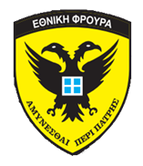

CIMIC EXERCISE «ARGONAUT 2019»

REGISTRATION FORM

Participant Contact Information:

Country | Israel
Rank/title | LTC / Head of the International Cooperation Branch, J5 ICU
Name | Doron Shaham
Public authority / organization | Israel Defense Forces
Work address | Haim Levanon 8, Tel Aviv, Israel
E-mail address | Benzi_zimerman@mail.gov.il
Cell phone number | +972 54 207 4487
Office phone number | -
Passport (country of origin / number) | Israel / 14047047
Accommodation (hotel) | Rimon Hotel, Larnaca
Food allergies (or vegetarian) | -

Travel information
Arrival Day | Time | Airport of arrival | Flight n°
29 / 05 / 2019 | TBD | LCA | TBD
Departure Day | Time | Airport of departure | Flight n°
30 / 05 / 2019 | TBD | LCA | TBD

Any additional information

Please send by e-mail the submission form for each participant as soon is prosiple (ASAP) and not later than 10 May 2019 to depix_ops@army.gov.cy
or Fax to +35722417323

