Operations Directorate (J3)

Israel Defense Forces (IDF)

Tel Aviv, Israel

December 2018

For the Attention Of:

Dear, _____________________

“Noah’s ark” mechanism has been a pillar for regional contingency planning, in the event of a conflict that will result in non-combatant evacuation from Lebanon. The IDF values this mechanism and is looking for avenues where we can enhance and elevate the mechanism.

**During this year’s annual meeting, scheduled to take place 3-5 June, 2018, we are hoping to conduct an “Executive Ark” meeting, with all the directors of operation, and or appropriate General Officers (1-3 Stars) from your respective militaries and organization, hosted by the head of the IDF Operations Directorate, Major General Aharon Haliva.**

During this 3-day session we hope to explore the various challenges - out in the field, to conduct a senior leaders table top exercise and to discuss the way ahead for the mechanism. A detailed agenda will be available as we get closer.

I would also like to take this opportunity, **and suggest we add the German Armed Forces to the mechanism, as some of the various planners and attaché’s suggested. Please email me your response – we will treat this as a “silent procedure” and will wait until 5 February for a response/silent response from all partner Nations**.

For further information and to provide your response please feel free to reach out to me at any time at the contact details provided below.

I would like to wish you, your family, and entire staff - a happy and prosperous new year!

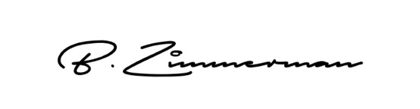

CPT (P) Benzi Zimmerman

Head, International Cooperation Desk

Israel Defense Forces Operations Directorate

