*onboard guided missile cruiser Moskva at the Black Sea port of Sochi, August 12, 2014.*

[**SNAPSHOT**](https://www.foreignaffairs.com/browse/snapshot)**September 16, 2015**

**Putin's Damascus Steal**

How Russia Got Ahead in the Middle East

*By*[*Dmitry Adamsky*](https://www.foreignaffairs.com/authors/dmitry-adamsky)

This year, Moscow is celebrating the 45th anniversary of Operation Kavkaz, the Soviet military intervention on behalf of Egypt in the 1969–70 Israeli-Egyptian War of Attrition. The engagement was a key moment in the history of the Cold War. It caught Western intelligence by surprise, and it was the first—and only—time the Soviet military fought the Israeli Defense Forces. Operation Kavkaz saved Russia’s closest ally from regime change and protected Moscow’s strategic assets on Egyptian soil. The Soviet Union’s subsequent activism in the region marked the height of Moscow’s Cold War achievements in the Middle East.

Once more, the Kremlin is increasingly assertive in the Middle East, and once more, [it has surprised the West](http://www.defenseone.com/threats/2015/09/nato-caught-surprised-russias-move-syria/120764/?oref=d-topstory). Emboldened by its perceived success in addressing regional challenges and capitalizing on opportunities, it has gotten closer than ever to its key diplomatic objective: acquiring a regional status on par with Washington’s.

KREMLIN’S TRIUMPH

Seen from the Kremlin, Russia’s regional policy has been a series of remarkable triumphs. Moscow’s traditional goals are straightforward: to build a buffer against radical jihadists on its southern flank, to export arms and nuclear energy, to project power in the Middle East’s warm waters and beyond, to compete with the West, and, recently, to expand influence among and through regional Christian communities.

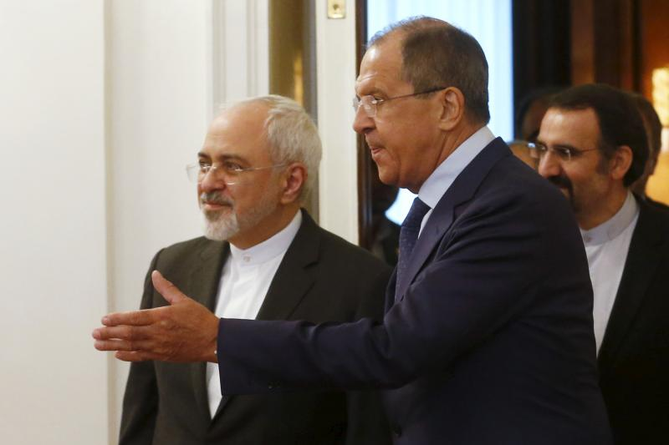

MAXIM ZMEYEV / REUTERS

Russian Foreign Minister Sergei Lavrov shows the way to his Iranian counterpart Mohammad Javad Zarif as they enter a hall during their meeting in Moscow, Russia, August 17, 2015.

The Arab Spring, which Moscow saw as an outcome of U.S. policies, put these goals, and the pillars of Russia’s regional architecture—its alliances with Iran, Libya, and Syria—at grave risk. In Moscow’s view, after throwing Libya into turmoil, Washington focused on cornering Iran with sanctions and threats and on destabilizing Syria by instigating an insurgency. The Kremlin believes that, faced with such challenges, it played each hand skillfully, holding and even improving Moscow’s positions. In Libya, after the initial loss, Moscow realized that it should be more assertive in the region. In Iran, Moscow preserved relations with both moderates and hard-liners, played a constructive role in the recent nuclear deal, and tightened its ties with Teheran through cooperation against the Islamic State (also called ISIS). In Syria, despite a daunting situation, Moscow has kept the regime afloat through diplomacy and airlifts and sealifts of ammunitions and supplies.

Moscow also made good on other opportunities brought about by the regional chaos and what it perceived as U.S. myopia. Namely, as ties between Washington and its regional allies grew strained, Moscow approached Egypt, Jordan, Saudi Arabia, and the Gulf States to establish cooperation on a range of issues. In June, the Saudi crown prince visited Moscow, and then, in the span of one week in August, the king of Jordan, the president of Egypt, and the crown prince of Abu Dhabi came to discuss arms and nuclear energy deals and regional politics. The emir of Kuwait and the king of Saudi Arabia have plans to travel to Moscow this fall.

Moscow’s progress with Riyadh, the main U.S. Arab regional ally and sponsor of Syria’s anti-Assad forces, is particularly noteworthy. In the past year, after years of barely talking, Russia and Saudi Arabia have established an ongoing dialogue about ending the conflict in Syria and discussed arms sales, a possible $10 billion of Saudi investment in Russia, and a deal to build more than a dozen nuclear energy reactors.

Beyond the Arab world, the Kremlin also counts some smaller successes in the region. Despite friction with Israel over Israel’s strikes in Syria, Moscow has established a modus vivendi with Jerusalem. In appreciation for Israeli abstention during the vote on the UN resolution reaffirming Ukraine’s territorial integrity, it voiced very little criticism during operation Protective Edge, Israel’s 2014 campaign in the Gaza Strip. Moscow is also proud of other diplomatic achievements in the Mediterranean. It cultivated Greece and Cyprus as potential enablers of its naval strategy, and it conducted its first-ever naval exercises with Egypt and with China[in the region’s waters](https://www.foreignaffairs.com/articles/china/2015-05-26/russia-and-china-go-sailing).

*The Moscow patriarchy’s outreach to Christian denominations beyond Orthodox communities in Egypt, Israel, Jordan, Lebanon, the Palestinian Authority, Syria, and Tunisia provided the Kremlin with the humanitarian pretext for further diplomatic initiatives in the region.*

Finally, the Russian Orthodox Church’s activism in the Middle East enabled the Kremlin to promote itself globally as the only patron of persecuted Christians in the region. The Moscow patriarchy’s outreach to Christian denominations beyond Orthodox communities in Egypt, Israel, Jordan, Lebanon, the Palestinian Authority, Syria, and Tunisia provided the Kremlin with the humanitarian pretext for further diplomatic initiatives in the region. Perhaps the Putin regime’s biggest achievement along these lines so far was, in 2013, [thwarting a potential U.S. intervention in Syria](https://www.foreignaffairs.com/articles/russian-federation/2015-06-16/pontiff-and-pariah) through alliance with the Holy See, which sees Putin, not the United States, as a protector of Middle Eastern Christians.

TRENDING

Encouraged by its successes to date, Moscow is likely to accelerate things. Here, five trends loom large.

First, ISIS and Syria are top priorities. The West underestimates Moscow’s anxiety about the situation in Syria and its readiness to take on ISIS. The Kremlin has named the terrorist group as an immediate national security threat and its “main adversary,” the term it usually preserves for NATO and the United States. Among other reasons, Moscow is so eager to shelter Damascus because it is the Assad regime’s battle against ISIS (together with Hezbollah and Iran) that is keeping jihadists from swarming into Russia. With ISIS volunteers from the Caucasus, Central Asia, and Russia calling to bring jihad back home; with the Caucasian Emirate in southwestern Russia swearing allegiance to ISIS; with experienced veteran jihadists returning to Central Asia and North Caucasus; and with Chechens and Muslims, including radicalized Crimean Tatars, volunteering to fight in Ukraine, Moscow’s concerns are genuine.

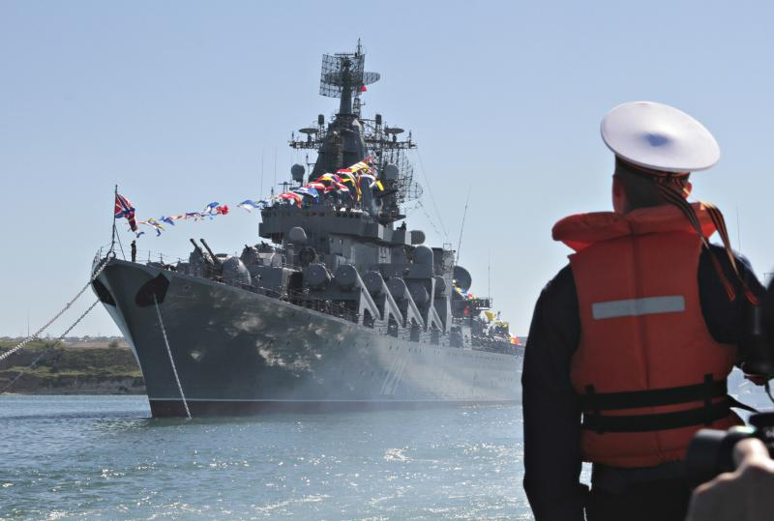

REUTERS

A sailor looks at the Russian missile cruiser Moskva moored in the Ukrainian Black Sea port of Sevastopol, May 10, 2013.

Russian anxiety is amplified by its frustration. Since late 2014, Moscow tried and failed to convince regional regimes and the West to unify command over all combat activities. The West repeatedly dismissed Moscow’s suggestion to extend the anti-ISIS coalition to include Syria, Iran, and Hezbollah. And so the Kremlin is likely to start acting unilaterally, including by building its own military coalition that is as broad as possible and which will unify all anti-ISIS forces. For this enterprise, Russia is likely to seek a UN mandate. Whatever Russia’s chances of defeating ISIS terminally, even partial liquidation of jihadists on the Syrian territory will check Moscow’s most underaddressed security concern, and will save a regional foothold.

Moreover, the consolidation and leadership of the anti-ISIS forces would hand Moscow some unique PR opportunities. The United States, the Kremlin would argue, demolished the Sykes-Picot order and unleashed regional chaos. After doing so, Washington was reluctant to commit boots on the ground to solve the problems it created. In contrast, Moscow will promote its own image as regional troubleshooter and reliable ally. For the European audience, it will position itself as a stabilizer of the refugee problem, which Putin has called a consequence of misguided U.S. policy. In particular, Putin will further aggrandize himself as a world-historical figure ready to settle the region, guard Christian values, and fight barbaric forces to fulfill Russia’s civilizational role.

Second, after Syria and ISIS, Moscow will try to emerge as a key middleman in every regional conflict or process. At least in its own eyes, Moscow has already risen as such. The Kremlin believes that it was the main broker during the Syrian chemical weapons crisis and the key player in the Iranian deal. Its participation in the P5+1 negotiations, Russia believes, showed that Russia can be constructive, not only a spoiler.

*As the prices of oil and natural gas fall, Moscow cultivates nuclear exports and engages anyone in the region who is willing to pay for civilian nuclear energy cooperation.*

In the coming months and years, Moscow is likely to continue positioning itself as an indispensable regional middleman. Given its ties to Iran, Syria, and Hezbollah, and its cultivation of Egypt, Saudi Arabia, Jordan, and the UAE, Moscow has even started to build its potential as a Sunni-Shia broker. It has already facilitated talks between Cairo and Damascus, which both face jihadi insurgency. It hosts the Syrian opposition and at the same time receives compliments from Assad for being a reliable ally. It maintains stable contacts with Israel and the Palestinian Authority, and it communicates with Hamas on statehood. In wargames conducted in the last few years by leading Israeli think tanks (including the Institute for Policy and Strategy of the IDC Herzliya, the Yuval Neeman Workshop on Science, Technology and Security, and Blavatnik Cyber Center of the Tel Aviv University) that simulated military conflicts with Hamas, Hezbollah, Iran, and Syria, Russia emerged as a pivotal broker with a unique ability to escalate or de-escalate confrontations.

Third, for Russia, there is more than power at stake. Sanctions-crippled and inflation-hit, Moscow also sees economic opportunities in the Middle East in the months and years ahead. Recent contracts with Egypt demonstrated the region’s potential as an alternative to European markets for Russian food and grain. As the prices of oil and natural gas fall, Moscow cultivates nuclear exports and engages anyone in the region who is willing to pay for civilian nuclear energy cooperation. Despite the setback brought by regional turmoil, the Middle East is still a potential market for the Russian arms industry. And so Moscow has promoted steady sales to traditional buyers, such as Syria and Iran, and cultivated new clientele. It is also diversifying its product line. Space cooperation—the development and launch of satellites and the training of cosmonauts for orbital work—is a new element in Iranian-Russian collaboration. Such cooperation is likely to expand to the Sunni camp.

*Russia may try to use the Middle East to settle the conflict in Ukraine.*

All this might come with an unexpected twist. On the Ukrainian battlefield, Russia fielded mid- and long-range ballistic and artillery capabilities, combined with high-end electronic warfare. It used high-power jamming to bring down UAVs and to disrupt command-and-control communications and guided weapons systems. It also hampered NATO training in the Baltics. Supplemented with the sophisticated air defense technologies that Russia is already selling, Moscow can now offer its buyers combat-proven, unique anti-access area-denial equipment. Such product is likely to have high regional demand, and Moscow is the perfect supplier. The first sales contract of advanced electronic warfare systems to the Middle East and North Africa is currently in the works.

And that leads to the fourth trend: Russia may try to use the Middle East to settle the conflict in Ukraine. In Moscow’s view, the situation in Ukraine escalated too far; the ideal geopolitical end state would have been Finlandization—a sovereign, federalized Ukraine streamlining its security policy with Moscow’s. Unable to de-escalate on these terms, the Kremlin continues bleeding money and soldiers, and is concerned with NATO reinforcements and massive military exercises across Europe. As Moscow seeks to achieve its goals in Ukraine with minimal costs, control tensions in the Baltics, and avoid the unacceptable beefing up of NATO, the Middle East offers an appealing outlet for diverting attention away from the European periphery and for using cooperation on shared Middle Eastern goals to create an atmosphere in which the powers can negotiate a solution to the conflict.

Indeed, from White House statements to *New York Times* editorials praising Russia’s constructive role in Iran and with ISIS, at least until the recent demarche, Moscow sensed that Washington appreciates its regional moves. A misreading or not, Moscow may be ready now to use the Middle East to reach a strategic accommodation with the United States. Within such a framework, Russian withdrawal could be traded for pressure on Kiev to adopt constitutional changes, and for U.S. commitments to respect Moscow’s security concerns in Europe.

Fifth, regional and global political-economic goals drive Moscow to increase its presence in the Mediterranean. In 2013, it reintroduced a permanent squadron to the sea. In 2014, following the annexation of Crimea, it built up the force. Then, in 2015, it released a new naval doctrine, which outlined an enhanced role for the Mediterranean and went relatively unnoticed. The doctrine envisions the sea basin as part of the Atlantic vector, through which the Russian navy will balance NATO. When discussing military policy in the Mediterranean, the doctrine uses the strongest wording that may suggest a commitment to large-scale military moves. The doctrine commands the Russian armed forces to embark on “purposeful course aimed at turning the region into the zone of military-political stability,” and to maintain “sufficient permanent military-naval presence” there. In the coming years, then, the Russian naval agenda is likely only to become more ambitious, elevating the role of the basin and squadron to highs unseen since the end of the Cold War.

PUTIN’S PLAYGROUND

So far, Moscow has mainly projected military power mainly on the European periphery and in the Atlantic. But the Middle East and the Mediterranean are fast becoming a Russian playground. Indeed, if the Cold War offers any lessons, it is that where Russian diplomacy and naval power goes ground and air combat components follow. History also teaches that Moscow is not afraid to use its forces for combat missions when allies face existential dangers that put Moscow’s strategic assets on their soil at grave risk. This was the logic behind the Soviet decision to establish combined military presence in Egypt and Syria and then to commit forces to fighting there.

In the coming years, Russian assertiveness in the Middle East may hit unprecedented highs. Syria and the battle against ISIS are likely to be Moscow’s first outlets. The country might go as far as an intervention—not with advisers but with military personnel taking battlefield responsibilities or even conducting combat missions in the air and on the ground. Regional and international sources already mention such a possibility. The Kremlin has yet to confirm, but Russian official and independent sources, and social media, offer direct and indirect supporting evidence. Building on Moscow’s existing foothold in Syria, Putin may use the forthcoming General Assembly to offer a plan for region’s stabilization and to request a UN mandate for a resolved and capable Russia to lead the regional anti-terrorism alliance. If the growing Russian military infrastructure, equipment, and personnel build-up materializes into a combined arms expeditionary force on Syrian battlegrounds, this should come as no surprise; it is the logical continuation of Russia’s regional resurgence.