Dennis Ross
American Diplomat and Author
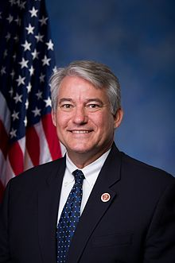
previous positions
2011 | Special Advisor to the National Security Council
2009 | Special Advisor for the Persian Gulf and Southwest Asia to Secretary of State Hillary Clinton
2009 | Special Assistant to the President and Senior Director for the Central Region
2008 | Principal author of presidential candidate Barak Obama
2002 | He became chair of the Jerusalem-based think tank
1991 | Director of the United States State Department's Policy Planning Staff
1982-1984 | Director of Near East and South Asian affairs in the National Security Council and Deputy Director of the Pentagon's Office of Net Assessment
Education
1970 | University of California, Los Angeles
Personal Information
Born in San Francisco, 1948

