David Nathan Saperstein
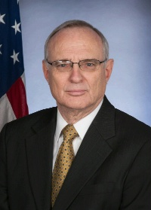
American Rabbi, Lawyer, Jewish Community Leader
previous positions

2015-2017 | United States Ambassador-at-Large for International Religious Freedom
2014 | Obama nominated Saperstein to be the first non-Christian to hold the post of United States Ambassador-at-Large for International Religious Freedom
2009 | President Obama's Council for Faith-Based and Neighborhood Partnerships
2009 | Adjunct professor at Georgetown University Law Center
2008 | Delivered the invocation at the Democratic National Convention's final session
1999 | First Chair of the U.S. Commission on International Religious Freedom
Education
Graduated from: | - Cornell University  - Hebrew Union College  - American University, Washington
1970 | He is a graduate member in good standing of the Tau Epsilon Phi fraternity
Personal Information
Born August 5, 1947

