Image result for check mark pngImage result for check mark pngImage result for check mark pngImage result for check mark pngImage result for check mark pngImage result for check mark png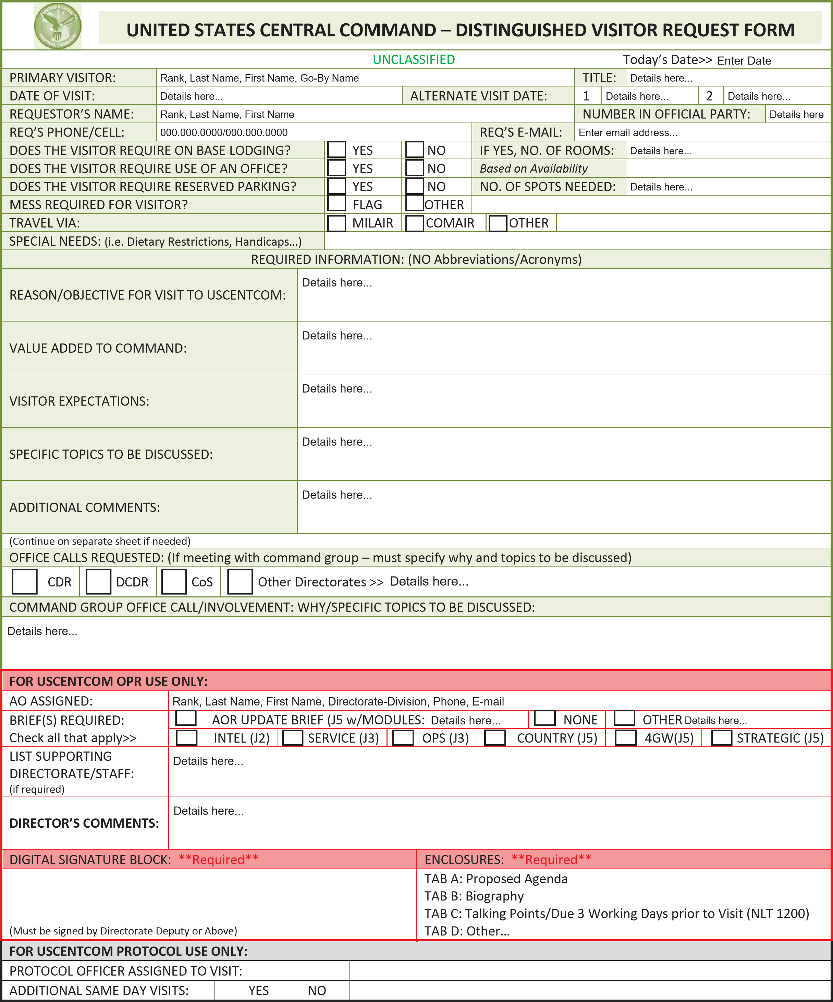

**N/A**

WILL BE AVAILABE UPON REQUEST VIA SEAGULL NETWORK

J3 and SOCCENT

Regional SITREP and Joint Cooperation

DCOM, J3 and SOCCENT CDR office calls, Round table with J3,J2,J5,J7, Tour IO-WEBOPS center And J3 JOC

Meetings with CENTCOM GO/FOs

**6**

Strengthen the strategic alliance, conduct Regional SITREP

**Benzi.zimerman@mail.gov.il**

**+972-542074487**

**CPT Zimmerman Benzi**

**14 November 2018**

**Director, IDF J-3**

**Major General Haliva Aharon, Aharon**

Email form to: protocol@centcom.smil.mil (preferred) or centcomƉƌŽƚŽĐŽů͘ŵŝůΛŵĂŝů͘ŵŝů

Phone: 813-529-0402/Fax: 813-827-6474

UNCLASSIFIED

CC FORM 14-DVR (Revised) 1 July 2015

Meetings with CENTCOM GO/FOs

Strengthen the strategic alliance, conduct Regional SITREP

DCOM, J3 and SOCCENT CDR office calls, Round table with J3,J2,J5,J7, Tour IO-Webops center And J3 JOC

Regional SITREP and Joint Cooperation

J3 And SOCCENT