David Michael Satterfield
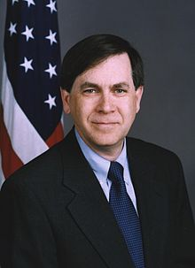
American diplomat and U.S. Ambassador
previous positions

2018 | Assistant Secretary of State for Near Eastern Affairs
2017 | Senior Foreign Service Officer
2017 | Special advisor to the Secretary of State for Libya
2013-2014 | Chief of Mission in Cairo
2009 | Director General of the Multinational Force and Observers (MFO)
2006 | Coordinator for Iraq and Senior Adviser to Secretary of State Condoleezza Rice
2004 | Deputy Chief of Mission with rank of Ambassador
1998-2001 | Ambassador to Lebanon
1996-1998 | Director of the Department of State’s Office of Israel and Arab-Israeli Affairs
1990-1993 | Director of the Department of State Executive Secretariat Staff
1980 | Entered the Foreign Service
Education
1976 | Graduated from the University of Maryland, College Park
Personal Information
Born December 18, 1954

