**David Harris**

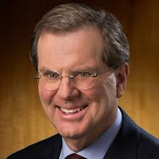 **Executive Director of the American Jewish Community**

|  |  |
| --- | --- |
| previous positions | |
| **1990-** | Executive Director of the AJC |
| **1984-1990** | Head of AJC Washington Branch |
| **1981-1984** | National Coalition Supporting Soviet Jewry |
| **1979-1981** | AJC |
|  | |
| Education | |
| **BA** | University of Pennsylvania |
| **MA** | London School of Economics |
| Personal Information | |
| Born September 23, 1949 | |