Commandant of HNDC CV

Lieutenant General Lamprakis Dimitriou

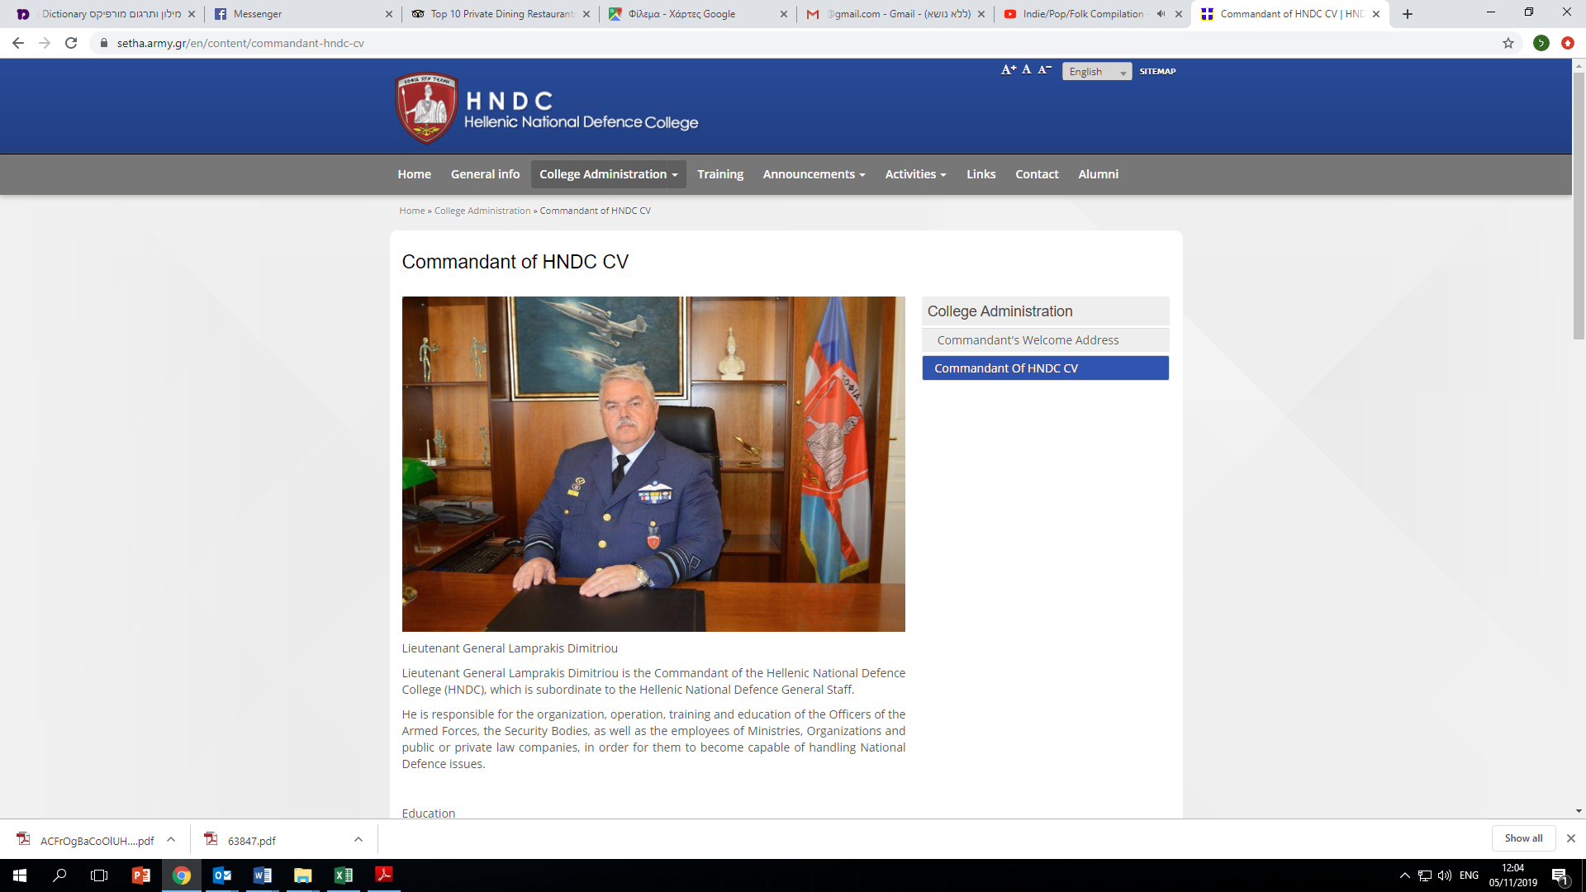

Lieutenant General Lamprakis Dimitriou is the Commandant of the Hellenic National Defence College (HNDC), which is subordinate to the Hellenic National Defence General Staff.

He is responsible for the organization, operation, training and education of the Officers of the Armed Forces, the Security Bodies, as well as the employees of Ministries, Organizations and public or private law companies, in order for them to become capable of handling National Defence issues.

Education

He was born in Ioannina. He joined the Hellenic Air Force Academy in 1980 and graduated in 1984 as a 2nd Lieutenant.

He graduated from:

• Air War College/Junior Officers  
• Intelligence Officers School  
• Tactical Weapons School  
• Instructors School  
• Supreme Joint War College

Foreign Languages: English

Assignments

• January 2019: Commandant of the Hellenic National Defence College  
• March 2018 January 2019: Commander of the Hellenic Air Force Training Command  
• February 2017 – March 2018: Director of the Hellenic Air Force General Staff (HAFGS) Policy and Planning Branch (D)  
• March 2016 – February 2017:Director of Hellenic National Defence General Staff Exercise – Operational Training Directorate (HNDGS/A3)  
• March 2015 – March 2016: Director of HAFGS Defence Planning and Programming Directorate (D2)  
• May 2013 – March 2015: Director of HAFGS Chief’s Staff Executive Office  
• June 2011 – May 2013:Commander of 120 Air Training Wing (120ATW)  
• October 2010 – June 2011: Director of Air Tactics Center (ATC) Operational Research Directorate  
• August 2008 – October 2010: Director of ATC Training Directorate  
• July 2006 – August 2008: Operations-Training Director in 111CW  
• September 2005 – July 2006: Supreme Joint War College  
• September 2003 – September 2005: Commander of 115CW/Operational Conversion Unit  
• June 2001 – July 2003: National Representative in the «IRIS – T» program, Germany  
• June 2000 – June 2001: Section Head of Air Tactics Center Operational Research Directorate  
• July 1997 – June 2000: Operations Officer of ATC/Tactical Weapons School  
• February 1994 – July 1997: Trainer of Tactical Weapons School in F-16 aircraft  
• July 1989 – February 1994: Pilot at 111CW/330 Squadron  
• April 1985 – July 1989: Pilot at 116CW/335 Squadron  
• June 1984 – April 1985: Trainee at 116CW/Operational Conversion Unit

Flight Experience

He has more than 3620 flight hours.  
He has flown with T-41D, T-37B/C, T-2E, F-104G and F16-C/D aircraft.

Promotions

• 2nd Lieutenant : 18/05/1984  
• 1st Lieutenant : 11/06/1987  
• Captain : 30/06/1991  
• Major : 04/06/1996  
• Lieutenant Colonel : 20/04/2001  
• Colonel : 24/03/2008  
• Brigadier General : 17/03/2014  
• Major General : 16/01/2017  
• Lieutenant General : 29/01/2019

Medals – Decorations

• Grand Commander of the Order of Honor  
• Commander of the Order of the Phoenix  
• Medal of Military Merit 1st Class

• Commendation Medal «Merit and Honor»  
• Air Force Formation Command Medal 1st Class  
• Air Force Meritorious Command Medal 1st Class  
• Staff Officer Service Commendation Medal 2nd Class