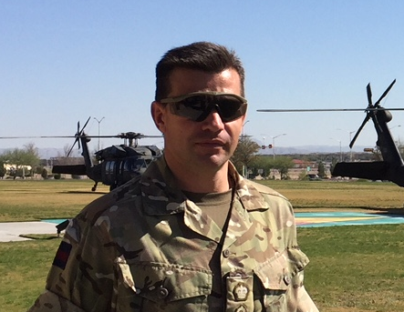
Colonel T P O Till MBE

Colonel Toby Till commissioned into the 2nd Battalion Coldstream Guards in April 1993. Up to Captain he served in London, including Ensign for the Queen’s Birthday Parade, in the Light Infantry role, in Germany in the Armoured Infantry Role and in Northern Ireland on internal security and as an instructor at the Infantry Training Centre Catterick. As Company Second in Command he deployed to the Falkland Islands and Belize. Two years as Reconnaissance Platoon Commander including a second deployment to Northern Ireland (South Armagh) in support of the Joint Support Group - HUMINT. He also completed a tour with Headquarters 19 Brigade as the Liaison Officer to the United Nations High Commission on Refugees working in both Kosovo and Serbia. Returned to Northern Ireland (Londonderry) on completion of Junior Staff College and assumed the appointment of Close Observation Platoon Commander from 2002-2003 as well as exercising in South East Asia. He then moved to HQ 3rd Division in 2003 as SO3 G3 O&D (Ops) and deployed to Iraq as part of HQ Multi-National Division South East in Basra.

In 2004, he passed 16 Air Assault Brigade Pathfinder Selection and on promotion to Major assumed the appointment of Officer Commander Pathfinders for two years deploying to Afghanistan as the first Brigade Reconnaissance Force on Op HERRICK 4 to Helmand Province, where he was Mentioned in Dispatches. From 2006 to 2008, he worked in the MOD Directorate of Equipment Capability (Special Projects) delivering UK Special Forces capabilities. On returning to the 1st Battalion Coldstream Guards (Light Infantry) in late 2008 he commanded a Rifle Company in Afghanistan where he was awarded an MBE. He then spent a year at the Joint Headquarters in Northwood as SO2 J2 Plans from 2010 to 2011 which involved intelligence support to rest of the world operations including the period of operations around the Arab Spring and in Libya.
Promoted to Lieutenant Colonel in 2011, he completed the Advanced Command and Staff Course in 2012 and earned a master’s degree in Defence Studies. After a very short stint on the staff at the Joint Services Command and Staff College supporting the ACSC Review, he assumed command of the 1st Battalion Coldstream Guards (Light Infantry) in December 2012 which included a tour in Afghanistan. His last year in command was dominated by small scale deployments across the globe, including a BG- deployment to central Romania in May 2015 as part of NATO Reassurance measures. He then moved to HQ 3rd (UK) Division as SO1 Plans (and Force Development) and conducted multiple Divisional CPXs as the lead planner over a two-year period including WFX 17-5 in the US. He assumed the appointment of Assistant Head Concepts (Joint and Land) in the Development Concepts and Doctrine Centre (DCDC) in Aug 2017 on promotion to full Colonel and for the last year has been the lead for the Integrated Operating Concept (IOpC).

